**Wind Tunnel Testing and Design Project**

**Objectives:**

* Experimentally determine the effect of flow separation on aerodynamic forces for bluff and aerodynamic bodies
* Explain trends by comparing with published theoretical, empirical and computational results
* Use this experience and knowledge to test a model of our own design
* Perform an analysis of a proposed design change – 1/28/2018 4:15 pm Ingrid Rumbaugh

**Why this Experiment is Important:**

* Wind tunnels are used for testing models of proposed aircraft and engine components. They are an integral part of the prototyping process.
* Wind tunnels are also used for flow visualization, which can be useful to see how the flow changes over and behind a specific shape like an airplane wing.
* Many different fields use wind tunnels to test their products before they become operational. For example, racecars and airplanes both focus on aerodynamic efficiency and therefore need to be tested in a wind tunnel. – 1/28/2018 5:30 pm Ingrid Rumbaugh

**Apparatus:**

The testing apparatus used in this lab is the wind tunnel located in the Thermal Fluids Lab (AEC 136). A picture of the apparatus can be seen below in Figure 1.

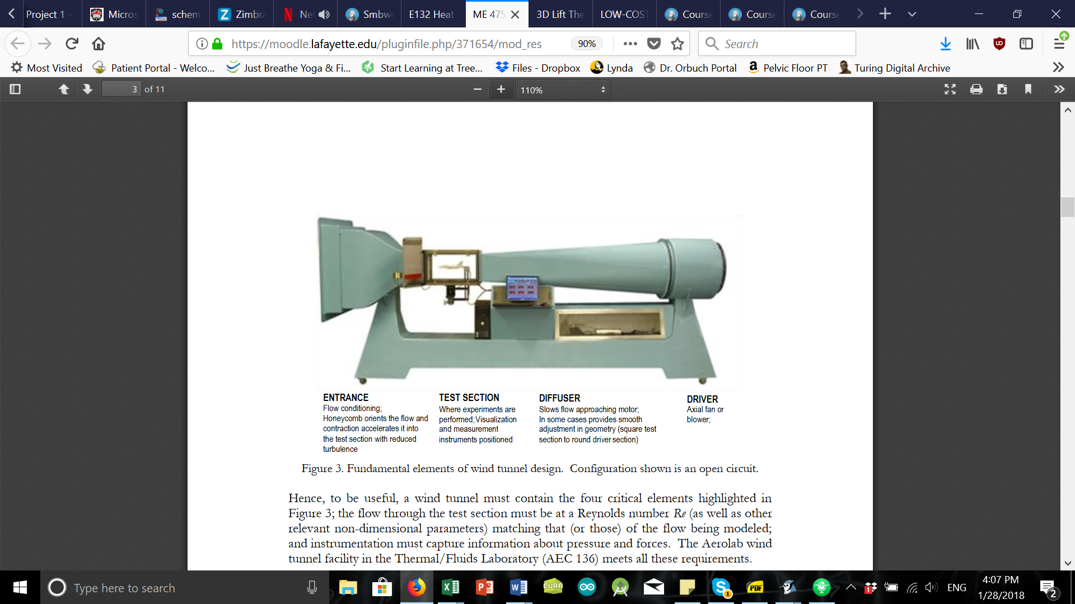

**Figure 1. Fundamental elements of wind tunnel design. Configuration shown is an open circuit.**

**Procedure for Known Shapes:**

1. Place a 1.5” sphere with zero angle of attack in the wind tunnel.
2. Measure the axial force over the entire speed range of the wind tunnel in increments of 5 mph.
3. Plot Cd vs. Re and compare the data to published values and correlations.
4. Repeat these measurements / plots for a 4” sphere, dimpled golf ball, and a 4” sphere with turbulent trip.
5. Then place a Clark-Y airfoil model in the wind tunnel.
6. Measure the normal and axial forces for a fixed freestream velocity (~ 40 m/s). Vary the angle of attack from -6 to +20 degrees, incremented by 2 degrees each time.
7. Plot Cl, Cd as functions of absolute angle of attack (a – a0).
8. Compare the results to theoretically predicted values, computationally generated values, and experimentally recorded values. (Using 3D Lifting line theory to account for the aspect ratio of the wing.)
9. Finally, record visualizations of the flow around selected models to support a physical description of the flow field. – 1/28/2018 4:50 pm Ingrid Rumbaugh

**Procedure for Custom Design:**

1. Identify a baseline geometry to investigate, such as airfoils w or w/o flaps, bluff bodies w turbulence trips/inlets/nozzles, or biologically inspired shapes.
2. Prepare an Inventor part (*.ipt) drawing for the baseline design that is < 8 in^2 projected frontal area.
3. Consider an aerodynamic design change to the baseline model using an analysis method such as published results, analytical modeling, or CFD to estimate the impact of the proposed design change.
4. Modify the baseline Inventor part based on the analysis and save as an STL file.
5. Perform wind tunnel testing using angles of attack of -5, 0, 5, and 10 degrees. For each angle of attack, vary the wind speed over the speed range of the wind tunnel. – 1/28/2018 4:50 pm Ingrid Rumbaugh

**Relevant theory:**

**The experiment will be conducted under the following assumptions:**

1. **The flow within the wind tunnel may be modeled as steady and constant across all surface that are being tested.**
2. **The fluid can be modeled as an ideal gas.**
3. **Since flow separation is often increases with the pressure gradient on the body, the effects of large flow separation will be observed when the wind tunnel is reading a larger pressure gradient and vice versa.**

**The following equations will be needed in order to determine the Lift and Drag effects on the body:**

$F_{d}=F_{N}∙sinα+F_{A}∙cosα$

$F_{l}=F_{N}∙cosα−F_{A}∙sinα$

$c_{l,d}=\frac{F_{l,d}}{ρ∙V^{2}∙A}$

**Additionally, when dealing with fluid flows it is helpful to know the Reynolds Number to determine flow qualities and is given by the equation:**

$ℜ=\frac{ρ∙V∙l}{μ}$

**Descriptions and units of each variable used in these equations can be found in the Excel data spreadsheet for the lab referenced below. – 1/29/2018 5:55 PM Owen Green**

**Data Table:**

|  |
| --- |
| **3d_WindTunnel_Data_V1.xlsx – 1/29/2018 5:20 PM Owen Green** |
| **Revision Number: 1** |
| **Revision Comments:** |

|  |
| --- |
| **3d_WindTunnel_Data_15.xlsx – 2/6/2018 Ingrid Rumbaugh** |
| **Revision Number: 2** |
| **Revision Comments: Organized data into different sheets. This one is for the 1.5” diameter ball.** |
| **3d_WindTunnel_Data_AirFoil.xlsx**  **3d_WindTunnel_Data_40_NoTrip.xlsx**  **3d_WindTunnel_Data_40_Trip.xlsx**  **3d_WindTunnel_Data_golf.xlsx**  **MATLAB CODE:**  **Team3D_WindTunnel_15.m → For the 1.5” diameter ball**  **Team3D_WindTunnel_Clarky → For the airfoil** |
| **Revision Number: 2** |
| **Revision Comments: Organized files more so that it’s easier to find things – 2/6/2018 Ingrid Rumbaugh** |

**Roles and Responsibilities:**

* **Ingrid was responsible for refining and completing the Matlab code for each of the data sets that were taken; additionally, she created Matlab scripts for the data sets that are to be taken in class today, specifically, the golf ball and our Clark-Y attachments. The key plots that were created from the spheres in the wind tunnel were the drag coefficient vs diameter. For the airfoil the primary plots we will be analyzing are the lift and drag versus angle of attack.**
* **Kexiang brainstormed ideas for the testing object we wished to fabricate with Owen, and it was decided that we would test the effects of various wing tips on the Clark-Y airfoil. After speaking with Professor Smith, it was determined that the most efficient way to do this would be to print attachments opposed to multiple similar airfoils. From this he created an inventor model for our proposed wing tip attachment and submitted it.**
* **Owen was responsible for recording, consolidating and organizing the observations and notes from the first lab period. He also helped brainstorm for possible test designs with Kexiang, as previously described.**
* **The group met outside of lab three times. In these meetings we discussed the structure of the Matlab code, so that each member would be able to effectively follow and use it. As a group we also discussed the relevant graphs that Professor Smith advised we had prepared for the next lab period, which are listed more specifically in Ingrid’s portion of this section. The group folder was reorganized by consolidating old data table files and creating separate folders to house files from different programs. We also discussed our desired outcomes for this lab period, these are as follows:**
  1. **Complete testing for the golf ball in the wind tunnel.**
  2. **If our airfoil attachment has been printed we must test its fit to the Clark-Y, if our test model fits, a group member may begin to create inventor models for various tip designs that could be fabricated and used for testing.**
  3. **Analyze our Matlab plots for each test object and looks for any points of error or complication, if any anomalies are discovered we would like to discuss them with the professor to gain an understanding as to what we will need to do differently with our data collection to correct the issue. Should a complication with our data analysis arise we would like to rerun the testing trial before the end of our second lab period.**
  4. **Once testing has officially been completed, we hope to identify trials in which we would like to have a flow visualization.**
  5. **If all other tasks are completed and lab time permits, we can begin our error propagation for each experiment.**

**-Owen Green 2/6/18**

**Wind Tunnel I – Lab Observations**

Notes & Observations:

* The baseline spreadsheet that was created for our data collection had improper units, most importantly, the pressure transducer readouts are in units of counts but our spreadsheet had them labeled as Newtons. The conversions on the wind tunnel were used to transform this data within the matlab script; however, for future reference a group member should be identified to check readout units and ensure they are uniform between the apparatus and spreadsheet.
* The work for the prelab should be divided, communicated, and distributed better, alternating who takes the bulk of the work is not an efficient work method.
* While testing spheres in the wind tunnel, we assume that the connector has negligible effects of the air flowing over the object. This assumption allows us to test the spheres at a single angle of attack because the uniform geometry of the spheres would make its interactions with the flowing air the same at any angle.
* The spherical surface area is needed to use make drag calculations. For our calculations the entire surface area of the sphere was used, however, it is possible that only the frontal surface area was needed. If results are skeptical this can be easily adjusted in the excel spreadsheet.
* Since the sphere is uniform and ‘suspended’ in flow, theoretically the airflow normal force that is measured by the pressure transducer should be zero because the flow on mirrored surfaces should be equal and cancel the other out. This is an easy way to inspect the validity of experimental data that is gathered; in other words, for spheres our experiment should only be measuring drag force on the spheres. Due the symmetry of flow on any side of the cylinder, only the flow vectors oriented directly in line with the center of the sphere should induce a drag. The four inch sphere with a turbulent trip will likely have the most readout errors for normal force because imperfections in applying the trip to the sphere.
* The amount of surface area exposed to the air flow increases the amount of drag that will act on the sphere, from this observation we can induce a check on the experimental drag data because for any specific airspeed smaller spheres should have less drag than the larger. We were unsure whether this same check could be used for both laminar and turbulent flows.
* At low airspeeds the readings of the pressure transducer are less accurate and even upon zeroing the pressure transducer outputs with no airspeed, the readouts are not completely accurate. This causes some of the data that has been gathered to change its sign at various points in the testing.
* Turbulent flow separation occurs at different areas on the sphere. Laminar separation begins approximately at the midline of the sphere, while turbulent separation begins approximately 1/3 of the diameter from the leading point on the sphere.
* Testing the Clark-Y airfoil required various measurements of the airfoil for lift and drag calculations. The specific qualities of the airfoil that are needed are its chord length, wingspan and planform area. The chord length and wingspan were measured to be three inches and ten inches. The planform area of the wing is the area of the top surface; it was assumed that the top surface could be approximated as a rectangle, so the planform area is simply the product of the chord length and wingspan.
* For the airfoil, we are unable to neglect the normal force readouts because the surface in no longer uniform. Additionally, as a result of its geometry the pressure transducer will produce different baseline readouts when it is oriented at each angle of attack. In order to account for this bias in the data analysis the readouts must be measured with no freestream air velocity at each angle of attack so they can be subtracted from the results that are produced with an airflow. This issue may lead us to redo our Clark-Y data collection because upon first collecting the data this factor was not considered until we had already begun collecting data.
* When the angle of attack is small, we expect to see the least drag because the leading edge of the airfoil is the only portion that is exposed to the airflow. As the angle increases we expect the lift increase as well as drag because the flow will be increasingly exposed to the bottom planform area of the wing.
* Airfoils have a specific range of angles of attack, in which the wing orientation would be beneficial for flight. Once the magnitude of the angle exceeds this range, the foil geometry should become detrimental to its flight mechanics, that is, the drag effect will dictate and destroy flight. Graphically, on a Lift/Drag plot this should as appear as an upward slope while the airfoil is within its operating range, followed by a steep drop off as it exits this range. Often the optimal and peak angle of attack is approximately between fifteen and twenty degrees. This can be used as a check for our data collection because we can search for this drop off point to be similar to the typical range of angles of attack in which flight mechanics would begin to fail.
* While testing, the condition of the room affected some of the reading that were being made by the wind tunnel. Things to be conscious of for future testing:

1. Airspeed changing with respect to the door being open or closed.
2. Velocity reading slowly falling as the wind tunnel is operated for prolonged periods of time.
3. Airspeed readouts became less constant as the angle of attack of the airfoil was increased.

-Owen Green 2/5/18

Notes for airfoil with vortex block plates:

* We plan to 3D print the vortex block plates to attach the metal airfoil we used before. The plate has a shape of a 4”x1.5” rectangle and a thickness of 0.2”. And the inside hole has a shape Clark-Y airfoil shape which can fit the airfoil we used before. The .ipt and .stl files are in the inventor folder called Airfoil.ipt and Airfoil.stl. A copy of these files is sent to Prof. Smith’s email also.
* Besides, we made several plates with the same shape but different attach angles. (30/45/60 degrees). . The .ipt and .stl files are in the inventor folder called Airfoil_degree_left/right.ipt and Airfoil_degree_left/right.stl. A copy of these files is sent to Prof. Smith’s email too.
* We are going to print the vertical plates first to see if they ca fit the airfoil. If not, we may use the milling machine or other kinds of tools to machine the hole. When these are all prepared, we will start our experiments.
* In the next experiment, we firstly will test the airfoil with the vertical (90 degrees) vortex block plates to see if they can increase the normal force compared to the airfoil without vortex block plates.
* If the normal force does increase, the next step is to attach the plates with different angles to see which angle has the best effort to block the vortex at the end of the airfoil.
* For the further experiment, we may also change the shape of these vortex block plates to compare with the original ones.

**-Kexiang Yin 2/5/18**

|  |
| --- |
| **A4_WindTunnel_Data_v2.xlsx** |
| **Revision Number:** |
| **Revision Comments:** |

**Insert relevant pictures (or links if media file is large). This is expected to unedited media with initial observations. Not everything included in this section will be seen in the report, but it is critical to record as much as you can as it is difficult to know what will turn out to be most important to your interpretation of the data.**

**Wind Tunnel I – Post Lab**

**Analysis approach described here.**

IMPORTANT! DO NOT BEGIN MATLAB FILE NAMES WITH A NUMBER! MATLAB WILL RETURN A CRYPTIC ERROR

|  |
| --- |
| **A4_WindTunnel_Analysis_m.xlsx** |
| **Revision Number:** |
| **Revision Comments:** |

**Roles and Responsibilities:**

**Identify the primary contribution of the team members during the post-lab.**