**Determining the Effect of Flow Separation on Aerodynamic Forces for Bluff and Aerodynamic Bodies**

Ingrid Rumbaugh, [rumbaugi@lafayette.edu](mailto:rumbaugi@lafayette.edu)

February 2018

Department of Mechanical Engineering

Lafayette College

Easton, PA 18042

**Abstract**

Aerodynamically shaped bodies and bluff bodies have different flow separation effects that dictate product design in the real world. This report explains those relationships between body shape and quantities such as coefficients of lift and drag, Reynolds number, and angle of attack. The results are within an expected range of error to published data, and explain the relationship between Reynolds number and coefficient of drag for bluff bodies. In addition, a Clark-Y airfoil was tested with variable angle of attack, and it can be observed where the induced downwash leads to increased drag, known as lift induced drag.

**Introduction and Methods**

The objective of this lab was to use a wind tunnel to experimentally determine the effect of flow separation on aerodynamic forces for both bluff and aerodynamic bodies. This report will explain common trends in values such as coefficients in lift and drag, and Reynolds number, and compare those trends with published theoretical, empirical, and computational results. These kinds of experiments and results are of interest because wind tunnels are used a lot for testing models of proposed aircraft and race cars. Wind tunnels are also used for flow visualizations, which can be useful to see how the flow of a fluid changes over a specific shape such as an airplane wing.

During these experiments, an object was placed inside the wind tunnel and differential pressure, axial force, and normal force were measured. The analysis in this report is operating under three assumptions. One, the flow within the wind tunnel may be modeled as steady and constant across all surfaces that are being tested. Two, the fluid can be modeled as an ideal gas. Finally, since flow separation is often increased with the pressure gradient on the body, the effects of large flow separation will be observed when the wind tunnel is reading a large pressure gradient.

This experiment is dealing with 2-dimensional (not 3-dimensional) fluid flow in the wind tunnel. 2D flow has two components, lift and drag. The component in the fluid flow direction is drag, which can have two sources: viscous drag and form drag. Viscous drag is due to viscous shear stresses acting on the solid surface. Pressure drag is due to pressure distribution on the object and the subsequent separation of the boundary layer from the solid surface.

Lift and drag can be represented by their non-dimensional coefficients. The following equations are needed in order to determine the lift and drag effects on the bodies that are being tested. Lift and drag forces can be calculated from the normal and axial forces measured using the wind tunnel readout system. Equations 1 and 2 can be used to calculate these quantities, using Fn as the normal force, Fa as the axial force, and alpha as the angle of attack.

**(1)**

**(2)**

Using the calculated values for lift and drag forces, the coefficient of lift and drag can be found. These coefficients can be found using Equation 3, where rho is the fluid density, V is the average free stream flow speed, and A is either the projected frontal area or the plan-form area. ­

**(3)**

In addition to coefficients of lift and drag, the Reynolds number is also a good characteristic of fluid flow. It is used to help predict flow patterns and can determine whether a fluid flow will be laminar or turbulent. This quantity can be calculated below using Equation 4, where rho is the density of the fluid, V is the average free stream flow speed, l is the characteristic length, and mu is the viscosity of the fluid.

**(4)**

The experiment setup can be seen below in Figure 1. This is a picture of the wind tunnel used for testing and shows the basic components that were involved in the testing and reading of data [1].

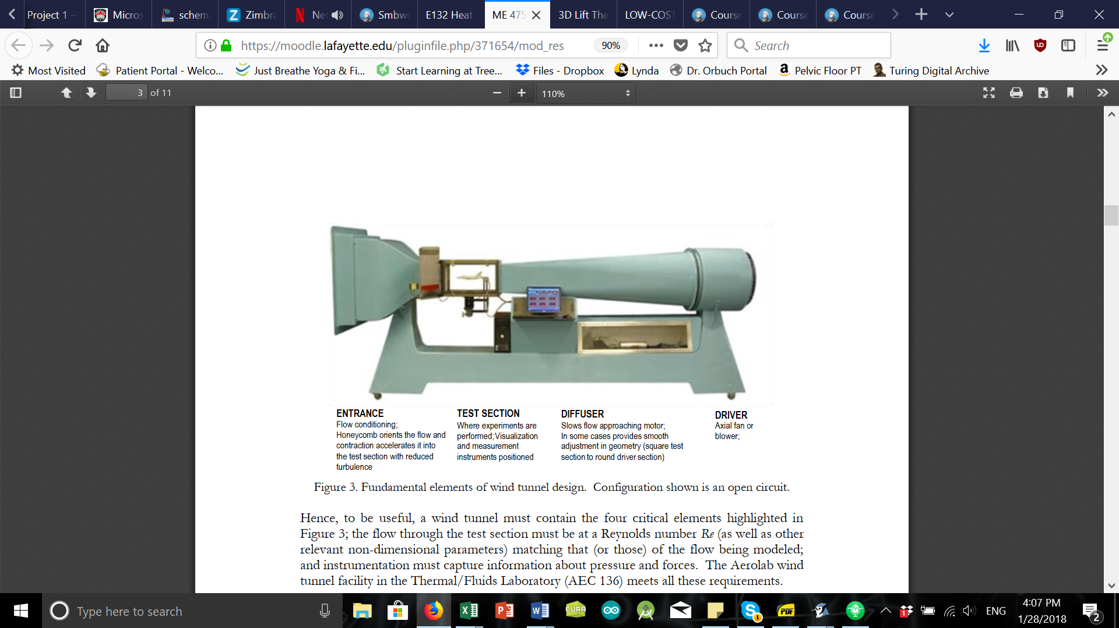

**Figure 1. Fundamental elements of wind tunnel design. Configuration shown is an open circuit [1].**

The following items were tested at a 0 angle of attack, with variable wind speeds from 0-40 m/s in increments of 5 m/s. A 1.5” diameter sphere, a 4” diameter sphere with and without a turbulent trip, and a dimpled golf ball were all tested under this procedure. In addition, a Clark-Y airfoil at free-stream velocity of 40 m/s was tested with a variable angle of attack in 2 degree increments from -6 to 20 degrees.

It is useful to understand the theory behind airfoils before analysis can begin. A mathematical explanation for lift on airfoils is that the airfoil shape creates a circulation in the airflow as seen by a still observer, much like that around a baseball thrown with backspin. Both the baseball and the airfoil then experience an upward lift force. Drag is a force that resists the object’s motion. Therefore, an airplane with lower drag will be able to fly at faster speeds than a higher-drag airplane with the same amount of power. In addition, lower-drag aircraft will require less power to fly at the same speed [2].

The Clark-Y airfoil used can be assumed to have a rectangular wing planform. This means that at the wing tip, there is a larger effective angle of attack due to the induced flow from the vortex than along the rest of the span of the wing. In addition, the influence of the wing tip vortex causes an effective reduction of the coefficient of lift at the wing tips. In order to analyze lift distribution on a wing, Prandtl’s lifting line theory is used. This theory is used under the assumptions that the flow is steady, inviscid, and incompressible. For a symmetric wing, the ideal section lift coefficient can be expressed in Equation 5 as,

**(5)**

Assuming that the airfoil has an ideal, infinite aspect ratio lift coefficient, the coefficient of lift can be described by the equation below. AR is the aspect ratio, alpha is the angle of attack, and e1 is the Oswald efficiency number which is a correction factor used for non-elliptical planform wings.

**(6)**

Similarly, these ideas can be extended to calculate the coefficient of drag to observe where the induced downwash leads to increased drag, known as lift induced drag. This equation is shown below in Equation 7.

**(7)**

**Results and Discussion**

Two different experimental setups were considered: 1) Airflow over various bluff bodies with a zero angle of attack and variable wind speed, and 2) Airflow over a Clark-Y airfoil at high free stream velocity and variable angle of attack.

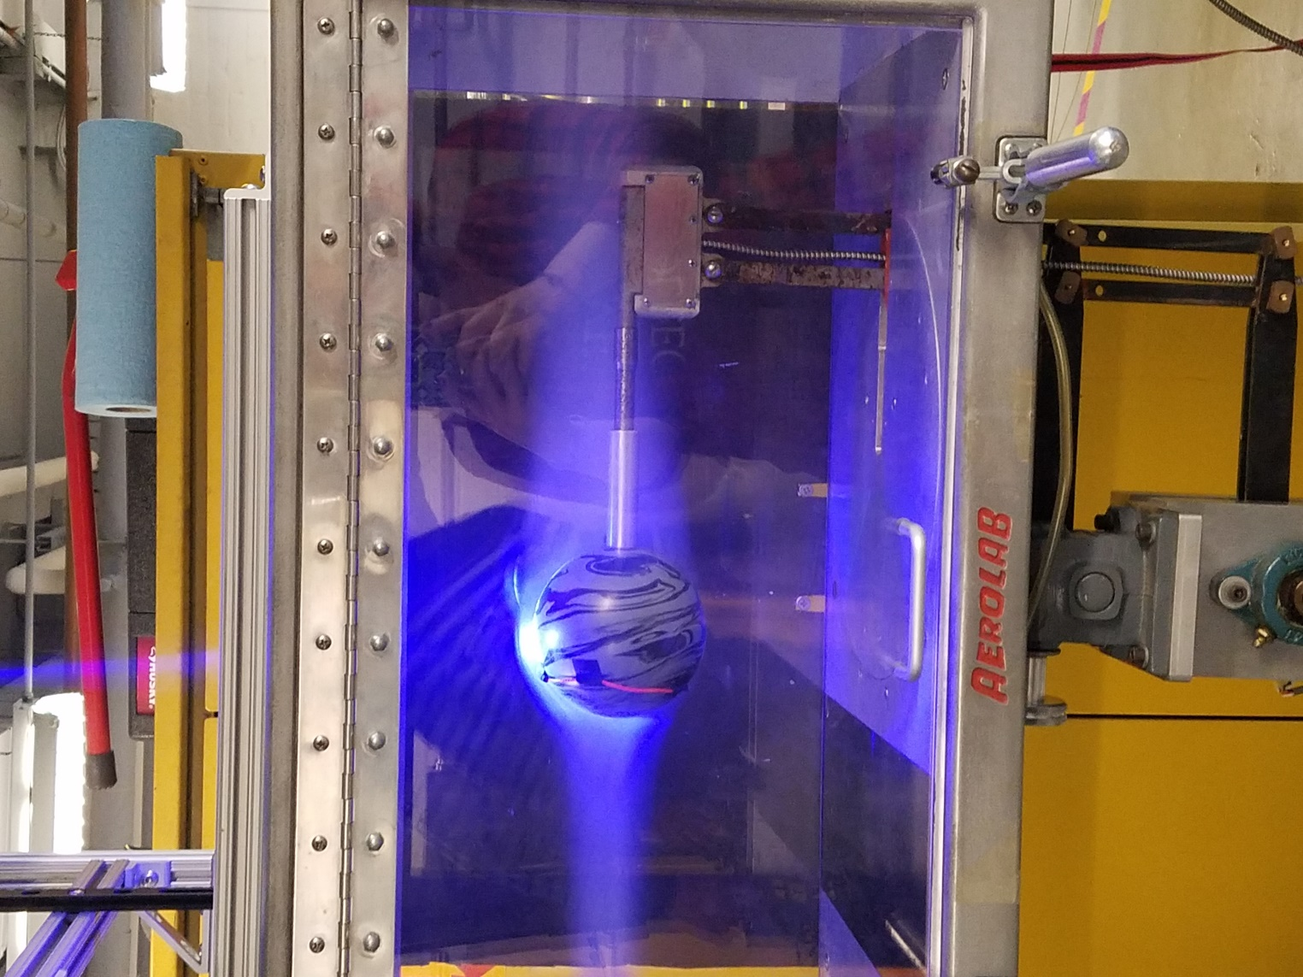

**Figure 2. Flow Visualization of a 4” Diameter Ball at 40 m/s and 0 Angle of Attack.**

It can be seen below that the experimental data (in blue) correlates well with the published data (in orange). There is an understandable amount of error in the graphs which can be due to both fluctuations in the pressure transducer readout, and error that has been accounted for in the error analysis in the next section.

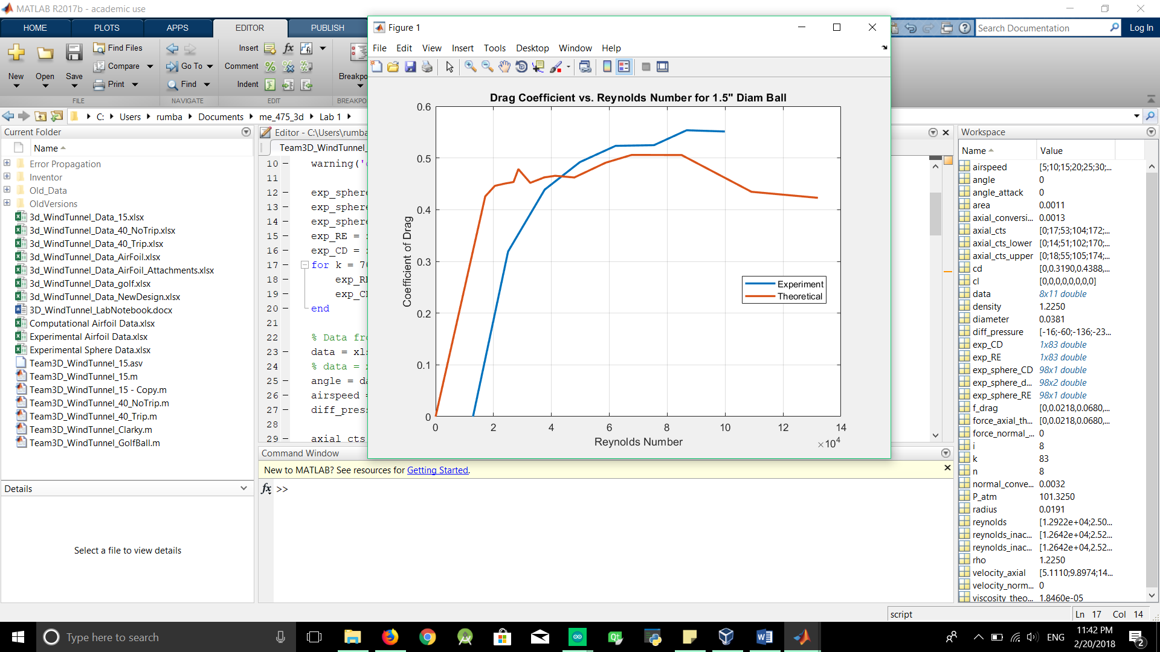

**Figure 3. Plot of Coefficient of Drag vs. Reynolds Number for the 1.5” Diameter Ball.**

**Error Analysis and Propagation**

**Conclusions**

An experiment was conducted to determine the effect of flow separation on various bluff and aerodynamic bodies, in order to correlate Reynolds number with coefficients of lift and drag. Given the error analysis and correlation shown in the graphs, it can be concluded that this experiment was successful in replicating published results. A trend was observed that with an increased free stream velocity and Reynolds number, the coefficient of drag dramatically increased. **[Will discuss error analysis a bit here]**. A new pressure transducer or strain gauges are recommended for future experiments, given that the wind tunnel readout was generally unpredictable. In addition, this experiment could be broadened by discussing the effects of wing tips for the Clark-Y airfoil, and examining the resulting airflow.

­­

**References**

[1] Smith, Joshua. “ME 475: Wind Tunnel Testing and Design Project.” *Moodle*, Lafayette College.

[2] Smith, Joshua. “3D Lift and Pitching Moment Theory.” *Moodle*, Lafayette College.