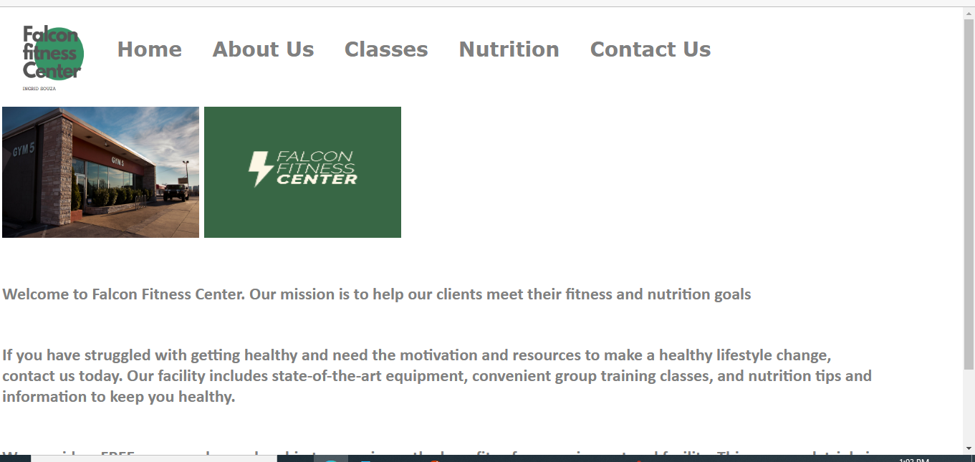

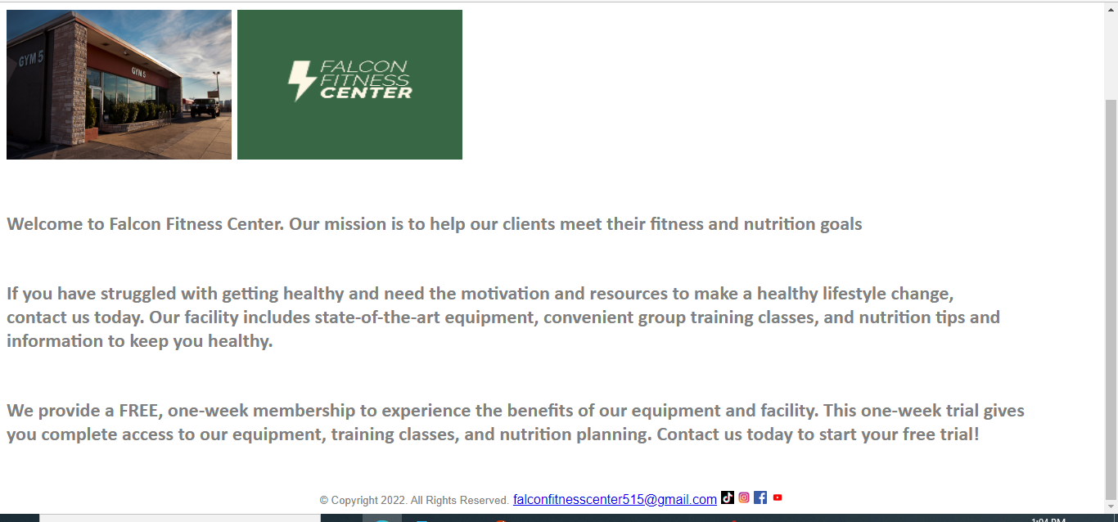

<!DOCTYPE html>

<html lang="en">

<head>

<title> Falcon Fitness Center </title>

<meta charset="utf-8">

<link href="css/ExternalStyleSheetFFC.css" rel="stylesheet">

<style>

h1 {

background color: white;

color: grey;

}

nav a{

text-decoration: none;

font-size: 28px;

font-family: verdana;

font-weight: bold;

height: 90px;

margin: 5px 10px;

float: left;

display: inline-block;

background-color: white;

color: grey;

line-height: 90px;

text-align: center;

transition: 350ms;

}

nav a:active{

background-color: white;

color: grey;

width: 100%;

}

</style>

</head>

<body>

<header>

</header>

<nav>

<div class="container1" style="height: 200%; width: 100%; display: flex;"><a href="FFCLogo.pngl"><img src="images/FFCLogo.png" alt="Falcon Fitness Center Logo" height="115" width="130"></a>

<a href="index.html">Home</a> &nbsp; &nbsp;

<a href="about.html">About Us</a> &nbsp; &nbsp;

<a href="classes.html">Classes</a> &nbsp; &nbsp;

<a href="nutrition.html">Nutrition</a> &nbsp; &nbsp;

<a href="contact.html">Contact Us</a>

</div>

</nav>

<main>

<br>

<a href="gympicture.jpg"><img src="images/gympicture.jpg" alt="Picture of Trainer with back turned" height="183" width="275"></a>

<img src="images/FALCONFITNESSCLOGO.png" alt="Secondary Logo" height="183" width="275"></a>

<h6> Welcome to Falcon Fitness Center. Our mission is to help our clients meet their fitness and nutrition goals </h6>

<h6> If you have struggled with getting healthy and need the motivation and resources to make a healthy lifestyle change, <br> contact us today. Our facility includes state-of-the-art equipment, convenient group training classes, and nutrition tips and information to keep you healthy. </h6>

<h6> We provide a FREE, one-week membership to experience the benefits of our equipment and facility. This one-week trial gives <br> you complete access to our equipment, training classes, and nutrition planning. Contact us today to start your free trial! </h6>

</main>

<footer>

<center>

<small> &copy; Copyright 2022. All Rights Reserved.</small>

<a href="mailto:falconfitnesscenter515@gmail.com">falconfitnesscenter515@gmail.com</a>

<a href="https://www.tiktok.com/"><img src="images/tiktok.png" alt="Weights 2" height="16" width="16"></a>

<a href="https://www.instagram.com"><img src="images/instagram.png" alt="Weights 2" height="16" width="16"></a>

<a href="https://www.facebook.com/"><img src="images/facebook.png" alt="Weights 2" height="16" width="16"></a>

<a href="https://www.youtube.com/"><img src="images/youtube.jpg" alt="Weights 2" height="16" width="16"></a>

</footer>

</body>

</html>