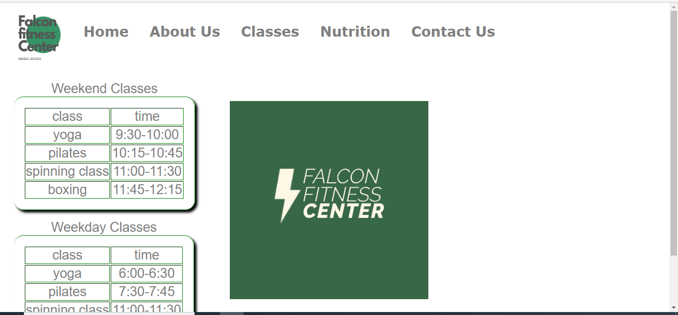

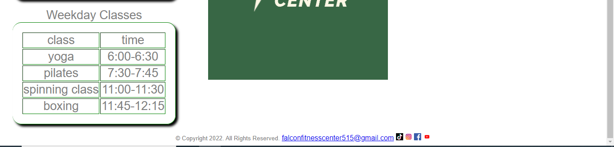

<!DOCTYPE html>

<html lang="en">

<head>

<title> Falcon Fitness Center </title>

<meta charset="utf-8">

<link href="css/ExternalStyleSheetFFC.css" rel="stylesheet">

<style>

h1 {

background color: white;

color: grey;

}

nav a{

text-decoration: none;

font-size: 28px;

font-family: verdana;

font-weight: bold;

height: 90px;

margin: 5px 10px;

float: left;

display: inline-block;

background-color: white;

color: grey;

line-height: 90px;

text-align: center;

transition: 350ms;

}

nav a:active{

background-color: white;

color: grey;

width: 100%;

}

.main{

width: 100%;

height:500px;

display: inline;

justify-content: center;

display: flex;

padding: 5px;

left: 20px;

margin: 5px;

}

.hi{position: absolute;

top: 400px;

left: 650px;}

</style>

</head>

<body>

<header>

</header>

<nav>

<div class="container1" style="height: 200%; width: 100%; display: flex;"><a href="FFCLogo.pngl"><img src="images/FFCLogo.png" alt="Falcon Fitness Center Logo" height="115" width="130"></a>

<a href="index.html">Home</a> &nbsp; &nbsp;

<a href="about.html">About Us</a> &nbsp; &nbsp;

<a href="classes.html">Classes</a> &nbsp; &nbsp;

<a href="nutrition.html">Nutrition</a> &nbsp; &nbsp;

<a href="contact.html">Contact Us</a>

</div>

</nav>

<main>

<div class="classes" style="float: left" display: flex;">

<br>

<table border="1">

<caption> Weekend Classes </caption>

<tr>

<td> class </td>

<td> time </td>

</tr>

<tr>

<td>yoga</td>

<td> 9:30-10:00 </td>

</tr>

<tr>

<td> pilates </td>

<td> 10:15-10:45 </td>

</tr>

<tr>

<td> spinning class </td>

<td> 11:00-11:30 </td>

</tr>

<tr>

<td> boxing </td>

<td> 11:45-12:15 </td>

<table border="1">

<caption> Weekday Classes </caption>

<tr>

<td> class </td>

<td> time </td>

</tr>

<tr>

<td>yoga</td>

<td> 6:00-6:30 </td>

</tr>

<tr>

<td> pilates </td>

<td> 7:30-7:45 </td>

</tr>

<tr>

<td> spinning class </td>

<td> 11:00-11:30 </td>

</tr>

<tr>

<td> boxing </td>

<td> 11:45-12:15 </td>

</table>

</div>

<div class="Logo" style="display: flex;">

<br>

</div>

<img style="position:relative; top:60px; left:50px;"src="images/FALCONFITNESSCLOGO.png" alt="Secondary Logo" width="400px" height="400px">

</main>

<footer style="clear: both; margin-top:100px;"><center>

<small> &copy; Copyright 2022. All Rights Reserved.</small>

<a href="mailto:falconfitnesscenter515@gmail.com">falconfitnesscenter515@gmail.com</a>

<a href="https://www.tiktok.com/"><img src="images/tiktok.png" alt="Weights 2" height="16" width="16"></a>

<a href="https://www.instagram.com"><img src="images/instagram.png" alt="Weights 2" height="16" width="16"></a>

<a href="https://www.facebook.com/"><img src="images/facebook.png" alt="Weights 2" height="16" width="16"></a>

<a href="https://www.youtube.com/"><img src="images/youtube.jpg" alt="Weights 2" height="16" width="16"></a></center>

</footer>

</body>

</html>