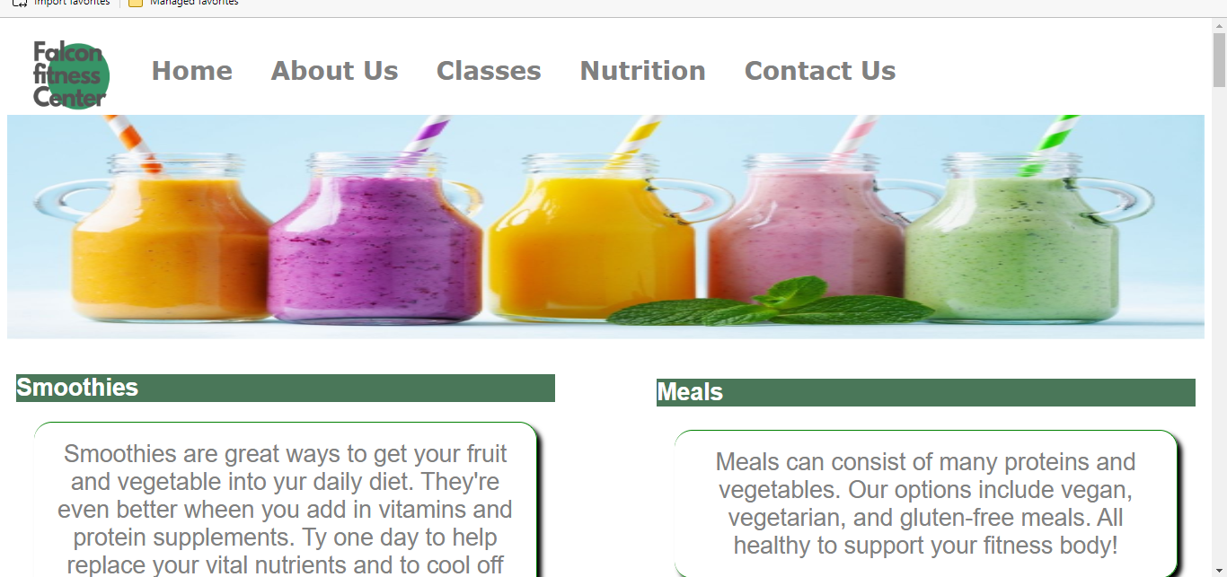

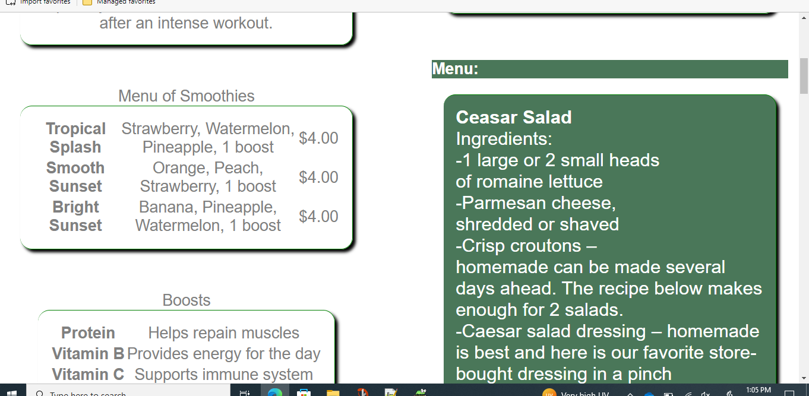

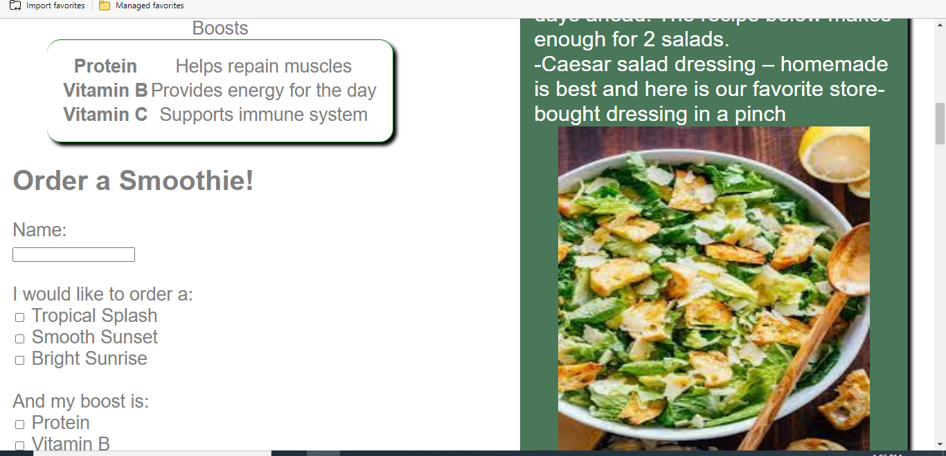

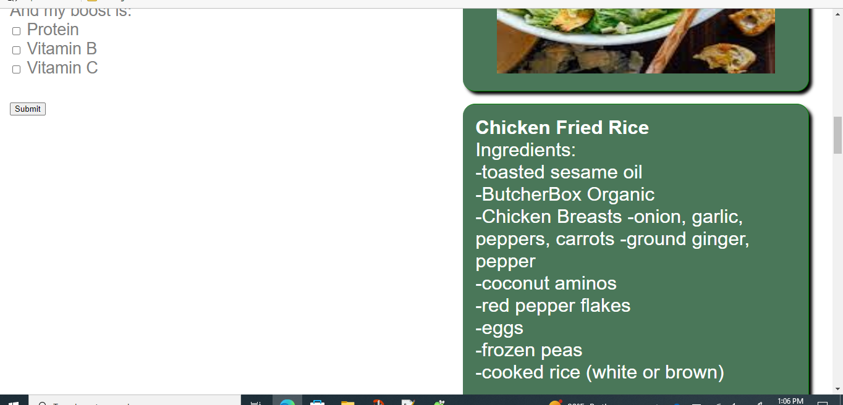

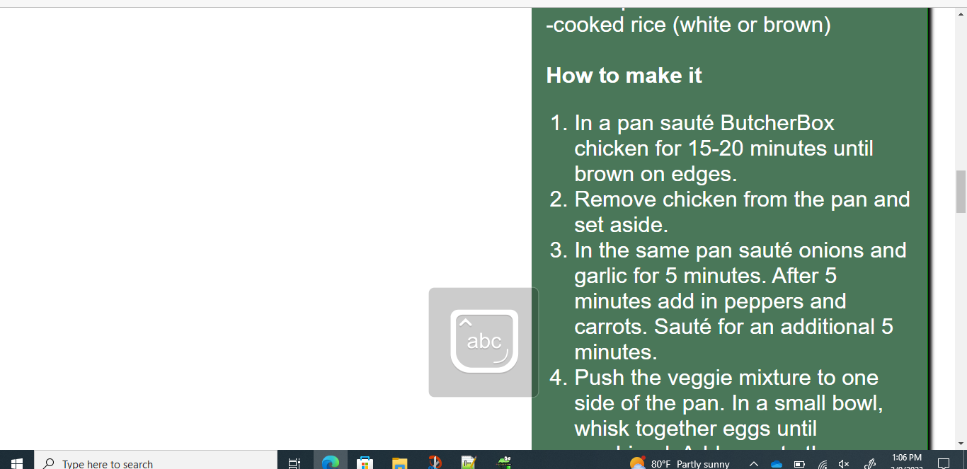

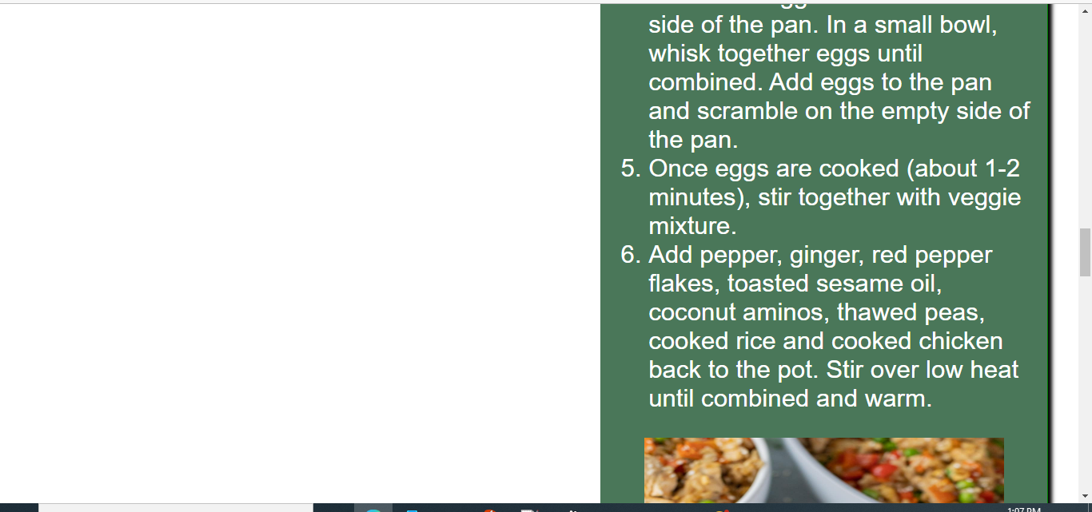

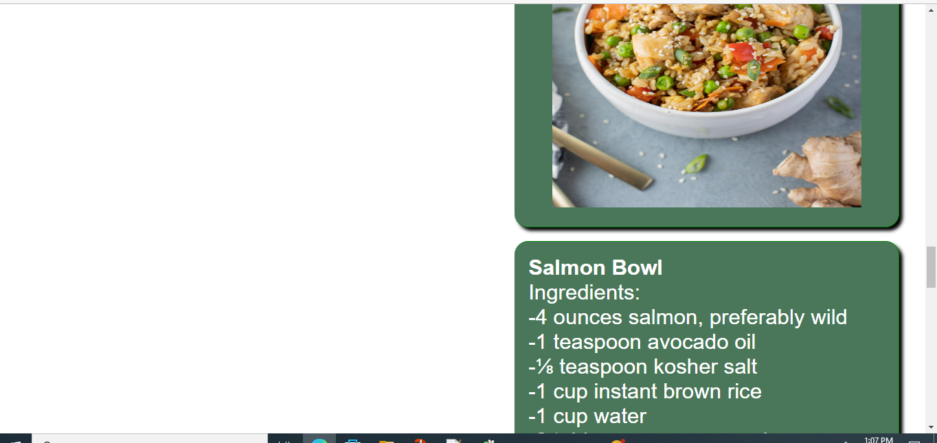

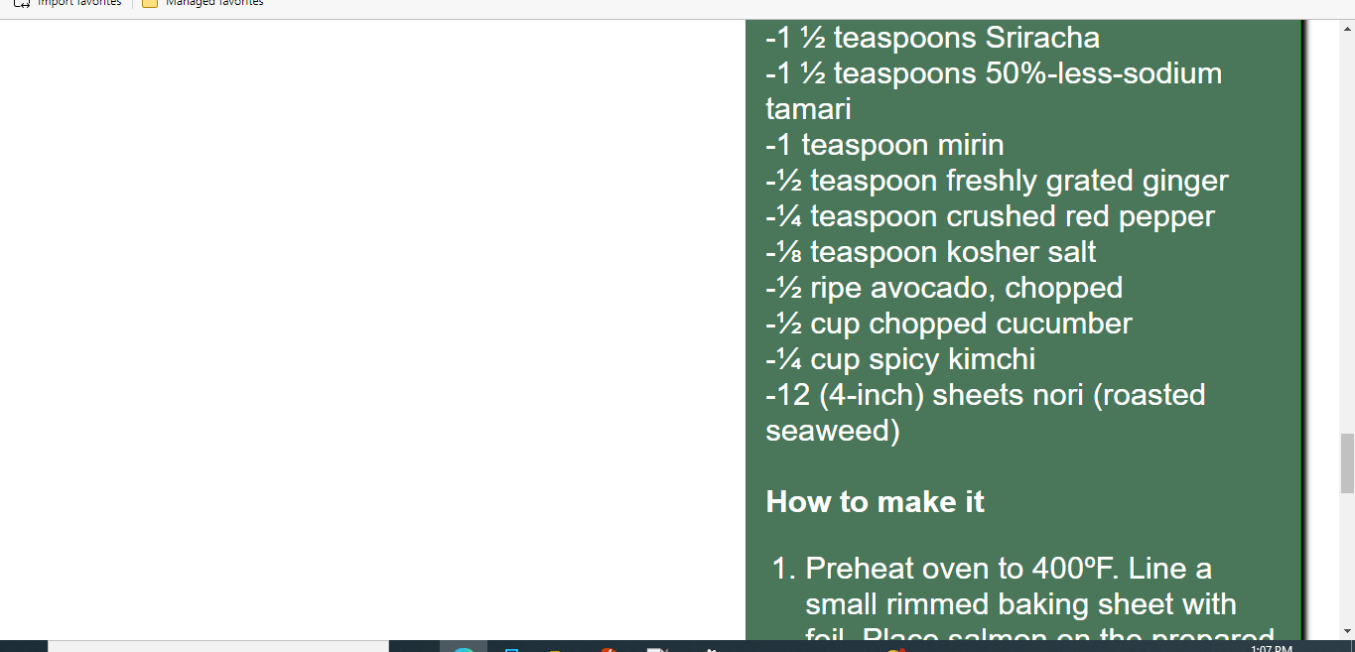

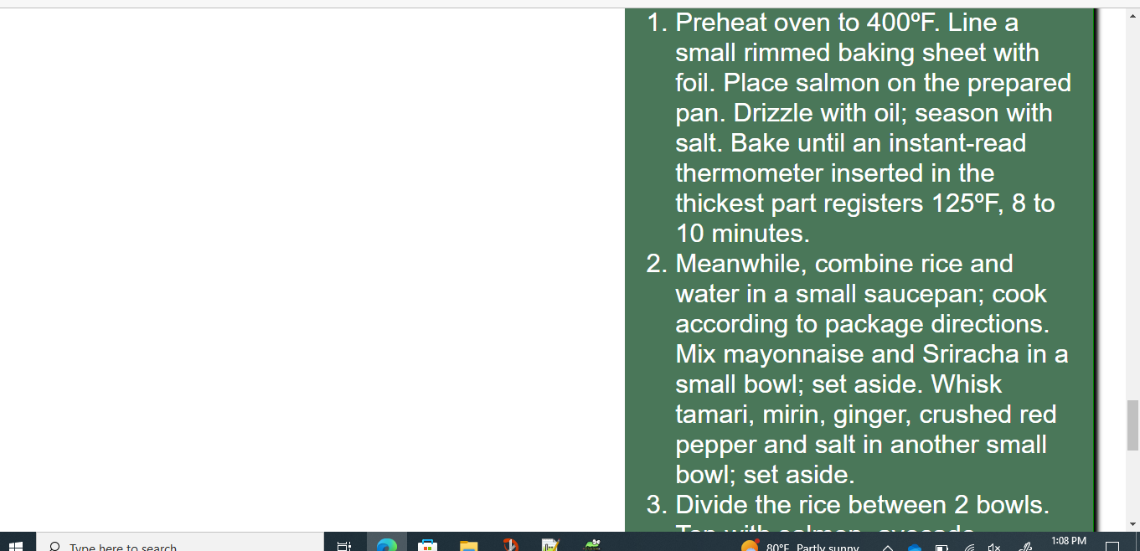

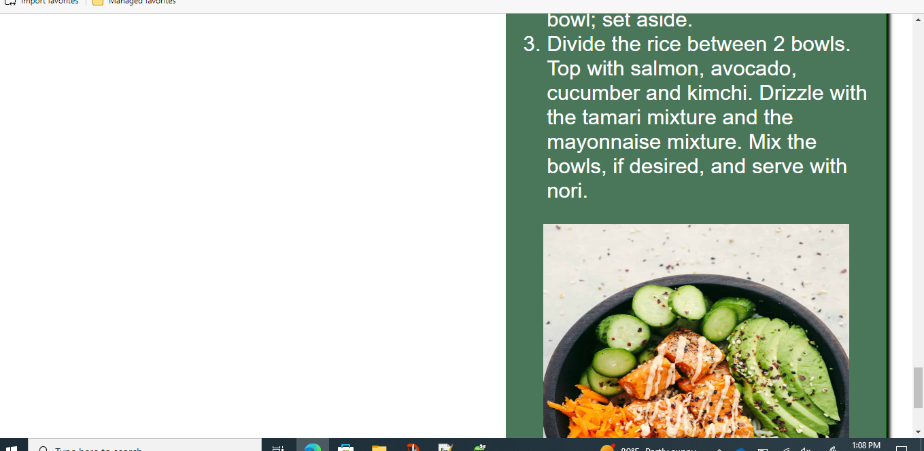

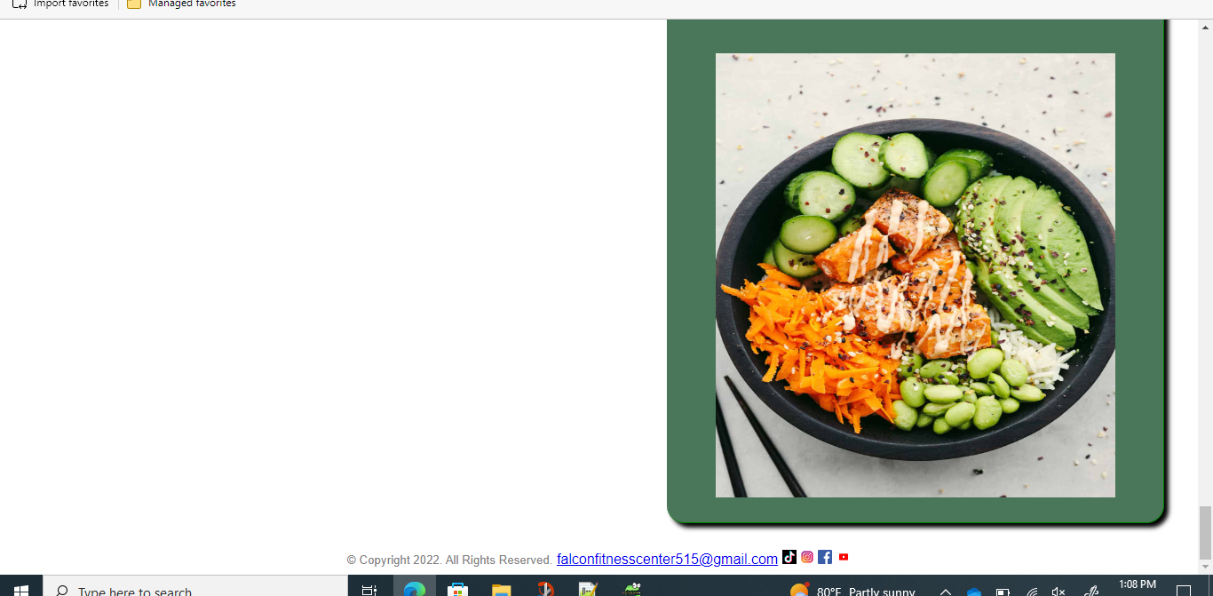

<!DOCTYPE html>

<html lang="en">

<head>

<title> Falcon Fitness Center </title>

<meta charset="utf-8">

<link href="css/ExternalStyleSheetFFC.css" rel="stylesheet">

<style>

h1 {

background color: white;

color: white;

}

nav a{

text-decoration: none;

font-size: 28px;

font-family: verdana;

font-weight: bold;

height: 90px;

margin: 5px 10px;

float: left;

display: inline-block;

background-color: white;

color: grey;

line-height: 90px;

text-align: center;

transition: 350ms;

}

nav a:active{

background-color: grey;

color: grey;

width: 100%;

}

</style>

</head>

<body>

<header>

</header>

<nav>

<div class="container1" style="height: 200%; width: 100%; display: flex;"><a href="FFCLogo.pngl"><img src="images/FFCLogo.png" alt="Falcon Fitness Center Logo" height="115" width="130"></a>

<a href="index.html">Home</a> &nbsp; &nbsp;

<a href="about.html">About Us</a> &nbsp; &nbsp;

<a href="classes.html">Classes</a> &nbsp; &nbsp;

<a href="nutrition.html">Nutrition</a> &nbsp; &nbsp;

<a href="contact.html">Contact Us</a>

</div>

</nav>

<main>

<div id="banner" class="desktop" style="margin: 0px;">

<img src="images/smoothies.jpg"alt="banner of smothies" width="100%" height="250px" style="margin: 0px; padding: 0px;"></div><section class="columncontainer" style="width: 100%; margin: 0 auto;"><div class="column1" style="width:45%; float: left; margin: 10px;">

<h1> Smoothies </h1>

<p> Smoothies are great ways to get your fruit and vegetable into yur daily diet. They're even better wheen you add in vitamins and protein supplements. Ty one day to help replace your vital nutrients and to cool off after an intense workout. </p>

<br>

<center><table>

<caption> Menu of Smoothies </caption>

<tr>

<th> Tropical Splash </th> <td> Strawberry, Watermelon, Pineapple, 1 boost</td><td> $4.00</td>

</tr>

<tr>

<th> Smooth Sunset </th><td>Orange, Peach, Strawberry, 1 boost</td><td>$4.00</td>

</tr>

<tr>

<th> Bright Sunset </th> <td> Banana, Pineapple, Watermelon, 1 boost</td><td> $4.00</td>

</tr>

</table></center>

<br>

<center><table>

<caption> Boosts </caption>

<tr>

<th> Protein </th> <td> Helps repain muscles</td>

</tr>

<tr>

<th> Vitamin B</th> <td> Provides energy for the day </td>

</tr>

<tr>

<th> Vitamin C</th> <td> Supports immune system </td>

</tr>

</table></center>

<h2> Order a Smoothie!</h2>

<form>

Name: <br>

<input type="text">

<br><br>

I would like to order a: <br>

<input type="checkbox" value="tropicalsplash">

Tropical Splash<br>

<input type="checkbox" value="smoothiesunset">

Smooth Sunset<br>

<input type="checkbox" value="brightsunrise">

Bright Sunrise<br><br>

And my boost is: <br>

<input type="checkbox" value="protein"> Protein <br>

<input type="checkbox" value="vitaminb"> Vitamin B <br>

<input type="checkbox" value="vitaminc"> Vitamin C <br><br>

<input type="submit" value="Submit">

</form>

</div>

<section class="columncontainer" style="width: 100%; margin: 0 auto;"><div class="column2" style="width:45%; float: right; margin: 10px;">

<h1> Meals </h1>

<p> Meals can consist of many proteins and vegetables. Our options include vegan, vegetarian, and gluten-free meals. All healthy to support your fitness body! </p>

<br>

<h1> Menu:</h1>

<h3 style="border: solid 1px green;background-color: #4A7759; color: white;padding: 20px;margin:20px ; font-weight: 500;border-style: ;border-width: ;border-color: ;border-bottom-color: ;border-left-color: ;border-top-color: ;border-right-color: ;border-radius: 20px;box-shadow: 5px 5px 5px black;border-left-width: 0px;"><b> Ceasar Salad</b> <br>

Ingredients:<BR>

-1 large or 2 small heads<br>

of romaine lettuce<br>

-Parmesan cheese, <br>

shredded or shaved<br>

-Crisp croutons – <br>

homemade can be made several days ahead. The recipe below makes enough for 2 salads.</br>

-Caesar salad dressing – homemade is best and here is our favorite store-bought dressing in a pinch<br>

<center><img src="images/Salad.jfif" alt="Falcon Fitness Center Logo" height="500px" width="450px"></center></h3>

<h3 style="border: solid 1px green;background-color: #4A7759; color: white;padding: 20px;margin:20px ; font-weight: 500;border-style: ;border-width: ;border-color: ;border-bottom-color: ;border-left-color: ;border-top-color: ;border-right-color: ;border-radius: 20px;box-shadow: 5px 5px 5px black;border-left-width: 0px;"><b> Chicken Fried Rice</b> <br>

Ingredients:<BR>

-toasted sesame oil<br>

-ButcherBox Organic<br>

-Chicken Breasts

-onion, garlic, <br>

peppers, carrots

-ground ginger, pepper<br>

-coconut aminos<br>

-red pepper flakes<br>

-eggs<br>

-frozen peas<br>

-cooked rice (white or brown)<br>

<br>

<b>How to make it</b>

<ol>

<li>In a pan sauté ButcherBox chicken for 15-20 minutes until brown on edges.

<li>Remove chicken from the pan and set aside.</li>

<li>In the same pan sauté onions and garlic for 5 minutes. After 5 minutes add in peppers and carrots. Sauté for an additional 5 minutes.</li>

<li>Push the veggie mixture to one side of the pan. In a small bowl, whisk together eggs until combined. Add eggs to the pan and scramble on the empty side of the pan.</li>

<li>Once eggs are cooked (about 1-2 minutes), stir together with veggie mixture.</li>

<li>Add pepper, ginger, red pepper flakes, toasted sesame oil, coconut aminos, thawed peas, cooked rice and cooked chicken back to the pot. Stir over low heat until combined and warm.</li>

</ol>

<center><img src="images/FriedRice.jpg" alt="Falcon Fitness Center Logo" height="500px" width="450px"></center>

</h3>

<h3 style="border: solid 1px green;background-color: #4A7759; color: white;padding: 20px;margin:20px ; font-weight: 500;border-style: ;border-width: ;border-color: ;border-bottom-color: ;border-left-color: ;border-top-color: ;border-right-color: ;border-radius: 20px;box-shadow: 5px 5px 5px black;border-left-width: 0px;"><b> Salmon Bowl</b> <br>

Ingredients:<BR>

-4 ounces salmon, preferably wild<br>

-1 teaspoon avocado oil<br>

-⅛ teaspoon kosher salt<br>

-1 cup instant brown rice<br>

-1 cup water<br>

-2 tablespoons mayonnaise<br>

-1 ½ teaspoons Sriracha<br>

-1 ½ teaspoons 50%-less-sodium tamari<br>

-1 teaspoon mirin<br>

-½ teaspoon freshly grated ginger<br>

-¼ teaspoon crushed red pepper<br>

-⅛ teaspoon kosher salt<br>

-½ ripe avocado, chopped <br>

-½ cup chopped cucumber<br>

-¼ cup spicy kimchi<br>

-12 (4-inch) sheets nori (roasted seaweed)<br><br>

<b>How to make it</b>

<ol>

<li>Preheat oven to 400ºF. Line a small rimmed baking sheet with foil. Place salmon on the prepared pan. Drizzle with oil; season with salt. Bake until an instant-read thermometer inserted in the thickest part registers 125ºF, 8 to 10 minutes.</li>

<li>Meanwhile, combine rice and water in a small saucepan; cook according to package directions. Mix mayonnaise and Sriracha in a small bowl; set aside. Whisk tamari, mirin, ginger, crushed red pepper and salt in another small bowl; set aside.</li>

<li>Divide the rice between 2 bowls. Top with salmon, avocado, cucumber and kimchi. Drizzle with the tamari mixture and the mayonnaise mixture. Mix the bowls, if desired, and serve with nori.</li>

</ol>

<center><img src="images/bowl.jpg" alt="Falcon Fitness Center Logo" height="500px" width="450px"></center>

</h3>

</main>

<footer style="clear: both;">

<center>

<small> &copy; Copyright 2022. All Rights Reserved.</small>

<a href="mailto:falconfitnesscenter515@gmail.com">falconfitnesscenter515@gmail.com</a>

<a href="https://www.tiktok.com/"><img src="images/tiktok.png" alt="Weights 2" height="16" width="16"></a>

<a href="https://www.instagram.com"><img src="images/instagram.png" alt="Weights 2" height="16" width="16"></a>

<a href="https://www.facebook.com/"><img src="images/facebook.png" alt="Weights 2" height="16" width="16"></a>

<a href="https://www.youtube.com/"><img src="images/youtube.jpg" alt="Weights 2" height="16" width="16"></a>

</footer>

</body>

</html>