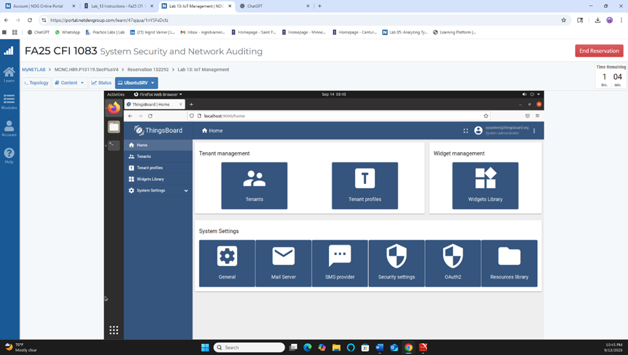
Dashboard view showing the main IoT management interface.

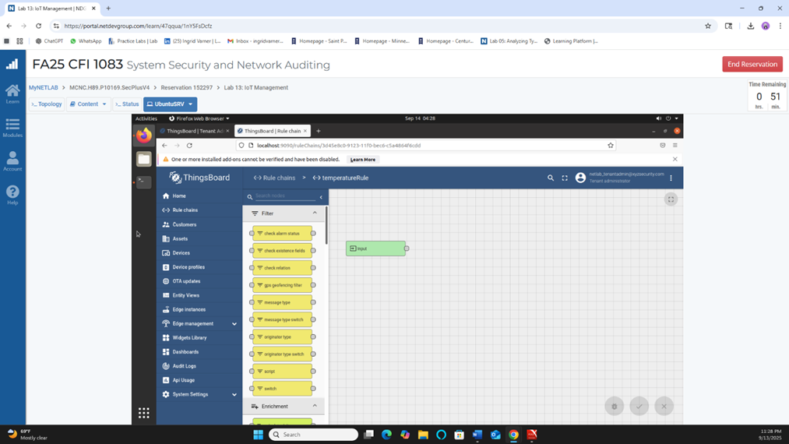
Rule chain workspace with the initial block.

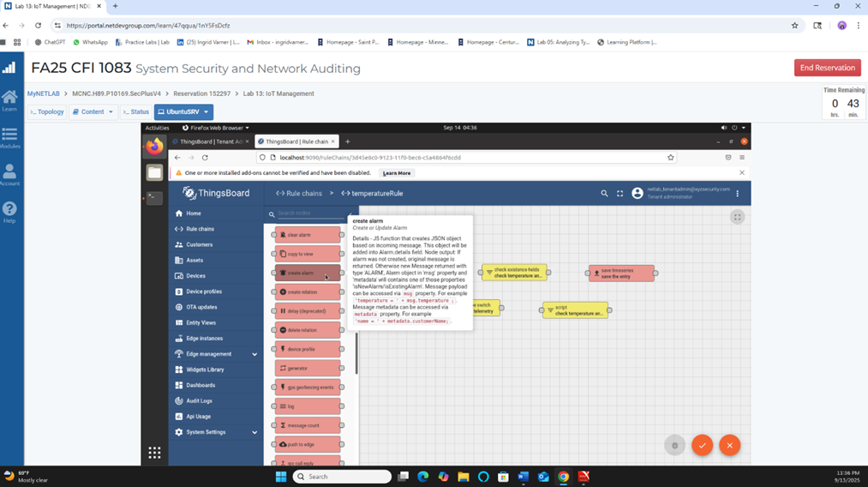
Exploring the available rule nodes for the temperature rule.

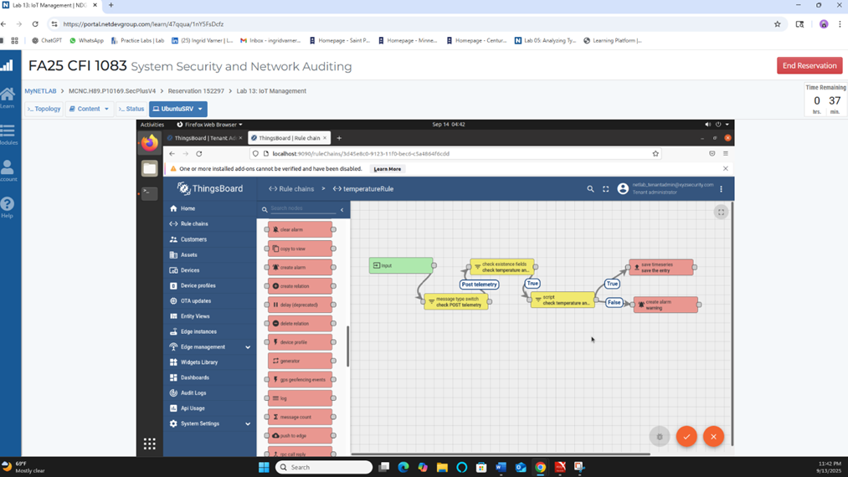
Completed temperature rule chain logic.

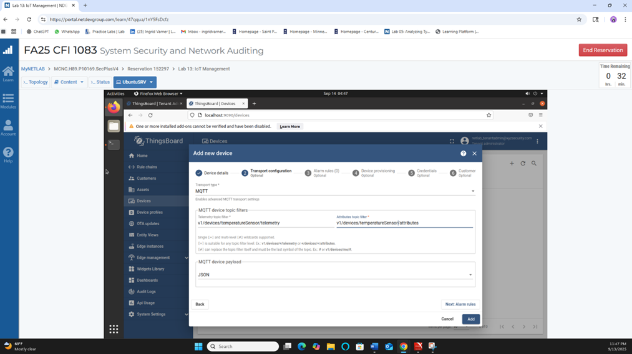
Adding a new MQTT device with topic configuration.

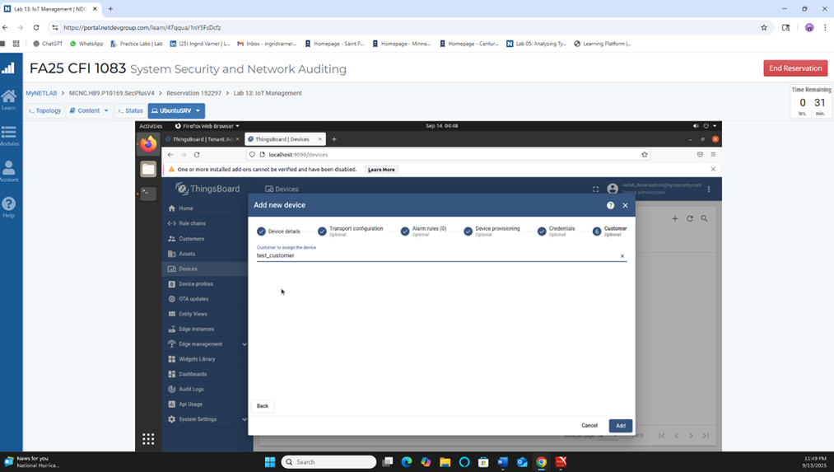
Assigning the device to a customer.

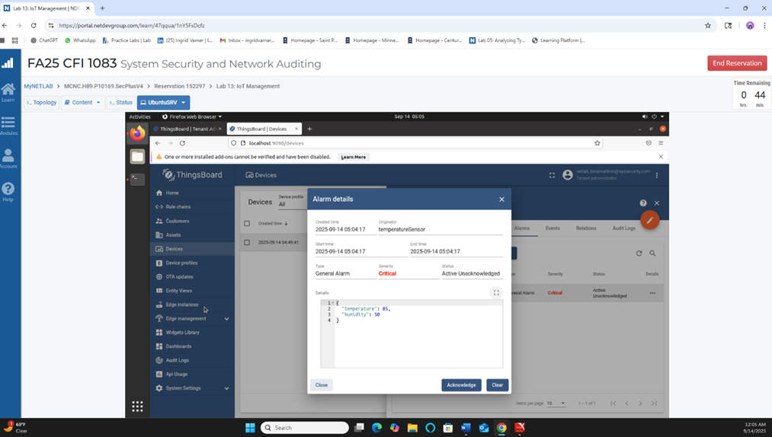
Alarm details showing a high temperature alert.

IoT Management Lab Explanation
In this lab I worked with an IoT platform called ThingsBoard. The screenshots show the steps I followed while learning how devices send data, how the system processes that data, and how alarms are created when something looks wrong.
First I explored the main dashboard. I looked at tenants, devices, rule chains and system settings. This helped me understand how everything is organized before any device starts sending information.
During this lab I also learned how to start using the ThingsBoard service from scratch. I practiced creating different user accounts and setting them up the right way. Understanding how permissions and roles work helped me see how IoT systems handle access for different people.
Next I created a rule chain that checks the temperature coming from a sensor. I added different blocks that verify the message, check the temperature value and decide if it is too high. If it is safe the message continues normally. If the temperature is too high the system creates an alarm.
When I first tried to create the alarm I had some trouble because the terminal showed everything was working but the alarm did not appear in the ThingsBoard dashboard. I had to restart and redo some of the steps a few times until it finally showed up. This helped me understand how important it is to test and verify every part of an IoT setup.
I also added a new device and configured it to use MQTT which is a common way real IoT devices send data. I set the telemetry and attributes topics and created a simple JSON format for the data. After that I assigned the device to a customer profile just like it would happen in real IoT deployments.
By the end of the lab I tested the device again to make sure it worked. I used the rule chain to check how the device sent information and how the system reacted. Doing this showed me how IoT devices can be controlled, monitored and managed in a real environment.
This lab helped me understand how IoT devices communicate, how accounts are managed, how the system checks incoming data and how alerts are created. It also showed me why monitoring IoT devices is important for security.

