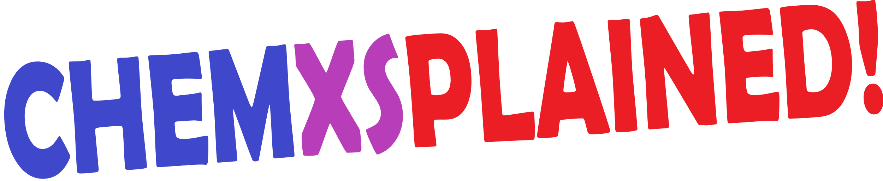

|  |
| --- |
| Questions |
| **Critical point**  **Partial pressure** |
|  |
| Pencil |
| **Amorphous solid**  **Non-electrolyte** |
|  |