
FYP Title: Autonomous Social Media Brand Manager Using Multi-Agent Agentic AI fot text generating.

Program Name: Bachelors of Science in Computer Science (BSCS)

Session: Session (2022 - 2026)

Authors Name and Roll Number: Submitted By

INAMULLAH KHAN | 12184
HAMZA SHAHID | 12176

Supervisor Name: DR MUHAMMAD ZEESHAN Co supervisor Name: DR ASIM SHAHZAD

Department Name: Department of Computer Science
Abbottabad University of Science & Technology

Approval Sheet

Dedication
This project is dedicated to my parents, whose unwavering support, patience, and encouragement have been the foundation of every achievement in my academic journey. I also dedicate this work to my teachers and mentors, whose guidance shaped my understanding of Computer Science and Artificial Intelligence, and to everyone who believed in my potential to build something meaningful.
Inamullah khan
Hamza shahid

Acknowledgement
I would like to express my sincere gratitude to my project supervisor, [DR MUHAMMAD ZEESHAN], whose continuous support, technical insight, and guidance played a crucial role in the successful completion of this Final Year Project. I am also thankful to the FYP coordinator and the faculty of the Department of Computer Science, Abbottabad University of Science & Technology, for their valuable feedback throughout the development of this project.
I extend my appreciation to my family and friends for their patience and moral support during the long hours of research, development, and documentation. Finally, I acknowledge the open-source community and the developers of the frameworks and tools — including CrewAI, Streamlit, and Google's Generative AI platform — whose work made this project possible.

PREFACE
This thesis concerns the design and development of the "Autonomous Social Media Brand Manager", a multi-agent Agentic AI system that automates the end-to-end social media content lifecycle for brands — from strategy planning and copywriting to brand-voice auditing, audience engagement, and performance analysis. This thesis covers the various phases of the development of this project, which are organized as follows:

Chapter 1. Introduction
This chapter gives a brief introduction to the "Autonomous Social Media Brand Manager" project, its purpose, scope, and the tools used for its development.

Chapter 2. Existing System
This chapter describes the background of existing social media management solutions and discusses their limitations.

Chapter 3. Proposed System
This chapter describes the proposed system, its modules, requirements, feasibility, and chosen development methodology.

Chapter 4. System Design
This chapter describes the system's architecture, agent pipeline, UML diagrams, and the user interface of the system.

Chapter 5. System Testing
This chapter describes the testing phase of the proposed system, including black box and white box testing.

Chapter 6. Conclusion & Future Work
This chapter presents the conclusion of the project along with proposed future enhancements.

Table of Contents

Approval Sheet II
Dedication II
Acknowledgement III
Chapter 1. Introduction IV
Chapter 2. Existing System IV
Chapter 3. Proposed System IV
Chapter 4. System Design IV
Chapter 5. System Testing IV
Chapter 6. Conclusion & Future Work IV
Abstract VIII
1.1 Introduction 17
1.2 Purpose 17
1.3 Scope of the Project 18
1.4 Definitions, Acronyms, Abbreviations 18
1.5 Use Case and Usage Scenario 20
1.5.1 Use Case Diagrams 20
1.5.2 Usage Scenarios 23
1.6 WBS and Gantt Chart 25
1.6.1 Work Breakdown Structure 25
1.6.2 Gantt Chart 25
2.1 Existing System 27
2.2 Literature Review 27
2.3 Limitations of Existing System 28
2.3.1 Manual Social Media Management Tools (Hootsuite, Buffer, Sprout Social) 28
2.3.2 Generic AI Writing Tools (ChatGPT, Jasper, Copy.ai) 28
2.3.3 Rule-Based Chatbots for Engagement 28
2.3.4 Existing Analytics Dashboards 28
3.1 Introduction 30
3.2 Modules of System 30
3.2.1 Strategy Director Agent 30
3.2.2 Copywriter Agent 30
3.2.3 Brand Voice Guardian Agent 31
3.2.4 Engagement Manager Agent 31
3.2.5 Performance Analyst Agent 31
3.2.6 Presentation & Tools Layer 31
3.3 Functional Requirements 32
3.4 Non-Functional Requirements 32
3.4.1 Usability 32
3.4.2 Maintainability 32
3.4.3 Reliability 32
3.4.4 Performance 32
3.4.5 Security 33
3.5 Feasibility 34
3.5.1 Economic Feasibility 34
3.5.2 Operational Feasibility 34
3.5.3 Technical Feasibility 34
3.6 Chosen Methodology 34
3.6.1 Incremental Development Model 34
3.7 Project Structure 35
4.1 Introduction 36
4.2 Purpose 36
4.3 Scope 36
4.4 System Architecture Diagram 37
4.5 Class Diagram 38
4.6 Activity Diagrams 39
4.6.1 Activity Diagram — Content Generation Pipeline 39
4.6.2 Activity Diagram — Audience Engagement Flow 40
4.6.3 Activity Diagram — Performance Analysis Flow 41
4.7 Data Flow Diagram 44
4.7.1 Level 0 44
4.7.2 Level 1 44
4.7.3 Level 2 44
4.8 Sequence Diagram 46
4.9 ERD 47
4.10 Graphical User Interface (GUI) 48
4.10.1 Dashboard Home / Campaign Brief Screen 48
4.10.2 Content Generation & Review Screen 48
4.10.3 Brand Voice Audit / Approval Screen 49
4.10.4 Engagement Manager Screen 50
4.10.5 Performance Analyst Report Screen 50
4.10.6 Live Logging Panel 51
5.1 Testing Introduction 53
5.2 Purpose of Testing 53
5.3 Objectives of Testing 53
5.4 Testing Techniques 53
5.4.1 Black Box Testing 53
5.4.2 White Box Testing 54
5.5 Black Box Test Cases 55
5.5.1 Black Box Testing for Brand Configuration Input 55
5.5.2 Black Box Testing for Platform Character Limit 55
5.5.3 Black Box Testing for Brand Voice Score Threshold 55
5.6 White Box Test Cases 56
5.6.1 White Box Test Case Using Path Coverage — Audit Scoring Logic 56
5.6.2 White Box Test Cases 56
5.6.3 Results 56
6.1 Conclusion 57
6.2 Future Work 57
Phase 1: Real-World Integrations (Short-Term) 57
Phase 2: Media Creation & Human-in-the-Loop (Medium-Term) 58
Phase 3: Closed-Loop Optimization (Long-Term) 58

Abstract
Managing a brand's presence across multiple social media platforms is a labour-intensive process that requires continuous content ideation, brand-consistent copywriting, compliance review, real-time audience engagement, and performance evaluation. Human social media managers must repeatedly context-switch between these roles, which limits scale, consistency, and response speed. This thesis presents the "Autonomous Social Media Brand Manager" (ASMB), a multi-agent Agentic AI system that automates this workflow by dividing it among five specialized, cooperating AI agents: a Strategy Director, a Copywriter, a Brand Voice Guardian, an Engagement Manager, and a Performance Analyst.
The system is built on the CrewAI multi-agent orchestration framework and is powered by the Google Gemini large language model. Given a campaign brief, the agent pipeline sequentially produces platform-specific content plans, generates A/B copy variations grounded in retrieved brand guidelines, automatically audits each draft against a five-point brand-safety rubric, drafts sentiment-aware replies to audience comments, and finally produces an analytics-driven performance report with actionable recommendations. The system exposes an interactive Streamlit dashboard as well as a command-line interface, and uses local rule-based tools — including a VADER-based sentiment analyzer and a platform compliance formatter — to keep the pipeline auditable, fast, and cost-effective.
The resulting prototype demonstrates that a modular, role-based multi-agent architecture can reliably standardize brand voice, reduce content-drafting time, and scale audience engagement without sacrificing brand safety. The thesis further outlines a roadmap for evolving the current advanced prototype into a production-ready system through real platform API integration, semantic (vector-based) brand knowledge retrieval, multi-modal content generation, and closed-loop learning from live performance data.

TABLE OF CONTENTS
Approval Sheet II
Dedication II
Acknowledgement III
Chapter 1. Introduction IV
Chapter 2. Existing System IV
Chapter 3. Proposed System IV
Chapter 4. System Design IV
Chapter 5. System Testing IV
Chapter 6. Conclusion & Future Work IV
Abstract VIII
1.1 Introduction 17
1.2 Purpose 17
1.3 Scope of the Project 18
1.4 Definitions, Acronyms, Abbreviations 18
1.5 Use Case and Usage Scenario 20
1.5.1 Use Case Diagrams 20
1.5.2 Usage Scenarios 23
1.6 WBS and Gantt Chart 25
1.6.1 Work Breakdown Structure 25
1.6.2 Gantt Chart 25
2.1 Existing System 27
2.2 Literature Review 27
2.3 Limitations of Existing System 28
2.3.1 Manual Social Media Management Tools (Hootsuite, Buffer, Sprout Social) 28
2.3.2 Generic AI Writing Tools (ChatGPT, Jasper, Copy.ai) 28
2.3.3 Rule-Based Chatbots for Engagement 28
2.3.4 Existing Analytics Dashboards 28
3.1 Introduction 30
3.2 Modules of System 30
3.2.1 Strategy Director Agent 30
3.2.2 Copywriter Agent 30
3.2.3 Brand Voice Guardian Agent 31
3.2.4 Engagement Manager Agent 31
3.2.5 Performance Analyst Agent 31
3.2.6 Presentation & Tools Layer 31
3.3 Functional Requirements 32
3.4 Non-Functional Requirements 32
3.4.1 Usability 32
3.4.2 Maintainability 32
3.4.3 Reliability 32
3.4.4 Performance 32
3.4.5 Security 33
3.5 Feasibility 34
3.5.1 Economic Feasibility 34
3.5.2 Operational Feasibility 34
3.5.3 Technical Feasibility 34
3.6 Chosen Methodology 34
3.6.1 Incremental Development Model 34
3.7 Project Structure 35
4.1 Introduction 36
4.2 Purpose 36
4.3 Scope 36
4.4 System Architecture Diagram 37
4.5 Class Diagram 38
4.6 Activity Diagrams 39
4.6.1 Activity Diagram — Content Generation Pipeline 39
4.6.2 Activity Diagram — Audience Engagement Flow 40
4.6.3 Activity Diagram — Performance Analysis Flow 41
4.7 Data Flow Diagram 44
4.7.1 Level 0 44
4.7.2 Level 1 44
4.7.3 Level 2 44
4.8 Sequence Diagram 46
4.9 ERD 47
4.10 Graphical User Interface (GUI) 48
4.10.1 Dashboard Home / Campaign Brief Screen 48
4.10.2 Content Generation & Review Screen 48
4.10.3 Brand Voice Audit / Approval Screen 49
4.10.4 Engagement Manager Screen 50
4.10.5 Performance Analyst Report Screen 50
4.10.6 Live Logging Panel 51
5.1 Testing Introduction 53
5.2 Purpose of Testing 53
5.3 Objectives of Testing 53
5.4 Testing Techniques 53
5.4.1 Black Box Testing 53
5.4.2 White Box Testing 54
5.5 Black Box Test Cases 55
5.5.1 Black Box Testing for Brand Configuration Input 55
5.5.2 Black Box Testing for Platform Character Limit 55
5.5.3 Black Box Testing for Brand Voice Score Threshold 55
5.6 White Box Test Cases 56
5.6.1 White Box Test Case Using Path Coverage — Audit Scoring Logic 56
5.6.2 White Box Test Cases 56
5.6.3 Results 56
6.1 Conclusion 57
6.2 Future Work 57
Phase 1: Real-World Integrations (Short-Term) 57
Phase 2: Media Creation & Human-in-the-Loop (Medium-Term) 58
Phase 3: Closed-Loop Optimization (Long-Term) 58

Approval Sheet II
Dedication II
Acknowledgement III
Chapter 1. Introduction IV
Chapter 2. Existing System IV
Chapter 3. Proposed System IV
Chapter 4. System Design IV
Chapter 5. System Testing IV
Chapter 6. Conclusion & Future Work IV
Abstract VIII
1.1 Introduction 17
1.2 Purpose 17
1.3 Scope of the Project 18
1.4 Definitions, Acronyms, Abbreviations 18
1.5 Use Case and Usage Scenario 20
1.5.1 Use Case Diagrams 20
1.5.2 Usage Scenarios 23
1.6 WBS and Gantt Chart 25
1.6.1 Work Breakdown Structure 25
1.6.2 Gantt Chart 25
2.1 Existing System 27
2.2 Literature Review 27
2.3 Limitations of Existing System 28
2.3.1 Manual Social Media Management Tools (Hootsuite, Buffer, Sprout Social) 28
2.3.2 Generic AI Writing Tools (ChatGPT, Jasper, Copy.ai) 28
2.3.3 Rule-Based Chatbots for Engagement 28
2.3.4 Existing Analytics Dashboards 28
3.1 Introduction 30
3.2 Modules of System 30
3.2.1 Strategy Director Agent 30
3.2.2 Copywriter Agent 30
3.2.3 Brand Voice Guardian Agent 31
3.2.4 Engagement Manager Agent 31
3.2.5 Performance Analyst Agent 31
3.2.6 Presentation & Tools Layer 31
3.3 Functional Requirements 32
3.4 Non-Functional Requirements 32
3.4.1 Usability 32
3.4.2 Maintainability 32
3.4.3 Reliability 32
3.4.4 Performance 32
3.4.5 Security 33
3.5 Feasibility 34
3.5.1 Economic Feasibility 34
3.5.2 Operational Feasibility 34
3.5.3 Technical Feasibility 34
3.6 Chosen Methodology 34
3.6.1 Incremental Development Model 34
3.7 Project Structure 35
4.1 Introduction 36
4.2 Purpose 36
4.3 Scope 36
4.4 System Architecture Diagram 37
4.5 Class Diagram 38
4.6 Activity Diagrams 39
4.6.1 Activity Diagram — Content Generation Pipeline 39
4.6.2 Activity Diagram — Audience Engagement Flow 40
4.6.3 Activity Diagram — Performance Analysis Flow 41
4.7 Data Flow Diagram 44
4.7.1 Level 0 44
4.7.2 Level 1 44
4.7.3 Level 2 44
4.8 Sequence Diagram 46
4.9 ERD 47
4.10 Graphical User Interface (GUI) 48
4.10.1 Dashboard Home / Campaign Brief Screen 48
4.10.2 Content Generation & Review Screen 48
4.10.3 Brand Voice Audit / Approval Screen 49
4.10.4 Engagement Manager Screen 50
4.10.5 Performance Analyst Report Screen 50
4.10.6 Live Logging Panel 51
5.1 Testing Introduction 53
5.2 Purpose of Testing 53
5.3 Objectives of Testing 53
5.4 Testing Techniques 53
5.4.1 Black Box Testing 53
5.4.2 White Box Testing 54
5.5 Black Box Test Cases 55
5.5.1 Black Box Testing for Brand Configuration Input 55
5.5.2 Black Box Testing for Platform Character Limit 55
5.5.3 Black Box Testing for Brand Voice Score Threshold 55
5.6 White Box Test Cases 56
5.6.1 White Box Test Case Using Path Coverage — Audit Scoring Logic 56
5.6.2 White Box Test Cases 56
5.6.3 Results 56
6.1 Conclusion 57
6.2 Future Work 57
Phase 1: Real-World Integrations (Short-Term) 57
Phase 2: Media Creation & Human-in-the-Loop (Medium-Term) 58
Phase 3: Closed-Loop Optimization (Long-Term) 58

LIST OF FIGURES
Figure 1: System Context Diagram .................................... 1
Figure 2: Use Case Diagram — Generate Social Media Post .................................... 2
Figure 3: Use Case Diagram — Auto-Reply to Audience Comment .................................... 3
Figure 4: Use Case Diagram — Weekly Performance Reporting .................................... 4
Figure 5: Work Breakdown Structure (WBS) .................................... 5
Figure 6: Gantt Chart .................................... 6
Figure 7: Incremental Development Life Cycle Model .................................... 7
Figure 8: High-Level System Architecture Diagram .................................... 8
Figure 9: Class Diagram .................................... 9
Figure 10: Activity Diagram — Content Generation Pipeline .................................... 10
Figure 11: Activity Diagram — Audience Engagement Flow .................................... 11
Figure 12: Activity Diagram — Performance Analysis Flow .................................... 12
Figure 13: Data Flow Diagram — Level 0 .................................... 13
Figure 14: Data Flow Diagram — Level 1 .................................... 14
Figure 15: Data Flow Diagram — Level 2 .................................... 15
Figure 16: Sequence Diagram — End-to-End Campaign Generation .................................... 16
Figure 17: Entity Relationship Diagram (Proposed Persistence Layer) .................................... 17
Figure 18: Dashboard Home / Campaign Brief Screen .................................... 18
Figure 19: Content Generation & Review Screen .................................... 19
Figure 20: Brand Voice Audit / Approval Screen .................................... 20
Figure 21: Engagement Manager Screen .................................... 21
Figure 22: Performance Analyst Report Screen .................................... 22
Figure 23: Live Logging Panel .................................... 23

LIST OF TABLES
Table 1: Definitions, Acronyms and Abbreviations
Table 2: Usage Scenario — Generate Social Media Post (UC-01)
Table 3: Usage Scenario — Auto-Reply to Audience Comment (UC-02)
Table 4: Usage Scenario — Weekly Performance Reporting (UC-03)
Table 5: Project Timeline (Gantt Table)
Table 6: Functional Requirements Summary
Table 7: Non-Functional Requirements Summary
Table 8: Black Box Test Cases — Brand Configuration
Table 9: Black Box Test Cases — Platform Character Limit
Table 10: Black Box Test Cases — Brand Voice Score Threshold
Table 11: White Box Test Cases — Audit Scoring Logic
Table 12: Test Case Results Summary

CHAPTER 1
INTRODUCTION

1.1 Introduction
Social media has become the primary channel through which brands communicate with their audiences, build trust, and drive engagement. Maintaining an effective presence, however, requires a brand manager to continuously perform several distinct roles: planning a content strategy, writing platform-appropriate copy, checking every draft against brand tone and compliance rules, replying to audience comments in a timely and empathetic manner, and analysing performance metrics to refine future content. Performing all of these roles manually, across multiple platforms and at scale, is time-consuming, inconsistent, and difficult to sustain — particularly for small teams and growing brands.
The "Autonomous Social Media Brand Manager" (ASMB) addresses this problem by applying multi-agent Agentic AI to the social media workflow. Rather than relying on a single, general-purpose AI model to perform all tasks at once, the system decomposes the workflow into five specialized roles — Strategy Director, Copywriter, Brand Voice Guardian, Engagement Manager, and Performance Analyst — each implemented as an autonomous agent with a clearly defined responsibility. These agents are orchestrated sequentially using the CrewAI framework and are powered by the Google Gemini large language model, allowing the system to move from a single creative brief to a fully analysed campaign outcome with minimal human intervention.
This chapter introduces the purpose and scope of the project, defines the key terms and abbreviations used throughout this thesis, presents the primary use cases and usage scenarios of the system, and outlines the project timeline through a Work Breakdown Structure and Gantt Chart.

1.2 Purpose
The purpose of this project is to design and develop an autonomous, multi-agent AI system capable of managing the core responsibilities of a social media brand manager on behalf of a human operator. Specifically, the system aims to:
- Reduce the time required to plan and draft brand-consistent social media content across multiple platforms.
- Standardize brand voice and enforce compliance rules automatically, reducing the risk of off-brand or non-compliant posts.
- Scale audience engagement by generating contextual, sentiment-aware replies to comments without manual monitoring of every conversation.
- Turn raw engagement metrics into actionable, human-readable performance insights without requiring manual spreadsheet analysis.
- Demonstrate a production-oriented architecture for agentic AI systems — one that go beyond notebook-level machine learning experimentation into a full-stack, tool-using, multi-agent AI engineering solution.
The target users of this system are social media managers, small marketing teams, and brand owners who need to maintain a consistent and responsive social media presence without the overhead of a full in-house marketing department.

1.3 Scope of the Project
The scope of the Autonomous Social Media Brand Manager, in its current version, covers the complete text-based content lifecycle for a social media campaign: from ingesting a brand's guidelines and a creative brief, to generating and auditing post copy, drafting engagement replies, and producing a performance report. The system supports content generation for four major platforms — Instagram, LinkedIn, X (formerly Twitter), and Facebook — each with platform-specific formatting and compliance constraints.
The current scope is intentionally limited to text-based content; image and video generation are out of scope for this version but are identified as a future enhancement (see Section 6.2). Similarly, the current prototype operates on locally stored brand guidelines and mock engagement/analytics data rather than live social media accounts, which allows the agent pipeline, auditing rubric, and reporting logic to be developed, tested, and evaluated in a controlled environment before integrating with real platform APIs. The project also does not include payment processing, ad-spend management, or influencer outreach — its scope is strictly limited to organic content strategy, copywriting, compliance auditing, engagement, and analytics.

1.4 Definitions, Acronyms, Abbreviations
Term | Definition
ASMB | Autonomous Social Media Brand Manager
LLM | Large Language Model (e.g., Google Gemini, GPT-4)
Agentic AI | AI architecture in which multiple autonomous agents collaborate to complete a task
API | Application Programming Interface
SRS | Software Requirements Specification
FR / NFR | Functional Requirement / Non-Functional Requirement
CrewAI | A Python framework for orchestrating role-based multi-agent AI systems
RAG | Retrieval-Augmented Generation — grounding LLM output in retrieved reference text
VADER | Valence Aware Dictionary and sEntiment Reasoner — a rule-based sentiment analysis tool
A/B Variation | Two alternative drafts of the same content produced for comparison and selection
CLI | Command-Line Interface
UI/UX | User Interface / User Experience
Table 1: Definitions, Acronyms and Abbreviations

1.5 Use Case and Usage Scenario

1.5.1 Use Case Diagrams
The Autonomous Social Media Brand Manager involves one primary human actor, the Brand Manager, who initiates campaigns and reviews output, and a System Administrator who is responsible for infrastructure and API-key management. The core system behaviours are represented in the following use case diagrams.
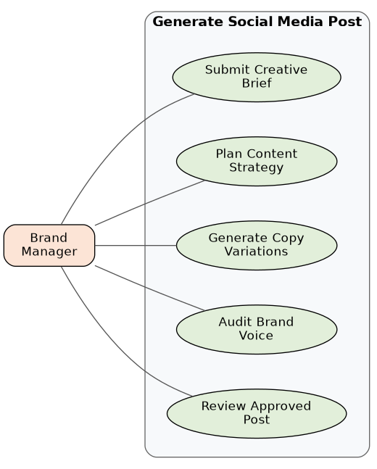
Figure 2: Use Case Diagram — Generate Social Media Post
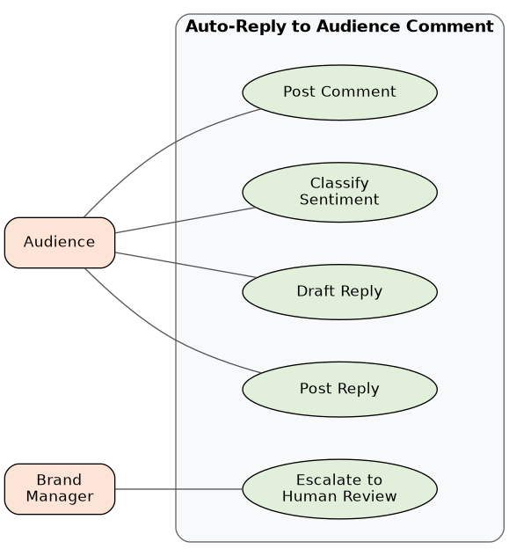
Figure 3: Use Case Diagram — Auto-Reply to Audience Comment
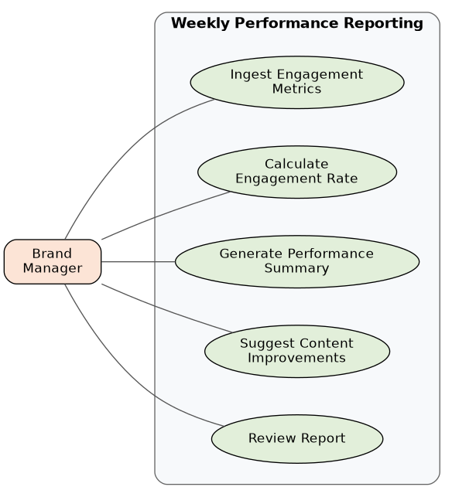
Figure 4: Use Case Diagram — Weekly Performance Reporting

1.5.2 Usage Scenarios
UC-01: Generate Social Media Post
Field | Description
Use Case ID | UC-01
Actors | Brand Manager (initiator), Strategy Director Agent, Copywriter Agent, Brand Voice Guardian Agent
Preconditions | Brand guidelines configuration file is loaded; Gemini API key is valid
Main Flow | 1. Brand Manager submits a creative brief and selects target platforms. 2. Strategy Director reads brand context and produces a platform-specific content plan. 3. Copywriter generates two content variations (safe and creative) per planned post. 4. Brand Voice Guardian scores and audits each variation against the five-point rubric. 5. Top-scoring, approved variation is returned to the Brand Manager for review.
Alternate Flow | If the Brand Voice score falls below the configured threshold, the Copywriter Agent regenerates the draft (up to a maximum number of retries).
Postconditions | At least one brand-approved post variation is available for review or export.
Priority | High
Table 2: Usage Scenario for Generate Social Media Post
UC-02: Auto-Reply to Audience Comment
Field | Description
Use Case ID | UC-02
Actors | Audience (external trigger), Engagement Manager Agent, Brand Voice Guardian Agent, Brand Manager
Preconditions | A comment feed (live or mock) is available; the Engagement Manager agent is active
Main Flow | 1. Audience posts a comment on a brand post. 2. Engagement Manager retrieves the comment. 3. Local sentiment analyzer classifies the comment as positive, neutral, or negative. 4. Engagement Manager drafts a sentiment-matched reply. 5. If the sentiment is positive or neutral, the reply is queued for posting; otherwise it is flagged for human review.
Alternate Flow | If the sentiment is negative or the comment contains a complex query, the reply is routed to the Brand Manager for manual handling.
Postconditions | The comment receives a contextual, brand-aligned reply or is escalated to a human.
Priority | Medium
Table 3: Usage Scenario for Auto-Reply to Audience Comment
UC-03: Weekly Performance Reporting
Field | Description
Use Case ID | UC-03
Actors | Performance Analyst Agent, Strategy Director Agent, Brand Manager
Preconditions | At least one posting cycle of engagement/analytics data exists (live or mock)
Main Flow | 1. Performance Analyst ingests engagement metrics. 2. Agent calculates engagement rates per post. 3. Agent generates a textual summary identifying top and bottom performing content. 4. Suggestions are forwarded to the Strategy Director. 5. Report is saved locally and displayed on the dashboard.
Alternate Flow | If live analytics data is unavailable, the report is generated from locally stored mock metrics.
Postconditions | The Strategy Director updates content priorities for the next posting cycle.
Priority | Medium
Table 4: Usage Scenario for Weekly Performance Reporting

1.6 WBS and Gantt Chart

1.6.1 Work Breakdown Structure
The project was broken down into major work packages covering research, design, agent development, integration, testing, and documentation.
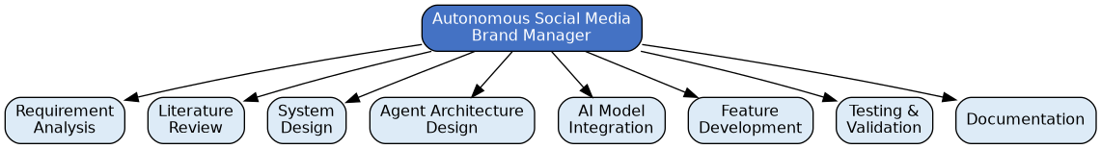
Figure 5: Work Breakdown Structure (WBS)

1.6.2 Gantt Chart
The project was planned and executed over a sixteen-week timeline, as summarized in the table and Gantt chart below.
Task | Start | End | Duration
Requirement Analysis | Week 1 | Week 2 | 2 weeks
Literature Review | Week 1 | Week 2 | 2 weeks
System Design | Week 3 | Week 4 | 2 weeks
Agent Architecture Design | Week 5 | Week 6 | 2 weeks
AI Model Integration | Week 7 | Week 9 | 3 weeks
Feature Development | Week 10 | Week 12 | 3 weeks
Testing & Validation | Week 13 | Week 14 | 2 weeks
Documentation | Week 15 | Week 16 | 2 weeks
Table 5: Project Timeline (Gantt Table)
Note: Literature Review and Requirement Analysis were carried out in parallel (Weeks 1–2). Documentation was a continuous activity throughout all phases.
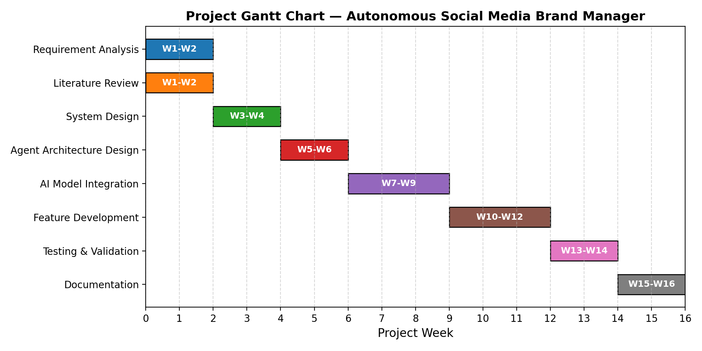
Figure 6: Gantt Chart

CHAPTER 2
EXISTING SYSTEM

2.1 Existing System
At present, social media management is carried out through a combination of manual effort and single-purpose software tools. A human social media manager typically drafts content ideas, writes copy directly or with the help of a generic AI writing assistant, manually cross-checks each post against a brand style guide, monitors comment sections across multiple platforms, and periodically exports analytics data into spreadsheets for review. Scheduling and publishing tools such as Hootsuite, Buffer, and Sprout Social help automate the publishing calendar, but the actual creative, compliance, and analytical decision-making remains a manual, human-driven process.
Generic conversational AI tools such as ChatGPT, Jasper, and Copy.ai are increasingly used to accelerate copywriting, but they operate as single, stateless assistants: a manager must open a chat session, describe the brand voice from scratch (or paste guidelines) every time, manually judge whether the output is compliant, separately draft engagement replies, and manually interpret raw analytics — with no persistent agent memory, no built-in auditing rubric, and no automatic hand-off between the planning, writing, and analysis stages of the workflow.

2.2 Literature Review
Recent research and industry practice in Large Language Models (LLMs) has increasingly moved from single-prompt "question and answer" usage toward Agentic AI, in which one or more LLM-backed agents are given a role, a set of tools, and the autonomy to plan and execute multi-step tasks. Frameworks such as LangChain, AutoGen, and CrewAI provide the scaffolding for defining agent roles, chaining tasks, and coordinating hand-offs between agents, and have been widely adopted for building assistants that go beyond simple text generation into structured, tool-using workflows.
A key technique explored in this space is Retrieval-Augmented Generation (RAG), where an LLM's output is grounded in externally retrieved context — such as a brand's guidelines document — rather than relying purely on the model's parametric knowledge. This reduces hallucination and keeps generated content aligned with domain-specific facts and rules. Similarly, rule-based and lexicon-based sentiment analysis tools such as VADER (Valence Aware Dictionary and sEntiment Reasoner) remain popular for lightweight, fast, and interpretable sentiment classification in social-media-style short text, and are often used alongside LLMs to keep certain decisions deterministic and auditable rather than delegating every judgment to a generative model.
Within the domain of marketing automation specifically, prior academic and industry work has explored using LLMs for ad copy generation, brand voice consistency checking, and social listening; however, most existing tools address a single stage of the pipeline (e.g., copy generation only, or sentiment analysis only) rather than orchestrating the full content lifecycle through cooperating, role-specialized agents. This project builds on the multi-agent orchestration and RAG literature to unify strategy, copywriting, compliance auditing, engagement, and analytics into a single cooperating pipeline.

2.3 Limitations of Existing System

2.3.1 Manual Social Media Management Tools (Hootsuite, Buffer, Sprout Social)
These platforms are effective at scheduling and publishing but do not generate or audit content themselves. Content strategy, copywriting, and brand-voice compliance remain entirely manual tasks performed by the human operator before content ever reaches the scheduler.

2.3.2 Generic AI Writing Tools (ChatGPT, Jasper, Copy.ai)
These tools accelerate copy drafting but function as isolated, single-turn assistants. They lack a persistent, structured brand-guideline memory, provide no automated compliance scoring, and require the user to manually repeat brand context in every session. They also do not natively hand off drafted content into an engagement or analytics stage.

2.3.3 Rule-Based Chatbots for Engagement
Traditional customer-engagement chatbots rely on rigid decision trees and keyword matching. They struggle to produce natural, context-aware, sentiment-appropriate replies and cannot easily incorporate a brand's tone of voice without extensive manual scripting.

2.3.4 Existing Analytics Dashboards
Native platform analytics dashboards (e.g., Instagram Insights, LinkedIn Analytics) present raw numeric metrics but do not synthesize this data into a narrative, actionable improvement plan. Interpreting the data and deciding what to change for the next posting cycle is left entirely to the human manager.
Collectively, these limitations create a fragmented workflow in which strategy, copywriting, compliance review, engagement, and analytics are handled by separate tools or entirely manual effort, with no automated coordination between them. The Autonomous Social Media Brand Manager proposed in this thesis directly addresses this fragmentation by unifying all five stages into a single, cooperating multi-agent pipeline, as described in the following chapter.

CHAPTER 3
PROPOSED SYSTEM

3.1 Introduction
The proposed system, the Autonomous Social Media Brand Manager, is a multi-agent Agentic AI platform that automates the social media content lifecycle using five cooperating, role-specialized agents orchestrated through the CrewAI framework and powered by the Google Gemini large language model. Given a single creative brief, the system autonomously produces platform-specific content strategies, drafts and audits copy for brand-voice compliance, generates sentiment-aware engagement replies, and analyses performance data to recommend improvements for the next campaign cycle — all accessible through an interactive Streamlit dashboard or a lightweight command-line interface.
The diagram below places the system in its operating context: a human Brand Manager supplies brand guidelines and a creative brief, and the system in turn produces generated content and reports, while independently exchanging posts, replies, comments, and metrics with external social media platforms.
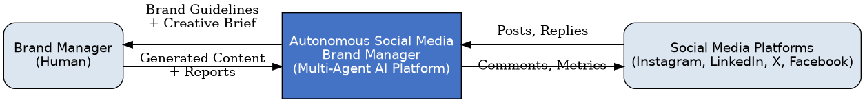
Figure 1: System Context Diagram

3.2 Modules of System
The system is organized around five specialized agent modules, supported by a shared tools layer and a presentation layer.

3.2.1 Strategy Director Agent
Acts as the orchestrator of the pipeline. It parses the brand guidelines and creative brief, decides the content plan across the selected platforms, and coordinates the hand-off between all downstream agents.

3.2.2 Copywriter Agent
Generates the primary textual content for each planned post. For every post, it produces two distinct variations — Variation A (safe, guideline-heavy) and Variation B (creative, experimental) — giving the Brand Manager a meaningful choice between safety and creative risk.

3.2.3 Brand Voice Guardian Agent
Performs automated, five-point auditing of every generated variation: tone matching against the brand's defined voice, linguistic naturalness, guardrail compliance (e.g., maximum exclamation points, forbidden terminology, competitor mentions), audience fit, and hashtag-count limits. Variations that fail to meet the configured score threshold are sent back to the Copywriter Agent for regeneration.

3.2.4 Engagement Manager Agent
Monitors the (live or mock) comment feed, uses a local rule-based sentiment engine to classify each comment as positive, neutral, or negative, and drafts a contextually appropriate, sentiment-matched reply — escalating negative or complex comments to the human Brand Manager rather than auto-posting a reply.

3.2.5 Performance Analyst Agent
Ingests engagement metrics (likes, shares, comments, reach), computes per-post engagement rates, and produces a plain-language performance report highlighting top and bottom performing content, along with at least three actionable recommendations that feed back into the Strategy Director for the next cycle.

3.2.6 Presentation & Tools Layer
A Streamlit-based web dashboard provides interactive controls (tone intensity, creativity level, post length) and a live logging panel that streams pipeline execution in real time; a parallel command-line interface supports the same pipeline for scripted or headless use. A shared tools layer provides brand-knowledge lookup, sentiment scoring, and platform-specific formatting/compliance trimming (character and hashtag limits for Instagram, LinkedIn, X, and Facebook) used across agents.

3.3 Functional Requirements
ID | Requirement Description | Priority
FR-01 | The system shall ingest brand guidelines from a structured text configuration file. | High
FR-02 | The Strategy Director Agent shall coordinate all sub-agents in the correct sequence. | High
FR-03 | The Copywriter Agent shall generate at least two platform-appropriate content variations per planned post. | High
FR-04 | The Brand Voice Guardian Agent shall score and validate tone/compliance before content is approved. | High
FR-05 | The Engagement Manager Agent shall generate sentiment-classified replies to audience comments. | Medium
FR-06 | The Performance Analyst Agent shall produce a textual weekly/campaign performance summary. | Medium
FR-07 | The system shall support content formatting for Instagram, LinkedIn, X, and Facebook. | High
FR-08 | All agent outputs shall be persisted locally in structured JSON format for auditing. | Medium
FR-09 | The system shall support a configurable retry limit for regenerating low-scoring content. | Medium
FR-10 | The system shall provide both a web dashboard (Streamlit) and a command-line interface. | High
Table 6: Functional Requirements Summary

3.4 Non-Functional Requirements

3.4.1 Usability
Brand configuration and campaign brief submission shall be completable by a non-technical user in under 30 minutes, aided by the Streamlit dashboard's guided input controls and live execution feedback.

3.4.2 Maintainability
Each agent module shall be independently developed, tested, and replaced without requiring changes to other agents, owing to the modular, role-based architecture and clear separation between agents, tasks, tools, and configuration.

3.4.3 Reliability
The system shall handle transient LLM API failures gracefully through configurable retry logic, ensuring that a single failed generation does not halt the entire campaign pipeline.

3.4.4 Performance
The system shall generate a complete post variation within a few seconds under normal LLM API latency, and shall complete a full performance report within two minutes.

3.4.5 Security
API keys and credentials shall never be hard-coded and shall be stored using environment variables or a secrets manager; negative-sentiment replies shall always require human approval before publishing.
Attribute | Requirement
Reliability | System shall gracefully retry failed LLM calls and continue pipeline execution.
Maintainability | Each agent shall be independently deployable and replaceable without affecting others.
Scalability | Architecture shall support adding new agent types (e.g., an image-generation agent) without redesign.
Testability | Each agent's tools shall expose unit-testable interfaces with mockable LLM responses.
Usability | Brand configuration shall be completable by a non-technical user in under 30 minutes.
Portability | System shall run on any Python 3.10+ environment without OS-specific dependencies.
Table 7: Non-Functional Requirements Summary

3.5 Feasibility

3.5.1 Economic Feasibility
The project relies entirely on open-source frameworks (CrewAI, Streamlit, VADER, TextBlob) and a pay-per-use LLM API (Google Gemini), avoiding any licensing cost. Development was carried out on standard consumer hardware, and the only recurring cost during development was a small amount of LLM API usage, making the project highly economically feasible for an academic Final Year Project.

3.5.2 Operational Feasibility
The system's dashboard-driven workflow requires no specialized AI expertise to operate: a Brand Manager only needs to supply a creative brief and brand guidelines through the UI. The modular agent design also means that a marketing team could operate the system with minimal training, and mock-data fallbacks (for metrics and comments) allow the system to be demonstrated and evaluated even before live platform accounts are connected.

3.5.3 Technical Feasibility
All required technologies — Python, CrewAI, Streamlit, the Google Generative AI SDK, and local sentiment libraries — are mature, well-documented, and freely available. The team's existing skills in Python, machine learning, and API integration, combined with the availability of extensive CrewAI and LangChain community documentation, made the technical implementation of the multi-agent pipeline achievable within the project's sixteen-week timeline.

3.6 Chosen Methodology

3.6.1 Incremental Development Model
The project was developed using an Incremental Development Model, in which the system was built and validated in successive increments — beginning with a single working agent (Copywriter) producing basic text output, followed by the sequential addition of the Brand Voice Guardian, Engagement Manager, and Performance Analyst agents, and finally the Streamlit dashboard and platform-formatting layer. This approach allowed each agent and tool to be tested independently before being integrated into the full pipeline, reducing integration risk and allowing continuous, demonstrable progress throughout the sixteen-week development timeline.
Figure 7: Incremental Development Life Cycle Model

3.7 Project Structure
The codebase follows a modular folder structure that cleanly separates the presentation layer, orchestration logic, agent/task definitions, shared tools, and local data:
Path | Purpose
app.py | Streamlit web dashboard — interactive controls and live logging panel
main.py | Command-line interface (CLI) entry point
config/settings.py | Campaign configuration and system settings
crew/social_media_crew.py | CrewAI orchestration layer coordinating the 5-agent pipeline
tasks/task_definitions.py | Task definitions for content generation, auditing, and reporting
agents/ | Definitions of the five specialized agents
tools/brand_knowledge_tool.py | Reads and injects brand guideline context (RAG-style grounding)
tools/sentiment_tool.py | Local VADER/TextBlob-based sentiment scoring
tools/platform_formatter.py | Platform-specific character/hashtag limit validation and trimming
data/ | Local datasets — sample brand guidelines and mock engagement metrics
outputs/ | Persisted campaign results in structured JSON format

CHAPTER 4
SYSTEM DESIGN

4.1 Introduction
This chapter presents the architectural and detailed design of the Autonomous Social Media Brand Manager. It covers the layered system architecture, the class-level structure of the agent pipeline, the activity and data flow of each major process, the sequence of interactions between the dashboard, orchestrator, tools, and the LLM, the conceptual data model for the (proposed) persistence layer, and the graphical user interface of the system.

4.2 Purpose
The purpose of the system design is to translate the functional and non-functional requirements identified in Chapter 3 into a concrete, modular architecture that can be implemented, tested, and extended. The design emphasizes separation of concerns — each agent, tool, and interface component has a single, well-defined responsibility — so that the system remains maintainable and can evolve toward the production roadmap described in Chapter 6.

4.3 Scope
The design scope covers six layers: (1) the presentation layer (Streamlit dashboard and CLI), (2) the orchestration layer (CrewAI-based crew orchestrator and campaign configuration), (3) the five-agent sequential pipeline, (4) the specialized tools layer (brand knowledge, sentiment analysis, platform formatting, mock social API), (5) the local data layer (JSON/TXT-based brand and metrics storage), and (6) the LLM engine (Google Gemini).

4.4 System Architecture Diagram
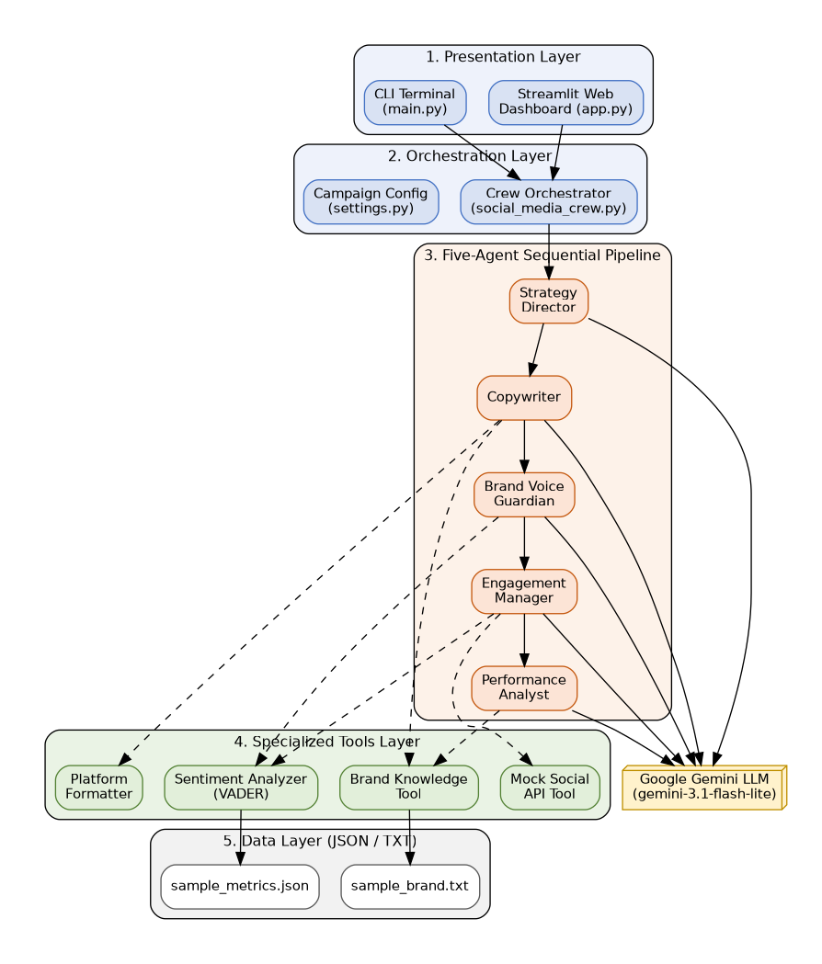
Figure 8: High-Level System Architecture Diagram
The architecture diagram illustrates the flow of control from the presentation layer down through the orchestrator and the five-agent pipeline, out to the specialized tools and local data layer, with the LLM engine invoked throughout the pipeline for text generation and reasoning.

4.5 Class Diagram
The class diagram models the core object structure of the system, including the CampaignConfig, the SocialMediaCrew orchestrator, the five Agent subclasses, the Task definitions each agent executes, and the shared Tool classes (BrandKnowledgeTool, SentimentTool, PlatformFormatter) they depend on.
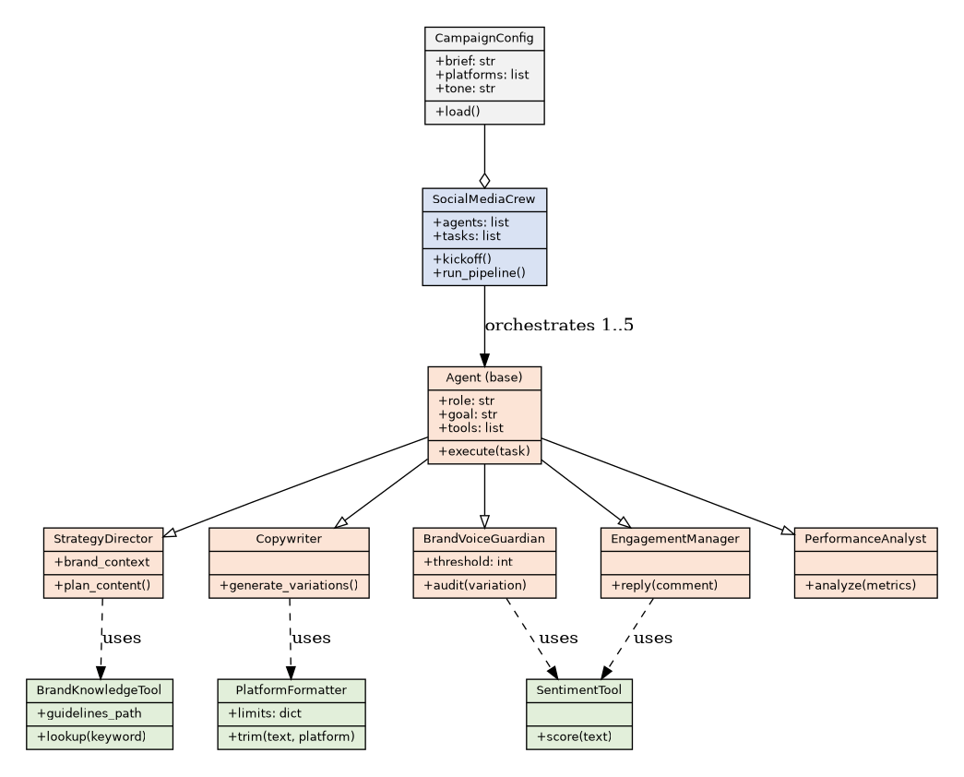
Figure 9: Class Diagram

4.6 Activity Diagrams

4.6.1 Activity Diagram — Content Generation Pipeline
Models the flow from campaign brief submission through strategy planning, A/B copy generation, and brand-voice auditing, including the regeneration loop triggered by a failing audit score.
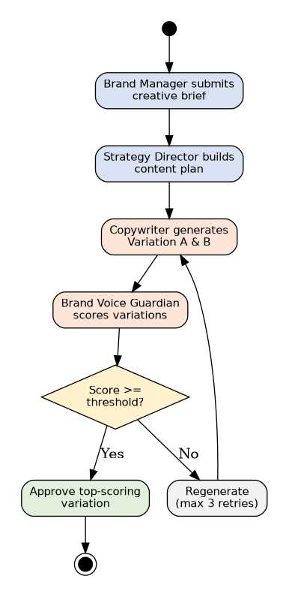
Figure 10: Activity Diagram — Content Generation Pipeline

4.6.2 Activity Diagram — Audience Engagement Flow
Models the flow from comment ingestion through sentiment classification, reply drafting, and the branch between auto-posting and human escalation.
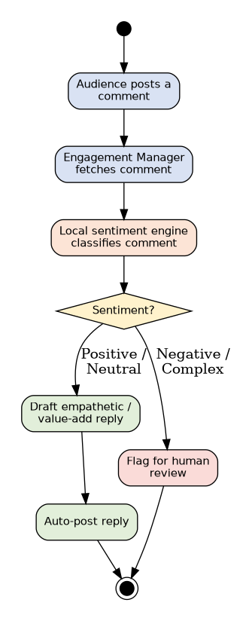
Figure 11: Activity Diagram — Audience Engagement Flow

4.6.3 Activity Diagram — Performance Analysis Flow
Models the flow from metrics ingestion through engagement-rate calculation, report generation, and feedback to the Strategy Director for the next campaign cycle.
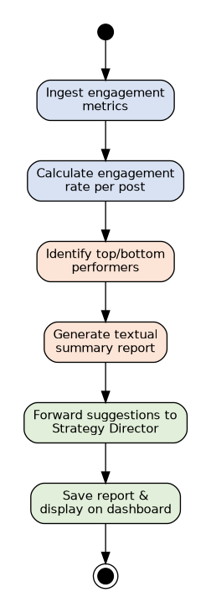
Figure 12: Activity Diagram — Performance Analysis Flow

4.7 Data Flow Diagram

4.7.1 Level 0
Represents the system as a single process, showing the Brand Manager as the external entity supplying a creative brief and brand guidelines, and receiving generated campaign content and reports in return.
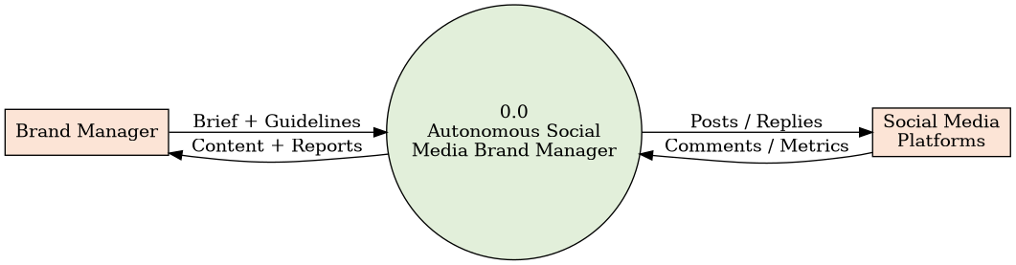
Figure 13: Data Flow Diagram — Level 0

4.7.2 Level 1
Decomposes the system into its five major agent processes (Strategy, Copywriting, Brand Voice Auditing, Engagement, Performance Analysis) and shows the data stores (brand guidelines file, mock metrics file, campaign output JSON) each process reads from or writes to.
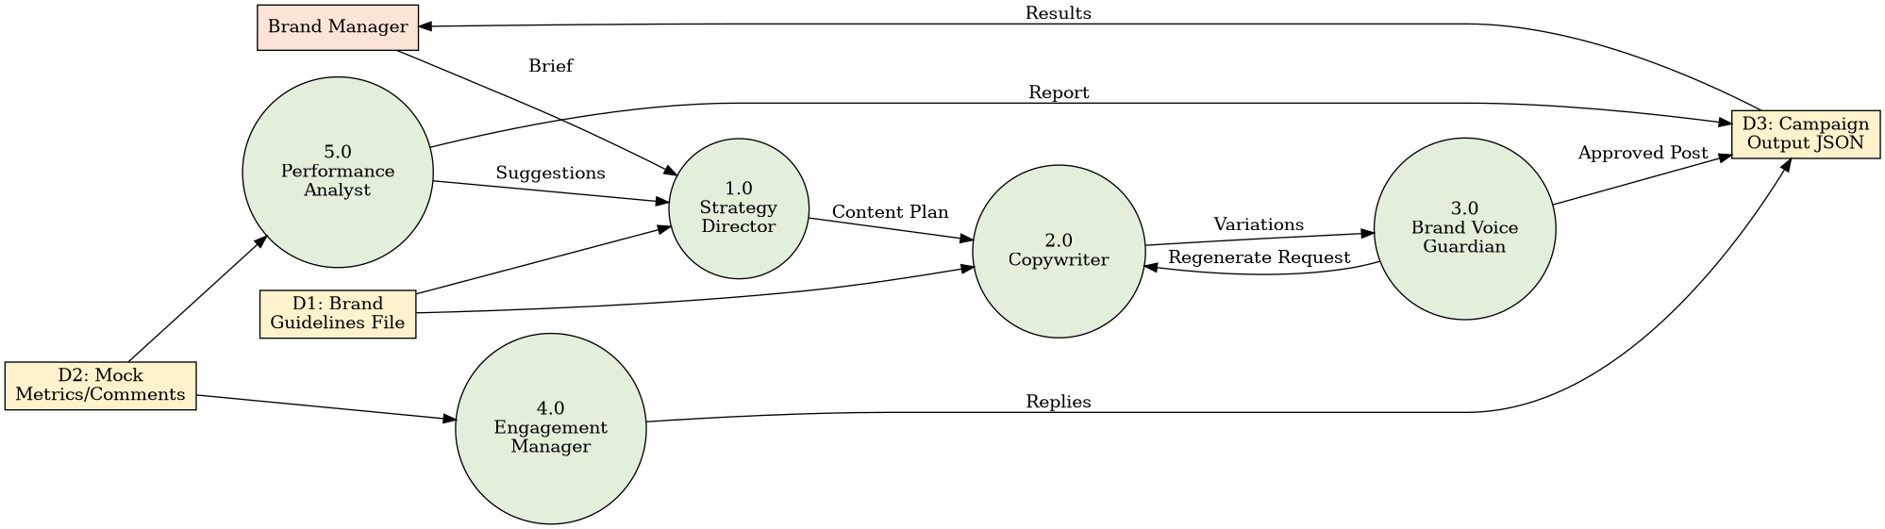
Figure 14: Data Flow Diagram — Level 1

4.7.3 Level 2
Further decomposes the Copywriting and Brand Voice Auditing processes to show the internal steps of variation generation, rubric scoring, and the regeneration feedback loop.
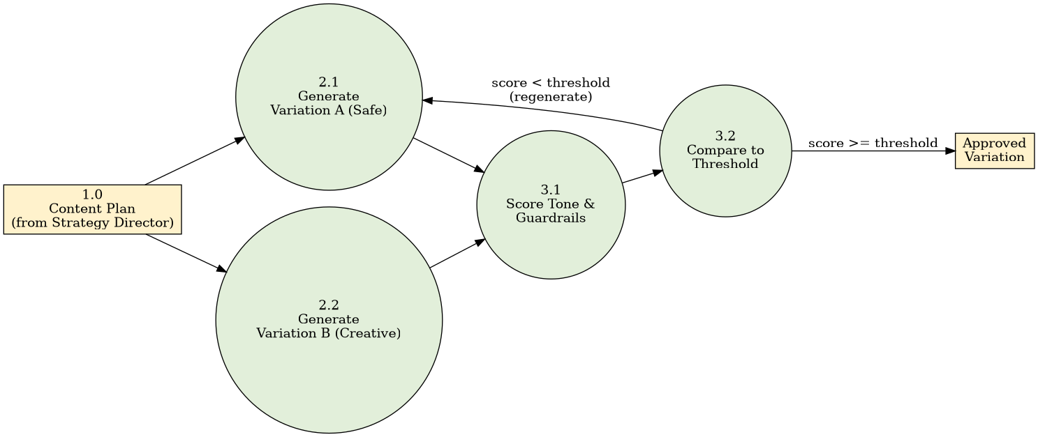
Figure 15: Data Flow Diagram — Level 2

4.8 Sequence Diagram
The sequence diagram below traces a complete campaign run: the Brand Manager submits a brief through the Streamlit dashboard; the orchestrator initializes the campaign configuration and launches the five-agent pipeline; the Strategy Director retrieves brand context and formulates platform-specific post plans; the Copywriter produces two variations per post; the Brand Voice Guardian audits and approves or requests revision; the Engagement Manager fetches comments and drafts sentiment-matched replies; and the Performance Analyst produces a final report — with the complete CampaignResult returned to the dashboard for display.
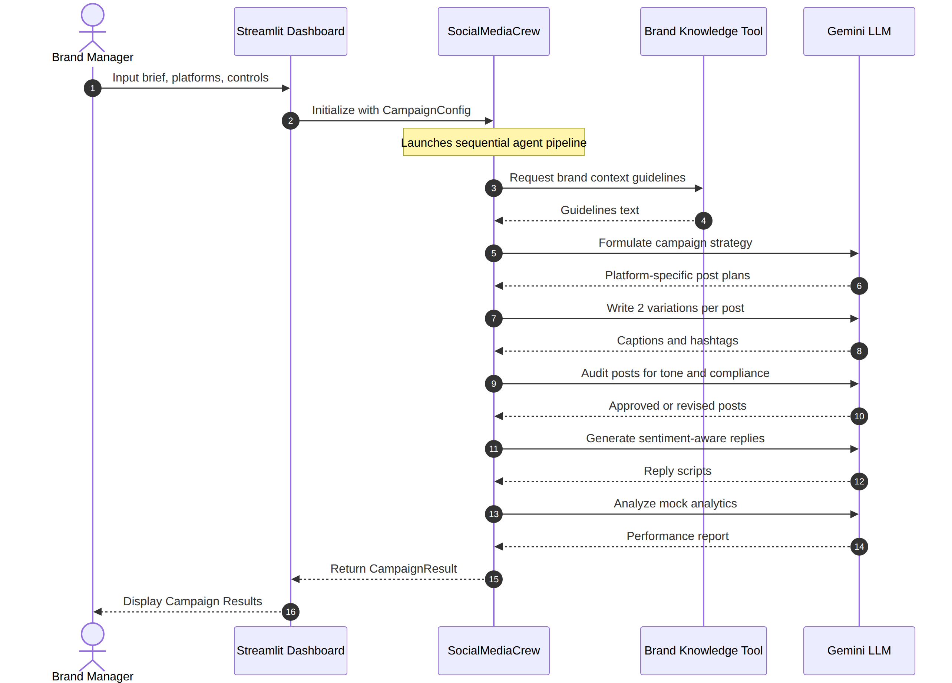
Figure 16: Sequence Diagram — End-to-End Campaign Generation

4.9 ERD
Although the current prototype persists campaign results as local JSON files rather than in a relational database, the following Entity Relationship Diagram models the conceptual data structure that underpins the system and that would be implemented as part of the production database roadmap described in Section 6.2 (Campaign, Post, Variation, Comment/Reply, and Metrics entities and their relationships).
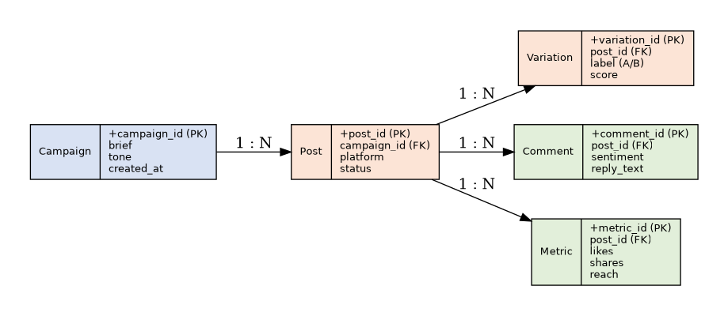
Figure 17: Entity Relationship Diagram (Proposed Persistence Layer)

4.10 Graphical User Interface (GUI)
The system's primary interface is a Streamlit-based web dashboard. The following screens represent the main interaction points of the application.

4.10.1 Dashboard Home / Campaign Brief Screen
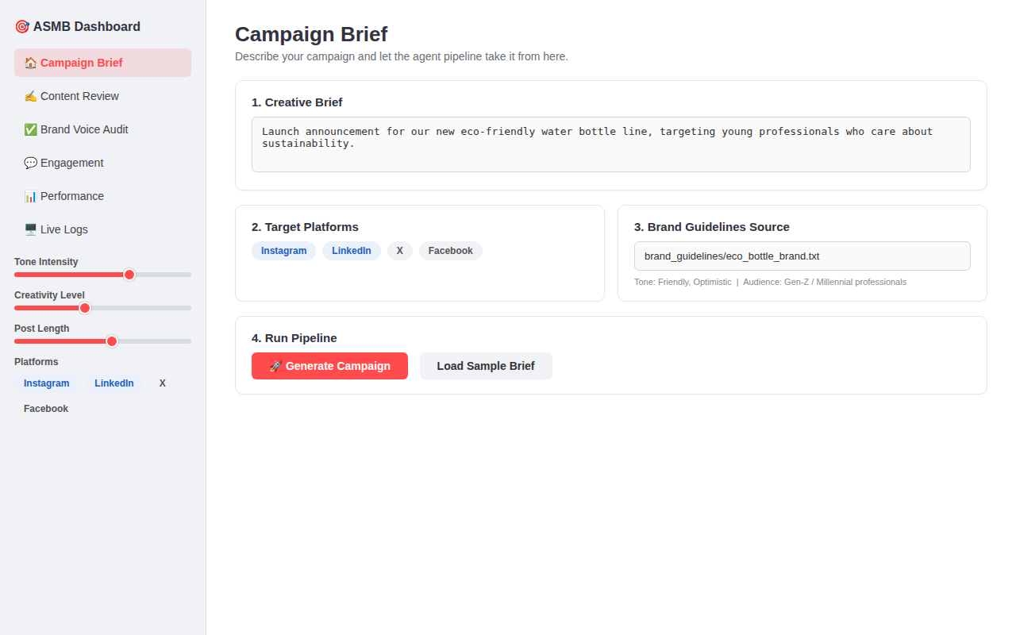
Figure 18: Dashboard Home / Campaign Brief Screen

4.10.2 Content Generation & Review Screen
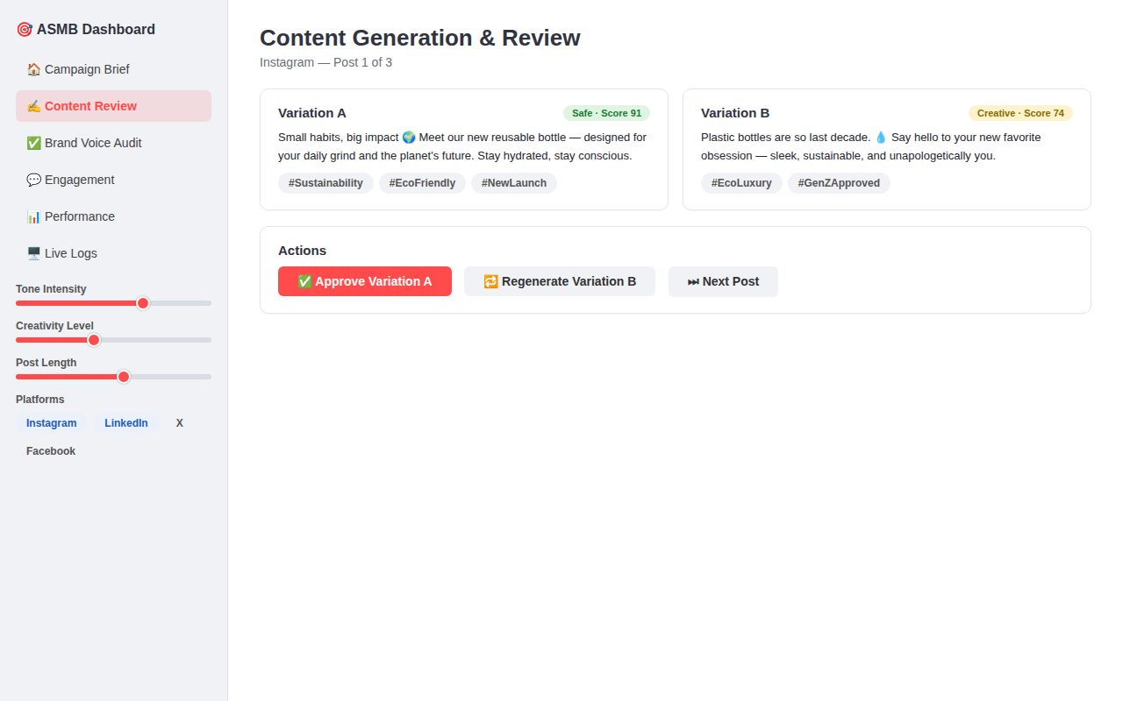
Figure 19: Content Generation & Review Screen

4.10.3 Brand Voice Audit / Approval Screen
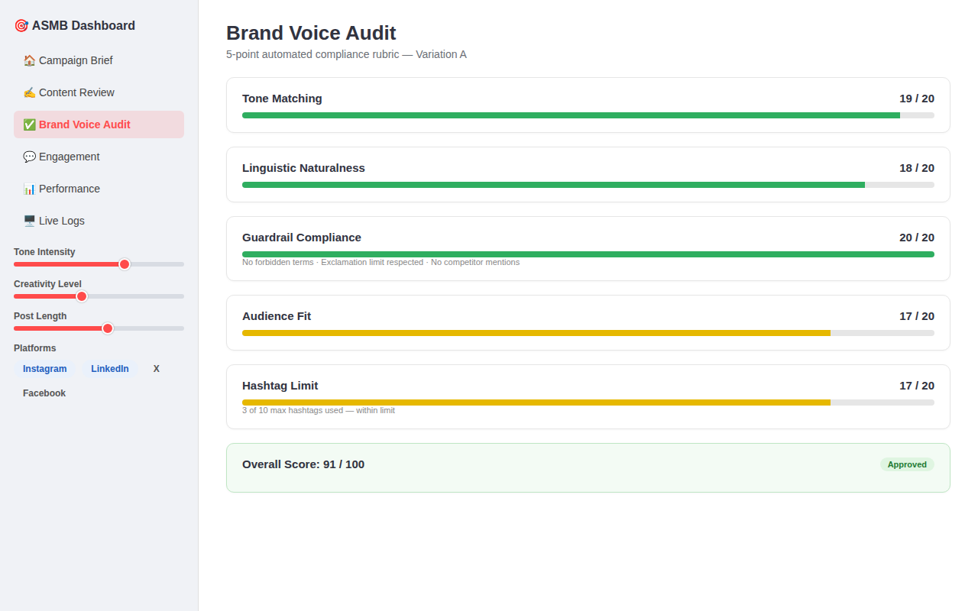
Figure 20: Brand Voice Audit / Approval Screen

4.10.4 Engagement Manager Screen
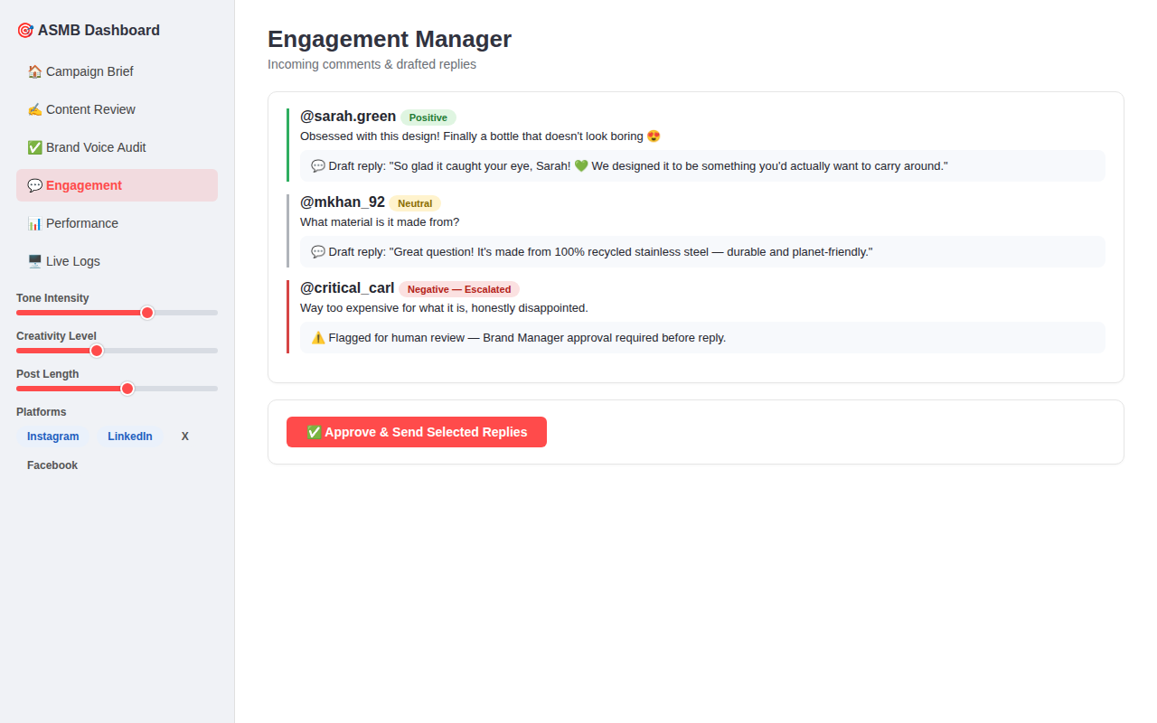
Figure 21: Engagement Manager Screen

4.10.5 Performance Analyst Report Screen
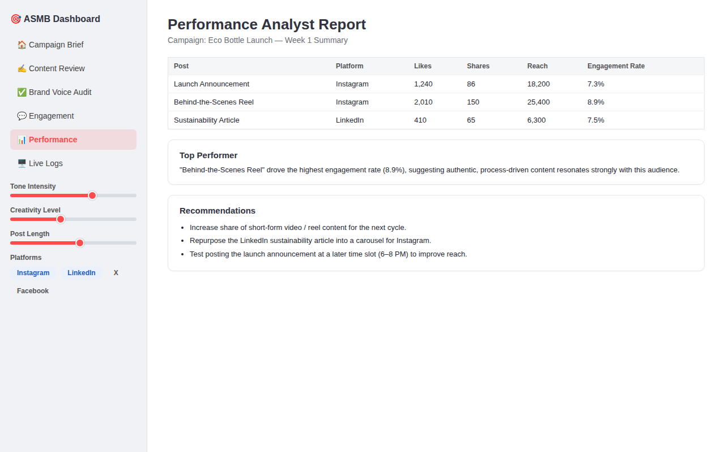
Figure 22: Performance Analyst Report Screen

4.10.6 Live Logging Panel
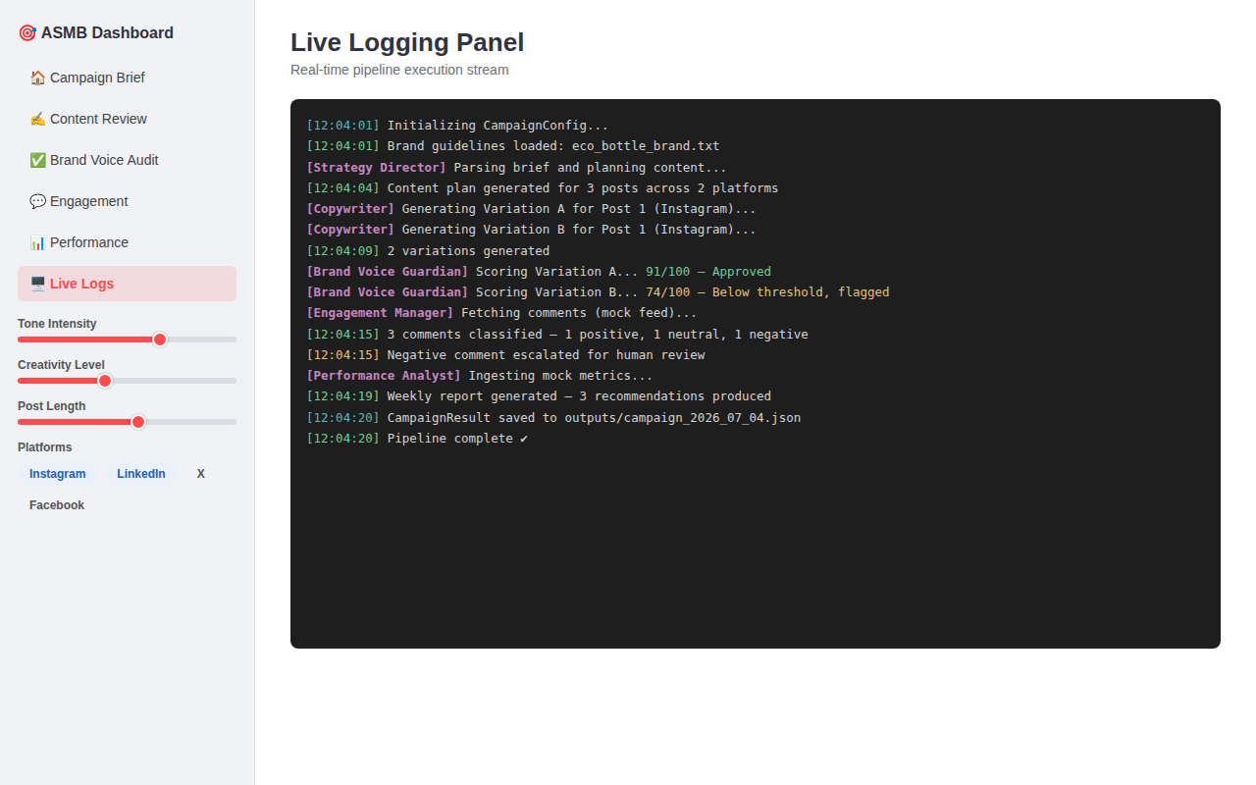
Figure 23: Live Logging Panel

CHAPTER 5
SYSTEM TESTING

5.1 Testing Introduction
Testing the Autonomous Social Media Brand Manager required validating both the deterministic, rule-based components of the system (input validation, platform formatting, sentiment scoring, audit rubric logic) and the non-deterministic, LLM-generated components (strategy plans, copy variations, replies, reports). This chapter documents the testing objectives, techniques, and representative test cases used to verify that the system behaves correctly and safely.

5.2 Purpose of Testing
The purpose of testing was to verify that each agent and tool performs its intended function correctly in isolation, that the five-agent pipeline correctly hands off data between stages, that brand-safety guardrails reliably reject non-compliant content, and that the system degrades gracefully (via retries or human escalation) when the LLM produces low-quality or non-compliant output.

5.3 Objectives of Testing
- Verify that brand configuration and campaign brief inputs are correctly validated and parsed.
- Verify that generated content respects platform-specific character and hashtag limits.
- Verify that the Brand Voice Guardian's scoring logic correctly approves or rejects content relative to the configured threshold.
- Verify that the regeneration/retry loop terminates correctly after the configured maximum number of attempts.
- Verify that negative-sentiment comments are correctly escalated for human review rather than auto-replied.

5.4 Testing Techniques

5.4.1 Black Box Testing
Black box testing was used to validate the system's inputs and outputs — brand configuration files, campaign briefs, and platform selections — without reference to the internal implementation, focusing on whether valid inputs produced accepted output and invalid or boundary inputs were correctly rejected or trimmed.

5.4.2 White Box Testing
White box testing was used to validate the internal logic of the deterministic components, particularly the Brand Voice Guardian's rubric-scoring function and the platform formatter's trimming logic, using path coverage over the conditional branches that decide approval, rejection, or content truncation.

5.5 Black Box Test Cases

5.5.1 Black Box Testing for Brand Configuration Input
Interface Name: Brand Guidelines Config File
Test Case ID | Input | Expected Output | Actual Output
1 | Valid .txt file with tone, keywords, audience fields | Guidelines loaded and injected into agent context | Valid
2 | Empty or missing configuration file | System raises a configuration error and halts pipeline | Valid
3 | Config file with unsupported encoding | System raises a parsing error with a clear message | Valid
Table 8: Black Box Test Cases — Brand Configuration Input

5.5.2 Black Box Testing for Platform Character Limit
Interface Name: Platform Formatter (Twitter/X ≤ 280 characters)
Test Case ID | Input | Expected Output | Actual Output
1 | Caption of 210 characters for X | Accepted without modification | Valid
2 | Caption of 320 characters for X | Caption trimmed to fit within 280-character limit | Valid
3 | Caption with 15 hashtags for Instagram (limit 10) | Hashtag list trimmed to top 10 relevant tags | Valid
Table 9: Black Box Test Cases — Platform Character Limit

5.5.3 Black Box Testing for Brand Voice Score Threshold
Interface Name: Brand Voice Guardian Scoring (default threshold = 70)
Test Case ID | Input | Expected Output | Actual Output
1 | Variation scoring 85/100 | Approved; passed to output | Valid
2 | Variation scoring 55/100 | Rejected; sent back to Copywriter for regeneration | Valid
3 | Variation fails 3 consecutive regeneration attempts | Best-scoring available variation returned with a flag for human review | Valid
Table 10: Black Box Test Cases — Brand Voice Score Threshold

5.6 White Box Test Cases

5.6.1 White Box Test Case Using Path Coverage — Audit Scoring Logic
The following simplified pseudocode illustrates the branching structure of the Brand Voice Guardian's audit function, which was used as the basis for white box path-coverage testing:
def audit_variation(variation, threshold=70, max_retries=3, attempt=0): score = score_tone(variation) + score_naturalness(variation) \ + score_guardrails(variation) + score_audience_fit(variation) \ + score_hashtags(variation) if score >= threshold: return approve(variation) elif attempt < max_retries: new_variation = regenerate(variation) return audit_variation(new_variation, threshold, max_retries, attempt + 1) else: return flag_for_human_review(variation)

5.6.2 White Box Test Cases
Id | Condition | Input | Output
1 | score >= threshold | score = 85, threshold = 70 | approve(variation)
2 | score < threshold, attempt < max_retries | score = 55, attempt = 1 | regenerate() then re-audit
3 | score < threshold, attempt = max_retries | score = 60, attempt = 3 | flag_for_human_review(variation)
Table 11: White Box Test Cases — Audit Scoring Logic

5.6.3 Results
Test Case ID | Path Covered | Result
1 | score → approve | Passed
2 | score → regenerate → re-audit | Passed
3 | score → regenerate → flag for review | Passed
Table 12: Test Case Results Summary

CHAPTER 6
CONCLUSION & FUTURE WORK

6.1 Conclusion
The Autonomous Social Media Brand Manager demonstrates that the traditionally fragmented, manually-coordinated workflow of social media management — strategy, copywriting, compliance review, engagement, and analytics — can be successfully unified into a single, cooperating multi-agent AI pipeline. By dividing responsibility among five specialized agents orchestrated through CrewAI and powered by the Google Gemini LLM, the system produces platform-appropriate content plans, brand-audited A/B copy variations, sentiment-aware engagement replies, and actionable performance reports from a single creative brief, with minimal human intervention required beyond initial configuration and final review.
The resulting prototype is highly modular, with a clean separation between agents, tasks, and tools, and demonstrates key architectural patterns relevant to production-grade AI engineering: context grounding through a retrieval-style brand knowledge tool, deterministic rule-based auditing layered alongside generative content creation, and a human-in-the-loop safety mechanism for negative-sentiment engagement. While the current system relies on local mock data for metrics and comment feeds and does not yet post directly to live social media platforms, it successfully validates the core multi-agent architecture and provides a strong foundation for a production-ready system.
Overall, this project meets its stated purpose: reducing content-drafting time, standardizing brand voice, scaling audience engagement, and simplifying performance analysis — while also serving as a practical demonstration of full-stack, tool-using Agentic AI engineering that goes beyond notebook-level machine learning experimentation.

6.2 Future Work
Several enhancements have been identified to evolve this Advanced Prototype / FYP-level system into an enterprise-ready production product, organized across three phases:

Phase 1: Real-World Integrations (Short-Term)
- Official API Connectivity — replace mock API classes with official SDK clients (e.g., Tweepy for X, the Meta Graph API for Instagram/Facebook, and the LinkedIn developer API) to enable direct publishing and live comment retrieval.
- RAG Enhancement — migrate the brand knowledge tool from simple keyword/substring searching to semantic retrieval using the already-configured FAISS vector database, allowing the system to ingest long-form PDF brand guidelines, past press releases, and full brand books.

Phase 2: Media Creation & Human-in-the-Loop (Medium-Term)
- Multi-Modal Generation — integrate image-generation models (e.g., Imagen or Stable Diffusion) to produce campaign creatives that match the drafted copy, extending the system beyond text-only content.
- Human-in-the-Loop (HITL) Workflow — insert manual approval checkpoints inside the Streamlit dashboard, allowing Brand Managers to edit, approve, or regenerate individual drafts before they proceed to the next agent in the pipeline.

Phase 3: Closed-Loop Optimization (Long-Term)
- Dynamic Session Memory — persist execution state in a proper database (PostgreSQL or MongoDB) so that subsequent campaigns can build upon historical performance data rather than starting from a blank context each time.
- Continuous Learning Loop — connect live analytics directly to the Performance Analyst Agent so that brand guidelines and content strategy are automatically refined based on which posts historically performed best.
Beyond these three phases, future work could also explore adding new specialized agents (e.g., a competitor-monitoring agent or an SEO/hashtag-trend research agent) without requiring redesign of the existing pipeline — a direct benefit of the system's modular, role-based architecture.

REFERENCES
[1] Russell, S. & Norvig, P. — Artificial Intelligence: A Modern Approach.
[2] Roger S. Pressman — Software Engineering: A Practitioner's Approach, 6th Edition, McGraw Hill, 2005.
[3] IEEE Std 830-1998 — IEEE Recommended Practice for Software Requirements Specifications.
[4] CrewAI Documentation — https://docs.crewai.com
[5] LangChain Official Documentation — https://docs.langchain.com
[6] Google AI for Developers — Gemini API Documentation — https://ai.google.dev/gemini-api/docs
[7] Streamlit Documentation — https://docs.streamlit.io
[8] Hutto, C.J. & Gilbert, E. — VADER: A Parsimonious Rule-based Model for Sentiment Analysis of Social Media Text, Eighth International Conference on Weblogs and Social Media (ICWSM-14), 2014.
[9] Lewis, P. et al. — Retrieval-Augmented Generation for Knowledge-Intensive NLP Tasks, NeurIPS, 2020.
[10] Meta for Developers — Instagram Graph API Documentation — https://developers.facebook.com/docs/instagram-api
[11] X (Twitter) Developer Platform — API v2 Documentation — https://developer.twitter.com/en/docs
[12] LinkedIn Developer Documentation — https://learn.microsoft.com/en-us/linkedin
[13] FYP Proposal & SRS: Autonomous Social Media Brand Manager, Department of Computer Science, Abbottabad University of Science & Technology, 2026.

