Carbon Pricing Policies and Decoupling Between Greenhouse Gas Emissions and Economic Growth: A Panel Study of 30 European Countries, 1996-2014

Abstract

This study explores why the levels of decoupling between greenhouse gas (GHG) emissions and economic growth vary across time and between countries, and examines which factors are driving this decoupling. We argue that the implementation of carbon pricing policies facilitates decoupling, as they are designed to achieve cost-efficient GHG reduction. We analyze the panel data of 30 European countries between 1996 and 2014 to examine the relationships between two carbon pricing policies, emission trading and carbon tax, and emission intensity (GHG emissions per unit of GDP) we use to capture decoupling trends. Our result indicates that while controlling for factors that may affect emission intensity, emission trading contributes to decoupling in all models, whereas carbon tax does not; this has also been suggested in previous literature. Furthermore, emission trading is negatively associated with GHG emissions, implying that it contributes to not weak, but strong decoupling of economic growth from GHG emissions.

Keywords: Decoupling, Carbon pricing, emission trading, carbon tax, emission intensity climate change mitigation

Word count: 6,463

**Introduction**

It is imperative to mitigate GHG emissions to meet the Paris Agreement target, to ensure sustainability both in the present and in the future. However, the concern that mitigation may dampen economic growth and prosperity has been the primary obstacle for active mitigation efforts. Decoupling in the context of climate policy literature and government regulation refers to the trend whereby GHG emissions decrease without economic growth being undermined (Andreoni and Galmarini 2012; Jorgenson and Clark 2012). Achieving a decoupling trend has been widely discussed as a potential breakthrough for the global climate change problem.

However, in reality, the current scenario does not conform to the idealistic discourse regarding decoupling: meaningful empirical variation exists in the degree of decoupling in different countries. Even among European countries, which have been most active regarding GHG mitigation, Figure 1 shows that some countries, such as Sweden or the United Kingdom, have largely achieved decoupling, whereas others, such as Italy or Portugal, have not. It is therefore important to determine which factors, all else being equal, drive a decoupling trend in a country.

Figure 1. Time-series graphs showing decoupling in 30 European countries, 1996-2014.

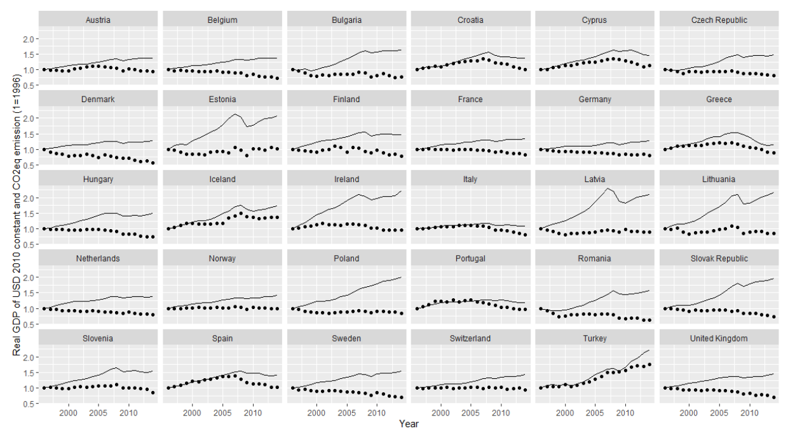

(1.0= 1996 value, the solid line is the real GDP (US$ 2010 constant), and the dotted line is GHG (tCO2eq)).

To answer this question, we examine the relationship between a decoupling trend and carbon pricing, which is a policy innovation that aims to promote cost-efficient mitigation actions. The idea of carbon pricing is to impose a Pigouvian fee, or tax, on pollution-inducing behaviors, for both carbon dioxide as well as other greenhouse gases. Emission trading and carbon taxes are two policy instruments that are commonly used to enable this, though they employ different ways to impose such a fee (Tietenberg 2013).

Our analysis of the relationship between decoupling and carbon pricing instruments represents a novel contribution to the literature for two reasons. First, previous studies have examined the various conditions required for decoupling to occur, yet few of these studies included carbon pricing policies as their key independent variables. We can determine which policies help countries to better achieve decoupling by examining whether different types of carbon pricing policies have different impacts on decoupling. Second, researchers have discussed the effectiveness of emission trading or carbon tax, yet these studies mainly consist of single country cases (Lundgren et al 2015; Mascher 2018; Mo et al 2016; Rogge and Hoffmann 2010; Sandoff and Schaad 2009). Despite the possible link between decoupling and carbon pricing in terms of cost-efficient GHG mitigation, few studies have analyzed their relationship using time-series and cross-country comparisons.

A careful examination of their relationship can provide two implications. First, understanding the relationship between decoupling and carbon pricing generates testable hypotheses that can explain the time-series and cross-country variation in the degree of decoupling. To test these hypotheses, we use panel data from 30 European countries, across the period of 1996-2014. Within this sample of European countries, there exists sufficient variation in the degree of economic growth, GHG emissions, and carbon pricing policies. Due to the salience of the issue of climate change issue in Europe, 47% and 28% of 30 European countries adopted emission trading and carbon tax, respectively, during the period of 1996-2014. We leverage this variation in the adoption of carbon pricing across these European countries to empirically test its impact on decoupling. We further justify our sample selection in the following section.

Second, decoupling allows us to test the effectiveness of different policy instruments for pricing carbon. Theoretical approaches that predict carbon pricing to be effective in reducing GHG abatement cost are well established, yet few studies have used an empirical approach to examine whether or which type of policy instruments are most effective for putting a price on carbon. Here, we examine the effectiveness of different carbon pricing policies in promoting decoupling leveraging a single measurement for decoupling, which is emission intensity (GHG emission per GDP), and showing how its relationship to each policy differs.

This paper is structured as follows. The next section reviews the literature on decoupling and carbon pricing, to identify the knowledge gap that we aim to fill. We also theorize the links between emission trading and carbon tax, and emission intensity. The following section presents data, data sources, and the method that this study uses. Analysis outcomes and discussion sections then follow. We conclude by highlighting the contributions and policy implications, and provide suggestions for future research.

**Literature Review: Decoupling and Carbon pricing**

*Emission Intensity as an Indicator for Decoupling*

In environmental studies literature, decoupling is referred to on a country level as a phenomenon whereby the national economy does not shrink, even though said nations’ GHG emissions decrease (Jorgenson and Clark 2012). Scholars have, however, often used different terms, such as, a low-carbon society or economic growth (Reilly 2013), green economy (Ferguson 2014), or green growth (Damonte 2014), to refer to similar phenomena. Proponents of decoupling have argued that economic growth can be environment-friendly if energy efficiency is enhanced through technological innovation (Dinda 2004), or if increased income leads to demands for environmental regulation (Mol 2002). One hypothesis based on this idea is the Environmental Kuznets Curve (EKC) hypothesis, which predicts that a country can achieve decoupling after it has attained a certain level of economic development (Clulow 2016). Yet, the primary differences between the EKC and our research are the dependent variables (the level of energy intensity instead of pollution in EKC) and the key independent variables (the presence of carbon pricing policies instead of economic development).

Decoupling can be measured as emission intensity, which is the volume of GHG emissions divided by the GDP of a given country in a given year. Consider an example of countries A and B for two periods, t and t+1, as shown in Table 1. For both A(t) and B(t), let GDP be US$ 1,000 and GHG be 100 kgCO2eq. At t+1, country A’s GDP increases by US$ 1 and its GHG decreases by 50 kgCO2eq. This is an example of decoupling, and we now see that its emission intensity has fallen, even though there has been an increase in its GDP. For country B, let its GDP increase by US$ 500 and its GHG increase by 2 kgCO2eq. Although both the GDP and the GHG have increased, GHG increased at a slower rate than GDP. Therefore, this is also a case of decoupling, and we see that the emission intensity has also fallen. Scholars have often labeled the case of country A as “strong decoupling” and the latter case as “weak decoupling” (Andreoni and Galmarini 2012). However, as for country C, GHG increased at a higher rate than GDP: this is not the case regarding decoupling, and its emission intensity has risen. In short, a lower emission intensity can indicate either a strong or weak decoupling trend in a country.

Table 1. Decoupling and emission intensity

|  |  |  |  |  |  |  |
| --- | --- | --- | --- | --- | --- | --- |
| **Country / Time** | **GDP (US$)** | **GHG (kgCO2eq)** | **ΔGDP** | **ΔGHG** | **Emission intensity** | **Decoupling** |
| A(t) | 1,000 | 100 | 0.001 | -0.5 | 0.1 | Strong  (ΔGDP > 0 > ΔGHG) |
| A(t+1) | 1,001 | 50 | 0.05 |
| B(t) | 1,000 | 100 | 0.5 | 0.02 | 0.1 | Weak  (ΔGDP > ΔGHG > 0) |
| B(t+1) | 1,500 | 102 | 0.068 |
| C(t) | 1,000 | 100 | 1 | 4 | 0.1 | Coupling  (ΔGDP < ΔGHG) |
| C(t+1) | 2,000 | 500 | 0.25 |

Measuring decoupling with emission intensity allows us to compare the degree of decoupling across countries. Figure 2 shows the variations in emission intensity across the countries of our sample group that we leverage in this research. Why does emission intensity vary across European countries, which have stood out as the most active country-group regarding mitigation actions?

Figure 2. Emission intensities of 30 European countries, 1996-2014

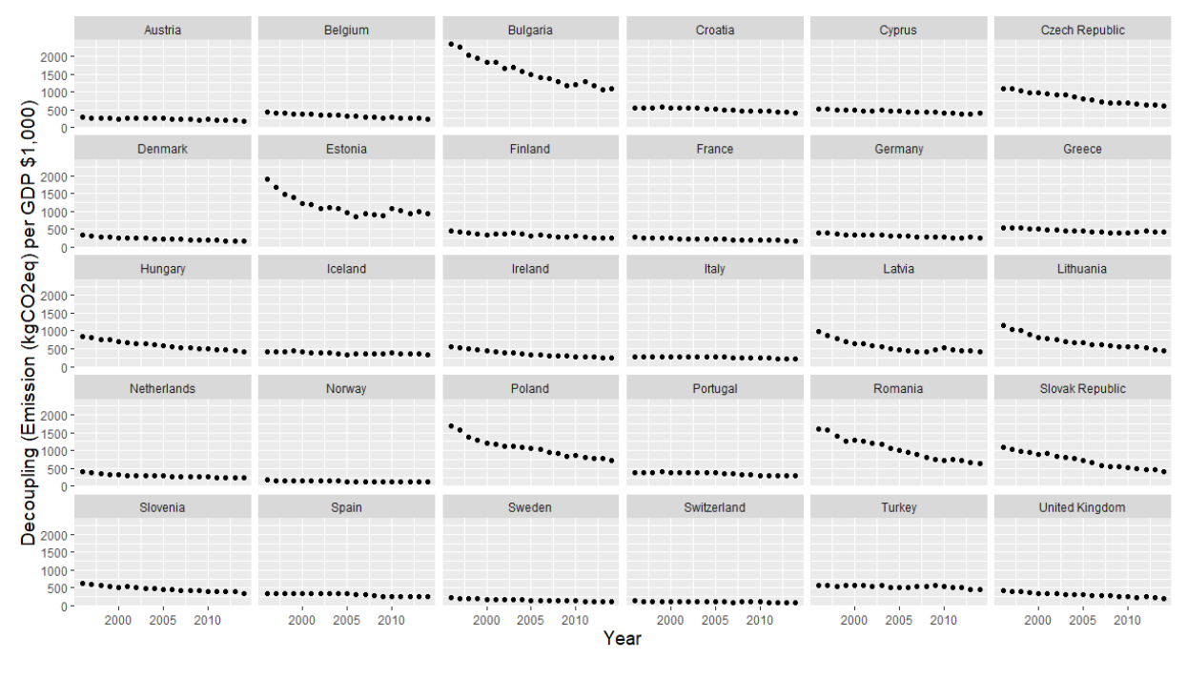

*Carbon Pricing and Decoupling*

Now we introduce the possible link between decoupling and carbon pricing, which is often understood as one type of policy innovation for GHG mitigation. As explained earlier, carbon pricing is designed to make GHG emissions costly by, as its name implies, “pricing carbon.” Generally, carbon pricing policies regulate specific GHGs, and covert the degree to which they contribute to global warming into CO2eq, or carbon dioxide equivalent; CO2 is used as a reference point. Then, they impose a certain amount of cost per unit of CO2eq, and internalize pollution as a negative externality to producers’ or consumers’ economic activities. Economists have pointed to the advantage of this market-based mechanism for environmental regulation, compared to the command-and-control mechanism, in terms of minimizing the aggregate cost of environmental protection (Stavins 1998).

Emission trading and carbon tax are commonly used policy instruments to employ carbon pricing, though they employ different ways to impose such a fee (Tietenberg 2013). Emission trading creates a “political market” (Keohane et al 1999) where liable firms (polluters) can trade emission allowance units with each other at market price (Lederer 2017). While the market determines a carbon price in emission trading, for a carbon tax, the government determines the price. The government imposes an additional tax on goods and services, based on how much GHG they emit in their production process, or how much they possess in their contents.

We suggest that there are two key factors for any mitigation policy to bring about decoupling trend: (1) whether it can make GHG mitigation “less costly,” and (2) whether it can ensure substantial GHG mitigation. First, the cost of GHG mitigation (or abatement cost) can be considered as an opportunity cost for economic growth. Therefore, a lowered abatement cost can lead to a better allocation of resources for economic growth. When reducing the same amount of GHG emissions, it is likely for a country to achieve a decoupling trend when it implements a policy instrument that is more capable of lowering the abatement cost. Second, a policy instrument that succeeds in reducing abatement cost, without reducing the actual amount of GHG emission, is partially contributing to a decoupling trend—in this case weak decoupling. Only when it succeeds in both aspects can it be considered to have contributed to strong decoupling.

While both carbon tax and emission trading are carbon pricing policies designed to curb GHG emissions in an efficient way, the two policies employ different mechanisms to attain the goal, and so may produce different outcomes for decoupling. First, emission trading can effectively deal with the first factor: lowering abatement cost. Under an emission trading scheme, liable firms whose abatement cost is below the price of carbon in the market have incentives to further reduce their GHG emissions, as they can have more allowance units, which they can sell to other firms whose abatement costs are higher than the price. Furthermore, it can encourage technological development (“environmental innovation”), which can gradually enhance polluters’ energy efficiency (Rogge et al 2011). Therefore, heavy polluters can reduce their abatement cost by simply buying allowances at a lower cost from the market, while other firms can offset their cost of innovation for efficient GHG reduction using the funds that heavy polluters pay to them. Additionally, most emission trading schemes adopt a “cap,” or total upper bound for GHG emission. This cap gradually declines over time to reduce emissions, and to increase the price of emission permits. This ensures that the emission reduction target is met. In theory, emission trading can both achieve cost-efficient GHG reduction and the actual mitigation of GHG emissions in a flexible way (Boyce 2018).

Meanwhile, carbon tax operates by setting a tax rate per unit of emissions or fossil fuel use (tax base). It aims to gradually dampen the use of taxed fossil fuels or GHG emissions by increasing prices (Haites 2018). Carbon tax may bring “an environmental double dividend” through emission reduction. The tax revenue can also be used to mitigate environmental hazards (Baranzini et al 2000). However, it may not provide more of an incentive for heavy polluters to reduce their abatement cost if incremental carbon tax rates are not set. Generally, all polluters must pay taxes per the amount of fossil fuel they use or the GHGs they emit, which are set by the government in a top-down manner. Therefore, carbon tax may be less flexible in reducing abatement cost than emission trading. In addition, carbon tax does not set a cap, which may not ensure that actual GHG reduction is achieved, if there are a significant number of firms or individuals who find paying taxes to be less costly than reducing their fossil fuel usage. Finally, innovation is hardly promoted by the taxpayers (industry, home, or automobiles) because the revenue of the carbon tax belongs to the government. Those who emit GHGs may have less incentive to innovatively reduce their GHG emissions, due to lack of direct benefits. Previous studies suggest that carbon tax may have a negative impact on GDP if revenues from carbon tax are not properly used to promote innovation or alternative economic activities (Allan et al 2014; Meng et al 2013).

Our survey of the difference between emission trading and carbon tax generates testable hypotheses regarding the relationship between decoupling and carbon pricing. We expect that emission trading contributes to decoupling, most likely strong decoupling. However, we expect that carbon tax does not promote decoupling, or at best contributes to weak decoupling. In the next section, we present our data and strategy to test these hypotheses.

**Data and method**

We use a novel panel data of 30 European countries from 1996 to 2014. Our dataset is strongly balanced except that Iceland does not have Polity IV score, which will be discussed in the later section. Choosing European countries as a sample group has two reasons. First, focusing on a single region like Europe mitigates the unobserved variable biases that arise when comparing countries from different regions. For instance, the European Union Emission Trading System (EU-ETS) and the ETS in South Korea (KETS) differ significantly in terms of their scope, design, and policy goal. This can create a bias from heterogeneous treatment. The second reason is a practical one. The European Environment Agency (EEA) and OECD provide us with data for almost all European countries, including various economic, social, and policy indicators, as well as GHG emissions of all types.

Our key dependent variable is decoupling. The extent of decoupling is measured in this paper as emission intensity (kgCO2eq per real GDP of $1,000, US$ 2010 constant) shown in Table 1 and Figure 2. If ΔGDP > ΔGHG in a given country in a given time, that is, if decoupling occurs, the emission intensity decreases. Therefore, a decrease in emission intensity is a proxy for decoupling. If the result indicates that a one unit increase of a certain independent variable contributed to a decrease in emission intensity, said variable is considered to have facilitated decoupling.

Our key independent variables are the adoption of emission trading (0-1) and carbon tax (0-1). For both policy instruments, we coded 1 to represent that a country in a given time had implemented the venue, and 0 if it had not. If each instrument is negatively associated with our dependent variable (emission intensity), it can be interpreted that each instrument generally improves the cost-efficiency of GHG reduction. Furthermore, to see if they also reduce the absolute amount of GHG emissions, we use an additional dependent variable, which is GHG emissions (million CO2eq). If each instrument is negatively associated with both emission intensity and GHG emissions, it promotes strong decoupling. If it is negatively associated with only emission intensity, it promotes weak decoupling.

Both Figures 3 and 4 plot the average emission intensity by a country group with and without emission trading and carbon tax, respectively. We also report the Tukey Honest Significant Difference in Table 3, which shows how different these two groups are in their mean emission intensity, based on the results of one-way ANOVA tests.[1]

Figure 3. Boxplot of average emission intensity by a country group with/without emission trading scheme (ETS)

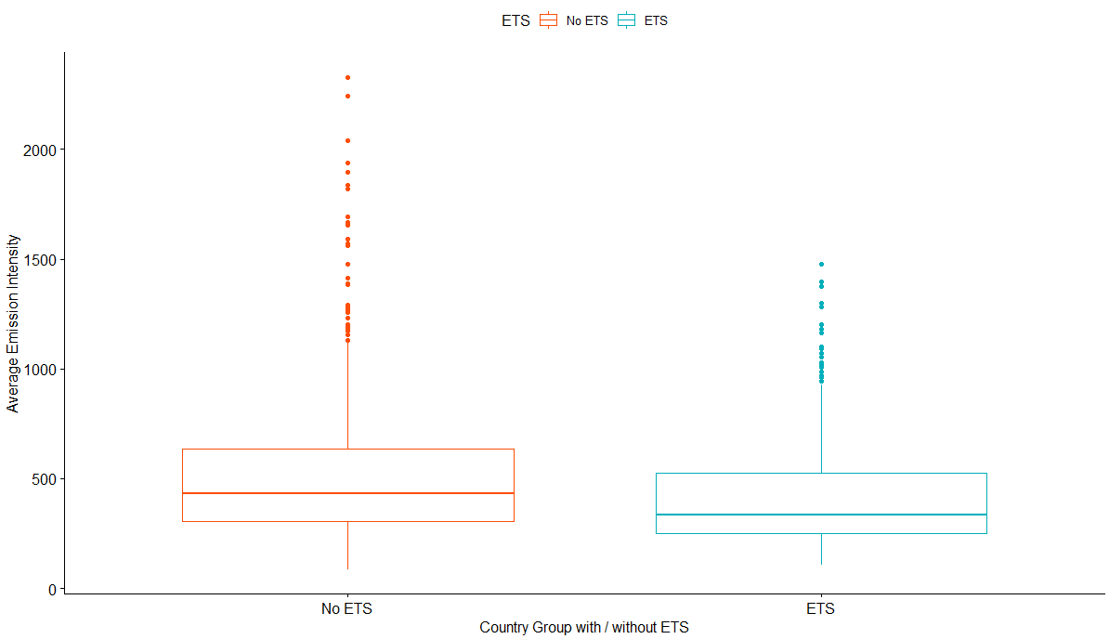

Figure 4. Boxplot of average emission intensity by a country group with/without carbon tax

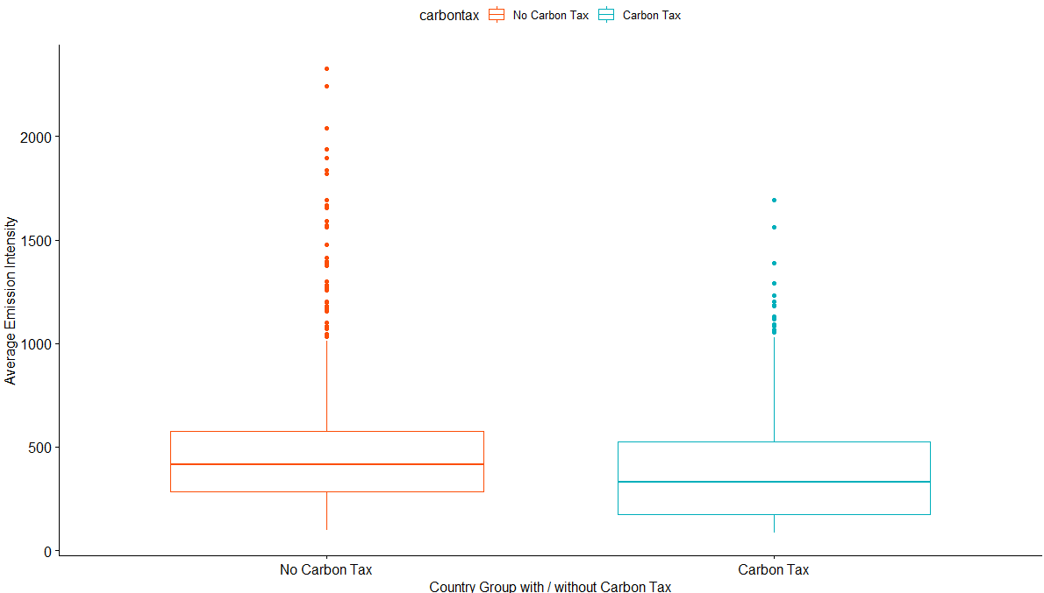

Table 3. Tukey Honest Significant Difference Test of emission intensity by country group

|  |  |  |
| --- | --- | --- |
|  | **Difference** | **Adjusted p-value** |
| **No ETS group – ETS group** | 124.606  [66.105, 183.107] | 0.000 |
| **No Tax group – Tax Group** | 80.893  [15.159, 146.627] | 0.0156 |

*Note*. Numbers in brackets indicate a 95% confidence interval. The difference is calculated by the average emission intensity of the no ETS/tax group *minus* the average emission intensity of the ETS/tax group.

Table 4.Descriptive statistics

|  |  |  |  |  |  |
| --- | --- | --- | --- | --- | --- |
| **Variable** | **Description** | **Mean** | **S.D.** | **(Min, Max)** | **Source** |
| ***Dependent Variables*** | | | | | |
| Emission Intensity | kgCO2eq / $1,000 of Real GDP (USD 2010 constant) | 499.67 | 359.86 | (85.52, 2327.52) | EEA[2] |
| GHG Emissions | Million tCO2eq | 186.20 | 239.47 | (3.64, 1154.42) | WDI[3] |
| ***Independent Variables*** | | | | | |
| Emission Trading | 1=implementation,  0=no implementation | .47 | .50 | (0, 1) | EEA |
| Carbon Tax | 1=implementation,  0=no implementation | .28 | .45 | (0, 1) | carbontax. org |
| ***Control Variables*** | | | | | |
| Carbon Intensity | kgCO2 per kg of oil equivalent | 2.23 | .65 | (.3, 3.44) | WDI |
| Electricity Inefficiency | A loss of electric power output in the transmission and distribution (%) | 8.32 | 4.51 | (1.82, 46.58) | WDI |
| Renewable | A percentage of renewable energy in final energy consumption | 18.12 | 15.83 | (.85, 77.35) | WDI |
| Fossil Fuel | A percentage of fossil fuel energy in final energy consumption | 71.78 | 20.13 | (10.26, 98.53) | WDI |
| Urbanization | A ratio of urban population to total population (%) | 71.30 | 11.32 | (49.66, 97.82) | WDI |
| GDP Growth Rate | Real GDP growth rate (%) | 2.55 | 3.54 | (-14.81, 11.89) | WDI |
| The Level of Democracy | Polity IV score | 9.44 | 1.42 | (-5, 10) | Polity IV |

**Table 4** presents the descriptive statistics of the panel data. To elicit the effect of carbon pricing in our analysis as much as possible, we included several control variables that may also affect decoupling. First, energy and electricity efficiency can promote decoupling (Dinda 2004). Therefore, we used carbon intensity and electricity inefficiency as control variables. Carbon intensity refers to the capacity of a society to produce less GHG emissions for a unit of energy use, calculated as kgCO2eq per kg oil equivalent. Electricity inefficiency refers to a loss of electric power in the process of its transmission and distribution, compared to the initial output (%). Next, decoupling can vary according to how the national energy mix is shaped (Harris and Lee 2017). Therefore, we also included the shares of renewable energy (%) and fossil fuel (%) in the national primary energy mix. The level of democracy is introduced to consider the impact of fairer elections and the degree of political participation on the environmental quality of a country (Farzin and Bond 2006). The urbanization rate is also included to control for its impact on environmental quality, in that cities are primary GHG emitters, not only globally but in Europe as well (Lee 2018). Finally, the GDP growth rate is included, due to the possibility that emission intensity may increase or decrease simply because the rate of GDP growth changes. We also report a correlation table for all variables in Appendix A.

We devised three models for the panel analysis. Models using emission intensity as a dependent variable are twofold. As we mentioned earlier, Iceland does not have a Polity IV score throughout the time span, so we first generate Model 1 to omit the Polity IV score as a control variable, to include all 30 countries. Next, Model 2 omits Iceland in the analysis, in order to include Polity IV as a control variable. Model 3 is the same as Model 1 except that it uses GHG emissions as a dependent variable. Model 3 is designed to test whether, and to what extent, carbon pricing policies and other covariates are associated with GHG emissions. Except for the abovementioned variables and panel units, all variables and units are included in each model.

**Result and Discussion**

Table 5 shows the results of the three models. We report the results of a Hausman test for Model 1 (p=.1737), Model 2 (p=.0049), and Model 3 (p=.9958). Admittedly, there is a growing concern that the result of a Hausman test should not be the sole reference to decide whether to use fixed or random effects (Bell et al 2019). However, we do not observe any significant difference in the estimation results between Model 1 and 2, for either a fixed or a random model. We report this result in Appendix B.

Confirming that the signs of the coefficients in Models 1 and 2 are not different from each other, a variable is understood to facilitate strong decoupling when it shows negative coefficients in both Models 1 and 3. A variable is interpreted to facilitate weak decoupling when it shows a negative coefficient in Model 1 (emission intensity as a dependent variable) but a positive one in Model 3 (GHG emissions as a dependent variable). When a variable has positive coefficients in both Models 1 and 3, it does not facilitate any type of decoupling.

Our analysis of the factors that influence the level of decoupling confirms our hypothesis that emission trading and carbon tax present different outcomes. Emission trading is negatively associated with emission intensity as well as GHG emissions. This shows that emission trading leads to strong decoupling. Using our previous example in Table 1, countries that adopted emission trading are more likely to resemble the case of country A rather than B. However, the implementation of carbon tax does not have a statistically significant impact on decoupling, as well as GHG reduction. This holds true even after taking into account cluster-robust variance estimators with the Satterthwaite degrees of freedom (Pustejovsky and Tipton 2018) in all panel models.

Table 5. Model Estimation Results

|  |  |  |  |
| --- | --- | --- | --- |
|  | **Model 1**  **Emission intensity** | **Model 2**  **Emission intensity** | **Model 3**  **GHG emissions** |
| Model | **Random Effect** | **Fixed Effect** | **Random Effect** |
| Emission Trading | -113.900**  (12.715) | -106.997**  (13.256) | -5.896*  (2.960) |
| Carbon Tax | -3.821  (25.071) | -40.295  (26.485) | -3.969  (6.909) |
| Carbon Intensity | 125.954*  (60.948) | 94.790  (70.849) | -29.669  (15.780) |
| Electricity Inefficiency | 17.732**  (2.222) | 16.074**  (2.233) | -1.789**  (.472) |
| Renewable | -11.550**  (2.120) | -16.812**  (2.356) | -2.134**  (.509) |
| Fossil Fuel | -7.962**  (2.244) | -8.022**  (2.689) | 1.711**  (.597) |
| Democracy | - | -21.301**  (4.232) | - |
| Urbanization | 0.924  (2.590) | 5.300  (3.026) | 1.174*  (.679) |
| Economic Growth | -3.133*  (1.429) | -3.313*  (1.405) | .305  (.315) |
| *Intercept* | 848.860**  (256.827) | - | 102.653  (76.746) |
| *N X T* | 30 X 19 | 29 X 19 | 30 X 19 |
| *Adj. R2* | .4410 | .5159 | .2026 |
| *Hausman Test* | p=.1737 | p=.0049 | p=.9958 |
| Note: Adjusted *R2* is reported. Standard errors are reported in parentheses. | | | |
| *- p<.05; **-p<.01 | | | |

This may reflect the different policy designs of carbon pricing, as we discussed above in the theory section. There are pitfalls of emission trading, including price volatility, complex or flawed system design, mistakes in allocation, hardships in implementation and monitoring, and linkage to other emission trading markets (Schneider et al 2017). However, our findings lend support to the conclusion that emission trading is an effective carbon pricing system for large GHG emitters to cap their amount of total emissions, lower emissions from each participant, and trade credits in a cost-effective manner. As existing research has identified, participants of emission trading have incentives to reduce GHG with lower costs and innovative technologies (Boyce 2018; Haites 2018; Rogge and Hoffman 2010). Unlike emission trading, carbon tax has been put on both households and firms (Jenkins 2014; Lundgren et al 2015). Given the lower level of elasticity and innovation in the household energy sector (each household has flexibility on the small scale but there are a number of households), carbon tax may not be associated with the reduction of GHG emissions. Furthermore, as with different types of taxes, carbon tax not only makes the direct emission of GHGs more costly, but also makes indirect emission (for example, energy consumption) more costly, the latter of which is essential for promoting domestic gross production of goods and services. Therefore, the results presented here meet our expectation that carbon tax may not promote decoupling trends.

Among the other control variables, as expected, renewable energy adoption reveals a strong decoupling factor. A higher percentage of renewable energy in final energy consumption accounts for a lower energy intensity, and therefore said country will emit less GHG emissions. This finding suggests that the renewable energy transition across the EU, and within the EU the country level, is an effective measure for strong decoupling. Compared to renewable energy, the adoption of fossil fuels presents weak decoupling. Fossil fuel adoption tends to increase GDP, which is the denominator of the emission intensity. This may lead to a decrease in emission intensity. However, in Model 3, stronger adoption of fossil fuels in the energy mix is positively associated with GHG emissions. In a similar vein, economic growth rate presents a negative association with emission intensity but no statistically significant effect on GHG emissions. This implies that economic growth and fossil fuel usage beget weak decoupling, but not strong decoupling, in which the actual GHG emissions reduce.

Next, we examine whether our result for the effect of emission trading in decoupling is robust. We focus on the fact that 25 out of 30 countries in our data introduced emission trading (EU-ETS) in 2005. This enables us to regard the introduction of emission trading as a policy intervention, and therefore estimate its effect on emission intensity, all else being equal. Therefore, we check if the effect of emission trading in decoupling is significant by estimating it with the longitudinal pre-post quasi-experimental design (Leatherdale 2018). This design enables us to estimate the implementation of emission trading by comparing the treatment and control groups.

Inarguably, the adoption of emission trading is not randomly assigned across countries. To overcome this obstacle, we attempt to make the treatment and control group as identical as possible by using Coarsened Exact Matching (CEM) (Iacus et al 2012). CEM enables us to match the means and distributions of control variables between two country-year groups, except for the presence of emission trading. The observed variables we use for matching are the same as in our previous models, including carbon tax as a binary variable. Through matching, 304 country-years without emission trading are reduced to 70 (control group), whereas 266 country-years with emission trading are reduced to 44 (treatment group). We use this matching result to estimate the mean difference of emission intensity between two groups, which is summarized in Table 6.

Table 6. The mean difference of emission intensity on CEM matched data

|  |  |
| --- | --- |
| **Model** | **Mean difference** |
| Linear regression  (no control variables) | -61.366  [-186.573, 63.8415] |
| Linear regression  (with control variables) | -26.644  [-109.813, 56.524] |
| Linear random effect model  (with control variables) | -38.590  [-42.988, -34.193] |

* 95% confidence interval is shown in parentheses.

The mean difference of emission intensity on CEM matched data is negative and significant only in the linear random effect model (-38.590). This suggests that if we reduce the model dependence, our data analysis confirms the effect of emission trading on decoupling only if we assume a non-homogeneous treatment effect. That is, although emission trading in our data exhibits a similar design across countries (EU-ETS), its effect on decoupling might vary depending on the country-level contexts. For instance, some countries may have more energy-intensive industry sectors in their national economy while others may not, which may lead to the different impact of even the same EU-ETS on decoupling trends. This necessitates future research into the relationship between decoupling and a carbon pricing, which should consider how not only carbon pricing in general, but specifically emission trading, works differently between different countries.

**Conclusion**

Decoupling is the target for countries that aim to both achieve economic growth and reduce their GHG emissions. However, not all countries are achieving decoupling. The analysis outcomes presented here suggest that countries that practice both emission trading and renewable energy adoption are likely to achieve strong decoupling. Countries with a high economic growth rate but practice fossil fuel adaption may achieve weak decoupling, as they achieve a lower emission intensity due to their higher GDP growth. However, using more fossil fuel in energy consumption inherently increases GHG emissions.

This study contributes to the literature of the political economy of climate change, particularly decoupling and carbon pricing literature, by posing questions regarding the variation in decoupling between different European countries. Theoretically, we propose a causal relationship between carbon pricing policies and decoupling. Carbon pricing was originally designed and implemented to reduce GHG emissions in an efficient manner (Tietenberg 2013). Market-based mechanisms grounded in carbon pricing facilitate innovation to mitigate climate impacts (Jenkins 2014). In agreement with extant studies of the impact of emission trading on environmental efficacy, this study finds that the adoption of emission trading is a driver for decoupling. Empirically, by using panel data analysis with a series of model specifications, this study tests this theoretical argument for European cases. Compared to existing literature with a focus on a specific country, an industrial sector, or a company, the time-series and cross-section data analysis presented here empirically covers all European countries, across a time period of nineteen years. Based on theoretical and empirical contributions, this study suggests that adopting emission trading is likely to achieve strong decoupling. Increasing the adoption of renewable energy in the energy mix is also an effective measure for lowering emission intensity, as well as GHG emissions. In addition, our estimation with CEM-matched data suggests that similar designs of emission trading may have different but positive impacts on decoupling across countries.

Despite the above contributions, future research would strengthen decoupling studies. Our result suggests that not all carbon pricing policies encourage decoupling. The utilization of sophisticated measures with stringency and prices for carbon pricing policy may result in nuanced outcomes regarding carbon pricing effects. Above all, we point to the weakness of carbon tax for promoting decoupling, when compared to emission trading. Future studies could explore the different policy components of carbon tax, and how their presence varies its estimated effect on decoupling. Empirically, extending this analysis to other regions and countries would generalize the suggested findings. This would be specifically beneficial for those countries to design and implement carbon pricing policies to promote economic growth, as well as reduce GHG emissions.

**References**

Andreoni, Valeria, and Stefano Galmarini. 2012. Decoupling Economic Growth from Carbon Dioxide Emissions: A Decomposition Analysis of Italian Energy Consumption. *Energy* 44 (1): 682-691.

Allan, Grant, Patrizio Lecca, Peter McGregor, and Kim Swales. 2014. The Economic and Environmental Impact of a Carbon Tax for Scotland: A Computable General Equilibrium Analysis. *Ecological Economics* 100:40-50.

Bell, Andrew, Malcom Fairbrother, and Kelvyn Jones. 2019. Fixed and Random Effects Models: Making an Informed Choice. *Quality & Quantity* 53 (2): 1051-1074.

Boyce, James K. 2018. Carbon Pricing: Effectiveness and Equity. *Ecological Economics* 150 52-61.

Baranzini, Andrea, José Goldemberg, and Stefan Speck. 2000. A Future for Carbon Taxes. *Ecological Economics* 32 (3): 195-412.

Clulow, Zeynep. 2016. When Does Economic Development Promote Mitigation and Why? *Climate Policy* 18 (2): 221-234.

Damonte, Alessia. 2014. Policy Tools for Green Growth in the EU15: A Qualitative Comparative Analysis. *Environmental Politics* 23 (1): 18-40.

Dinda, Soumyananda. 2004. Environmental Kuznets Curve Hypothesis: A Survey. *Ecological Economics* 49 (4): 431-455.

Farzin, Y. Hossein, and Craig A. Bond. 2006. Democracy and Environmental Quality. *Journal of Development Economics* 81 (1): 213-235.

Ferguson, Peter. 2014. The Green Economy Agenda: Business as Usual or Transformational Discourse? *Environmental Politics* 24 (1): 17-37.

Haites, Erik. 2018. Carbon Taxes and Greenhouse Gas Emissions Trading Systems: What Have We Learned? *Climate Policy* 18 (8): 955-966.

Harris, Paul G., and Taedong Lee. 2017. Compliance with Climate Change Agreements: The Constraints of Consumption. *International Environmental Agreements: Politics, Law and Economics* 17 (6): 779-794.

Iacus, Stefano M., Gary King, and Giuseppe Porro. 2012. Causal Inference without Balance Checking: Coarsened Exact Matching. *Political Analysis* 20 (1): 1-24.

Jenkins, Jesse D. 2014. Political Economy Constraints on Carbon Pricing Policies: What Are The Implications for Economic Efficiency, Environmental Efficacy, and Climate Policy Design? *Energy Policy* 69: 467-477.

Jorgenson, Andrew K., and Brett Clark. 2012. Are the Economy and the Environment Decoupling? A Comparative International Study, 1960-2005. *American Journal of Sociology* 118 (1): 1-44.

Keohane, Nathaniel O., Robert N. Stavins, and Richard L. Revesz. 1999. The Positive Political Economy of Instrument Choice in Environmental Policy. In *Environmental and Public Economics: Essays in Honor of Wallace E. Oates,* edited by Wallace E. Oates, Arvind Panagariya, Paul R. Portney and Robert M. Schwab. 89–125. London, UK: Edward Elgar, Ltd.

Lederer, Markus. 2017. Carbon Trading: Who Gets What, When and How? *Global Environmental Politics* 17 (3): 134-140.

Lee, Taedong. 2018. Local Energy Agencies and Cities' Participation in Translocal Climate Governance. *Environmental Policy and Governance* 28(3): 131-140.

Löfgren, Åsa, Markus Wråke, Tomas Hagberg, and Susanna Roth. 2014. Why the EU ETS Needs Reforming: An Empirical Analysis of the Impact on Company Investments. *Climate Policy* 14 (5): 537-558.

Lundgren, Tommy, Per-Olov Marklund, Eva Samakovlis, and Wenchao Zhou. 2015. Carbon Prices and Incentives for Technological Development. *Journal of Environmental Management* 150: 393-403.

Mascher, Sharon. 2018. Striving for Equivalency Across the Alberta, British Columbia, Ontario and Québec Carbon Pricing Systems: the Pan-Canadian Carbon Pricing Benchmark. *Climate Policy* 18 (8): 1012-1027.

Meng, Sam, Mahinda Siriwardana, and Judith McNeill. 2013. The Environmental and Economic Impact of the Carbon Tax in Australia. *Environmental and Resource Economics* 54 (3): 313-332.

Mo, Jian-Lei, Paolo Agnolucci, Mao-Rong Jiang, and Ying Fan. 2016. The Impact of Chinese Carbon Emission Trading Scheme (ETS) on Low Carbon Energy (LCE) Investment. *Energy Policy* 89: 271-283.

Mol, Arthur P. J. 2002. Ecological Modernization and the Global Economy. *Global Environmental Politics* 2 (2): 92-115.

Perdan, Slobodan, and Adisa Azapagic. 2011. Carbon Trading: Current Schemes and Future Developments. *Energy Policy* 39 (10): 6040-6054.

Pustejovski, James E., and Elizabeth Tipton. 2018. Small-Sample Methods for Cluster-Robust Variance Estimation and Hypothesis Testing in Fixed Effects Models. *Journal of Business & Economic Statistics* 36 (4): 672-683.

Reilly, John. 2013. Achieving a Low Carbon Society. *Climate Policy* 13 (S1): S155-S158.

Rogge, Karoline S., and Volker H. Hoffmann. 2010. The Impact of the EU ETS on the Sectoral Innovation System for Power Generation Technologies – Findings for Germany. *Energy Policy* 38 (12): 7639-7652.

Rogge, Karoline S., Malte Schneider, and Volker H. Hoffmann. 2011. The Innovation Impact of the EU Emission Trading System — Findings of Company Case Studies in the German Power Sector. *Ecological Economics* 70 (3): 513-523.

Sandoff, Anders, and Gariela Schaad. 2009. Does EU ETS Lead to Emission Reductions Through Trade? The Case of the Swedish Emissions Trading Sector Participants. *Energy Policy* 37 (10): 3967-3977.

Schneider, Lambert, Michael Lazarus, Carrie Lee, and Harro van Asselt. 2017. Restricted Linking of Emissions Trading Systems: Options, Benefits, and Challenges. *International Environmental Agreements: Politics, Law and Economics* 17 (6): 883-898.

Stavins, Robert N. 1998. What Can We Learn from the Grand Policy Experiment? Lessons from SO2 Allowance Trading. *Journal of Economic Perspectives* 12 (3): 69-88.

Appendix A. Table of correlation between variables used in Model 2 and its p-value (95% confidence interval)

A1. Correlation Table

|  |  |  |  |  |  |  |  |  |  |  |
| --- | --- | --- | --- | --- | --- | --- | --- | --- | --- | --- |
|  | Emission Intensity | Emission Trading | Carbon Tax | Carbon Intensity | Electric Inefficiency | Renewable  Energy | Fossil  Fuel | Urbanization Rate | GDP  Growth Rate | Level of Democracy |
| Emission Intensity | 1 | -0.17695 | -0.05097 | 0.420751 | 0.414343 | -0.23797 | 0.053781 | -0.3697 | 0.25253 | -0.27898 |
| Emission Trading | -0.17695 | 1 | 0.090104 | -0.08547 | -0.23708 | 0.087949 | -0.07789 | 0.092058 | -0.30162 | 0.149109 |
| Carbon  Tax | -0.05097 | 0.090104 | 1 | -0.14231 | -0.00295 | 0.535098 | -0.42006 | 0.099966 | 0.084892 | 0.08103 |
| Carbon Intensity | 0.420751 | -0.08547 | -0.14231 | 1 | 0.079184 | -0.53334 | 0.611294 | -0.29632 | 0.152756 | -0.04607 |
| Electric Inefficiency | 0.414343 | -0.23708 | -0.00295 | 0.079184 | 1 | 0.190615 | -0.03355 | -0.30173 | 0.219523 | -0.48347 |
| Renewable  Energy | -0.23797 | 0.087949 | 0.535098 | -0.53334 | 0.190615 | 1 | -0.60841 | 0.030146 | -0.07306 | -0.10136 |
| Fossil  Fuel | 0.053781 | -0.07789 | -0.42006 | 0.611294 | -0.03355 | -0.60841 | 1 | -0.18113 | 0.017409 | 0.053058 |
| Urbanization Rate | -0.3697 | 0.092058 | 0.099966 | -0.29632 | -0.30173 | 0.030146 | -0.18113 | 1 | -0.19171 | 0.183174 |
| GDP Growth Rate | 0.25253 | -0.30162 | 0.084892 | 0.152756 | 0.219523 | -0.07306 | 0.017409 | -0.19171 | 1 | -0.1205 |
| Level of Democracy | -0.27898 | 0.149109 | 0.08103 | -0.04607 | -0.48347 | -0.10136 | 0.053058 | 0.183174 | -0.1205 | 1 |

A2. P-Value Table

|  |  |  |  |  |  |  |  |  |  |  |
| --- | --- | --- | --- | --- | --- | --- | --- | --- | --- | --- |
|  | Emission Intensity | Emission Trading | Carbon Tax | Carbon Intensity | Electric Inefficiency | Renewable  Energy | Fossil  Fuel | Urbanization Rate | GDP  Growth Rate | Level of Democracy |
| Emission Intensity |  | 0 | 0.232 | 0 | 0 | 0 | 0.208 | 0 | 0 | 0 |
| Emission Trading | 0 |  | 0.034 | 0.045 | 0 | 0.039 | 0.068 | 0.031 | 0 | 0 |
| Carbon  Tax | 0.232 | 0.034 |  | 0.001 | 0.945 | 0 | 0 | 0.019 | 0.046 | 0.057 |
| Carbon Intensity | 0 | 0.045 | 0.001 |  | 0.063 | 0 | 0 | 0 | 0 | 0.28 |
| Electric Inefficiency | 0 | 0 | 0.945 | 0.063 |  | 0 | 0.432 | 0 | 0 | 0 |
| Renewable  Energy | 0 | 0.039 | 0 | 0 | 0 |  | 0 | 0.48 | 0.087 | 0.017 |
| Fossil  Fuel | 0.208 | 0.068 | 0 | 0 | 0.432 | 0 |  | 0 | 0.683 | 0.214 |
| Urbanization Rate | 0 | 0.031 | 0.019 | 0 | 0 | 0.48 | 0 |  | 0 | 0 |
| GDP Growth Rate | 0 | 0 | 0.046 | 0 | 0 | 0.087 | 0.683 | 0 |  | 0.005 |
| Level of Democracy | 0 | 0 | 0.057 | 0.28 | 0 | 0.017 | 0.214 | 0 | 0.005 |  |

Appendix B. Estimation Results of Both the Fixed and Random Effects for Model 1 and 2

|  |  |  |  |  |  |
| --- | --- | --- | --- | --- | --- |
|  | **Model 1**  **Emission intensity** | | **Model 2**  **Emission intensity** | | **Model 3**  **GHG emissions** |
| Model | **Fixed** | **Random** | **Fixed** | **Random** | **Random Effect** |
| ETS | -119.208**  (13.509) | -113.900**  (12.715) | -106.997**  (13.256) | -102.500**  (12.727) | -5.896*  (2.960) |
| Carbon Tax | -4.896  (25.342) | -3.821  (25.071) | -40.295  (26.485) | -33.840  (26.176) | -3.969  (6.909) |
| Carbon Intensity | 71.620  (72.650) | 125.954*  (60.948) | 94.790  (70.849) | 141.076*  (59.838) | -29.669  (15.780) |
| Electricity Inefficiency | 17.051**  (2.277) | 17.732**  (2.222) | 16.074**  (2.233) | 16.792**  (2.192) | -1.789**  (.472) |
| Renewable | -12.472**  (2.341) | -11.550**  (2.120) | -16.812**  (2.356) | -15.464**  (2.164) | -2.134**  (.509) |
| Fossil Fuel | -6.820*  (2.755) | -7.962**  (2.244) | -8.022**  (2.689) | -8.713**  (2.209) | 1.711**  (.597) |
| PolityIV | - | - | -21.301**  (4.232) | -21.413**  (4.239) | - |
| Urbanization | 4.460  (3.126) | 0.924  (2.590) | 5.300  (3.026) | 1.342  (2.584) | 1.174*  (.679) |
| Economic Growth | -3.003*  (1.431) | -3.133*  (1.429) | -3.313*  (1.405) | -3.433*  (1.408) | .305  (.315) |
| *Intercept* | - | 848.860**  (256.827) | - | 1108.123  (254.388) | 102.653  (76.746) |
| *N X T* | 30 X 19 | | 29 X 19 | | 30 X 19 |
| *Adj. R2* | .4228 | .4410 | .5159 | .4939 | .2026 |
| *Hausman Test* | p=.1737 | | p=.0049 | | p=.9958 |
| Note: Adjusted *R2* is reported. Standard errors are reported in parentheses. | | | | | |
| *- p<.05; **-p<.01 | | | | | |

1. We report the result of a one-way ANOVA test as follows: Between ETS and non-ETS groups, the sum of squares (SS) was 2,202,703 (P-value: .000), and between carbon tax and non-carbon tax groups, SS was 750,210 (P-value: .016). A relatively high SS is attributed to a high variance in our dependent variable, emission intensity, which is shown in Table 4.
2. European Environmental Agency.

   **URL**: <https://www.eea.europa.eu/data-and-maps/data/data-viewers/greenhouse-gases-viewer>
3. World Developmental Indicators.

   **URL**: [http://databank.worldbank.org/data/source/world-development-indicators#](http://databank.worldbank.org/data/source/world-development-indicators)