Nama : Siti Masitoh

NPM : 065118184

Kelas : O (Ekstensi)

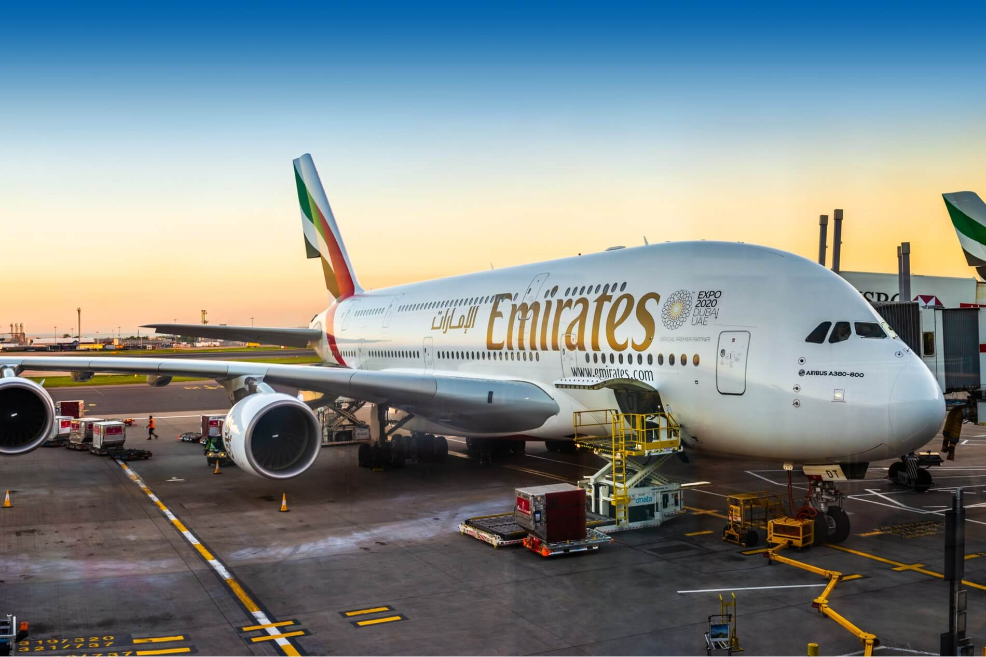

**Emirates**

IATA Code : EK

Base in : Dubai Interantional Airport – Uni Emirate Arab

Fleet : 257 passenger + 12 cargo

Route : 158 International flight

**Emirates** is an international airline. It is the largest airline in, and also the [flag carrier](https://en.wikipedia.org/wiki/Flag_carrier) of, the [United Arab Emirates](https://en.wikipedia.org/wiki/United_Arab_Emirates). Based in [Garhoud](https://en.wikipedia.org/wiki/Al_Garhoud" \o "Al Garhoud), [Dubai](https://en.wikipedia.org/wiki/Dubai), the airline is a subsidiary of [The Emirates Group](https://en.wikipedia.org/wiki/The_Emirates_Group), which is owned by the [government of Dubai](https://en.wikipedia.org/wiki/Government_of_Dubai)'s [Investment Corporation of Dubai](https://en.wikipedia.org/wiki/Investment_Corporation_of_Dubai). It is also the largest airline in the [Middle East](https://en.wikipedia.org/wiki/Middle_East), operating over 3,600 flights per week from its hub at [Terminal 3](https://en.wikipedia.org/wiki/Dubai_International_Airport_Terminal_3) of [Dubai International Airport](https://en.wikipedia.org/wiki/Dubai_International_Airport) before the [COVID-19 pandemic](https://en.wikipedia.org/wiki/COVID-19_pandemic). It operates to more than 150 cities in 80 countries across six continents through its fleet of nearly 300 aircraft.[[5]](https://en.wikipedia.org/wiki/Emirates_(airline)#cite_note-5) Cargo activities are undertaken by [Emirates SkyCargo](https://en.wikipedia.org/wiki/Emirates_SkyCargo).

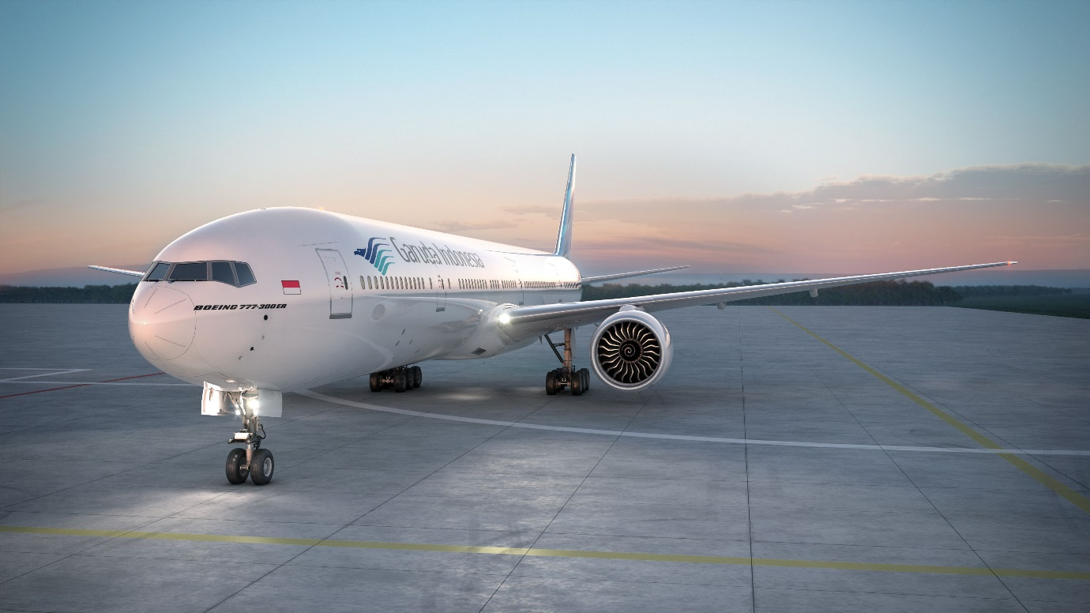

**Garuda Indonesia**

IATA Code : GA

Base in : Soekarno Hatta Interantional Airport – Indonesia

Fleet : 147 passenger + 4 cargo

Route : 69 Domestic flight + 22 International flight

**Garuda Indonesia** (operating as **Garuda Indonesia**, formerly **Garuda Indonesian Airways**) is the [flag carrier](https://en.wikipedia.org/wiki/Flag_carrier) of [Indonesia](https://en.wikipedia.org/wiki/Indonesia), headquartered at [Soekarno–Hatta International Airport](https://en.wikipedia.org/wiki/Soekarno%E2%80%93Hatta_International_Airport" \o "). A successor of [KLM Interinsulair Bedrijf](https://en.wikipedia.org/wiki/KLM_Interinsulair_Bedrijf), it is a member of [SkyTeam](https://en.wikipedia.org/wiki/SkyTeam" \o "SkyTeam) and the second-largest [airline of Indonesia](https://en.wikipedia.org/wiki/List_of_airlines_of_Indonesia) after [Lion Air](https://en.wikipedia.org/wiki/Lion_Air), operating scheduled flights to [a number of destinations](https://en.wikipedia.org/wiki/List_of_Garuda_Indonesia_destinations) across Asia, Europe, and Australia from its hubs, focus cities, as well as other cities for [Hajj](https://en.wikipedia.org/wiki/Hajj). It is the only Indonesian airline that flies to the European airspace.

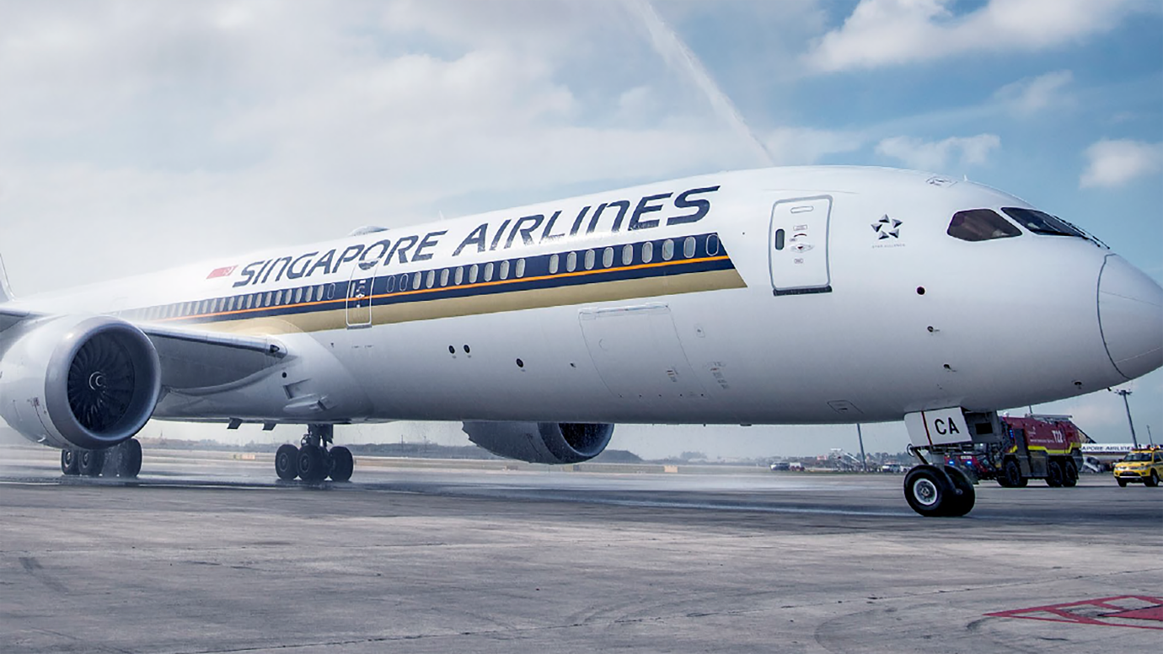

**Singapore Airlines**

IATA Code : SQ

Base in : Changi Interantional Airport – Singapore

Fleet : 153 passenger + 7 cargo

Route : 62 International flight

**Singapore** is the [flag carrier](https://en.wikipedia.org/wiki/Flag_carrier) [airline](https://en.wikipedia.org/wiki/Airline) of [Singapore](https://en.wikipedia.org/wiki/Singapore) with its [hub](https://en.wikipedia.org/wiki/Airline_hub) at [Singapore Changi Airport](https://en.wikipedia.org/wiki/Singapore_Changi_Airport). The airline is notable for using the [Singapore Girl](https://en.wikipedia.org/wiki/Singapore_Girl) as its central figure in corporate branding. It has been ranked as the world's best airline by [Skytrax](https://en.wikipedia.org/wiki/Skytrax" \o "Skytrax) four times and topped [*Travel & Leisure*](https://en.wikipedia.org/wiki/Travel_%26_Leisure)'s best airline rankings for more than 20 years.