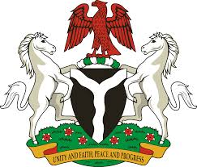
Certificate No:
Validity Period

FEDERAL MINISTRY OF INDUSTRY, TRADE AND INVESTMENT
WEIGHTS AND MEASURES DEPARTMENT
Old Federal Secretariat, Area 1, Garki, Abuja.
Website: www.wmdnigeria.com Email: metrology@wmdnigeria.com Tel: 092915722

This is to certify that …………………………………………………………………………………………has been duly appointed by the Weights and Measures Department as an Authorized Verifier (AV) in line with Section 7(3) of the Weights and Measure ACT CAP W3 LFN, 2004 to carryout verification of Weights, Measures, Weighing and Measuring Instrument(s) use for trade in………………………………………………State of the Federal Republic of Nigeria.
CERTIFICATE OF AUTHORIZATION AS A VERIFIER

______________________________
Director
Weights and Measures Department

