Different implementations of the wake condition are compared and contrasted.

The possibilities are:

- Cutting or not cutting the wake elements

- Moving the trailing edge (and the rest of the nodes laying on the wake) up or down

- How many Kutta elements are needed:
  - zero (leads ill-conditioned system)
  - only element touching the airfoil
  - all wake elements touching the trailing edge (original implementation)
  - all the elements touching the trailing edge

- Applying or not the penalty
  - Applying the penalty only on the kutta elements
  - Applying the penalty on the neighbourhood of the trailing edge

- Including a trailing edge element or not

The files that need to be changed for each implementation are the element and the wake process. That means, each implementation involves a different element or wake process or both.

All implementations are in branch: cps/wake_implementations.

Implementations:

1. wake_implementation_01_cutting_no_penalty_TE_up

2. wake_implementation_02_cutting_no_penalty_TE_down

3. wake_implementation_03_no_cutting_no_penalty_TE_up

4. wake_implementation_04_no_cutting_no_penalty_TE_down

5. wake_implementation_05_no_cutting_no_penalty_no_Kutta_TE_up

6. wake_implementation_06_no_cutting_no_penalty_no_Kutta_TE_down

7. wake_implementation_07_no_cutting_no_penalty_one_Kutta_TE_up

8. wake_implementation_08_no_cutting_no_penalty_one_Kutta_TE_down

9. wake_implementation_09_no_cutting_no_penalty_half_Kutta_TE_up

10. wake_implementation_10_no_cutting_no_penalty_half_Kutta_TE_down

11. wake_implementation_11_no_airfoil_TE_up

12. wake_implementation_12_no_airfoil_TE_down

13. wake_implementation_13_no_te_TE_up

14. wake_implementation_14_no_te_TE_down

11. wake_implementation_11_no_cutting_no_penalty_new_TE_element_TE_up

12. wake_implementation_09_no_cutting_no_penalty_new_TE_element_TE_down

Preliminary observations based on preliminary computations up to 13.11.208 (to be double checked within the new automatic workflow):

- Cutting or not cutting the elements:
  - Cutting the elements leads to:
    - A wrong far field at the outlet
    - A large condition number
    - Wrong pressure distribution
  - Not cutting the elements leads to:
    - A wrong pressure distribution (correction from 13.11.2018: actually the wrong pressure distribution is observed also when cutting the elements. TODO: find the way of always getting the right pressure distribution)

Results

What to look at in the solution:

- Convergence of cl towards the reference solution (xfoil)
- Convergence of the relative error of cl
- Convergence of cd towards 0°
- Far-field velocity values
- Pressure distribution
- Kutta condition
- Condition number
- Constant potential jump along the wake (linear convection equation for the potential jump across the wake).
- Linear dependency of cl with the angle of attack
- Convergence of the relative error in the energy norm (TODO discuss this. Is it really done properly? Should I check just the convergence of the norm of the solution?)

1. wake_implementation_01_cutting_no_penalty_TE_up

Short description:

This is the original implementation from Riccardo as described in the paper: “A cut finite element method for the solution of the full-potential equation with an embedded wake”.

There are basically three types of elements:

- Normal laplacian elements: these are all of the elements in the domain except for the ones cut by the wake.

- Embedded wake elements where the wake condition is applied: these are all the elements cut by the wake except for the ones containing (or touching) the trailing edge node.

- Embedded kutta wake elements: these are typically 3 elements that are cut by the wake and are containing (or touching) the trailing edge node. In this elements the wake condition is not applied

Sometimes it can also be 4 or 5 elements, depending on how the mesh looks like in the sorroundings of the trailing edge. In the results we will see that this actually plays a mayor role in the results.

Observations:

1. Convergence of cl towards the reference solution (xfoil)

- Does not converge
- There are jumps
- The cl computed integrating the pressure and from the potential jump only coincides for AOA = 0°

Important observation:

For large angles of attack (i.e. 11, 12, 13, 14 and 15), the jumps correlate with the meshes that have 6 elements around the TE. Moreover, for all angles of attack all of the meshes with 6 elements and the node down lead to peaks.

There are three types of meshes around the trailing edge:

Reverse order: blue
In bold the peaks of cl are indicated

1. Almost all of the meshes have 5 elements
2. Some have 6 elements with a node above the wake
3. Some have 6 elements with a node under the wake

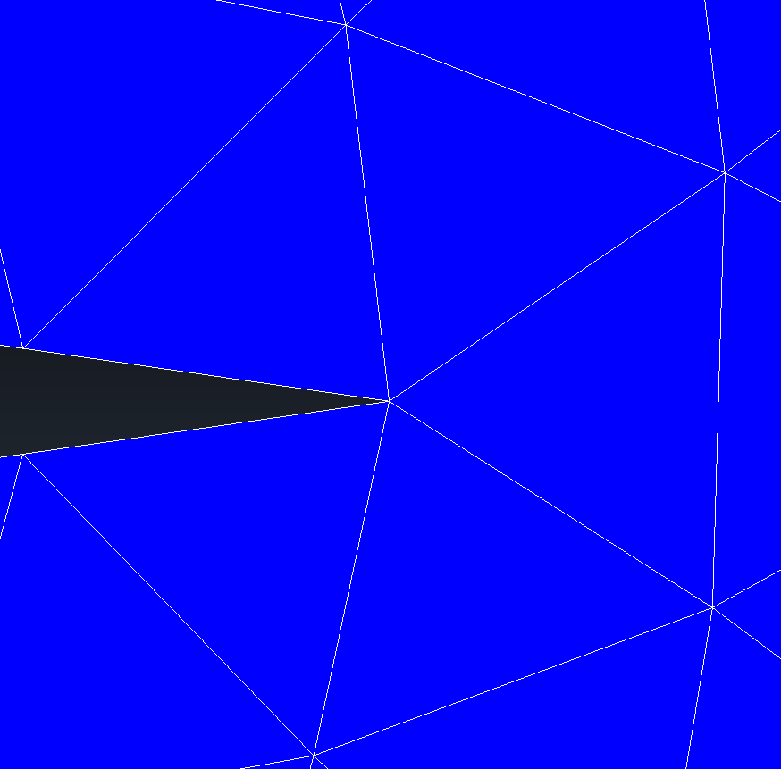
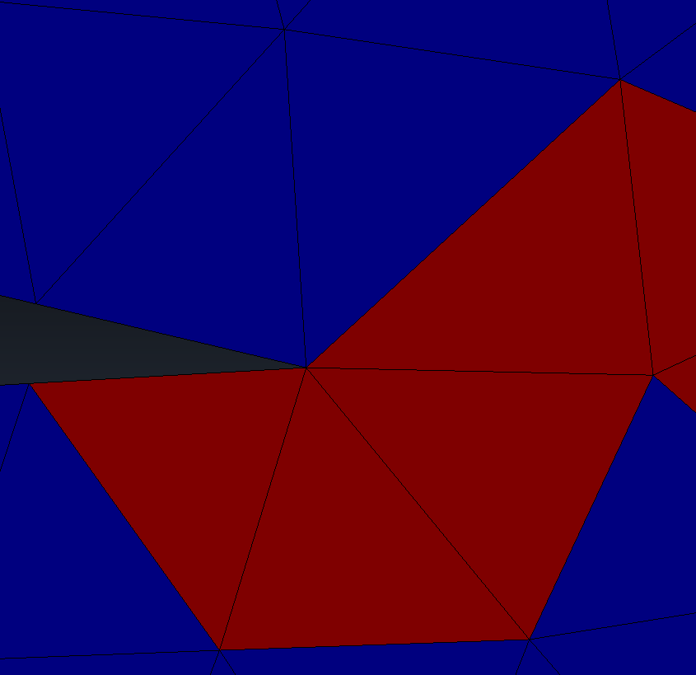
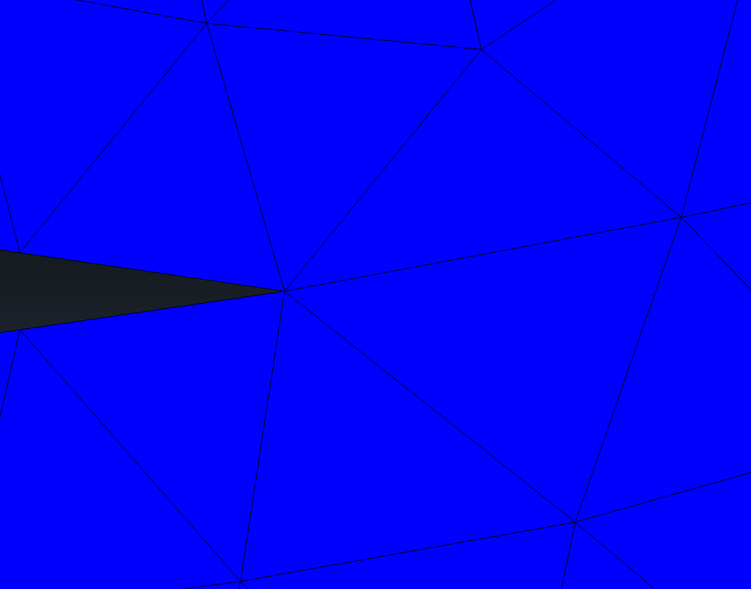

5 elements 6 elements node above 6 elements node down

AOA | 5 elements | 6 elements node moved up | 6 elements node moved down | Cp with crossing
0 | 0, 1, 2, 4, 5, 6, 7, 8 | 3 | none
1 | 9, 10, 11, 12, 13, 14, 15, 16, 17 | none | none
2 | 18, 19, 23, 24, 25, 26 | 22, 21, 20 | none | 24
3 | 27, 28, 29, 30, 34, 35 | 31, 32, 33 | none | 34
4 | 36, 37, 38, 39, 41, 42, 43, 44 | 40 | none
5 | 45, 46, 47, 48, 50, 51, 52, 53 | none | 49 | 49
6 | 54, 55, 56, 57, 60, 61, 62 | none | 58, 59 | 58, 59
7 | 63, 64, 65, 67, 68, 69, 70, 71 | 66 | none
8 | 74, 77, 78, 79 | 72, 73, 75, 76, 80 | none
9 | 81, 82, 83, 84, 85, 86, 88, 89 | none | 87 | 87
10 | 90, 91, 92, 93, 94, 95, 96, 97, 98 | None | None | 96
11 | 99, 100, 101, 103, 104, 105, 106, 107, 108 | none | 102 | 102
12 | 108, 109, 110, 112, 113, 115, | none | 111, 114, 116 | 111, 114, 116
13 | 117, 118, 119, 120, 121, 123, 124, 125 | none | 122 | 122
14 | 126, 127, 128, 129 130, 132, 133, | none | 134, 131 | 131, 134
15 | 135, 136, 137, 138, 139, 140, 142, 143 | none | 141 | 141

2. Convergence of the relative error of cl:

Idem

3. Convergence of cd towards 0°

- In general it does not converge (it presents jumps).
- For angles of attack 0, 1 and 2 the convergence behavior looks promising.
- It has an order of magnitude of 10⁻³ in most of the cases, in two cases (aoas 4 and 5) 10⁻⁴ and in one case (aoa 14) 10⁻².

Cd order of magnitud | 10⁻² | 10⁻³ | 10⁻⁴
AOA | 14 | 0, 1, 2, 3, 6, 7, 8, 9, 10, 11, 12, 13, 15 | 4, 5

4. Far-field velocity values:

- At the outlet the element touching the wake presents a wrong solution
- For increasing angle of attack one should make the domain wider (one should find a relation how wide should the domain be)

5. Pressure distribution and 6. Kutta condition:

- For some cases there is a crossing: 24, 34, 49, 58, 59...(look table above) These cases correspond to the cases where there are peaks on the cl.

7. Condition number:

Smallest: 5.71e+05
Largest: 2.33e+09

8. Constant potential jump along the wake (linear convection equation for the potential jump across the wake).

The potential jump is constant along the wake, but for the first elements. There are always 6 elements where the wake condition is not applied. This appears to be normal for the three elements touching the TE, where the wake condition is not applied. But why does it happen for the next three too?

9. Linear dependency of cl with the angle of attack:
The cl is linear with the AOA but for a kinck observed for AOA = 7°.

10. Convergence of the relative error in the energy norm (TODO discuss this. Is it really done properly? Should I check just the convergence of the norm of the solution?)

No convergence observed.

2. wake_implementation_02_cutting_no_penalty_TE_down

Short description:

Same as implementation 01 but with the TE (and the rest of the nodes laying on the wake) moved down.

Observations:

1. Convergence of cl towards the reference solution (xfoil) and
2. Convergence of the relative error of cl:

Same as in implementation 01. (this is interesting because some times moving the TE up or down was leading to a convergence from above or from below, lets check the rest of the branches)

3. Convergence of cd towards 0°

- For small angles of attack the values are surprisingly better than in implementation 01. Why?

Cd order of magnitud | 10⁻² | 10⁻³ | 10⁻⁴
AOA | 14 | 3, 6, 7, 8, 9, 10, 11, 12, 13, 15 | 0, 1, 2, 4, 5,

4. Far-field velocity values, 5. Pressure distribution and 6. Kutta condition:

Same as in implementation 01.

7. Condition number:

Smallest: 2.66e+06
Largest: 2.39e+09

8. Constant potential jump along the wake (linear convection equation for the potential jump across the wake), 9. Linear dependency of cl with the angle of attack and 10. Convergence of the relative error in the energy norm (TODO discuss this. Is it really done properly? Should I check just the convergence of the norm of the solution?)

Same as in implementation 01.

3. wake_implementation_03_no_cutting_no_penalty_TE_up

Short description:

In this implementation the embedded elements are not cut. This mainly fixes the problems observed in the far field in the outlet and reduces the condition number.

Observations:

1. Convergence of cl towards the reference solution (xfoil)

- Does not converge
- There are jumps
- The cl computed integrating the pressure and from the potential jump coincides for all AOA

The peaks are very similar to implementations 01 and 02.

Reverse order: blue
In bold the peaks of cl are indicated

AOA | 5 elements | 6 elements node moved up | 6 elements node moved down | Cp with crossing
0 | 0, 1, 2, 4, 5, 6, 7, 8 | 3 | none | 3, 5, 8
1 | 9, 10, 11, 12, 13, 14, 15, 16, 17 | none | none | 13, 14, 15, 16, 17
2 | 18, 19, 23, 24, 25, 26 | 22, 21, 20 | none | 24, 25, 26
3 | 27, 28, 29, 30, 34, 35 | 31, 32, 33 | none | 31, 32, 33, 34, 35,
4 | 36, 37, 38, 39, 41, 42, 43, 44 | 40 | none | 40
5 | 45, 46, 47, 48, 50, 51, 52, 53 | none | 49 | 49
6 | 54, 55, 56, 57, 60, 61, 62 | none | 58, 59 | 58, 59, 62
7 | 63, 64, 65, 67, 68, 69, 70, 71 | 66 | none | 66, 71
8 | 74, 77, 78, 79 | 72, 73, 75, 76, 80 | none | 75, 76, 80
9 | 81, 82, 83, 84, 85, 86, 88, 89 | none | 87 | 87
10 | 90, 91, 92, 93, 94, 95, 96, 97, 98 | None | None | 96, 97, 98
11 | 99, 100, 101, 103, 104, 105, 106, 107, 108 | none | 102 | 102
12 | 108, 109, 110, 112, 113, 115, | none | 111, 114, 116 | 111, 114, 116
13 | 117, 118, 119, 120, 121, 123, 124, 125 | none | 122 | 122
14 | 126, 127, 128, 129 130, 132, 133, | none | 134, 131 | 131, 134
15 | 135, 136, 137, 138, 139, 140, 142, 143 | none | 141 | 141

2. Convergence of the relative error of cl:

Idem

3. Convergence of cd towards 0°

- In general it does not converge (it presents jumps).
- Cd increases with the AOA. It makes sense, since the far field is more disturbed. (The domain should be bigger with increasing angle of attack)

Cd order of magnitud | 10⁻² | 10⁻³ | 10⁻⁴
AOA | none | 5, 6, 7, 8, 9, 10, 11, 12, 13, 14, 15 | 0, 1, 2, 3, 4,

4. Far-field velocity values:

Idem

5. Pressure distribution and 6. Kutta condition:

- There are more cases with crossing than in implementations 01 and 02. These cases correspond to the cases where there are peaks on the cl.

7. Condition number:

Since we are not cutting the elements, the condition number is much better (i.e. smaller). The largest condition number of this implementation is smaller than the smallest condition number of implementations 01 and 02. Also, the condition number increases with the mesh refinement as expected (in implementations 01 and 02 this was not happening.)

Smallest: 1.37e+05
Largest: 4.19e+05

8. Constant potential jump along the wake (linear convection equation for the potential jump across the wake).

The potential jump is constant along the wake, but for the first elements. There are always 7 elements where the wake condition is not applied, this is one element more compared to implementations 01 and 02. This appears to be normal for the three elements touching the TE, where the wake condition is not applied. But why does it happen for the next three too?

9. Linear dependency of cl with the angle of attack:
The cl is linear with the AOA for the most refined meshes.

10. Convergence of the relative error in the energy norm (TODO discuss this. Is it really done properly? Should I check just the convergence of the norm of the solution?)

No convergence observed.

4. wake_implementation_04_no_cutting_no_penalty_TE_down

Short description:

Same as implementation 03 but with the TE (and the rest of the nodes laying on the wake) moved down.

Moving the node has more influence that between implementations 01 and 02

Observations:

1. Convergence of cl towards the reference solution (xfoil)
2. Convergence of the relative error of cl

Idem

3. Convergence of cd towards 0°:

- All in 10⁻³

Cd order of magnitud | 10⁻² | 10⁻³ | 10⁻⁴
AOA | none | 0, 1, 2, 3, 4, 5, 6, 7, 8, 9, 10, 11, 12, 13, 14, 15 | none

4. Far-field velocity values 5. Pressure distribution and 6. Kutta condition:

Idem

7. Condition number:

Smallest: 1.37e+05
Largest: 4.07e+05

8. Constant potential jump along the wake (linear convection equation for the potential jump across the wake).

Idem

9. Linear dependency of cl with the angle of attack:
Correct (idem)

10. Convergence of the relative error in the energy norm (TODO discuss this. Is it really done properly? Should I check just the convergence of the norm of the solution?)

No convergence observed.

5. wake_implementation_05_no_cutting_no_penalty_no_Kutta_TE_up and
6. wake_implementation_05_no_cutting_no_penalty_no_Kutta_TE_down

Short description:

In this implementation there are no kutta elements. The wake condition is applied in all of the wake elements. This leads to a singular system because we are introducing equations that are linear dependent. However, what looks promising is that the wake condition is satisfied in all of the elements.

Observations:

1. Convergence of cl towards the reference solution (xfoil)
2. Convergence of the relative error of cl
3. Convergence of cd towards 0°

cl and cd explote and are completely wrong

4. Far-field velocity values

5. Pressure distribution and 6. Kutta condition:

The pressure explodes at the TE.

7. Condition number:

Not able to computed due to the zero eigen value due to the singular system matrix (linear dependen rows)

8. Constant potential jump along the wake (linear convection equation for the potential jump across the wake).

The potential jump is constant along the whole wake! And the wake condition is satisfied in all of the wake elements! This looks promising.

9. Linear dependency of cl with the angle of attack:
Complete randomness

10. Convergence of the relative error in the energy norm (TODO discuss this. Is it really done properly? Should I check just the convergence of the norm of the solution?)

No convergence observed.

7. wake_implementation_07_no_cutting_no_penalty_one_Kutta_TE_up and
8.
wake_implementations_wake_implementation_08_no_cutting_no_penalty_one_Kutta_TE_down

Short description:

Based on the observations above in this implementation the wake condition is applied everywhere on the wake but for the element with one face on the airfoil. This makes the system again non singular.

Observations:

1. Convergence of cl towards the reference solution (xfoil)

- A good convergence graph without jumps is observed.
- The error is too high.
- The cl from pressure coincides with the cl from the potential jump.
- For 07 the cl converges from the upper side and for 08 from the lower side.

2. Convergence of the relative error of cl

3. Convergence of cd towards 0°

- It converges without jumps.
- It does not converge to zero but to a value that increases with the angle of attack (this must be related to the fact that the domain is not big enough)
- It has an order of magnitude of 10⁻³ in all of the cases.

Cd order of magnitud | 10⁻² | 10⁻³ | 10⁻⁴
AOA |  | 0, 1, 2, 3, 4, 5, 6, 7, 8, 9, 10, 11, 12, 13, 15

4. Far-field velocity values:

- Idem
- For increasing angle of attack one should make the domain wider (one should find a relation how wide should the domain be)

5. Pressure distribution and 6. Kutta condition:

- The Kutta condition is not fulfilled for any of the cases!!
- For 07 the cp is always open and for 08 always crossed.

7. Condition number:

Smallest: 1.36e+05
Largest: 4.72e+05

8. Constant potential jump along the wake (linear convection equation for the potential jump across the wake).

The potential jump is constant along the wake, but for the first elements. There are always 3 elements where the wake condition is not applied.

9. Linear dependency of cl with the angle of attack:

Yes

10. Convergence of the relative error in the energy norm (TODO discuss this. Is it really done properly? Should I check just the convergence of the norm of the solution?)

No convergence observed.

9. wake_implementation_09_no_cutting_no_penalty_half_Kutta_TE_up and

10. wake_implementation_10_no_cutting_no_penalty_half_Kutta_TE_down

Short description:

This implementations are based on 07 and 08. They are called half Kutta because in the only one kutta element (the wake element with a face on the airfoil) the wake condition is applied only on the nodes above the wake. That means, for 09 only on one node, the trailing edge node, since it is moved up. And for 10 on the two nodes that are not the trailing edge node, since the TE is moved down.

One can define the conjugate of 09 and 10 and would expect similar results.

Observations:

Similar results as an 07 and 08 (To be checked more in detail)

11. wake_implementation_11_no_airfoil_TE_up

12. wake_implementation_12_no_airfoil_TE_down

Short description:

In these implementations we start looking at the contribution to each wake element from each wake node. In this implementation the wake condition is applied in all of the wake nodes except for the two nodes laying on the airfoil surface.

Preliminary Observations on coarse example:

These implementations seem to yield the same results as implementations 3 and 4. The cl presents peaks but with smaller errors.

13. wake_implementation_13_no_te_TE_up

14. wake_implementation_14_no_te_TE_down

Short description:

In this implementation the wake condition is applied in all of the wake nodes except for the trailing edge.

Preliminary Observations on coarse example:
The results do not look promising. The error is large and it presents peaks!

15. wake_implementation_15_no_corner_TE_up

16. wake_implementation_16_no_corner_TE_down

Short description:

The goal of these implementations is that the flow does not see a corner in the trailing edge. To achieve this, the trailing edge is completely decoupled and has two dofs. For example the positive for the upper part and the negative for the lower part. The wake condition is not applied on the negative dof of the TE.

The goal of these implementations is that the flow does not see a corner in the trailing edge. To achieve this, the kutta wake elements (elements cut by the wake and containing the trailing edge node) are not duplicated. For a 5 element trailing edge mesh this means:

- The kutta wake element touching the airfoil and the adyacent one, have a negative dof at the TE to separate from the upper part.

- The ramining kutta wake elements are marked as structure and the following applies:
  - They are cut and each cut contributes to the dofs of the TE node accordingly.
  - To the rest of the nodes the whole element is integrated
  - They treat the other two nodes normaly applying the wake condition on the negative dofs and everything.

- The rest of the wake elements are treated normaly.

- OLD :Leaving it like this, the system is singular. We need to try the following:
    - Dont apply the wake condition in one or the two nodes form the first wake elements
    - Dont deactivate the rest of the kutta elements, but make them so, that they do not contribute to the TE node.

How to do it:

- Mark the kutta wake elements as TRAILING EDGE and include them in the model part trailing_edge_model_part.

- Mark the kutta wake element with a face to the airfoil and the adyacent one as KUTTA and put them not as marker (these elements are not going to be duplicated so the stiffness matrix is going to be the normal one).

- OLD: Deactivate the rest of the kutta wake elements. And mark their nodes as
- OLD: Alternative: mark the rest of the kutta wake elements as STRUCTURE and make them so that:
  - They only decouple
  - They dont apply the wake condition
  - They dont contribute to the TE node
  - Mark their nodes as DEACTIVATED_WAKE and do not apply the wake condition there

- Check in the equation Id vector and the dofs vector whether the element is kutta. Then check for each node its distance. If the node is up then it contains the NEGATIVE_FACE_PRESSURE.

Preliminary Observations on coarse example:

It converges nicely with low error

17. wake_implementation_17_no_corner_one_structure_TE_up

18. wake_implementation_18_no_corner_one_structure_TE_down

Short description:

In this implementations the only difference is that when the mesh has 6 elements only one element will be structure. The element that appart from the TE has a node above and a node below the wake.

Preliminary Observations on coarse example:

It converges nicely with low error

Diary
13.11.2018

- Implementations 5 and 6
- Starting this diary to keep track of work and advances
- Starting Results chapter where a short description and the main outcomes of each implementation are sumarized.

29.10.2018

Running in serial leads to exactly the same result.
Running in open mp leads to undeterministic results.
Source: https://stackoverflow.com/questions/33193620/why-is-this-openmp-program-giving-me-different-answers-every-time

Difference between two different runs with 8 threads (example with 5000 dofs, only laplacian without the wake):

1 thread POTENTIAL node = -495.30527697520125 12 cifras iguales
8 thread POTENTIAL node = -495.3052769751922
8 thread POTENTIAL node = -495.30527697519517

1 thread Cl = -0.0026349803671990375 9 cifras iguales
8 thread Cl = -0.0026349803669385393
8 thread Cl = -0.0026349803671693512

1 thread Cd = -0.00951040295058227 10 cifras iguales
8 thread Cd = -0.00951040295018247
8 thread Cd = -0.00951040295006602

Example 581353 dofs:

1 thread POTENTIAL node = -494.61399443587254 11 cifras iguales
8 thread POTENTIAL node = -494.613994436093
8 thread POTENTIAL node = -494.61399443580933

1 thread Cl = 0.0004152015967819017 8 cifras iguales
8 thread Cl = 0.0004152015986210822
8 thread Cl = 0.00041520159708761505

1 thread Cd = -0.007038100522600015 9 cifras iguales
8 thread Cd = -0.00703810051788733
8 thread Cd = -0.007038100516066772

Open question: how large can the difference between runs be? Does it depend on the size of the system (answer seems to be yes)? Does it depend on the conditioning of the matrix?

Mikes idea of creating a trailing edge element leads a better convergence for the lift coefficient but now the drag coefficient has a strage convergence behavior.

05.11.2018

Starting the tests of each wake implementation in different branches.

Different implementations of the wake condition are compared and contrasted.

The possibilities are:

- Cutting or not cutting the wake elements
- Moving the trailing edge (and the rest of the nodes laying on the wake) up or down
- Applying or not the penalty
  - Applying the penalty only on the kutta elements
  - Applying the penalty on the neighbourhood of the trailing edge
- Including a trailing edge element or not

Each implementation is in a different branch. This is a preliminary list of the branches, which will be updated depending on the results:

- cps/wake_implementation_01_cutting_no_penalty_TE_up
- cps/wake_implementation_02_cutting_no_penalty_TE_down
- cps/wake_implementation_03_no_cutting_no_penalty_TE_up
- cps/wake_implementation_04_no_cutting_no_penalty_TE_down
- cps/wake_implementation_05_cutting_only_kutta_no_penalty_TE_up
- cps/wake_implementation_06_cutting_only_kutta_no_penalty_TE_down
- cps/wake_implementation_07_cutting_only_kutta_penalty_on_Kutta_TE_up
- cps/wake_implementation_08_cutting_only_kutta_penalty_on_Kutta_TE_down
- cps/wake_implementation_09_no_cutting_penalty_on_Kutta_TE_up
- cps/wake_implementation_10_no_cutting_penalty_on_Kutta_TE_down
- cps/wake_implementation_11_no_cutting_penalty_on_neighbourhood_TE_up
- cps/wake_implementation_12_no_cutting_penalty_on_neighbourhood_TE_down
- cps/wake_implementation_13_no_cutting_no_penalty_TE_element_TE_up
- cps/wake_implementation_14_no_cutting_no_penalty_TE_element_TE_down

cps/fix_outlet_testing3 contains all of the implementations, so branches will usually be created out of it unless it is easier otherwise.

Observations:

What to look at in the solution:

- Convergence of cl and cd
- Check that cd is 0°
- Far-field velocity values
- Kutta conditioning
- Pressure distribution
- Linear dependency of cl with the angle of attack

cps/wake_implementation_01_cutting_no_penalty_TE_up and cps/wake_implementation_02_cutting_no_penalty_TE_down

1. The cl:

- Does not converge
- Jumps
- The cl computed integrating the pressure and from the potential jump only coincides for AOA = 0°

2. The cd:

- In general it does not converge (it presents jumps).
- For angles of attack 0, 1 and 2 the convergence behavior looks promising.
- It has an order of magnitude of 10⁻³ in most of the cases, in two cases 10⁻⁴ and in one case 10⁻².

3. The far-field:

- At the outlet the element touching the wake presents a wrong solution
- For increasing angle of attack one should make the domain wider (one should find a relation how wide should the domain be)

4. Pressure distribution:

- The kutta condition seems to be always respected.
- For some cases there is a crossing: 9, 12, 20, 28, 49, 57, 58, 83, 104, 108, 110, 113, 126, 128, 137.

5. The potential jump is constant along the wake, but for the first elements.

6. The cl is linear with the AOA but for a kinck observed for AOA = 7°.

cps/wake_implementation_02_cutting_no_penalty_TE_down

1. cl presents the same behaviour as branch cps/wake_implementation_01_cutting_no_penalty_TE_up (this is interesting because some times moving the TE up or down was leading to a convergence from above or from below, lets check the rest of the branches)

2. Compared to the previous branch the cd looks better for AOAs 0, 1 and 2 and it is the same for the rest of AOAs.

8.11.2018

About rate of convergences.
Sources:
- Lecture notes High-Order FEM Düster: page 9 and 72
- The FEM blue book from Hughes: page 190
- Theory and Practice of Finite Elements from Guermond (yellow book from Mike): page 120

The slope when ploting the relative error in the energy norm (or H1 norm since they are kind of equivalent for the poisson problem because they are defined on the first derivative of the field (the bilinear form contains first derivatives of the field)) vs the element size (h) is p independent of the dimension of the problem. p being the order of the polinomial of the shape functions. So for linear elements the slope is 1.

When plotting against the number of degress of freedom one needs to take into account that h depends on N and the dimenson of the problem: 1/h is proportional to N^d. So the slope would be -1, -1/2 and -1/3 for 1, 2 and 3 dimensions respectively.

The slope when ploting the relative error in the l2 norm (the l2 norm is less restrictive than the energy and the h1 norm, since it is defined directly on the field and not on its derivative) vs the element size (h) is 2p independent of the dimension of the problem. p being the order of the polinomial of the shape functions. So for linear elements the slope is 2.

All of this assuming a problem without singularities, i.e. smooth, and a mesh refinement with meshes that contain each other and some further mathematical requirements.

9.11.2018

After including the plots of the relative error in cl and in the energy norm I continue testing each implementation separately and saving the results.

- cps/wake_implementation_01_cutting_no_penalty_TE_up_02
- cps/wake_implementation_02_cutting_no_penalty_TE_down_02
- cps/wake_implementation_03_no_cutting_no_penalty_TE_up_02
- cps/wake_implementation_04_no_cutting_no_penalty_TE_down_02
- cps/wake_implementation_05_cutting_only_kutta_no_penalty_TE_up_02
- cps/wake_implementation_06_cutting_only_kutta_no_penalty_TE_down_02
- cps/wake_implementation_07_cutting_only_kutta_penalty_on_Kutta_TE_up_02
- cps/wake_implementation_08_cutting_only_kutta_penalty_on_Kutta_TE_down_02
- cps/wake_implementation_09_no_cutting_penalty_on_Kutta_TE_up_02
- cps/wake_implementation_10_no_cutting_penalty_on_Kutta_TE_down_02
- cps/wake_implementation_11_no_cutting_penalty_on_neighbourhood_TE_up_02
- cps/wake_implementation_12_no_cutting_penalty_on_neighbourhood_TE_down_02
- cps/wake_implementation_13_no_cutting_no_penalty_TE_element_TE_up_02
- cps/wake_implementation_14_no_cutting_no_penalty_TE_element_TE_down_02

There are three types of meshes around the trailing edge:

Normal order: black
Reverse order: blue

1. Almost all of the meshes have 5 elements
2. Some have 6 elements with a node above the wake
3. Some have 6 elements with a node under the wake

5 elements 6 elements node above 6 elements node down

AOA | 5 elements | 6 elements node moved up | 6 elements node moved down
0 | 0, 1, 2, 3, 4, 6, 7, 8 | 5 | none
1 | 9, 10, 11, 12, 13, 14, 15, 16, 17 | none | none
2 | 18, 19, 20, 21, 25, 26 | 22, 23, 24 | none
3 | 27, 28, 32, 33, 34, 35 | 29, 30, 31 | none
4 | 36, 37, 38, 39, 41, 42, 43, 44 | 40 | none
5 | 45, 46, 47, 48, 50, 51, 52, 53 | none | 49
6 | 54, 55, 56, 59, 60, 61, 62 | none | 57, 58
7 | 63, 64, 65, 66, 67, 69, 70, 71 | 68
8 | 73, 74, 75, 78 | 72, 76, 77, 79, 80
9 | 81, 82, 84, 85, 86, 87, 88, 89 | none | 83
10 | 90, 91, 92, 93, 94, 95, 96, 97, 98 | None | None
11 | 99, 100, 101, 102, 103, 105, 106, 107, 108 | none | 104
12 | 109, 111, 112, 114, 115, 116 | none | 108, 110, 113
13 | 117, 118, 119, 121, 122, 123, 124, 125 | none | 120
14 | 127, 128, 130, 131, 132, 133, 134 | none | 126, 129
15 | 135, 136, 138, 139, 140, 141, 142, 143 | none | 137

