MODELO LOGIT/A:
summary(modelo_logit)

Call:
glm(formula = win_local ~ tiros_puerta_local + xG_local + xGA_local +
tiros_puerta_concedidos_local + posesion_local + diff_descanso +
no_descanso_previo + pos_previa_local + pos_previa_visitante +
forma_local_5 + forma_visitante_5, family = binomial(link = "logit"),
data = d1_modelo)

Coefficients:
Estimate Std. Error z value Pr(>|z|)
(Intercept) 2.80248 0.54325 5.159 2.49e-07 ***
tiros_puerta_local 0.17630 0.03989 4.419 9.90e-06 ***
xG_local 0.72303 0.12173 5.940 2.85e-09 ***
xGA_local -0.78254 0.14095 -5.552 2.82e-08 ***
tiros_puerta_concedidos_local -0.14894 0.04444 -3.351 0.000805 ***
posesion_local -6.87153 0.81872 -8.393 < 2e-16 ***
diff_descanso -0.05480 0.02288 -2.395 0.016637 *
no_descanso_previo -0.80748 0.54408 -1.484 0.137775
pos_previa_local -0.06460 0.01514 -4.267 1.98e-05 ***
pos_previa_visitante 0.07701 0.01454 5.297 1.18e-07 ***
forma_local_5 0.04881 0.02241 2.178 0.029418 *
forma_visitante_5 -0.07175 0.02035 -3.526 0.000423 ***
---
Signif. codes: 0 ‘***’ 0.001 ‘**’ 0.01 ‘*’ 0.05 ‘.’ 0.1 ‘ ’ 1

(Dispersion parameter for binomial family taken to be 1)

Null deviance: 1570.9 on 1139 degrees of freedom
Residual deviance: 1169.0 on 1128 degrees of freedom
AIC: 1193

Number of Fisher Scoring iterations: 5

OR_logit_sin_intercepto[order(abs(log(OR_logit_sin_intercepto$estimate)), decreasing = TRUE), ]
# A tibble: 11 × 7
term estimate std.error statistic p.value conf.low conf.high
<chr> <dbl> <dbl> <dbl> <dbl> <dbl> <dbl>
1 posesion_local 0.00104 0.819 -8.39 4.74e-17 0.000203 0.00503
2 no_descanso_previo 0.446 0.544 -1.48 1.38e- 1 0.145 1.24
3 xGA_local 0.457 0.141 -5.55 2.82e- 8 0.345 0.601
4 xG_local 2.06 0.122 5.94 2.85e- 9 1.63 2.62
5 tiros_puerta_local 1.19 0.0399 4.42 9.90e- 6 1.10 1.29
6 tiros_puerta_concedidos_local 0.862 0.0444 -3.35 8.05e- 4 0.789 0.940
7 pos_previa_visitante 1.08 0.0145 5.30 1.18e- 7 1.05 1.11
8 forma_visitante_5 0.931 0.0204 -3.53 4.23e- 4 0.894 0.968
9 pos_previa_local 0.937 0.0151 -4.27 1.98e- 5 0.910 0.966
10 diff_descanso 0.947 0.0229 -2.39 1.66e- 2 0.903 0.988
11 forma_local_5 1.05 0.0224 2.18 2.94e- 2 1.00 1.10

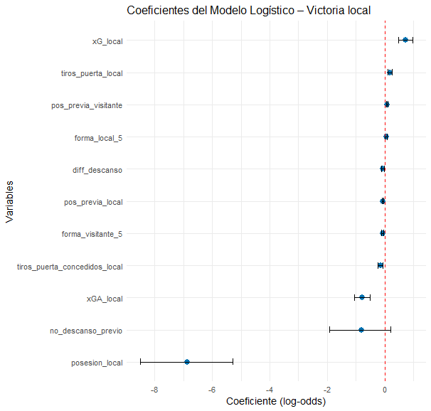

pR2(modelo_logit)
fitting null model for pseudo-r2
llh llhNull G2 McFadden r2ML r2CU
-584.4911549 -785.4373240 401.8923383 0.2558399 0.2970975 0.3972382

table(real = datos_eval$win_local, pred = pred_logit)
pred
real 0 1
0 490 132
1 153 365
> # =========================
> # 7. ACCURACY
> # =========================
> accuracy_logit <- mean(pred_logit == datos_eval$win_local)
> accuracy_logit
[1] 0.75

