**PHASE 1:**

**GITHUB Link**

<https://github.com/shalini06mittal/VodafoneJan_2023>

CODEBUNK LINK:

<https://codebunk.com/b/5741100557813/>

**download jdk 11**

https://www.oracle.com/in/java/technologies/javase/jdk11-archive-downloads.html

**step by step guide to install jdk 11 on windows**

https://www.studytonight.com/post/step-by-step-guide-to-install-jdk-11-on-windows

**intellij - editor**

https://www.jetbrains.com/idea/download/#section=windows

**STS - editor**

https://spring.io/tools

Core Java videos

<https://youtube.com/playlist?list=PLCStwJYVkwTZVehTKbGmDLKwX_pbKbLDV>

**PHASE 2**

1. **Tomcat server -** [**https://tomcat.apache.org/download-90.cgi**](https://tomcat.apache.org/download-90.cgi) **Download the zip , unzip it and keep it in a folder on the desktop**
2. **MYSQL download   
   WINDOWS [PLEASE DOWNLOAD THE ONE WITH HIGHER SIZE => 405.2M]:**

**MYSQL => https://dev.mysql.com/downloads/windows/installer/8.0.html**

**Steps to install MYSQL : https://dev.mysql.com/doc/mysql-installationexcerpt/8.0/en/mysql-installer.html**

**MAC [ Just install the mamp. Rest I will guide ]**

**MYSQL [mamp] => https://www.mamp.info/en/downloads/**

**PHASE 3**

**PHASE 4**

1. **VSCode – editor**[**https://code.visualstudio.com/download**](https://code.visualstudio.com/download)
2. **Node js :**[**https://nodejs.org/en/download**](https://nodejs.org/en/download) **npm version  
   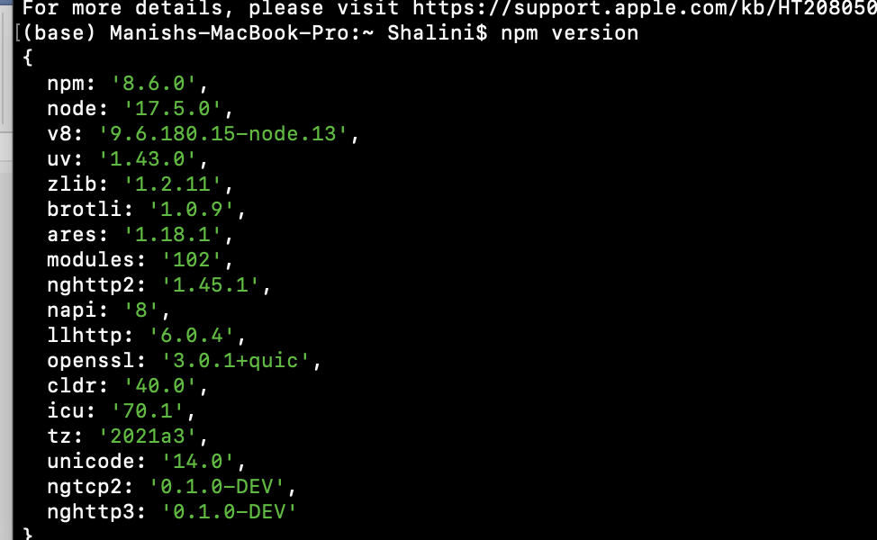**
3. **To create react project  
   npx create-react-app reactapp  
   npx :npm/ node tool  
   create-react-app : react CLI to create react project  
   reactapp : is the name of project**
4. **Go inside reactapp folder  
   npm start : start the server and website will be open automatically**