A Final Year Project Report On

JOB INTELLIGENCE PLATFORM

Submitted in partial fulfillment of the requirements for the degree of

Master of Computer Applications (MCA)

Submitted By:

Niraj Kumar
Year: 2026

Shobhit Institute of Engineering & Technology

Acknowledgement
I would like to express my profound gratitude to everyone who supported me throughout the course of this MCA project titled 'Job Intelligence Platform'. First and foremost, I thank my university, Shobhit Institute of Engineering & Technology, for providing the necessary infrastructure and academic framework to undertake this endeavor.
I am deeply grateful to my project guide and the faculty members of the MCA department for their constant encouragement, insightful feedback, and invaluable guidance. Their expertise helped shape the direction of this project and navigate the technical challenges encountered during the development of this platform.
I also extend my sincere thanks to my family and friends for their unwavering support, patience, and motivation during the challenging phases of this project. Finally, I acknowledge the open-source community and the creators of the various tools and technologies used in this project, without which this system would not have been possible.

Abstract
The 'Job Intelligence Platform' is an advanced, automated job matching and resume parsing system designed to bridge the gap between job seekers and recruiters. In the contemporary recruitment landscape, candidates face challenges in finding relevant job opportunities, while recruiters struggle to filter through thousands of resumes manually. This platform aims to solve these inefficiencies by leveraging intelligent parsing algorithms and a modern tech stack.
The system features automated resume parsing using Python to extract vital information such as skills and calculate total work experience. These details are then utilized to seamlessly match candidates with suitable job openings. The platform utilizes a robust backend built with Java (Spring Boot) and Python, and relies on MongoDB Atlas for scalable data storage. Secure communication and user authentication are facilitated through a robust OTP system.
The deployment architecture employs Docker for containerization, ensuring consistency across environments, and is hosted on Render via seamless GitHub integration. By automating tedious processes and providing intelligent recommendations, the Job Intelligence Platform significantly enhances the efficiency, accuracy, and user experience of the recruitment lifecycle. This project report details the problem statement, system architecture, design methodologies, implementation intricacies, and the final results achieved.

Table of Contents
1. Introduction
2. Literature Review
3. System Architecture
4. Tools & Technologies
5. System Design
6. Implementation
7. Results & Output
8. Conclusion & Future Scope
References

Chapter 1: Introduction

1.1 Introduction to the Problem
In the rapidly evolving digital landscape, the process of recruitment and talent acquisition has become increasingly complex. The traditional methods of job hunting and candidate screening are characterized by manual labor, inefficiencies, and a significant lack of precision. Organizations frequently receive an overwhelming number of applications for a single job posting, making it humanly impossible for recruiters to meticulously review every resume. Consequently, highly qualified candidates often go unnoticed due to the sheer volume of data, leading to suboptimal hiring decisions and prolonged vacancy periods.
On the other hand, job seekers face a equally frustrating challenge. Navigating through multiple job boards, tailoring applications, and waiting for responses often leads to what is commonly referred to as 'application fatigue'. Candidates often find themselves applying to positions that do not align with their actual skill sets or experience levels due to ambiguous job descriptions and poor search algorithms on traditional platforms. This disconnect between what recruiters need and what candidates offer is the core problem that the Job Intelligence Platform seeks to address.
The problem is further compounded by the unstructured nature of resumes. Resumes are typically submitted in various formats (PDF, DOCX) and lack a standardized structure. Extracting meaningful information such as specific technical skills, years of experience, and educational background requires sophisticated processing. Manual data entry from these documents is prone to human error and consumes an exorbitant amount of time. Therefore, there is a pressing need for an intelligent system capable of automatically parsing resumes, understanding the semantic context of the candidate's profile, and aligning it with the nuanced requirements of available job opportunities.
Furthermore, the recruitment process requires secure and verifiable interactions. Ensuring that the users—both recruiters and candidates—are authentic is crucial to maintaining the integrity of the platform. Traditional username and password systems are often vulnerable to breaches, making the implementation of robust verification mechanisms, such as One-Time Passwords (OTP), a necessity rather than a luxury. The current project addresses these multifaceted problems by integrating cutting-edge technologies into a cohesive, user-centric platform.

1.2 Objective of the Project
The primary objective of the Job Intelligence Platform is to engineer a highly efficient, automated, and intelligent ecosystem that seamlessly connects job seekers with potential employers. By leveraging advanced parsing algorithms and a scalable microservices-inspired architecture, the platform aims to eliminate the bottlenecks inherent in traditional recruitment processes. The core goal is to transform the recruitment experience from a manual, time-consuming chore into a streamlined, data-driven operation.
Specifically, the project aims to achieve the following sub-objectives:
1. To develop an intelligent resume parsing engine capable of accurately extracting key data points, including technical skills, professional experience, and educational qualifications, from diverse resume formats.
2. To implement a sophisticated experience calculation module that accurately quantifies a candidate's tenure in the industry, thereby enabling precise filtering and matching.
3. To design and integrate an advanced job matching algorithm that correlates the parsed candidate profile with the specific requirements of active job postings, ensuring a high degree of relevancy in recommendations.
4. To build a robust and secure backend infrastructure utilizing Java and Spring Boot, capable of handling high volumes of traffic and complex data transactions with minimal latency.
5. To ensure data persistence and scalability by utilizing MongoDB Atlas, a cloud-based NoSQL database that offers flexible schema design and high availability.
6. To establish a secure user authentication system utilizing OTP verification, thereby protecting user data and preventing unauthorized access to the platform.
7. To create an intuitive, responsive, and aesthetically pleasing frontend interface using modern HTML, CSS, and JavaScript, providing an optimal user experience across various devices.
8. To implement a modern DevOps pipeline utilizing Docker for containerization and Render for cloud deployment, ensuring continuous integration and continuous deployment (CI/CD) practices.

1.3 Scope of the Project
The scope of the Job Intelligence Platform encompasses the end-to-end development of a web-based application designed to facilitate the recruitment lifecycle. The platform is targeted towards two primary user groups: job seekers looking for relevant opportunities, and recruiters or organizations seeking qualified talent. The project covers the design, development, testing, and deployment phases of the software development lifecycle.
From a functional perspective, the scope includes the implementation of a user registration and authentication module fortified with OTP verification. For candidates, the platform will provide features to upload resumes, view parsed profiles, browse recommended jobs, and manage applications. For recruiters, the system will offer functionalities to post job openings, define required skills and experience levels, and view automatically ranked candidates based on matching algorithms.
Technologically, the scope is confined to the specific tech stack selected for this project: Java (Spring Boot) for the core backend services, Python for the specialized resume parsing and data extraction scripts, MongoDB Atlas for the database layer, and fundamental web technologies (HTML, CSS, JS) for the frontend. The integration between the Spring Boot backend and the Python parsing engine via API endpoints is a critical component of the system's scope.
The project also includes the containerization of the application using Docker, ensuring that the development, testing, and production environments remain consistent. The final phase involves deploying the application to the cloud using Render, integrating with GitHub for version control and automated deployments. While the platform provides a comprehensive set of features, it currently focuses on text-based resume parsing and does not include advanced features like video interviews or deep natural language processing (NLP) for sentiment analysis, which are reserved for future enhancements.

Chapter 2: Literature Review

2.1 Existing Platforms
The online recruitment industry is currently dominated by several major players, each offering distinct features and catering to different segments of the market. Understanding these existing platforms is crucial for identifying gaps and positioning the Job Intelligence Platform effectively. The most prominent platforms include LinkedIn, Naukri.com, Indeed, and Glassdoor.
LinkedIn has revolutionized professional networking by combining social media elements with job hunting. It allows users to build comprehensive digital profiles, connect with industry peers, and apply for jobs directly through the platform. LinkedIn's strength lies in its vast user base and the ability for recruiters to source passive candidates who might not be actively looking for jobs but are open to opportunities. However, the sheer volume of users can make it difficult for an individual candidate to stand out, and the platform's job matching algorithms often prioritize engagement metrics over precise skill alignment.
Naukri.com is a leading job portal, particularly dominant in the Indian market. It operates primarily as a massive database of resumes and job postings. Recruiters use complex Boolean search strings to find candidates, while job seekers rely on keyword matching to find relevant openings. While Naukri provides a broad reach, its reliance on keyword matching often leads to irrelevant search results. A candidate might include a skill as a minor keyword, leading to matches for roles where that skill is the primary requirement, causing frustration for both parties.
Indeed operates largely as an aggregator, pulling job listings from various company career pages and other job boards into a single search interface. It simplifies the search process but suffers from issues related to duplicate postings and outdated listings. Its matching capabilities are relatively basic, relying heavily on keyword proximity rather than deep contextual understanding of a candidate's profile.
Glassdoor, while initially focused on company reviews and salary insights, has expanded into a full-fledged job board. It provides valuable context to job seekers about company culture, but its core job matching functionalities are similar to those of Indeed and Naukri, lacking the sophisticated automated parsing and matching proposed in the Job Intelligence Platform.

2.2 Limitations of Existing Systems
Despite the popularity and widespread use of these existing platforms, they exhibit several critical limitations that hinder the efficiency of the recruitment process. These limitations form the primary motivation for developing the Job Intelligence Platform.
Firstly, the reliance on keyword-based searching and matching is a significant drawback. Traditional platforms often fail to understand the semantic context of a resume. For instance, a candidate might list 'Java' under a project completed five years ago, while another might have 'Java' as their primary skill in their current role. Keyword matching treats both equally, leading to inaccurate rankings. The Job Intelligence Platform addresses this by utilizing intelligent parsing that calculates total experience and correlates specific skills with tenure.
Secondly, the manual effort required by candidates to create and maintain their profiles is substantial. On platforms like Naukri or LinkedIn, candidates must often manually enter their work history, education, and skills, even after uploading a resume. This redundant data entry is tedious and prone to errors. The proposed system alleviates this by automatically extracting these details directly from the uploaded resume, minimizing manual input.
Thirdly, many platforms struggle with unstructured data. Resumes come in various formats and layouts. Traditional parsers often fail to accurately extract data from complex PDFs or documents with unconventional formatting. The Job Intelligence Platform incorporates advanced Python-based parsing techniques designed to handle a wider variety of document structures, ensuring higher accuracy in data extraction.
Furthermore, the feedback loop in traditional platforms is often non-existent. Candidates apply for numerous jobs and rarely receive feedback on why they were not selected or how well their profile matched the job requirements. While the current scope of the Job Intelligence Platform focuses on the core matching engine, the architecture is designed to eventually support transparent matching scores, giving candidates insights into their compatibility with specific roles.
Lastly, security and spam remain prevalent issues. Fake job postings and unverified candidates clutter existing platforms. By integrating a robust OTP-based authentication system from the ground up, the Job Intelligence Platform ensures a higher level of trust and security, verifying the identity of users and reducing fraudulent activities within the ecosystem.

Chapter 3: System Architecture

3.1 Architectural Overview
The architecture of the Job Intelligence Platform is meticulously designed to ensure scalability, reliability, and maintainability. It follows a modern, distributed architecture pattern, separating the frontend presentation layer from the backend business logic and the specialized data processing engine. This decoupling allows each component to be developed, scaled, and maintained independently, facilitating a more agile development process.
At the core of the system is the backend API, built using Java and the Spring Boot framework. Spring Boot was chosen for its robustness, comprehensive ecosystem, and built-in support for creating RESTful web services. The Spring Boot application serves as the central orchestrator, handling user requests, managing business rules, and communicating with the database. It exposes a series of well-defined REST API endpoints that the frontend application consumes.
The specialized resume parsing and intelligence engine is implemented as an independent service using Python. Python is the industry standard for text processing, natural language tasks, and data manipulation, thanks to its rich ecosystem of libraries. When a candidate uploads a resume, the Spring Boot application routes the file to the Python service. The Python service processes the document, extracts the necessary data points (skills, experience), and returns structured JSON data back to the Spring Boot application.
The data persistence layer is powered by MongoDB Atlas, a fully managed cloud database service. As a NoSQL document database, MongoDB provides the flexibility required to store the dynamic and highly variable data extracted from resumes. It eliminates the need for rigid relational schemas, allowing the system to easily adapt to changes in the data structure as the parsing algorithms evolve.
The presentation layer is a responsive web application built with HTML, CSS, and JavaScript. It provides the user interface for both candidates and recruiters, interacting asynchronously with the backend APIs to provide a seamless and dynamic user experience without requiring full page reloads.

3.2 Data Flow and Interaction
The data flow within the Job Intelligence Platform is designed to be asynchronous and efficient. When a user interacts with the system, the data traverses through multiple layers, undergoing transformation and processing at each stage.
Consider the critical use case of a candidate uploading a resume. The process begins at the presentation layer, where the user selects a file (PDF or DOCX) through the web interface. The frontend JavaScript code captures the file and initiates a secure POST request to the Spring Boot backend, attaching the file as a multipart form data payload.
Upon receiving the request, the Spring Boot application's controller layer authenticates the user and validates the request. It then temporarily stores the file and invokes a REST client to forward the resume to the Python parsing service. This communication between the Java backend and the Python service is crucial for offloading the computationally intensive parsing task.
The Python service receives the file and utilizes specialized libraries to extract the raw text. It then applies regular expressions and text processing algorithms to identify specific sections like 'Experience', 'Skills', and 'Education'. It calculates the total years of experience by analyzing date ranges and extracts key technical skills. The service then formats this extracted information into a structured JSON object and sends it back in the HTTP response.
The Spring Boot application receives the JSON response from the Python service. The service layer processes this data, maps it to the internal domain models, and initiates a database transaction. The application connects to MongoDB Atlas and persists the parsed candidate profile, associating it with the user's account.
Once the data is successfully stored, the Spring Boot application executes the job matching algorithm. It queries the MongoDB database for active job postings that align with the candidate's newly extracted skills and experience level. The matching results are then compiled and returned to the frontend via the API response.
Finally, the frontend application receives the matching data and dynamically updates the User Interface, presenting the candidate with a curated list of relevant job opportunities. This entire data flow happens within seconds, providing the user with immediate and actionable intelligence based on their uploaded resume.

Chapter 4: Tools & Technologies

4.1 Backend Technologies: Java & Spring Boot
The core backend infrastructure of the Job Intelligence Platform is engineered using Java and the Spring Boot framework. Java, a mature and widely adopted object-oriented programming language, provides the necessary performance, security, and portability required for enterprise-grade applications. Its strong typing and extensive standard library ensure robust and predictable code execution.
Spring Boot, an extension of the Spring framework, was selected for its ability to rapidly bootstrap robust applications. It significantly reduces the boilerplate configuration typically associated with Java enterprise development by providing intelligent defaults and auto-configuration capabilities. In this project, Spring Boot is utilized to build the RESTful APIs that serve as the communication bridge between the frontend, the Python parsing service, and the database.
Key Spring Boot modules utilized include Spring Web for building the REST controllers, Spring Data MongoDB for seamless integration with the NoSQL database, and Spring Security for implementing robust authentication and authorization mechanisms. The inversion of control (IoC) and dependency injection features of Spring ensure a modular and easily testable codebase, facilitating maintainability and future enhancements.

4.2 Frontend Technologies: HTML, CSS, JS
The user interface of the platform is constructed using foundational web technologies: HTML5, CSS3, and JavaScript. This approach ensures maximum compatibility across different web browsers and devices without the overhead of heavy frontend frameworks.
HTML5 provides the semantic structure of the application, ensuring accessibility and proper document outlining. CSS3 is employed to create a modern, responsive, and visually appealing design. Advanced CSS features such as Flexbox and CSS Grid are utilized to construct complex layouts that adapt seamlessly to various screen sizes, from mobile devices to large desktop monitors. Custom styling ensures a professional and intuitive user experience.
JavaScript (ES6+) is used to add dynamic behavior and interactivity to the platform. It handles user events, form validations, and asynchronous communication with the backend APIs using the Fetch API or Axios. JavaScript is crucial for manipulating the Document Object Model (DOM) to update the user interface dynamically, such as displaying parsed resume data or rendering the list of matched jobs without requiring a full page reload, thereby ensuring a smooth and responsive experience.

4.3 Database: MongoDB Atlas
For data persistence, the project leverages MongoDB Atlas, a fully managed cloud database service built on the MongoDB NoSQL engine. The choice of a NoSQL database over a traditional relational database (RDBMS) is driven by the specific data requirements of the application.
Resume data is inherently unstructured and highly variable; different candidates present their information in vastly different ways. MongoDB's document-oriented architecture, which stores data in flexible, JSON-like BSON documents, perfectly accommodates this variability. It allows the system to store complex hierarchical data structures, such as lists of skills and detailed work history arrays, within a single document.
MongoDB Atlas provides several critical advantages, including automated provisioning, scaling, and backups. As a cloud service, it eliminates the need for manual database administration, allowing the focus to remain on application development. The platform utilizes MongoDB's powerful querying capabilities to efficiently execute the job matching algorithms, filtering candidates based on multiple criteria such as experience level and skill sets.

4.4 Parsing Engine: Python
The complex task of extracting meaningful data from diverse resume formats is handled by a dedicated service written in Python. Python's dominance in the fields of data science and natural language processing makes it the ideal choice for this specific requirement.
The Python service utilizes powerful libraries such as pdfminer or PyPDF2 to extract raw text from PDF documents. Once the text is extracted, the script employs sophisticated regular expressions (regex) and text processing logic to identify distinct sections of the resume. It specifically looks for patterns indicating dates of employment to calculate total experience and cross-references the text against a predefined taxonomy of technical skills to identify the candidate's core competencies.
By isolating this computationally heavy task in a separate Python microservice, the main Java backend is freed from the processing overhead, ensuring that the API remains highly responsive to user requests.

4.5 DevOps & Deployment: Docker, Render, GitHub
The project incorporates modern DevOps practices to ensure reliable and efficient deployment. Docker is utilized for containerization. By packaging the application and its dependencies into standardized Docker containers, the project ensures consistency across development, testing, and production environments, eliminating the 'it works on my machine' syndrome.
Render is selected as the cloud hosting platform for its simplicity and robust support for containerized applications. Render provides a fully managed environment that easily integrates with Docker, allowing for seamless deployment of both the Spring Boot backend and the Python parsing service.
GitHub serves as the version control system, tracking changes to the codebase and facilitating collaboration. The deployment pipeline is integrated directly with GitHub; every push to the main branch triggers an automated build and deployment process on Render, ensuring that the live application is always running the latest version of the code. This CI/CD approach significantly accelerates the development cycle and reduces the risk of deployment errors.

Chapter 5: System Design

5.1 System Modules
The Job Intelligence Platform is structurally divided into several cohesive modules, each responsible for a distinct functional area of the application. This modular design promotes separation of concerns and facilitates easier maintenance.
The **Authentication Module** handles user registration, login, and secure session management. It incorporates the OTP generation and verification logic, ensuring that all user access is strictly authenticated.
The **Candidate Management Module** is responsible for managing the job seeker's profile. It handles the uploading of resumes, displays the parsed data, and allows candidates to track their job applications.
The **Recruiter Management Module** provides tools for employers to create and manage job postings. It allows recruiters to define the specific requirements for a role, including necessary skills and minimum experience levels.
The **Core Intelligence Module** acts as the brain of the platform. It encompasses the Python-based resume parsing service, the experience calculation algorithms, and the sophisticated job matching logic that correlates candidates with appropriate opportunities.

5.2 Use Case Analysis
Use Case diagrams are instrumental in modeling the interactions between the users (actors) and the system. They provide a high-level view of the system's functionality from the user's perspective.
For the **Job Seeker (Candidate)** actor, the primary use cases include: 'Register Account', 'Verify OTP', 'Login', 'Upload Resume', 'View Parsed Profile', 'View Matched Jobs', and 'Apply for Job'. The 'Upload Resume' use case 'includes' the underlying system process of 'Parse Resume', highlighting the dependency between the user action and the backend processing.
For the **Recruiter** actor, the primary use cases include: 'Register Account', 'Verify OTP', 'Login', 'Post New Job', 'Manage Job Listings', and 'View Matched Candidates'. The 'View Matched Candidates' use case relies on the system's ability to execute the matching algorithm against the database of parsed candidate profiles.
The **System Administrator** actor handles backend management tasks, with use cases such as 'Monitor System Logs', 'Manage User Accounts', and 'Update Skill Taxonomy'.

5.3 Data Flow Diagrams (DFD)
Data Flow Diagrams provide a visual representation of how data moves through the system, illustrating the inputs, processes, and outputs.
In the **Level 0 DFD (Context Diagram)**, the Job Intelligence Platform is represented as a single central process. The external entities are the Candidate and the Recruiter. The Candidate sends 'Registration Data', 'OTP', and 'Resume File' into the system, and receives 'Parsed Profile Data' and 'Matched Job Opportunities' in return. The Recruiter inputs 'Registration Data', 'OTP', and 'Job Details', and receives 'Matched Candidate Profiles'.
The **Level 1 DFD** breaks down the central process into major sub-processes: 'Authentication Process', 'Profile Processing', 'Job Management', and 'Matching Engine'. Data stores such as 'User Database', 'Candidate Profiles DB', and 'Job Postings DB' are introduced. For instance, the 'Profile Processing' sub-process takes the 'Resume File' from the candidate, utilizes the 'Parsing Engine', stores the result in the 'Candidate Profiles DB', and passes the data to the 'Matching Engine'.

Chapter 6: Implementation

6.1 Resume Parsing Implementation
The resume parsing mechanism is a critical feature, primarily executed by the Python microservice. The implementation involves several complex steps to transform unstructured document text into structured data.
The first step is text extraction. For PDF files, libraries such as `pdfplumber` or `PyPDF2` are utilized to read the binary document and extract the raw text content while attempting to maintain the logical reading order. For DOCX files, the `python-docx` library is employed to traverse the document's XML structure and extract text from paragraphs and tables.
Once the text is extracted, the system applies rigorous text preprocessing. This involves converting text to lowercase, removing special characters, and normalizing whitespace. The core parsing logic relies on sophisticated Regular Expressions (Regex) and keyword matching. The script searches for specific headers like 'Experience', 'Work History', 'Skills', and 'Technical Proficiencies' to segment the document.
To extract skills, the parsed text is tokenized and cross-referenced against a comprehensive, pre-defined taxonomy of technical skills stored in the system. The matching algorithm accounts for variations and synonyms (e.g., 'JS' and 'JavaScript') to ensure accurate skill identification.

6.2 Experience Calculation Logic
Calculating a candidate's total professional experience is one of the most challenging aspects of resume parsing due to the diverse ways candidates format dates.
The implementation involves scanning the 'Experience' section of the resume for date patterns using Regex. The system is trained to recognize various formats, such as 'MM/YYYY - MM/YYYY', 'Month Year to Present', and 'YYYY - YYYY'.
Once date ranges are identified, the Python script utilizes the `datetime` module to parse these strings into date objects. It then calculates the difference in months between the start and end dates for each role. For current roles (e.g., 'to Present'), the end date is dynamically set to the current system date.
The calculated durations for all listed roles are then summed to determine the total months of experience. This total is then converted into years (as a floating-point number) and returned to the Java backend. This precise calculation allows the matching engine to accurately filter candidates based on the minimum experience required for a job.

6.3 Job Matching Algorithm
The job matching algorithm is implemented in the Java backend and relies on querying the MongoDB Atlas database. The algorithm computes a compatibility score between a candidate's parsed profile and the requirements of active job postings.
The process begins by retrieving the candidate's total years of experience and their array of extracted skills. The system queries the database for jobs where the `minimum_experience` field is less than or equal to the candidate's experience.
For the skill matching, the algorithm compares the candidate's skills against the required skills for the job. It calculates a matching percentage based on how many required skills the candidate possesses. Jobs that exceed a certain threshold of matching percentage are flagged as recommended. The results are sorted primarily by skill match percentage and secondarily by experience proximity, ensuring the most relevant opportunities are presented first.

6.4 OTP System and Security
Security is paramount in the platform, and the authentication system is fortified with a One-Time Password (OTP) mechanism. The implementation utilizes Spring Security and Java's built-in secure random number generators.
When a user attempts to register or log in, the system generates a secure, 6-digit random number. This OTP is temporarily stored in the database or an in-memory cache with a strict expiration time (e.g., 5 minutes).
The OTP is then transmitted to the user via email using a service integration like JavaMailSender. The user must enter this OTP on the frontend interface. The Spring Boot application verifies the submitted OTP against the stored value. Only upon successful validation is an authentication token (such as a JWT - JSON Web Token) issued, granting the user access to the platform's secure endpoints.

6.5 API Integration
The platform relies heavily on RESTful API integration for communication between its distributed components. The Spring Boot backend exposes a comprehensive set of API endpoints using Spring MVC annotations like `@RestController` and `@RequestMapping`.
For the inter-service communication between Java and Python, the Spring Boot application utilizes the `RestTemplate` or `WebClient` utility to construct and send HTTP requests to the Python service. The Java application serializes the file data, transmits it, and synchronously waits for the JSON response containing the parsed data.
The frontend JavaScript application consumes the Java backend APIs using the `fetch` API. All API endpoints dealing with sensitive data are secured, requiring the frontend to include the JWT in the `Authorization` header of every request.

6.6 Deployment Steps (GitHub, Render, Docker)
The deployment pipeline is fully automated and containerized. The implementation steps are designed to ensure seamless transitions from development to production.
First, a `Dockerfile` is created for both the Spring Boot application and the Python service. The Dockerfile specifies the base image (e.g., OpenJDK for Java, Python slim for the parsing service), copies the compiled application artifacts, exposes the necessary ports, and defines the startup commands.
The source code is hosted on GitHub. Upon pushing changes to the main branch, a webhook triggers the deployment process on Render. Render is configured to connect directly to the GitHub repository.
During deployment, Render builds the Docker image based on the instructions in the Dockerfile. Once the build is successful, Render provisions a container instance and deploys the image. Environment variables, such as database connection strings and API keys, are securely managed within Render's dashboard and injected into the container at runtime. This integration provides a robust CI/CD workflow with zero downtime deployments.

Chapter 7: Results & Output

7.1 User Interface Explanation
The User Interface (UI) of the Job Intelligence Platform is designed with a focus on clarity, usability, and modern aesthetics. Built using HTML, CSS, and JS, the UI provides a seamless experience for both job seekers and recruiters.
The design language employs a clean, minimalist approach, utilizing a professional color palette that instills trust. Ample whitespace is used to reduce cognitive load and draw the user's attention to critical information, such as job descriptions or parsed skills.
Navigation is intuitive, with a persistent sidebar or top navigation bar providing easy access to core functionalities like 'Dashboard', 'Profile', 'Job Search', and 'Settings'. The layout is fully responsive, utilizing CSS Grid and Flexbox to ensure that the interface adapts perfectly to mobile, tablet, and desktop screens, providing an uncompromised experience regardless of the device used.

7.2 System Screens and Workflows
The application flow encompasses several key screens. The **Landing Page** introduces the platform's value proposition and provides clear calls to action for registration or login.
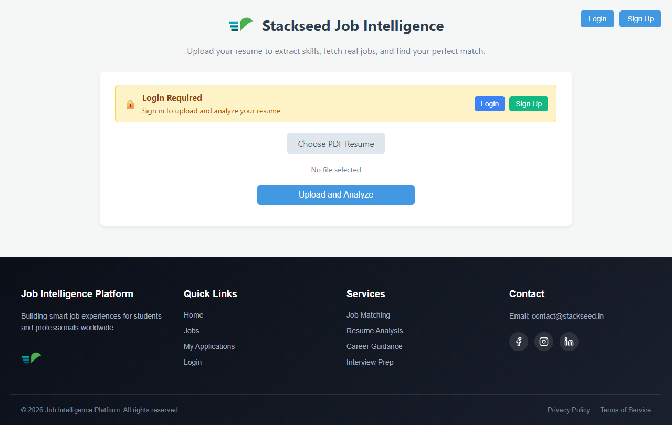
Figure: Home Screen and Resume Upload
The **Authentication Screen** is a secure, clean interface for user credentials, followed by the **OTP Verification Screen**, which features clear input fields and countdown timers for code validity.
For candidates, the **Dashboard** is the central hub. It prominently features the **Resume Upload Interface**, a drag-and-drop zone with clear instructions on supported file formats. Upon successful upload, the system seamlessly transitions to the **Parsed Profile View**, displaying the extracted skills, calculated experience, and educational background in an organized, easily readable format, allowing the user to verify the extracted data.
The **Job Recommendation Screen** presents matching jobs in a card-based layout. Each card summarizes the role, company, required experience, and the calculated match percentage. The **Recruiter Dashboard** provides analogous screens for creating new job postings and reviewing the ranked list of matched candidates for specific roles.
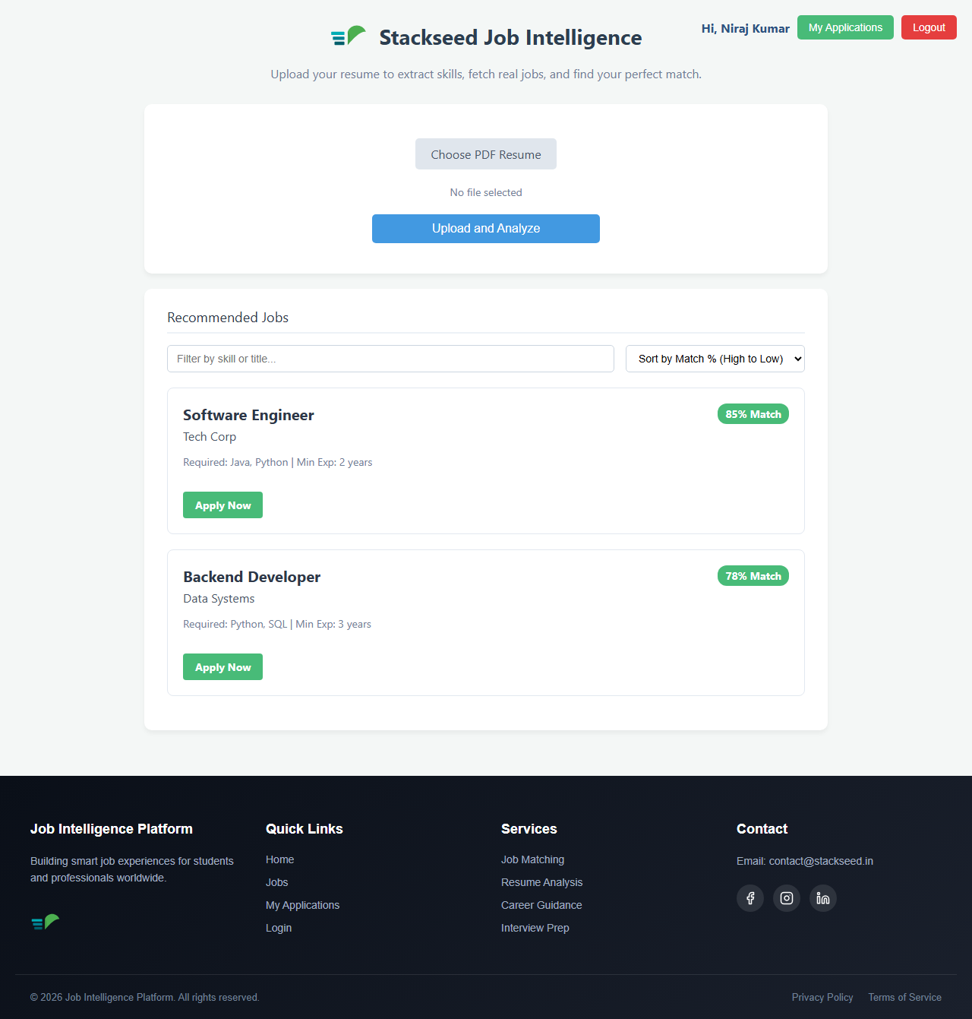
Figure: Job Recommendations Screen

Chapter 8: Conclusion & Future Scope

8.1 Conclusion
The Job Intelligence Platform successfully addresses the critical inefficiencies prevalent in modern recruitment processes. By automating the arduous task of resume parsing and implementing intelligent matching algorithms, the system significantly reduces the time and effort required by both candidates and recruiters.
The integration of a robust tech stack—Java (Spring Boot) for secure, scalable backend operations, Python for specialized data extraction, and MongoDB Atlas for flexible data management—has proven highly effective. The platform successfully translates unstructured resume data into actionable intelligence, accurately calculating experience and mapping technical skills.
Furthermore, the implementation of an OTP-based authentication system ensures a high level of security and user verification. The automated deployment pipeline utilizing Docker, Render, and GitHub provides a reliable foundation for continuous delivery and future scaling. In conclusion, this project demonstrates the powerful application of modern software engineering principles and specialized parsing techniques to solve real-world problems in the human resources domain.

8.2 Future Scope
While the current implementation of the platform is fully functional and addresses core requirements, there are numerous avenues for future enhancement and expansion.
1. **Advanced Natural Language Processing (NLP):** Future iterations will incorporate advanced NLP models, such as transformers, to move beyond keyword matching. The system will understand the semantic context of a resume, differentiating between managing a project and merely participating in it.
2. **Machine Learning for Matching:** The job matching algorithm can be upgraded to utilize Machine Learning models. By analyzing historical hiring data and user interactions (which jobs a candidate applies to and which candidates a recruiter interviews), the system can learn and continuously improve the accuracy of its recommendations.
3. **Integration with External APIs:** The platform could integrate with external platforms like LinkedIn to allow users to import profiles directly, further reducing the onboarding friction. Integration with assessment platforms could also provide verifiable skill badges.
4. **Analytics Dashboard:** Developing a comprehensive analytics dashboard for recruiters would provide insights into hiring trends, candidate demographics, and the effectiveness of different job postings.
5. **Mobile Application:** While the current web interface is responsive, developing dedicated native mobile applications for iOS and Android would further enhance accessibility and user engagement.

References
[1] Spring Boot Documentation. Available at: https://docs.spring.io/spring-boot/
[2] Python Official Documentation. Available at: https://docs.python.org/3/
[3] MongoDB Atlas Guide. Available at: https://www.mongodb.com/docs/atlas/
[4] Docker Containerization Best Practices. Available at: https://docs.docker.com/develop/dev-best-practices/
[5] Render Deployment Documentation. Available at: https://render.com/docs
[6] 'Natural Language Processing with Python' by Steven Bird, Ewan Klein, and Edward Loper.
[7] 'Designing Data-Intensive Applications' by Martin Kleppmann.
[8] 'Spring in Action' by Craig Walls.

