|  |  |  |
| --- | --- | --- |
|  | |  |
| **Factor Model – MSCI EAFEv2** | | ING-Corp-500pct |
|  |  |
|  | |
|  |  |
|  |  |  |

**Version 1.0**

## Version Control

| **Version** | **Date** | **Note** | **Author** |
| --- | --- | --- | --- |
| 1.0 | 17-June-2012 |  | Bhanu Arora |
|  |  |  |  |
|  |  |  |  |

Contents

Version Control 2

1 Introduction 4

2 Universe breakdown 5

3 Model Sub model Classification 6

4 Factor Selection process with factor detail list for each sub model 8

5 Blending Process and optimal parameters for each sub models 11

6 Location of Reports 13

Appendix: Database table contents 14

## 1 Introduction

This document describes the methodology of generating alpha for MSCI EAFE universe using Factor model framework. The EAFE model is based on MSCI EAFE universe. The process involves several key steps including Fundamental factor selection process, Blending method and Linear Optimization.

This document is organized in following manner.

1. MSCI EAFE Universe Breakdown

2. Model Sub model classification

3. Factor Selection process with detail factor list for each sub model.

4. Blending Process and optimal parameters for each sub models

5. Location of Reports

Appendix – Database table contents.

## 2 Universe breakdown

The EAFE universe (aggid = 0064990300) is broken down into following regions. Each region refers to a model.



There is further breakdown of each model into sub models. The selection of factors is done at these sub model levels.

## 3 Model Sub model Classification

Factor selection process involves two important aspects.

1. Stock Universe for selecting factors for each sub model.
2. Neutralizing Style or each factor.

***For Europe***

MSCI Europe region model is divided into 10 GICS level 1 Sectors. These 10 sectors refer to sub models.

1. For each sub model, factor **neutralization is done at sector level (GICS level 1)**



***For Japan***

MSCI Japan region model is divided in the similar manner as Europe with following exceptions

1. Energy and Telecommunication sector is combined into one sub model. There is less number of stocks in both the sectors.
2. There is **no sub model for utility Sector** as it has been benchmarked.
3. For each sub model, *factor* ***neutralization is done at sub industry groups (GICS level 2)***



***For Australasia***

1. This model has one sub model with all the stocks from Aus and NZL in EAFE universe.
2. For this sub model, Factor **neutralization is done is done at sector level (GICS level 1).**



***For Hong Kong and Singapore***

1. This model has one sub model with all the stocks from HKG and SGP in EAFE universe.
2. For this sub model, Factor **neutralization is done is done at sector level (GICS level 1).**



**Strategy Model Mapping**

The strategyid refers to the alpha process for the whole EAFE universe and is composed of underlying models.



## 4 Factor Selection process with factor detail list for each sub model

The idea is to explain the cross section of stock returns through fundamental factors at each sub model level.

1. The factor selection process is done by analyzing individual factor characteristics for each sub model.
2. The factor reports are generated using Factor Analyzer tool.
3. The factor reports for selected factors are present at following location. These reports are located under respective folders with folder names based on model sub model level.
   * 1. \\FactorModel\MSEAFEv2\FactorReports\
4. Detailed list of factors for each sub model is as follows

**Sector wise Factor List for MSCI Europe region (Model id – 53)**





Following chart to show the number of factors belonging to five style categories for each sub model

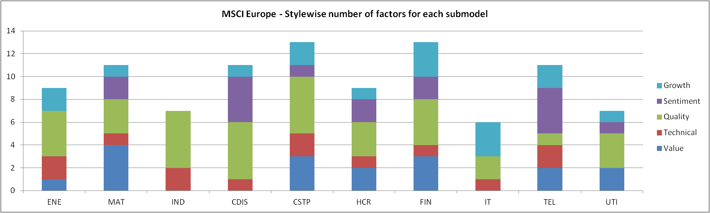

**Sector wise Factor List for MSCI Japan region (Model id – 56)**





Following chart to show the number of factors belonging to five style categories for each sub model

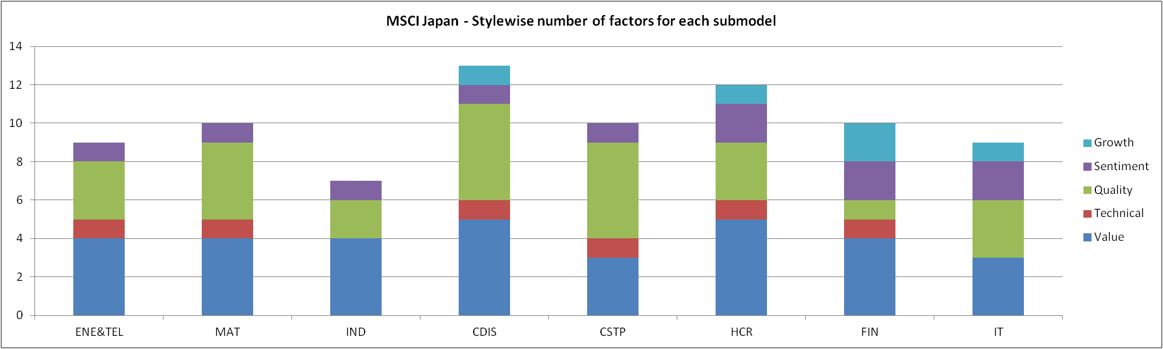

**Universe wise Factor List for Australasia region (Model id – 57)**

 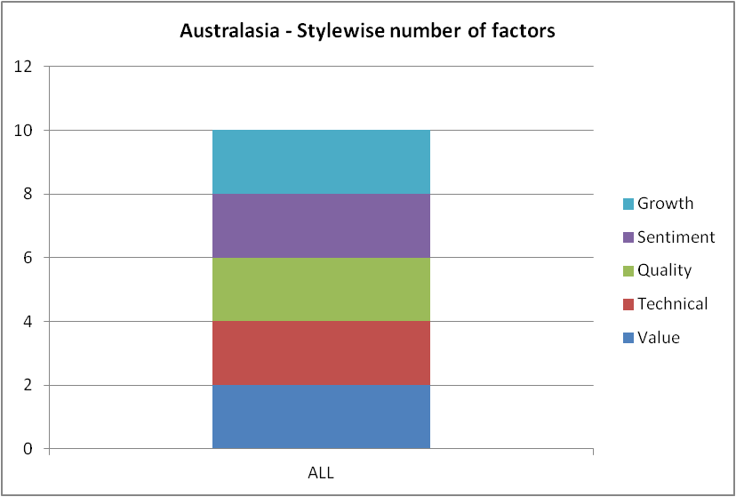

**Universe wise Factor List for Hong Kong and Singapore region (Model id – 58)**

 

## 5 Blending Process and optimal parameters for each sub models

The blending process is dynamic factor weighting process. There are different factor weighting schemes embedded into the process. The weighting schemes mainly depend upon the historical factor performances, Turnover control, Risk Parity based on factor returns (Factor Allocation adjusted to same risk level).

*Blending Weighting Methods*

1. Risk Parity (***RISKPAR***) – The Risk parity portfolio ensures all the factors have equal contribution to total risk. All the risk measures are ex ante. The math is as follows

$${RiskContrib}_{i}= \frac{1}{σ_{p}}\sum_{j=1}^{n}{w_{i} w_{j} σ_{i,j}}$$

$where σ_{p}^{2}=\sum_{i=1}^{n}{.}\sum_{j=1}^{n}{w_{i} w_{j} σ_{i,j}}$

$$σ_{i,j}is the covariance between i^{th} and j^{th} factor returns.$$

$$Risk Parity allocates the factor weightes based on equal Ex Ante Risk Contribution.$$

$$This implies =>{RiskContrib}_{1}={RiskContrib}_{2}=...{RiskContrib}_{n}$$

$$The above equation is solved using fsolver in Matlab with followinga dditional constraints$$

$$\sum_{i}^{n}{w_{i}=1} and lb≤ w_{i}≤ub for i=1,2…n$$

$$lb and ub are the lower bound and upper bounds on each factor weights$$

Different methods are employed to calculate covariance matrix of factor returns. The weighted covariance is defined as follows

$σ_{j,k}= \frac{\sum_{i=1}^{n}{w_{i}}}{{\left(\sum_{i=1}^{n}{w_{i}}\right)}^{2}-\sum_{i=1}^{n}{w_{i}^{2}}}\sum_{i=1}^{n}{w_{i} \left(x_{i,j}-{\overline{x}}_{j}\right)\left(x_{i,k}-{\overline{x}}_{k}\right)}$

The weights $w_{i}$ can take following forms

1. Exponential Weighted Covariance
2. Equally Weighted covariance
3. Triangular weighted covariance

Another measure of covariance (Downside covariance) is also tested.

2. Mean Variance Optimization (***M/V: RFAC***) - This weighting scheme is based on mean variance optimization of expected factors returns and their covariance matrix. Average Historical factor returns are used as expected factor returns for next period. Covariance matrix based on historical factor returns is used as expected covariance matrix for optimization. The factor weights in the optimization process are constrained using upper bounds, lower bounds and the autocorrelation of the combined factor portfolio. The math is described in the blending process documentation.

3. Equally Weight (***EW***) – Equally weight the factors.

Blending details for each submodel is as follows

***For MSCI Europe (Model id – 53)***



***For MSCI Japan (Model id – 56)***



***For Australasia (Model id – 57)***



***For Hong Kong and Singapore (Model id – 58)***



## 6 Location of Reports

1.Factor Analyzer Reports

The factor reports for selected factors are present at following location. These reports are located under respective folders with folder names based on model sub model level.

\\FactorModel\MSEAFEv2\FactorReports\

2. Blending Reports

All the reports to select the blending parameters for each sub model are present at following location

\\FactorModel\MSEAFEv2\BlendingReports\

3. Linear Optimization Results

The Linear Optimization has been performed at each model level and over all MSCI EAFE universe. The reports are present at following location.

\\FactorModel\MSEAFEv2\Backtest\

Linear optimization reports are with “_LinOpt” as suffix

4. Axioma Backtest Report

The reports from Axioma backtest is present at following location

\\FactorModel\MSEAFEv2\Backtest\

Axioma Backtest report is with “_Axioma” as suffix

5. Performance Attribution Report

Performance attribution based on the Axioma based back tested portfolio is present at following location

There are three reports. Inception to date, Year to date and Past 15 Months.

\\FactorModel\MSEAFEv2\PerfAttrib\

6. Migration Scripts

Migration Guide and scripts are present at following location.

\\FactorModel\MSEAFEv2\Migration\

## Appendix: Database table contents

1. Content of table bld.strategymodel



2. Content of table bld.modelmstr



3. Content of bld.modelsubmodel









4. Content of bld.modelfactormap









5. Content of bld.submodelparameter



