Database Systems Case Study
Team Members:
1. Aarushi Singh - 24BDS0436
2. Ojaswi Om - 24BCE2186
Faculty: Poornima N
Project Title: Adaptive Execution Strategy Selection for Filtered Vector Similarity Queries in PostgreSQL
1. Brief Overview
Modern applications (semantic search, recommendations, RAG) store embeddings in PostgreSQL using the pgvector extension and combine nearest-neighbour search with SQL predicates, e.g. “find the 10 most similar products where category = 'shoes' AND price < 2000”. This project builds an adaptive layer that decides, per query, how such filtered vector queries should be executed.
2. Problem Addressed
Filtered vector queries can run as (a) an approximate index scan (HNSW/IVFFlat) followed by post-filtering, or (b) a filter-first plan with an exact scan over matching rows. Neither is always best: with a highly selective filter, post-filtering returns too few or zero results (low recall); with a loose filter, an exact scan is needlessly slow. The PostgreSQL planner uses a fixed cost model that does not account for filter selectivity versus vector-index behaviour, so it often picks a poor plan.
3. Methodology / Technologies Used
- Stack: PostgreSQL + pgvector (HNSW index), PL/pgSQL selector function, B-tree index on filter column, Python (NumPy, scikit-learn, Matplotlib) for benchmarking.
- Selectivity estimation: fraction of rows passing the filter is estimated from planner statistics (pg_stats histogram_bounds).
- Strategy selection: a cost model compares rows scanned by filter-first exact search (selectivity × N) against ANN search with ef_search enlarged to ceil(3k / selectivity), and picks the cheaper plan.
- Evaluation: Python prototype emulating pgvector ANN + post-filter behaviour (IVF index); 50,000 vectors (64-d), k = 10, 100 queries per point, selectivity 0.1%–100%; metrics are recall@10 and latency versus the default ANN + post-filter plan.
4. Key Features / Outcomes
- Per-query adaptive choice of execution strategy; no change to application SQL.
- Fixes the low-recall failure of post-filtering under restrictive filters; avoids slow exact scans under loose filters.
5. Final Outcome of the Project
Working prototype with SQL code (adaptive_search function) and a benchmark. Adaptive selection reached recall@10 = 1.00 at every selectivity, versus 0.007 (0.1%), 0.059 (1%), 0.226 (5%) and 0.794 (20%) for the default plan. At 1% selectivity it was also ~14× faster (0.05 ms vs 0.70 ms); at 50% and 100% it matched or beat the default latency. Publication: not published; submitted as a course case study. Full measured results: results.json | Code: benchmark.py.
6. Proof of Outcome (project / demo screenshots)
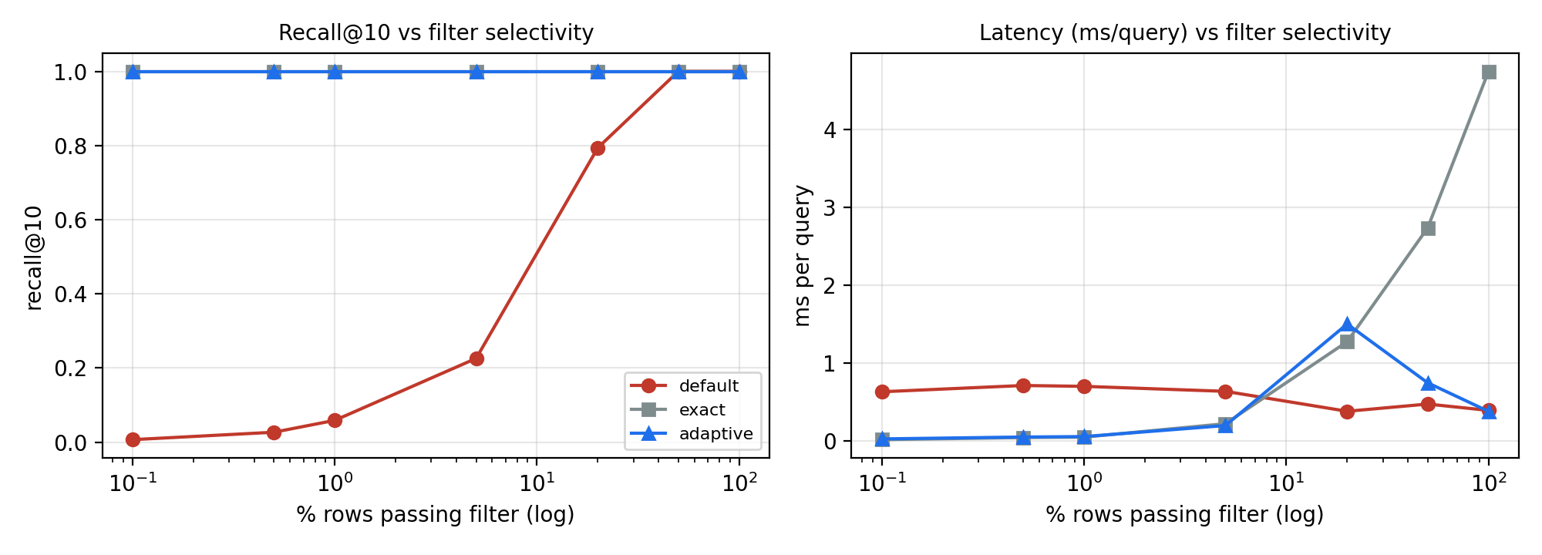 | 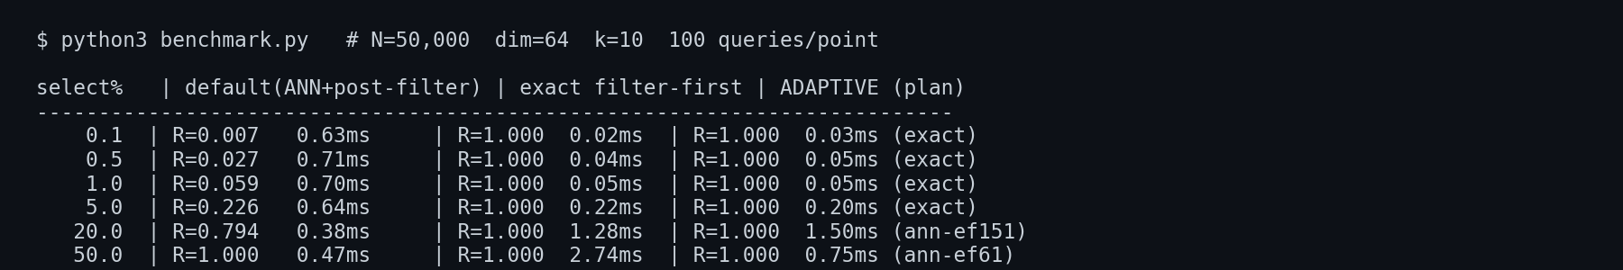
Figure 1: Recall@10 and latency vs filter selectivity | Figure 2: Benchmark console output (adaptive plan chosen per row)
Source code (click to open): benchmark.py | adaptive_filtered_vector_search.sql | results.json

