To create a folder in cloudinary –

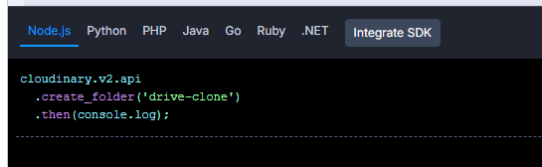

how to create folder in j