**Encapuslation –**

Encapsulation is wrapping up of data and member function in a single unit called class.

Bundling data (variables) and functions (methods) together in a class to protect the data from outside interference.

It helps in data hiding – you can create sensitive information in private access specifier.

Eg. -

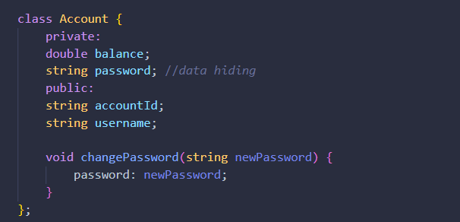

**Abstraction –**

Hiding unnecessary details and showing only the essential features of an object.

**Inheritance –**

Creating a new class (child class) from an existing class (parent class) to promote code reusability.

**Polymorphism –**

Enabling a single function, operator, or object to behave differently in different contexts (e.g., function overloading, operator overloading, virtual functions).

**Constructor –**

Constructor is a special method invoked automatically at time of object creation. Used for initialisation.

* Same name as class
* Constructor doesn’t have a return type
* Only called once (automatically), at Object creation
* Memory allocation happens when constructor is called
* If we don’t create constructor the compiler automatically creates a constructor
* Always declared in public access specifier
* We can declare more than one constructor but with different arguments and while calling the constructor the arguments passed to it decides which constructor will be invoked – This is called constructor overloading(constructor overloading is an example of polymorphism).

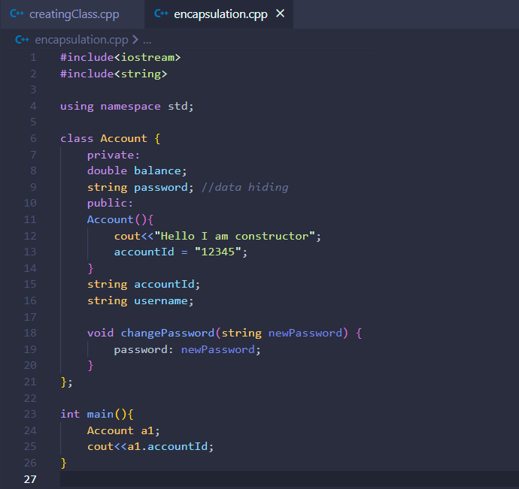

**This Keyword -**

this is a special pointer in C++ that points to the current object.

this->prop is same as *(this).prop

**Copy constructor –**

Special Constructor (default) used to copy properties of one object into another.

You don’t need to define it. You can directly use it by giving another object of same class to copy the values to the new object.

Or you can also create your own copy constructor.

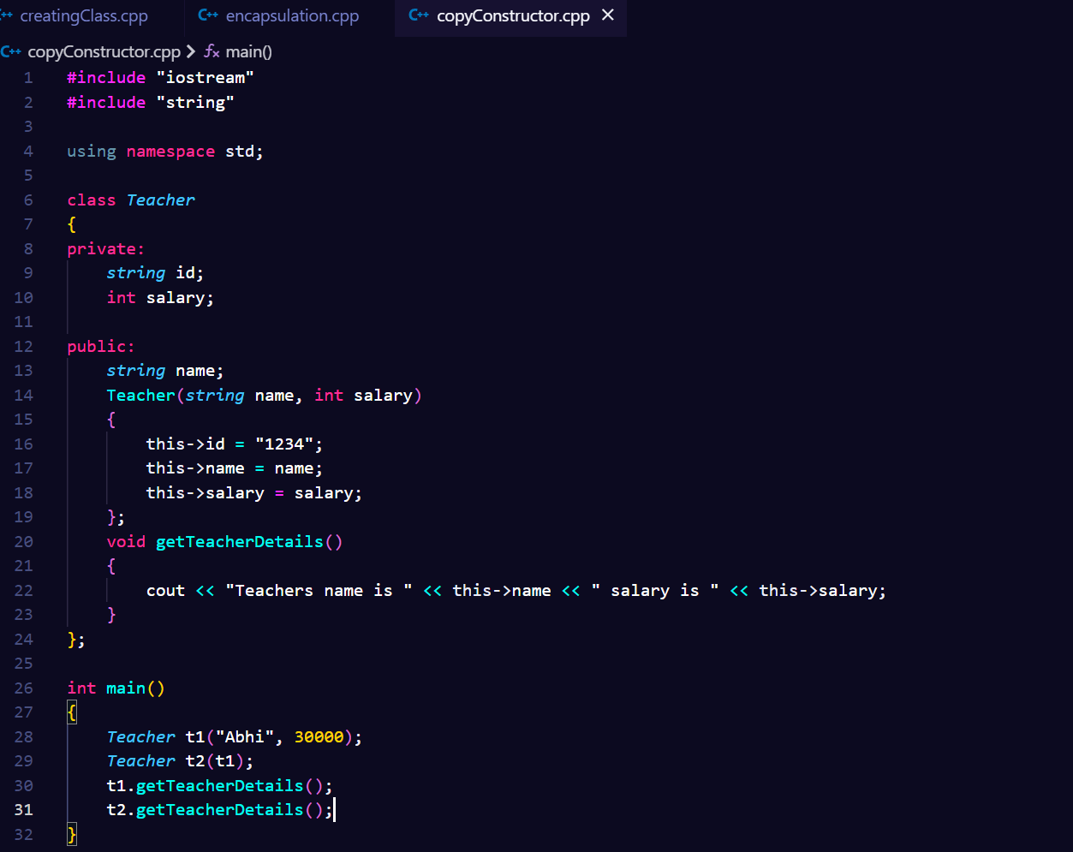

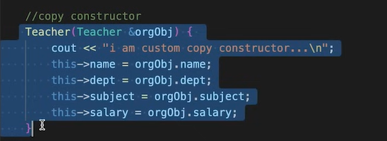

**Shallow and deep copy**

A shallow copy of an object copies all of the member values from one object to another.

A deep copy, on the other hand, not only copies the member values but also makes copies of and dynamically allocated memory that the members point to