Movie Recommendation System Using Collaborative Filtering, SVD, Content-Based Filtering, and a Web Demo

InitForge Recommendation System Team

Leader: Nguyễn Xuân Lĩnh (24IT140)
Members: Ngô Đa Bảo Nhân (24IT184), Đặng Tiến Tân (24IT238), Trần Lê Gia Khánh (24IT112)

Goal | - Build an end-to-end movie recommendation system.  - Compare multiple recommendation methods instead of relying on one model.  - Expose recommendations through a working API and browser demo.
Domain | - Domain: movie recommendation and personalized information filtering.  - Related areas: machine learning, recommender systems, ranking, and lightweight web deployment.
Recommendation method | - User-Based Collaborative Filtering.  - Item-Based Collaborative Filtering.  - SVD matrix factorization for latent preference modeling.  - Content-Based Filtering using TF-IDF over movie genres.  - Weighted Hybrid recommender with temporal and demographic context analysis.
Data collection | - Source: official GroupLens MovieLens 1M benchmark.  - ratings.dat: 1,000,209 explicit ratings.  - movies.dat: 3,883 catalog movies.  - users.dat: 6,040 user profiles.  - Loaded with pandas using the original double-colon separator and Latin-1 movie metadata.
Evaluation  results | - Offline evaluation uses an 80/20 train-test split.  - RMSE and MAE measure rating-prediction accuracy.  - Precision@K, Recall@K, MAP@K, and NDCG@K measure top-N ranking quality.  - SVD is the strongest pure predictor, with RMSE around 0.87 in the project materials.  - Content-Based Precision@10 is around 0.116; Hybrid is used for the demo because it balances accuracy, explainability, and cold-start support.
Conclusion | - SVD is best for rating prediction.  - Hybrid recommendation is more practical for real user interaction.  - The project is engineered as a full pipeline: data loading, models, evaluation, API, frontend, and deployment.
Online  repository | - GitHub repository: https://github.com/initforge/recommendation-system  - Frontend demo: https://movie-recsys.pages.dev/
Team R&R  Peer review | - Data and EDA: load, clean, and analyze MovieLens 1M.  - Modeling: implement Collaborative Filtering, SVD, Content-Based, and Hybrid methods.  - Evaluation: compare prediction and ranking metrics.  - Frontend and deployment: connect Cloudflare Pages to Colab/FastAPI through ngrok.  - Peer review: verify notebooks, reusable modules, and presentation outputs before final integration.
History of  team meeting | - Week 1-2: setup, dataset loading, and EDA.  - Week 3-4: User-Based and Item-Based Collaborative Filtering.  - Week 5: SVD and Content-Based Filtering.  - Week 6: Hybrid recommender integration.  - Week 7: temporal and demographic context analysis.  - Week 8-10: evaluation, web demo, report, and presentation preparation.

1. Introduction

Backgrounds
- Modern streaming and digital content platforms face a basic but difficult problem: the catalog is far larger than any user can browse manually.
- That creates information overload, weak discovery, and lower engagement.
- A recommender system reduces this burden by learning preference patterns from historical behavior and surfacing the most relevant items first.
Motivation
- This project is motivated by the need to turn recommender-system theory into a complete engineering workflow.
- Rather than stopping at one algorithm, the repository implements multiple recommendation paradigms, compares them systematically, and pushes the final system into a live web demo that can be used during presentation and testing.

What is the research issue?
- The central research issue is how to predict user preference and generate useful top-N movie recommendations from a highly sparse user-item matrix.
- In MovieLens 1M, the repository contains 1,000,209 ratings from 6,040 users over 3,706 rated movies, yet the matrix is still about 95.53% empty.
- The system must infer missing interactions, rank unseen movies, and remain useful for both established and partially cold-start scenarios.
Why is this research important?
- The problem matters because recommendation is no longer a niche feature; it directly affects user satisfaction, engagement, and discovery in large-scale digital systems.
- Academically, the project is also important because it compares several standard recommendation strategies on a shared benchmark, which makes strengths and limitations easier to explain and defend.

2. Problem description and modeling

Problem modeling
- The project models recommendation as a personalized ranking and rating prediction problem.
- The core input is the rating tuple (userId, movieId, rating, timestamp), enriched by movie metadata (title, genres) and user attributes (gender, age, occupation).
- Given a target user, the system identifies unseen movies and estimates which of them are most likely to be relevant.
- At the system level, the repository treats recommendation as a pipeline: load raw data, preprocess features, split training and test data, train several models, compare their performance, and expose the selected model behavior through API endpoints and a browser interface.

Mathematical modeling (e.g., user feedbacks)
- Let R be the user-item rating matrix, where each observed entry r(u, i) is an explicit score from 1 to 5.
- Collaborative Filtering estimates unknown ratings from neighborhood structure.
- In User-Based CF and Item-Based CF, cosine similarity is used to find nearest neighbors and prediction is computed as a similarity-weighted average.
- SVD factorization approximates the sparse matrix as R ≈ P × Q^T, where P represents latent user factors and Q represents latent item factors.
- Content-Based Filtering converts movie genres into TF-IDF vectors and uses cosine similarity between items.
- The deployed Hybrid model combines collaborative and content scores using a weighted rule, conceptually `score(u, i) = alpha * SVD(u, i) + (1 - alpha) * Content(u, i)`.

3. Recommendation by your idea

What is your idea for recommendation?
- The key idea is not to trust a single recommendation philosophy.
- The repository is designed as a comparative recommendation laboratory where each algorithm plays a clear role.
- Neighborhood methods explain social or behavioral similarity, SVD captures hidden latent preference structure, Content-Based Filtering provides interpretable metadata-driven retrieval, and the Hybrid model combines them for deployment.
What kind of recommendation can be generated?
- The system can generate several recommendation outputs.
- First, it can return a personalized top-N movie list for an existing user.
- Second, it can generate collaborative recommendations based on similar users or similar items.
- Third, it can produce genre-driven recommendations for cases where metadata is more reliable than behavioral history.
- Fourth, it can expose context-aware insights such as how ratings differ by gender, age group, day of week, or hour of activity.
- From the repository structure, the final demo is intended to support direct recommendation requests by user ID and algorithm choice, making it suitable both for experimentation and presentation.

4. Implementation

Development environment
- The development environment combines notebook-based experimentation with modular Python code.
- The project uses Python, pandas, NumPy, matplotlib, seaborn, and scikit-learn for data handling and feature processing.
- The notebooks are designed for Google Colab so that heavy model training can be executed in a convenient cloud runtime, while reusable logic is organized under `src/`.
- For application delivery, the backend stack uses FastAPI and Uvicorn, while the frontend is a static HTML/CSS/JavaScript interface styled with Tailwind.
- Deployment relies on Google Colab for model execution, ngrok for temporary public tunneling, and Cloudflare Pages for the static frontend.
System architecture
- The architecture is intentionally decoupled.
- Model training and the recommendation API are prepared in the notebook pipeline and exposed through FastAPI endpoints such as `/api/health`, `/api/recommend`, `/api/stats`, and `/api/evaluation`.
- The frontend does not host the machine learning models; instead, it connects to the Colab backend through an ngrok URL supplied by the user.
- This design has two advantages.
- First, it keeps deployment cost low because the user interface can remain fully static on Cloudflare Pages.
- Second, it lets the team demonstrate a real end-to-end system without maintaining a continuously running server.
- Internally, the codebase is cleanly divided into constants, data loading, models, evaluation, and context analysis modules.
User interface
- The frontend follows a minimalist 'Zen UI' concept.
- It guides the user through three steps: connect to the backend, inspect high-level dataset statistics, and request recommendations by entering a user ID and selecting an algorithm.
- The algorithm selector includes Hybrid, SVD, Content-Based, and User-Based CF, and the interface is designed for quick demo interaction rather than complex dashboarding.
- This interface is well aligned with the project goal.
- It translates a notebook-based recommender into a presentable artifact that can be used during a classroom presentation or live demonstration.
Screenshot
Figure 1. Screenshot of the deployed Zen-style frontend interface used to connect to the recommendation API and request personalized movie suggestions.
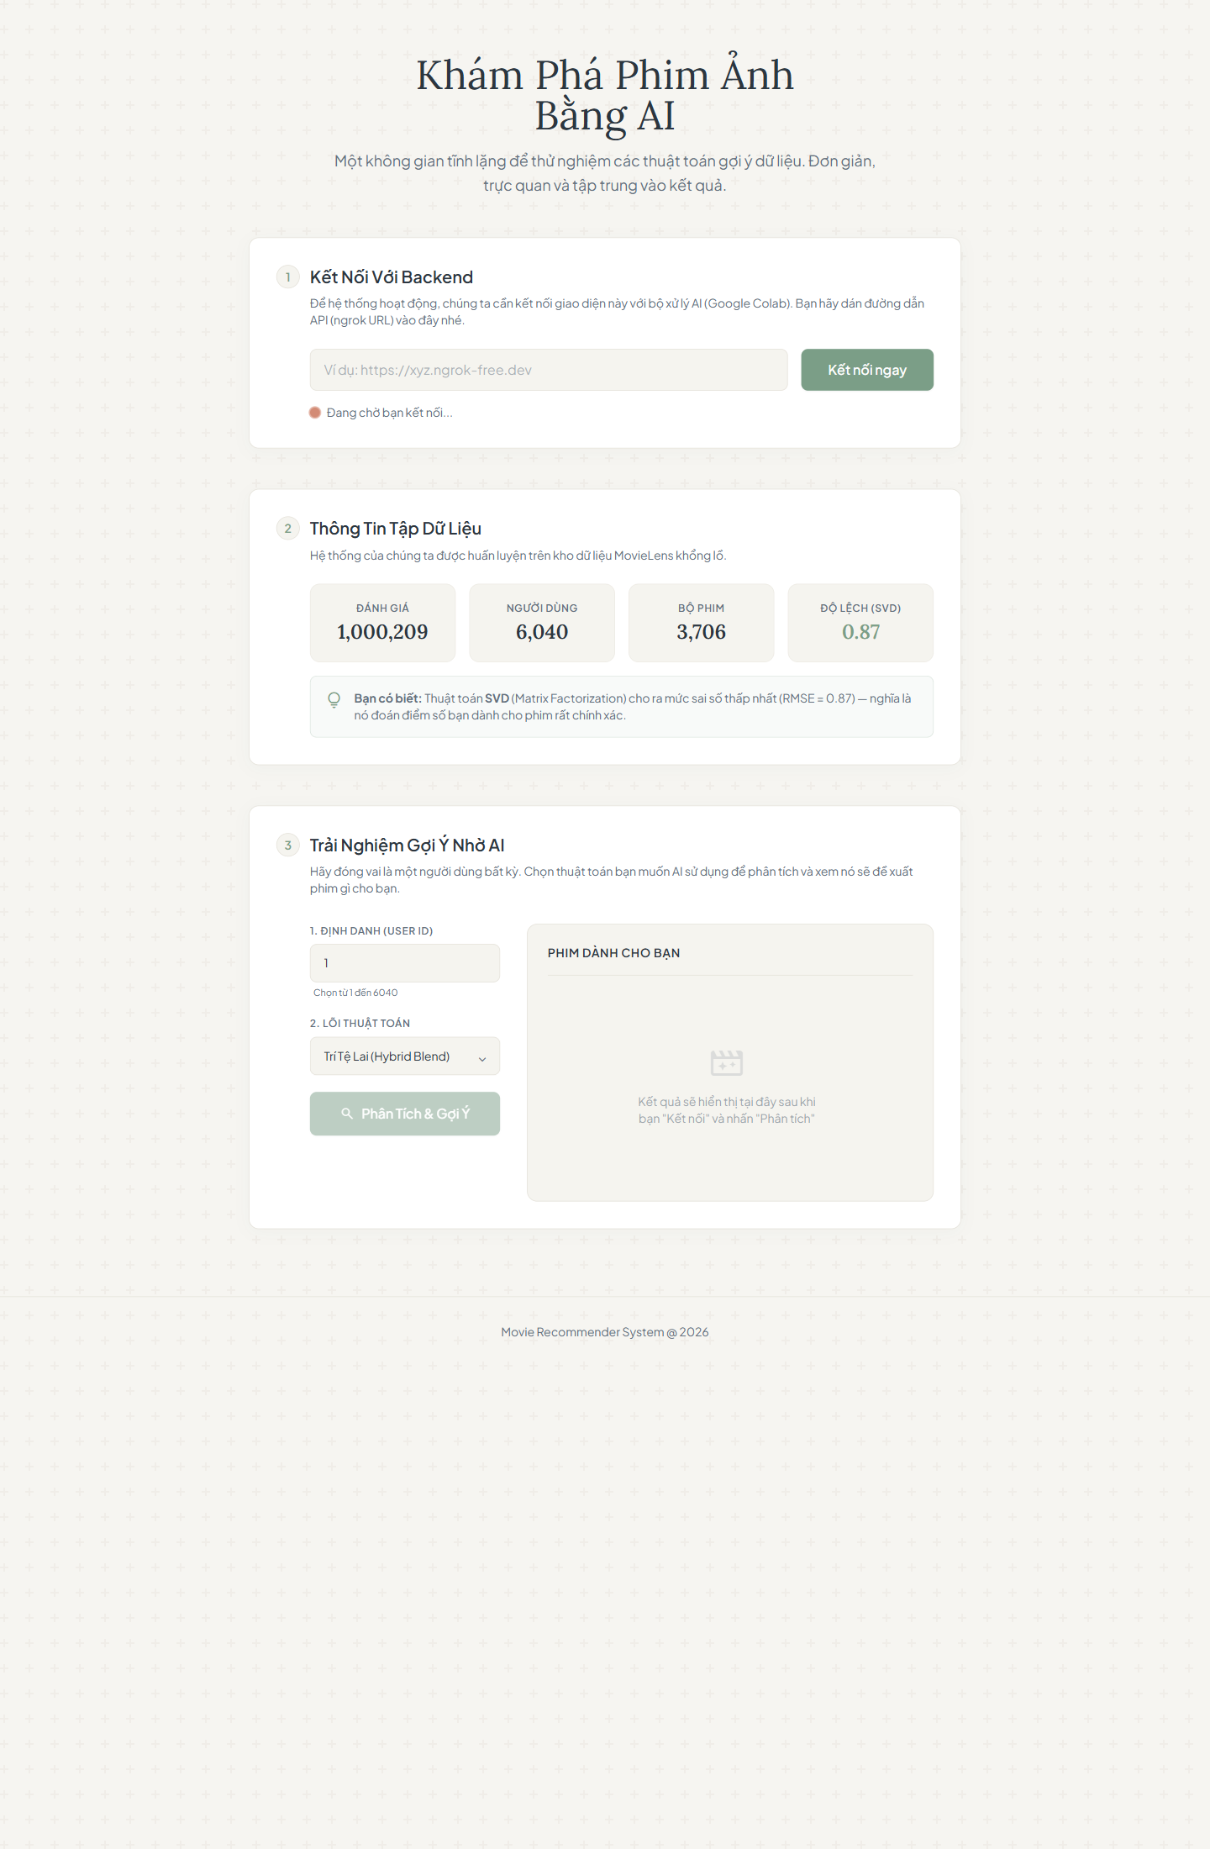

5. Evaluation and discussion

How to design the evaluation?
- The evaluation design combines offline prediction and ranking assessment.
- The notebooks use an 80/20 train-test split for observed ratings.
- For rating prediction models such as User-Based CF, Item-Based CF, and SVD, the project evaluates RMSE and MAE so that predicted scores can be compared directly with actual ratings.
- For recommendation quality, the project also uses top-K ranking metrics such as Precision@K, Recall@K, MAP@K, and NDCG@K.
- This is important because users experience the ranked list, not only the raw predicted rating.
- Content-Based and Hybrid approaches are therefore especially meaningful in ranking-oriented evaluation.
Evaluation results
- The repository consistently positions SVD as the strongest pure prediction model.
- Prepared evaluation notes and slides report an RMSE of about 0.87 for SVD, while neighborhood-based Collaborative Filtering models stay around the low 0.9 range.
- The project also reports Content-Based Precision@10 around 0.116, which is reasonable for a sparse movie catalog.
- Locally recomputed descriptive statistics support the difficulty of the task: the matrix is about 95.53% sparse, the average rating is 3.5816, and each user contributes about 165.60 ratings on average.
- The most common genres are Drama (1603), Comedy (1200), Action (503), Thriller (492), Romance (471).
- Highly rated and frequently discussed movies such as American Beauty (1999) (3,428 ratings); Star Wars: Episode IV - A New Hope (1977) (2,991 ratings); Star Wars: Episode V - The Empire Strikes Back (1980) (2,990 ratings) provide strong anchors for collaborative behavior.
Discussion
- The results suggest a clear division of strengths.
- SVD performs best for rating prediction because latent factor models compress the sparse matrix into a more informative representation.
- User-Based and Item-Based CF are conceptually transparent and useful for teaching, but they are more exposed to sparsity and neighbor instability.
- Content-Based Filtering is not the best pointwise predictor, yet it remains valuable because it is interpretable and can recommend even when interaction history is limited.
- Context analysis also reveals meaningful patterns.
- In this dataset, female users rate slightly higher on average than male users (3.6204 vs.
- 3.5689).
- The highest mean rating belongs to the `56+` group at 3.7666.
- Temporal behavior is more nuanced than the generic assumption that weekends are always strongest: the repository's data shows solid activity and rating quality around late work-week periods, while Sunday is weaker than Friday and Saturday.
- These observations strengthen the case for combining collaborative, content, and contextual reasoning.

6. Conclusion

What is your insight? What is your experience?
- The main insight is that recommendation quality should be judged from more than one angle.
- A model that wins RMSE is not automatically the most deployable model, and a model that is easy to explain may still be strategically useful even if its numeric accuracy is lower.
- This project demonstrates that a hybrid mindset is usually more practical than algorithmic purism.
- From an implementation perspective, the most valuable experience is architectural separation.
- Keeping notebooks for experimentation, `src/` for reusable logic, and `frontend/` for presentation made the project easier to debug, extend, and explain.
What do you realize?
- We realize that recommender systems are as much about engineering decisions as they are about machine learning formulas.
- Dataset preparation, sparsity handling, evaluation design, API exposure, and interface clarity all affect whether a model becomes a usable product.
- We also realize that benchmark datasets remain useful because they make algorithm comparison reproducible and academically defensible.
- A natural next step would be to replace the temporary Colab-plus-ngrok deployment with a more stable containerized backend and to explore deeper recommendation models such as Neural Collaborative Filtering.

7. References
1. GroupLens Research. MovieLens 1M Dataset. https://grouplens.org/datasets/movielens/
2. InitForge. Recommendation System Repository. https://github.com/initforge/recommendation-system
3. scikit-learn documentation. TF-IDF and cosine similarity tools. https://scikit-learn.org/
4. scikit-surprise documentation. Recommendation algorithms for explicit ratings. https://surpriselib.com/
5. FastAPI documentation. https://fastapi.tiangolo.com/
6. Cloudflare Pages documentation. https://developers.cloudflare.com/pages/
7. ngrok documentation. https://ngrok.com/docs

