Create docker volume foo



Create docker containers mapped to foo: Feature-1

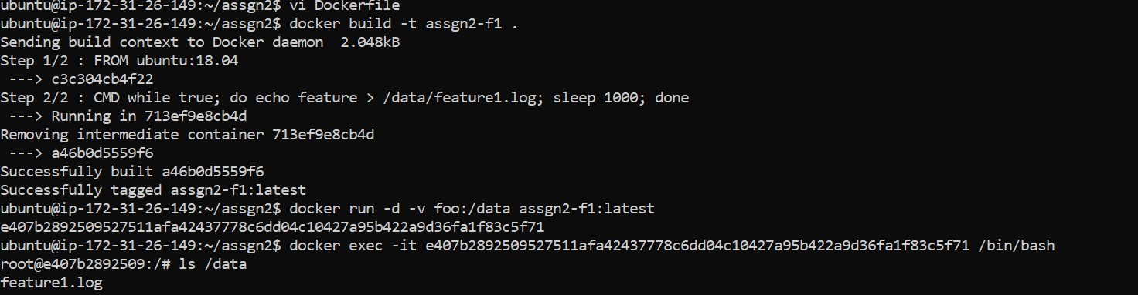

Feature-3

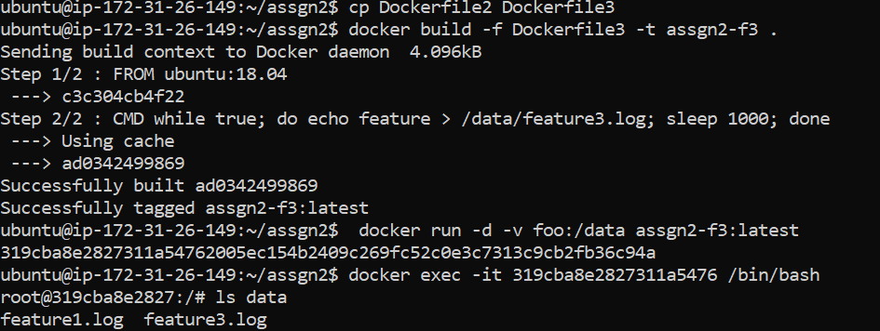

Feature-2

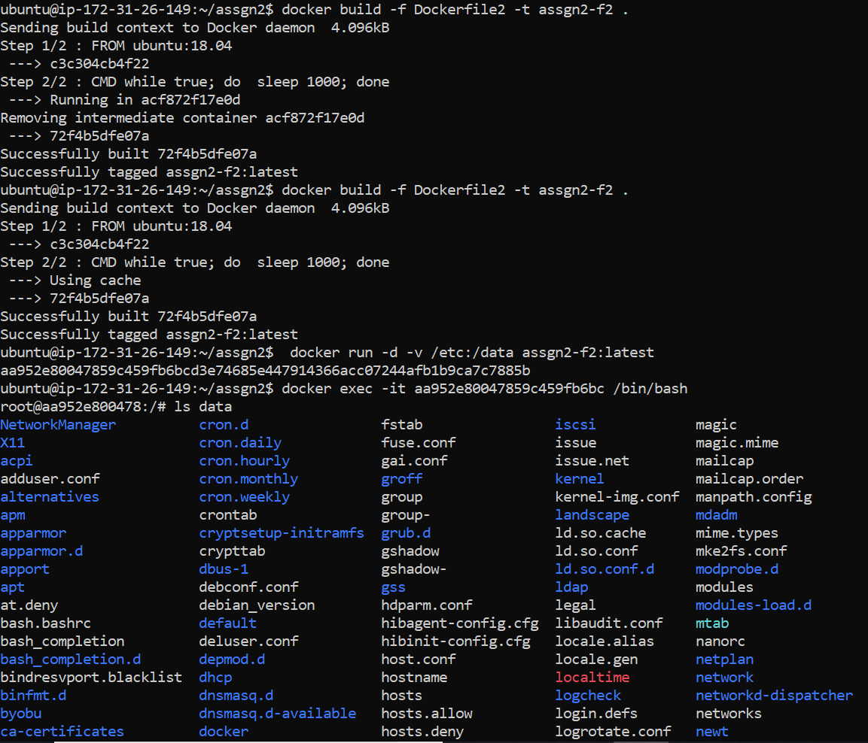

Take backup of volume

