Create new Docker compose file:

version: '3.3'

services:

db:

image: mysql:5.7

volumes:

- db_data:/var/lib/mysql

restart: always

environment:

MYSQL_ROOT_PASSWORD: somewordpress

MYSQL_DATABASE: wordpress

MYSQL_USER: wordpress

MYSQL_PASSWORD: wordpress

net: ${NETWORK}

wordpress:

depends_on:

- db

image: wordpress:latest

ports:

- 8000:80

restart: always

environment:

WORDPRESS_DB_HOST: db:3306

WORDPRESS_DB_USER: wordpress

WORDPRESS_DB_PASSWORD: wordpress

WORDPRESS_DB_NAME: wordpress

net: ${NETWORK}

volumes:

db_data: {}

Create overlay network mynet and add it to above compose file and start docker-compose.

…

…

volumes:

db_data: {}

networks:

default:

external:

name: mynet



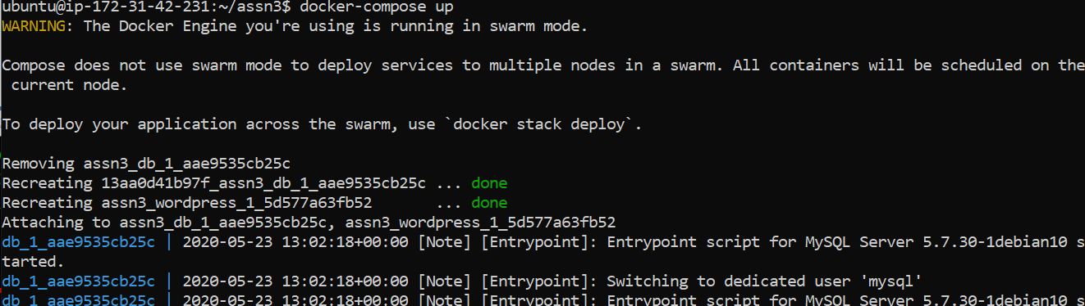

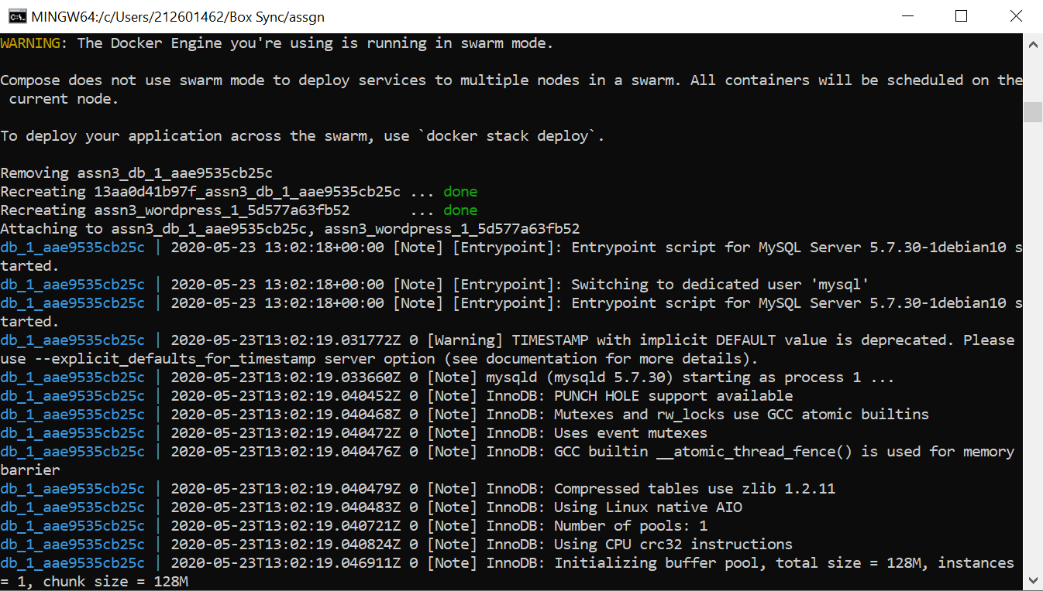

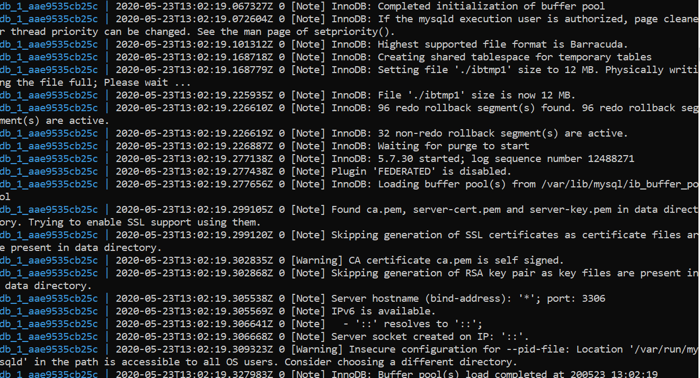

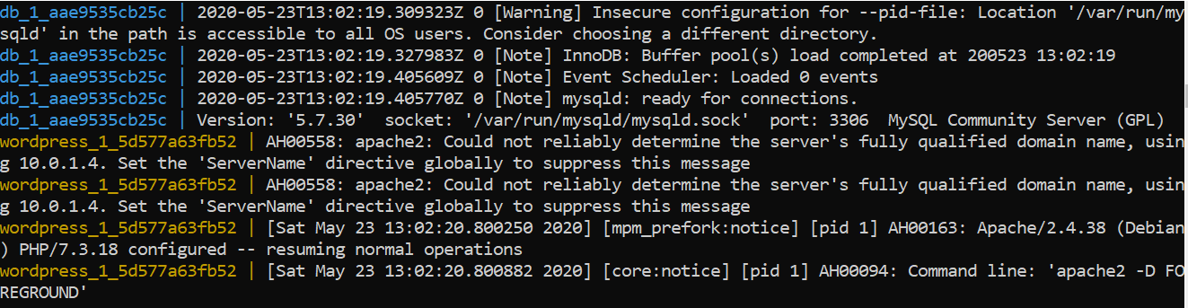

Open the wordpress with ip from browse:

