1. Deploy a sample HTML website in any apache container, and demonstrate how we can

dynamically change content in the container by making changes on the host machine ( Bind

Mounts)

FROM ubuntu:18.04

RUN apt-get update

RUN apt-get install -y apache2

COPY index.html /var/www/html

CMD apachectl -D FOREGROUND

EXPOSE 80







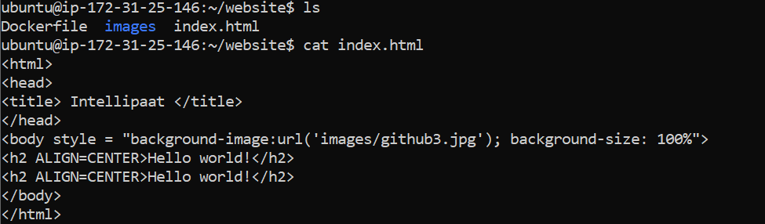

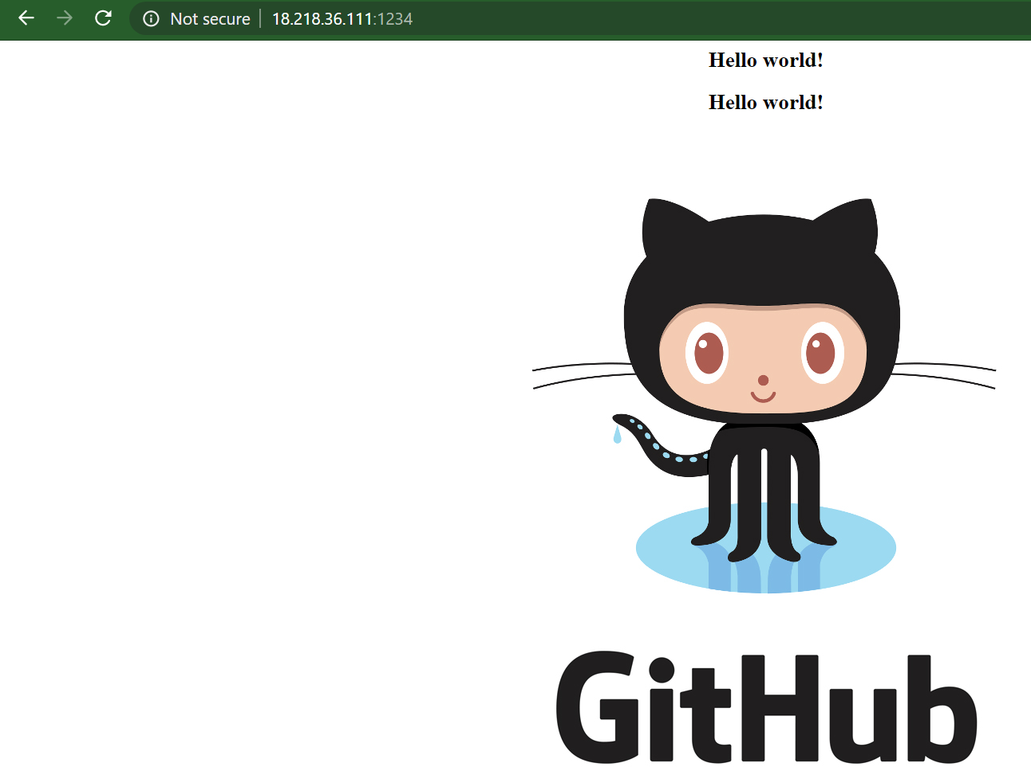

2. Deploy apache and nginx containers using Docker Compose, Apache should be exposed onPort 91 and nginx on port 92

version: '3.3'

services:

webserver:

image: nginx

ports:

- 92:80

networks:

- app-network

apache:

image: bitnami/apache:2.4

ports:

- 91:8080

networks:

- app-network

networks:

app-network:

driver: overlay

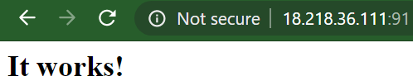

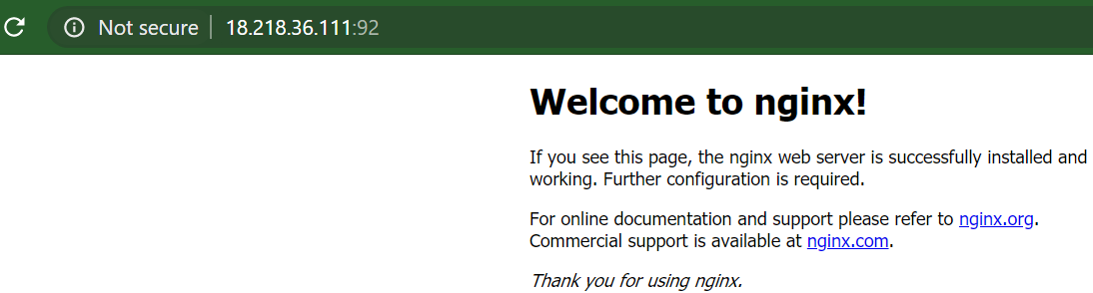

3. Initialize a Docker Swarm Cluster, and deploy two ubuntu containers in a overlay network.

Demonstrate they can communicate with each other, by pinging them

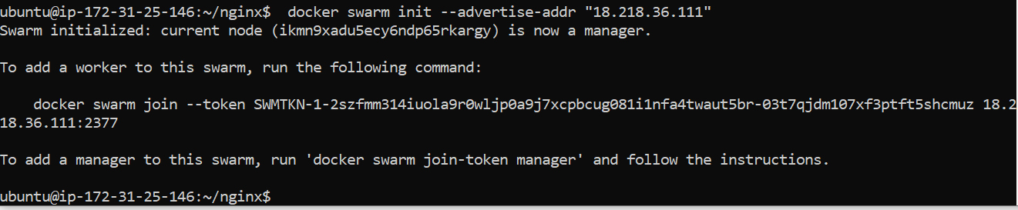



ubuntu@ip-172-31-25-146:~/cluster$ cat Dockerfile

FROM ubuntu:latest

CMD tail -f /dev/null

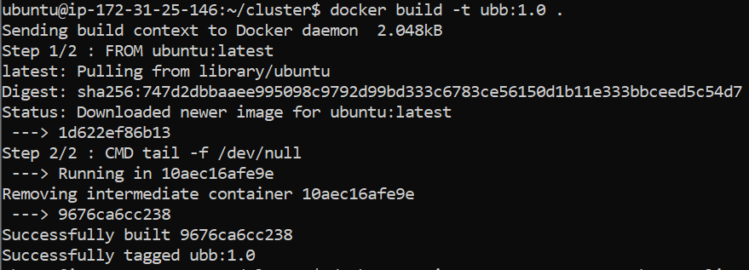

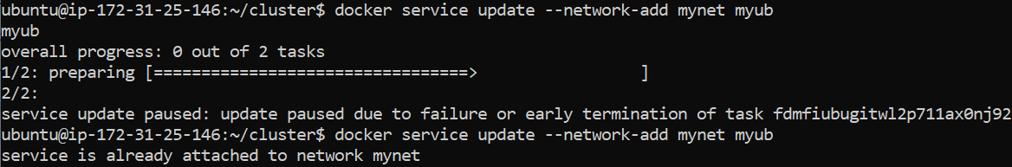

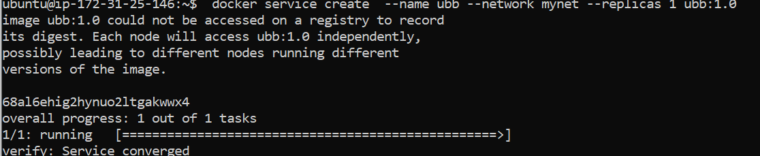

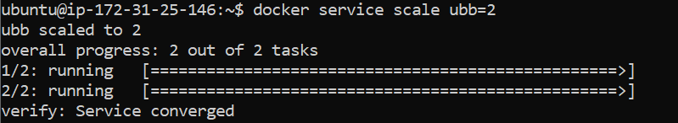

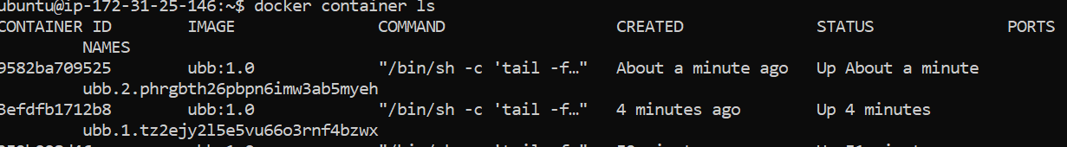

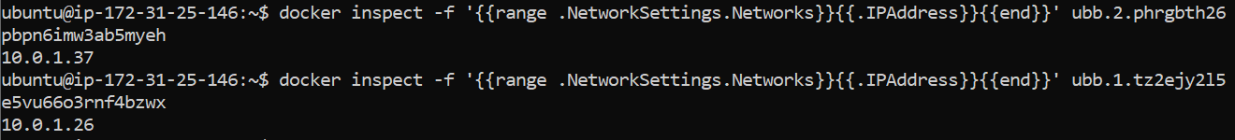

Ping works.

