# Software Requirements

Version 8, last updated by Hangting Ye and Jia Ding at 2021-05-06

# Software Requirements Specification (SRS)

Revision History:

|  |  |  |
| --- | --- | --- |
| Date | Author | Description |
| 4-15-2021 | Jia Ding | Adding/Editing Introductions, Concept of Operations and Use Cases |
| 4-18-2021 | Hangting Ye | Adding System Inputs and Outputs, Fundamental Assumptions and Appendices |
| 4-19-2021 | Hangting Ye | Editing the Introduction |
| 4-20-2021 | Hangting Ye | Editing the Use Cases |
| 4-23-2021 | Hangting Ye | Editing the Use Cases and the Introduction |
| 4-26-2021 | Hangting Ye | Editing the System Inputs and Outputs |
| 5-2-2021 | Hangting Ye | Editing the Use Cases |
| 5-6-2021 | Hangting Ye | Editing the Use Cases |

Contents

Software Requirements 1

Software Requirements Specification (SRS) 1

1.   Introduction 4

1.1    Purpose 4

1.2    How to use the document 4

2.   System Context 4

3.   Use Cases 5

Case 1: The user wants to get all the key points of the bone 5

Case 2: The user wants to get the points of the bones that form the Cobb 7

Case 3: The user wants to get the Cobb value. 10

4 System Inputs and Outputs 12

5.    Fundamental Assumptions 12

6.    Appendices  13

6.1 Definitions...................................................................................................13

6.2    References 13

## Introduction

### 1.1    Purpose

This documents is intended to provide information about how to use the system to upload spinal X-ray image and get the results of the representation of COBB.

### 1.2    How to use the document

Table of Contents:  
  
1. Introduction

2. System Context - details any specific system requirements the application will require to run  
3. Use cases - A detailed look at each functional requirement, describing the application context both before and after an action is taken  
4. System Inputs and Outputs - A description of allowed inputs and generated outputs  
5. Fundamental Assumptions - Some specifics about input, output, or behavior upon which other requirements are founded will be listed here  
6. Appendicies - Details aiding the understanding of this document

### **2****System Context**

**System Requirements:**  
Requires a system with a GUI display because all of the operations are performed through a GUI. The application is in Java so users must have an updated version of Java installed on their machine to use the application.

Windows:

* Windows 10 (8u51 and above)
* Windows 8.x (Desktop)
* Windows 7 SP1
* Windows Vista SP2
* Windows Server 2008 R2 SP1 (64-bit)
* Windows Server 2012 and 2012 R2 (64-bit)
* RAM: 128 MB
* Disk space: 124 MB for JRE; 2 MB for Java Update
* Processor: Minimum Pentium 2 266 MHz processor

Mac OS X:

* Intel-based Mac running Mac OS X 10.8.3+, 10.9+
* Administrator privileges for installation

Linux:

* Oracle Linux 5.5+1
* Oracle Linux 6.x (32-bit), 6.x (64-bit)2
* Oracle Linux 7.x (64-bit)2 (8u20 and above)
* Red Hat Enterprise Linux 5.5+1, 6.x (32-bit), 6.x (64-bit)2
* Red Hat Enterprise Linux 7.x (64-bit)2 (8u20 and above)
* Ubuntu Linux 12.04 LTS, 13.x
* Ubuntu Linux 14.x (8u25 and above)
* Ubuntu Linux 15.04 (8u45 and above)
* Ubuntu Linux 15.10 (8u65 and above)

## Use Cases

### Case 1: The user wants to get all the key points of the bone

|  |  |  |  |
| --- | --- | --- | --- |
| Use Case | The user wants to get all the key points of the bone | | |
| Version | 8 | Created (date): | 2021-5-6 |
| Author | *Hangting Ye & Jia Ding* | | |
| Source | \ | | |
| Goals | Get all the key points of the bone | | |
| Summary | \ | | |
| Actors | *Server* | | |
| Trigger | \ | | |
| Precondition | The spinal X-ray image has been stored on the host server. | | |
| Frequency | Once every time you use the application | | |
| Postconditions | Server get the status and points | | |
| Diagram | \ | | |

|  |  |  |
| --- | --- | --- |
| **Basic Flow** | *Actor* | *System* |
|  | The server developer calls this algorithm program by passing in command options (-keypoints) and the path address of the given spinal X-ray image. | Algorithm program receives the input. |
|  |  | The algorithm program gets the spinal X-ray image through the path and processes it and then calculate the result. |
|  |  | The algorithm returns a JSON string, where the "status" key corresponds to "success" and the "points" key contains a JSON array, and each bone of each term contains 4 x values and 4 y values.  e.g. {  “status”: “success”,  “points”: [  {  “1”: [x1,y1],  “2”:[x2,y2],  “3”:[x3,y3]  },  {  ……  }  ]  } |

|  |  |  |
| --- | --- | --- |
| **Alternative Flow** | *Actor* | *System* |
|  | The server developer calls this algorithm program by passing in command options (-keypoints) and the path address of the given spinal X-ray image. | Algorithm program receives the input. |
|  |  | The source image path does not have read permission or the destination image path does not have write permission. |
|  |  | The "status" key in the returned JSON string corresponds to "failed". |
|  |  | The image format corresponding to the image path is wrong. |

**Diagram:**

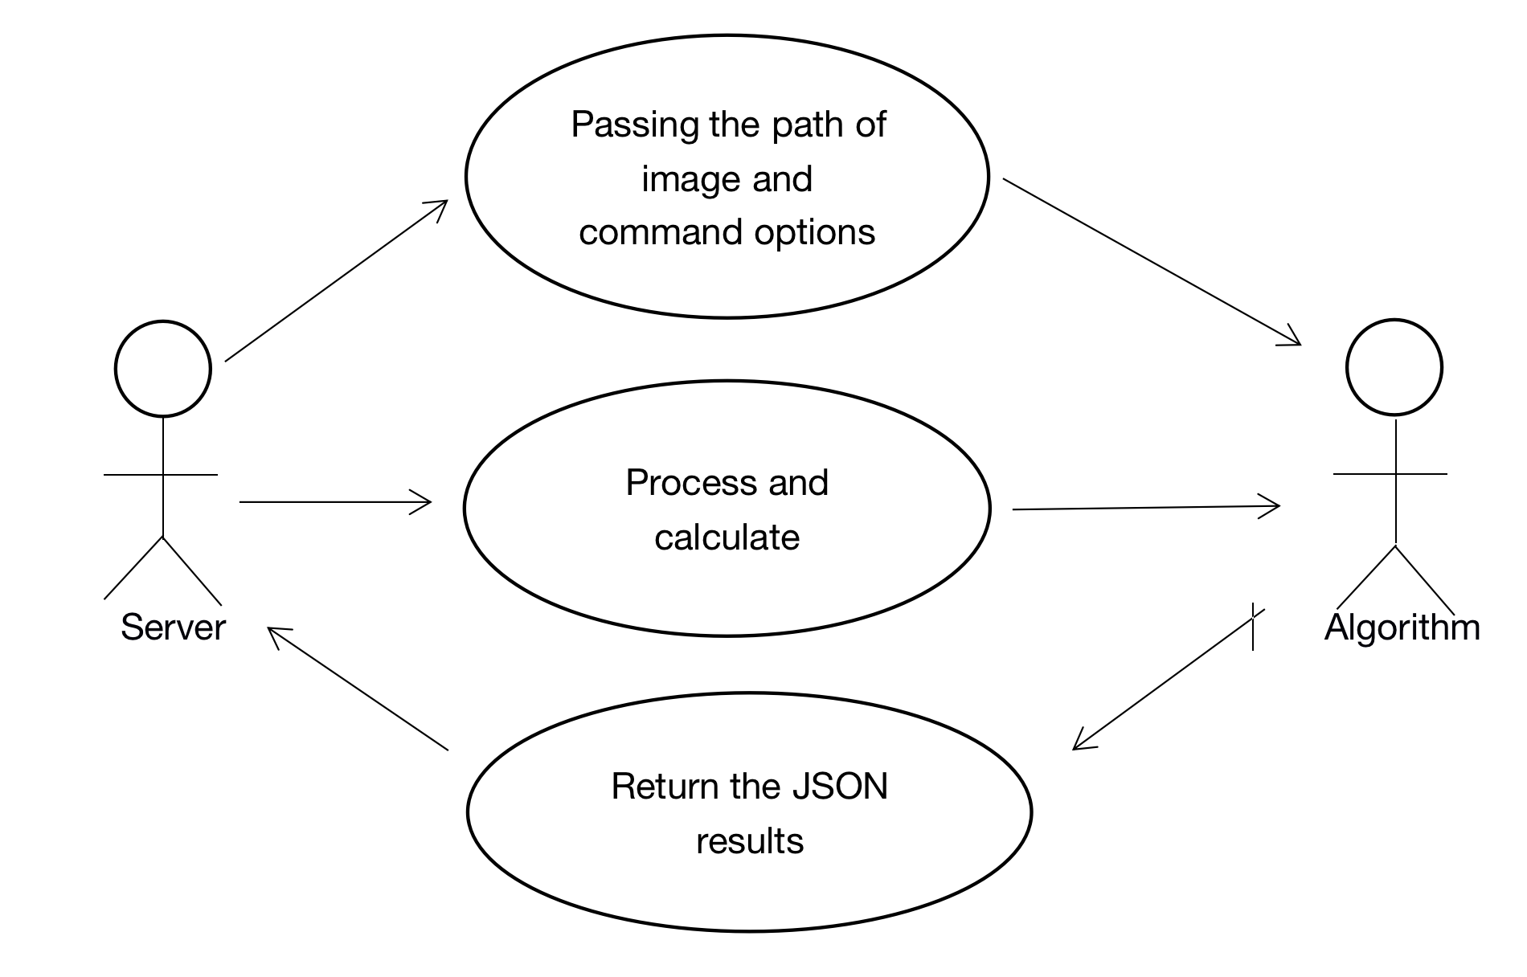

### Case 2: The user wants to get the points of the bones that form the Cobb

|  |  |  |  |
| --- | --- | --- | --- |
| Use Case | The user wants to get the points of the bones that form the Cobb | | |
| Version | 8 | Created (date): | 2021-5-6 |
| Author | *Hangting Ye & Jia Ding* | | |
| Source | \ | | |
| Goals | Get all the points of the two that form the Cobb | | |
| Summary | \ | | |
| Actors | *Server* | | |
| Trigger | \ | | |
| Precondition | The spinal X-ray image has been stored on the host server. | | |
| Frequency | Once every time you use the application | | |
| Postconditions | Server get status and two terms of points for each bone | | |
| Diagram | \ | | |

|  |  |  |
| --- | --- | --- |
| **Basic Flow** | *Actor* | *System* |
|  | The server developer calls this algorithm program by passing in command options (-locate) and the path address of the given spinal X-ray image. | Algorithm program receive the input. |
|  |  | The algorithm program gets the spinal X-ray image through the path and processes it and then calculate the result. |
|  |  | The algorithm returns a JSON string, where the "status" key corresponds to "success" and “points” key contains a JSON array, which contains two terms and each term contains 2 x value and 2 y value for each bone.  e.g. {  “status”: “success”,  “points”: {{‘1’: [[x1,y1],[x2,y2]]}  , {‘2’: [[x1,y1],[x2,y2]]}  } //each cobb have a list of points(order:top-right,top-left,bottom-right,bottom-left) |

|  |  |  |
| --- | --- | --- |
| **Alternative Flow** | *Actor* | *System* |
|  | The server developer calls this algorithm program by passing in command options (-locate) and the path address of the given spinal X-ray image. | Algorithm program receive the input. |
|  |  | The source image path does not have read permission or the destination image path does not have write permission. |
|  |  | The "status" key in the returned JSON string corresponds to "failed". |
|  |  | The image format corresponding to the image path is wrong. |

**Diagram:**



### Case 3: The user wants to get the Cobb value.

|  |  |  |  |
| --- | --- | --- | --- |
| Use Case | The user wants to get the Cobb value | | |
| Version | 8 | Created (date): | 2021-5-6 |
| Author | *Hangting Ye & Jia Ding* | | |
| Source | \ | | |
| Goals | Get the Cobb value | | |
| Summary | \ | | |
| Actors | *Server* | | |
| Trigger | \ | | |
| Precondition | The spinal X-ray image has been stored on the host server. | | |
| Frequency | Once every time you use the application | | |
| Postconditions | Server get status and cobb value | | |
| Diagram | \ | | |

|  |  |  |
| --- | --- | --- |
| **Basic Flow** | *Actor* | *System* |
|  | The server developer calls this algorithm program by passing in command options (-cobb) and the path address of the given spinal X-ray image. | Algorithm program receive the input. |
|  |  | The algorithm program gets the spinal X-ray image through the path and processes it and then calculate the result. |
|  |  | The algorithm returns a JSON string, where the "status" key corresponds to "success" and the “cobb_value” key corresponds to the value of cobb. |

|  |  |  |
| --- | --- | --- |
| **Alternative Flow** | *Actor* | *System* |
|  | The server developer calls this algorithm program by passing in command options (-cobb) and the path address of the given spinal X-ray image. | Algorithm program receive the input. |
|  |  | The source image path does not have read permission or the destination image path does not have write permission. |
|  |  | The "status" key in the returned JSON string corresponds to "failed". |
|  |  | The image format corresponding to the image path is wrong. |

**Diagram:**



## 4 System Inputs and Outputs

#### 4.1 Inputs

The input comes from a call from the developer applying the algorithm.

Inputs When Call This Algorithm  
   *Path: the path of the computed spinal X-ray image.

   *Command: Selecting the option on the spinal X-ray image to be computed.

-keypoint：Obtaining the labelling of key points for obtaining all bone masses for a given spinal X-ray.

-locate：Obtaining the key points of all the bone fragments and marking the position of the bone fragments constituting Cobb Angle.

-cobb：Obtaining the key points of all the bone fragments, marking the position of the bone fragments constituting Cobb Angle and Cobb value.

#### 4.2 Outputs

The output is the output of the result of running this algorithm

Outputs When Call This Algorithm

*json: The return value is rendered as a JSON string. The JSON string has the following keys

“status”: Whether the algorithm runs successfully.

“path”: The storage address of the marked image.

“cobb”: The Cobb Angle value

## 5.    Fundamental Assumptions

The application can run on any system.

The application will not terminate when all windows are closed.  
Software updates will be downloaded by the end user as opposed to pushed out by the developers.

## 6.    Appendices

#### **6.1    Definitions**

|  |  |
| --- | --- |
| **Keyword** | **Definitions** |
| COBB | The severity of scoliosis is mostly evaluated by measuring the contralateral bending angle, and the most common angle measurement is the Cobb angle measurement method. The X-ray film used for measurement is the normal phase of the standard full length of the spine. |

### **6.2    References**

Comments are disabled for this space. In order to enable comments, Messages tool must be added to project.

You can add Messages tool from Tools section on the Admin tab.