

**Independent University Bangladesh**

Department of Electrical and Electronics Engineering

**Lab Report** **05**

Name: Injamamul Haque Sourov

Id: 1820170

Course code: EEE 321L

Couse name: Digital Signal Processing Lab

Lab no: 05

Lab title: Study on cross-correlation, auto-correlation and impulse response

Date: 16/12/2020

1. **Cross-correlation of two signals**

Code and output:

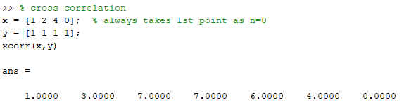

1. **Auto-correlation of a signal**

Code and output:

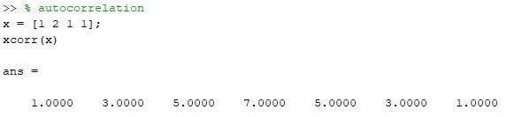

1. **Convolution of signals**

Code:

% convolution

n = -10:50;

x = stepseq(0,-10,50) - stepseq(10,-10,50);

stem(n,x)

h = ((0.9).^n).*(stepseq(0,-10,50));

figure(2);

stem(n,h)

m = -10:0.5:50; % convolution doubles the number of points

y = conv(x, h);

figure(3);

stem(m,y)

Output:

  
x(n)

  
h(n)

  
x(n)*h(n)

1. **Assignment (median and 3-point moving average of a signal)**
   1. Function definition

% compute the median(m) and the n-point moving average(y) of a signal

function [m, y] = med_avg(x, n)

m = median(x);

y = movmean(x, n);

end

* 1. Calls and outputs

Example 1:

x = [1 2 3 4 5 6 7]; % odd number of points

[median, mov_agv] = med_avg(x, 3) % 3-point moving average

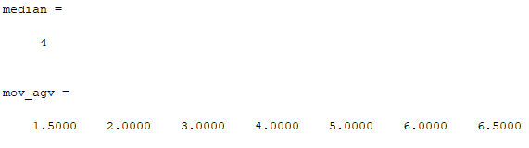

Example 2:

x = [2 4 6 8 6 4]; % even number of points

[median, mov_agv] = med_avg(x, 3) % 3-point moving average

