

**Independent University Bangladesh**

Department of Electrical and Electronics Engineering

**Lab Report** **01**

Name: Injamamul Haque Sourov

Id: 1820170

Course code: EEE 321L

Couse name: Digital Signal Processing Lab

Lab no: 01

Lab title: Introduction to EEE321L

Date: 11/11/2020

1. Generating sinusoidal signals with phase shifts

Code:

% define signals

x = -2*pi:0.01:2*pi; % specify domain

y = 20*sin(x+pi/4); % leading waveform

z = 20*sin(x-pi/4); % lagging waveform

% plot(independent, dependent var)

plot(x,y) % plot of y wrt x

plot(x,z) % plot of z wrt x

plot(x,y,x,z) % plot both in same graph

grid % toggles grid

^ Plots were obtained one after another, utilizing the same figure window;

Outputs:

1. Plot of y with respect to x



1. Plot of z with respect to x



1. Plot of both curves in same graph



1. Generating exponential signals

Code:

% exponential signal

expo = 10*exp(x); % exp = exponetial function

plot(x, expo)

Output:



1. Working with complex variable (i)

Code:

% operations with complex numbers

a = 3+4i;

b = 3-8i;

c = a+b

Output:

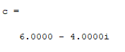

1. Combining multiple signals

Code:

% combining cosine and exponetial signal

x = 0:0.01:10;

comb = 10*exp(-x) + cos(x);

plot(x, comb)

Output:



1. Generating square wave

Code:

% square wave

x = 0:0.01:10;

y = 5*square(x);

plot(x,y)

Output:



1. Periodic signals

Code:

% periodic signal

t = 0:0.01:2*pi;

x = 2*sin(t);

plot(t,x)

Output:



1. Sub-plotting signals

Code:

% subplots

x = -2*pi:0.01:2*pi;

y = 20*sin(x+pi/4);

z = 20*sin(x-pi/4);

% side by side (1 row, 2 col)

figure(1) % open figure window

subplot(1,2,1) % (row, col, handle)

plot(x,y)

subplot(1,2,2)

plot(x,z)

% one above other (2 row, 1 col)

figure(2) % open figure window

subplot(2,1,1) % (row, col, handle)

plot(x,y)

subplot(2,1,2)

plot(x,z)

Output:

1. Side by side plots (1 row, 2 coumns)



1. One above the other (2 rows, 1 column)



1. Generating random matrices (signals)

Code:

% random signal

rand(4) % random 4x4 matrix with elements between 0 to 1

randn(4) % negative included

rand(1,5) % 1 row, 5 col, 0 to 1

Output:

1. Random 4x4 matrix with values between 0 and 1

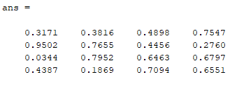

1. Random 4x4 matrix with where element can be negative

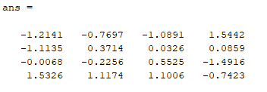

1. Random 5x1 matrix with elements between 0 and 1

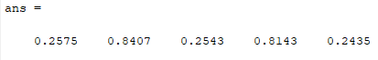

1. Defining and calling functions (defined as separate scripts)
   1. Function to add two numbers

Definition: [addition.m]

% function to add two numbers

function [z] = addition(x,y) % function [output] = name(comma_seperated_inputs)

z = x + y; % can only have general expressions

end % completes loop

Call and output:

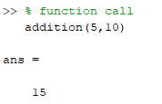

* 1. (Assignment) Function to calculate factorial

Definition: [factorial2.m]

% function to calculate factorial

function [f] = factorial2(a)

f = 1; % default value

while a > 1

f = f*a;

a = a-1;

end

end

Calls and outputs:

