WEEK 3
Incident Response Simulation
& Documentation
Cyber Security Analyst – Online Virtual Internship | 2026

Candidate | Injmam Ansari
Program | Cyber Security Analyst – Online Virtual Internship
Task | Week 3: Incident Response Simulation and Documentation
Assessment Type | Hypothetical defensive simulation

Contents
- 1. Executive Summary
- 2. Incident Scenario
- 3. Environment & Assumptions
- 4. Incident Classification
- 5. Detection & Initial Analysis
- 6. Incident Response Plan
- 7. Roles & Responsibilities
- 8. Communication Plan
- 9. Evidence & Investigation Workflow
- 10. Containment, Eradication & Recovery
- 11. Post-Incident Review
- 12. Metrics & Improvement Plan
- 13. Conclusion
- 14. References

1. Executive Summary
This report presents a structured incident response simulation for a hypothetical organization. The scenario models a suspected malware infection that begins with a compromised employee endpoint and creates a risk of credential theft, lateral movement, data exposure, and service disruption. The purpose is to demonstrate how a Cyber Security Analyst can coordinate detection, triage, containment, eradication, recovery, communication, and lessons learned without interacting with any real third-party system.
The response approach is aligned with NIST SP 800-61 Rev. 3, which integrates incident response with the broader NIST Cybersecurity Framework 2.0 risk-management lifecycle. The plan emphasizes preparation, continuous detection, evidence preservation, controlled containment, verified recovery, and improvement.

2. Incident Scenario
At 09:15, the security monitoring team receives an alert for unusual PowerShell activity on an employee workstation. Shortly afterward, the endpoint begins making repeated outbound connections to an unfamiliar external destination. Authentication logs also show an abnormal login attempt associated with the same user account.

Scenario Timeline
Time | Event | Analyst Observation | Priority
09:15 | EDR alert | Suspicious script execution | High
09:22 | SOC triage | Outbound connection anomaly | High
09:35 | Identity review | Unusual authentication attempt | High
09:50 | Scope analysis | Potentially affected endpoint + account | Critical
10:10 | Containment | Endpoint isolated; account protected | Critical

3. Environment & Assumptions
- Approx. 150-user organization with Windows endpoints, directory services, file servers and cloud applications.
- Centralized logging through a SIEM and endpoint telemetry through EDR.
- Backups are available and protected from direct workstation access.
- Incident-response actions are performed only by authorized personnel.
- The scenario is simulated; no real victim, network, credentials, malware, or third-party infrastructure is involved.

4. Incident Classification
Category | Assessment | Reason
Incident Type | Malware / Account Compromise | Endpoint telemetry + authentication anomaly
Severity | High | Potential business and data impact
Scope | Limited but uncertain | Initial evidence points to one endpoint/account
Business Risk | High | Possible access expansion and service disruption
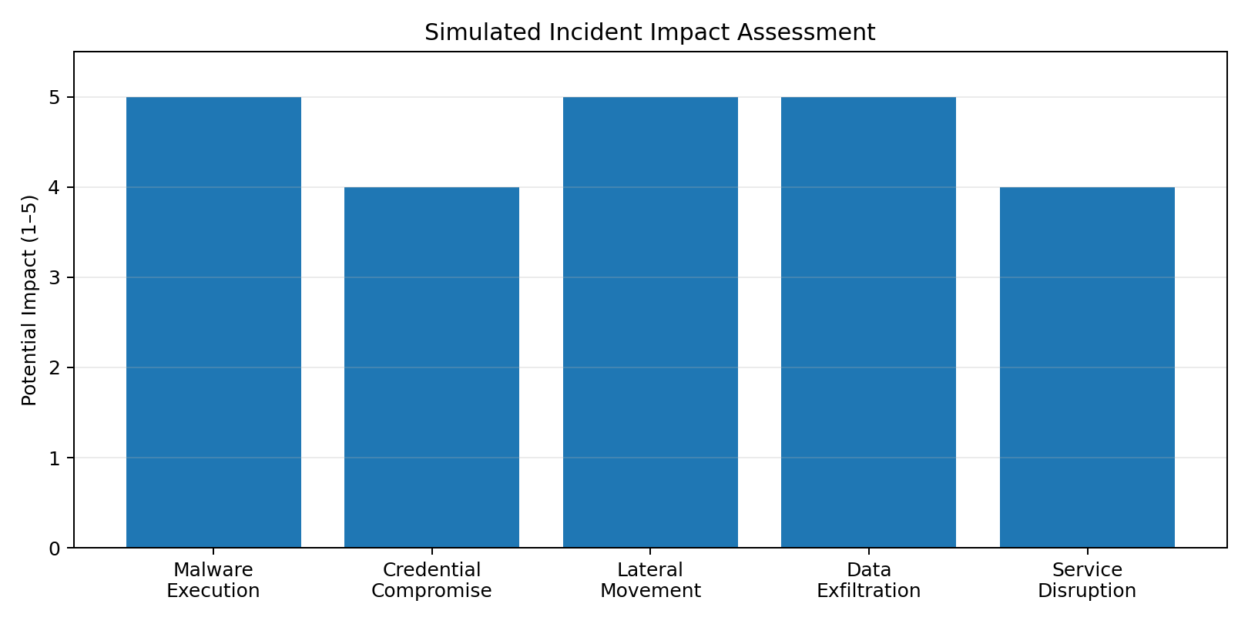

5. Detection & Initial Analysis
- Validate the alert using endpoint, identity, network and application telemetry.
- Identify the affected asset, user account, timestamps and relevant indicators.
- Assign an initial severity and open an incident record with a unique case ID.
- Preserve relevant logs and volatile evidence according to organizational procedures.
- Check whether similar indicators appear on other authorized systems.
- Escalate to the incident lead when evidence indicates material business risk.

Key Indicators to Review
- Unexpected script or process execution
- Abnormal authentication attempts
- New persistence mechanisms or scheduled tasks
- Unusual outbound network activity
- Unexpected file modification or encryption
- Security-control tampering

6. Incident Response Plan
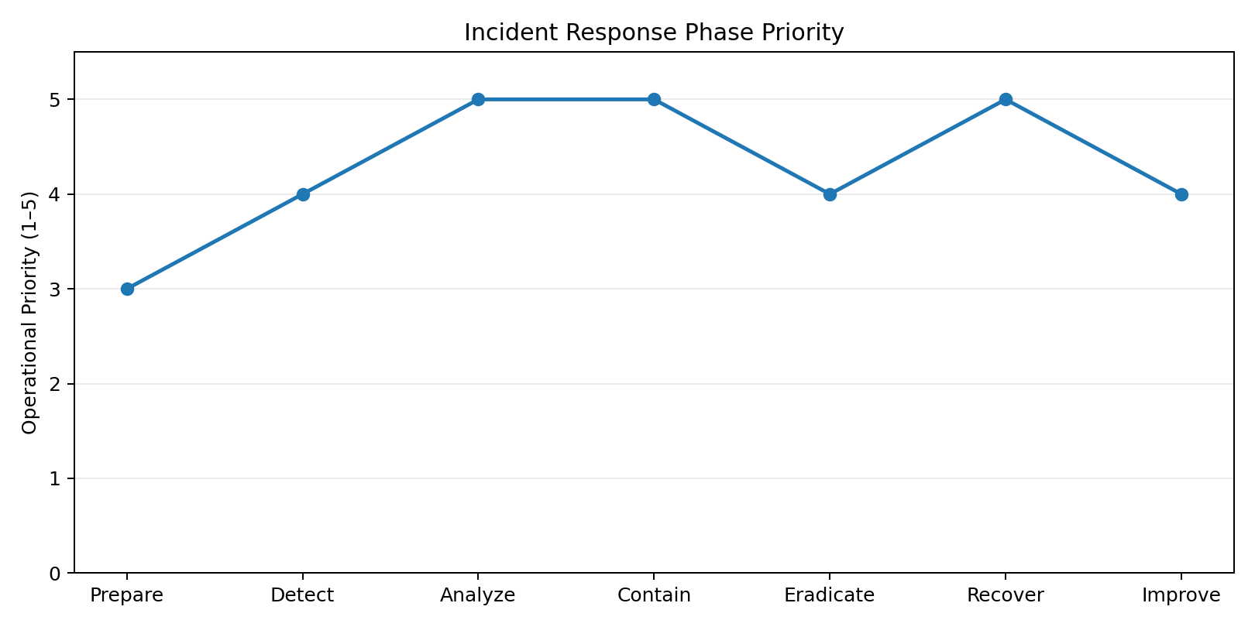

Preparation
Maintain asset inventories, response contacts, logging, backups, endpoint controls and tested procedures.

Detection
Collect alerts from EDR, SIEM, identity systems, firewalls and other authorized telemetry.

Analysis
Validate indicators, determine scope, establish timeline and assess business impact.

Containment
Isolate affected endpoints, protect accounts, restrict risky connectivity and prevent spread.

Eradication
Remove malicious artifacts, reset exposed credentials, close the root cause and verify controls.

Recovery
Restore trusted systems, validate integrity, monitor closely and return services to normal.

Improvement
Conduct an after-action review, document lessons learned and update controls and procedures.

7. Roles & Responsibilities
Role | Primary Responsibility | Key Decision
Incident Lead | Coordinates response and priorities | Declare/escalate incident
Security Analyst | Triage, analysis and evidence review | Scope and severity
IT / Endpoint Admin | Isolation, remediation and restoration | Technical containment
Identity / Cloud Admin | Protect accounts and sessions | Credential actions
Management | Business-risk decisions and resources | Major service decisions
Communications / Legal | Controlled internal/external communication | Notification requirements

8. Communication Plan
Communication should be accurate, need-to-know, time-stamped, and coordinated through the incident lead.
- Internal security team: immediate technical coordination through the incident channel.
- Management: concise status, business impact, decisions required, and estimated recovery milestones.
- Employees: actionable instructions only, avoiding unnecessary technical details.
- Customers/partners/regulators: communication only after appropriate organizational and legal review.
- Incident record: maintain a complete timeline of major decisions, actions and evidence.

9. Evidence & Investigation Workflow
- Create an incident case and record the initial alert.
- Preserve relevant endpoint, authentication, DNS, proxy, firewall and application logs.
- Record hashes, timestamps and source identifiers where applicable.
- Maintain chain-of-custody documentation for evidence that may require formal handling.
- Correlate events into a timeline and identify affected accounts/assets.
- Document analytical conclusions and confidence levels before taking major actions.

10. Containment, Eradication & Recovery
Phase | Action | Success Check | Owner
Containment | Isolate suspected endpoint | No unauthorized outbound activity | IT/SOC
Containment | Protect affected account | Risky sessions revoked; credentials reset | Identity
Eradication | Remove malicious persistence | Clean security scan + expected baseline | IT/SOC
Eradication | Address root cause | Initial access path mitigated | Security/IT
Recovery | Restore trusted service | Integrity and functionality verified | IT
Recovery | Enhanced monitoring | No recurrence during observation window | SOC

11. Post-Incident Review
- What happened and how was it first detected?
- Which controls worked and which controls failed or were missing?
- Was the incident scope identified quickly enough?
- Were communication and escalation decisions timely?
- Did recovery assets remain trustworthy and available?
- What specific control, training, logging, or policy changes should be implemented?

12. Metrics & Improvement Plan
Metric | Meaning | Target Direction
Mean Time to Detect (MTTD) | Time from suspicious activity to confirmed detection | Reduce
Mean Time to Contain (MTTC) | Time from confirmation to effective containment | Reduce
Mean Time to Recover (MTTR) | Time from containment to verified service recovery | Reduce
Evidence Completeness | Percentage of required evidence captured and documented | Increase
Exercise Success Rate | Response exercises completed without critical gaps | Increase

13. Conclusion
This simulation demonstrates that effective incident response is not limited to technical remediation. A mature response capability combines preparation, monitoring, structured analysis, controlled containment, secure eradication, verified recovery, communication, evidence handling and continuous improvement. Using a documented process helps reduce confusion during a crisis and enables an organization to make consistent, defensible decisions.

14. References
NIST SP 800-61 Rev. 3 (2025) — Incident Response Recommendations and Considerations for Cybersecurity Risk Management
https://csrc.nist.gov/pubs/sp/800/61/r3/final
NIST Incident Response Project
https://csrc.nist.gov/projects/incident-response
CISA — Incident Response Plan (IRP) Basics
https://www.cisa.gov/sites/default/files/publications/Incident-Response-Plan-Basics_508c.pdf
CISA — Cybersecurity Incident & Vulnerability Response Playbooks
https://www.cisa.gov/sites/default/files/publications/Cybersecurity_Incident_Vulnerability_Response_Playbooks_508C.pdf
NIST Ransomware Risk Management: CSF 2.0 Community Profile (2026)
https://csrc.nist.gov/Projects/ransomware-protection-and-response/publications

