WEEK 4
Security Policy Review, Evaluation,
and Improvement Recommendations
Cyber Security Analyst – Online Virtual Internship | 2026

Prepared by
Injmam Ansari
BCA Student | Cyber Security Intern

Contents
1. Executive Summary
2. Scope and Objectives
3. Hypothetical Security Policy
4. Review Methodology
5. Policy Strengths
6. Gap Analysis
7. Benchmark Against Industry Practices
8. Improvement Recommendations
9. Prioritized Improvement Roadmap
10. Governance and Review Cycle
11. Metrics and Assurance
12. Conclusion
13. References

1. Executive Summary
This report presents a structured review of a hypothetical organization’s security policy. The purpose is to evaluate whether the policy provides practical coverage for access control, data protection, incident response, user behaviour, logging, backup, and third-party risk, and to recommend improvements aligned with recognized cybersecurity practices.
The review uses a simulated policy rather than an assessment of a real organization. The policy is compared with principles from the NIST Cybersecurity Framework (CSF) 2.0, NIST security and privacy controls, and the ISO/IEC 27000 family. The assessment identifies reasonable baseline strengths but also several gaps: incomplete multi-factor authentication coverage, inconsistent policy review, insufficiently defined logging retention, limited backup testing, and a need for stronger third-party security requirements.
The recommendations are designed to be actionable and risk-based. High-priority actions include enforcing MFA for privileged and remote access, formalizing annual and event-driven policy reviews, defining log retention and monitoring requirements, testing restoration from backups, and adding measurable security clauses to supplier contracts.

2. Scope and Objectives
Scope: a generic medium-sized organization with cloud services, employee endpoints, business applications, and external suppliers.
- Review the strengths and weaknesses of a generic security policy.
- Benchmark major policy areas against recognized cybersecurity frameworks.
- Identify outdated, incomplete, or weakly defined practices.
- Prioritize recommendations according to risk and implementation effort.
- Define a practical roadmap for improving security governance.

Assessment Assumptions
- The organization has approximately 100–250 users and uses a mixture of cloud and on-premises services.
- Employees access business systems remotely and from managed endpoints.
- The organization processes confidential business information and limited personal data.
- The assessment is documentary and hypothetical; no real systems are scanned or tested.

3. Hypothetical Security Policy
The policy reviewed for this exercise contains the following control areas:
Policy Area | Current Requirement | Initial Assessment
Access Control | Unique accounts, role-based access, password requirements | Partially effective
Authentication | Passwords and optional MFA | Needs improvement
Data Protection | Encryption for sensitive data; controlled sharing | Partially effective
Incident Response | Report incidents to IT/security and follow response plan | Generally effective
User Behaviour | Acceptable-use and awareness requirements | Needs measurable training
Logging | Security events should be logged | Retention/ownership unclear
Backup | Regular backups are required | Testing frequency unclear
Third Parties | Suppliers must follow security expectations | Contractual detail limited
Policy Governance | Policy reviewed periodically | Review trigger and owner unclear

4. Review Methodology
The review follows a policy-gap-analysis approach. Each control area was examined for clarity, ownership, enforceability, measurability, review frequency, and alignment with recognized security practices.
- Define the policy scope and organizational assumptions.
- Map each policy area to relevant security outcomes.
- Assess whether requirements are specific, measurable, and assigned to an owner.
- Identify gaps, weaknesses, and areas where wording could be modernized.
- Assign a risk priority based on likely impact and exposure.
- Develop recommendations with rationale, expected benefit, and implementation priority.
- Create a roadmap for short-, medium-, and long-term improvements.
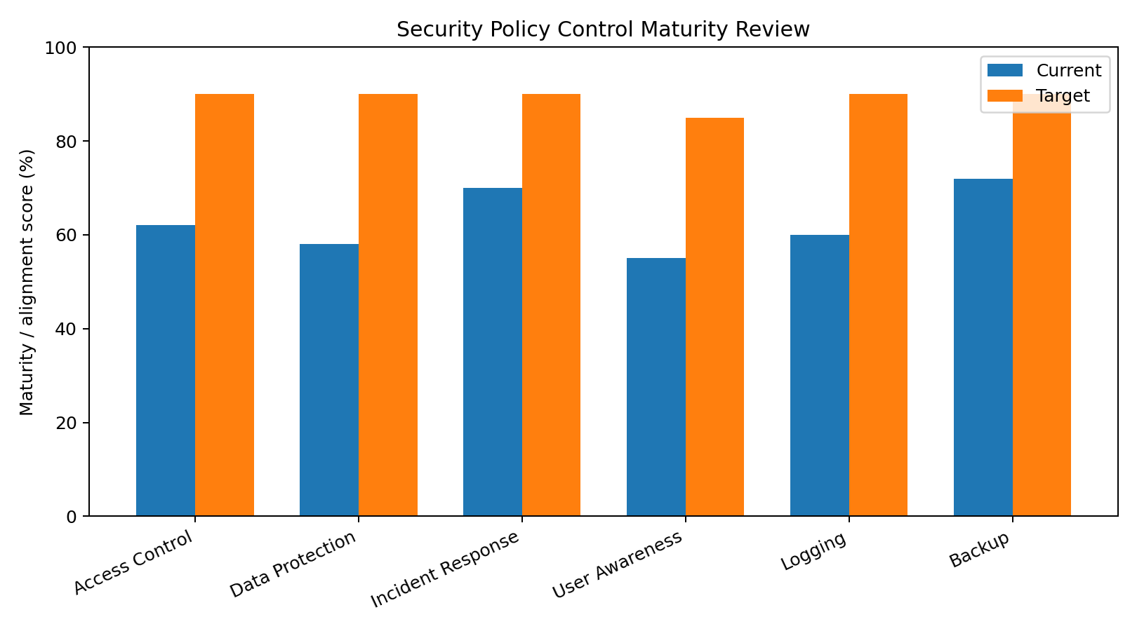
Figure 1. Simulated maturity comparison between current policy coverage and target state.

5. Policy Strengths
- The policy recognizes role-based access and unique user accounts, providing a foundation for least-privilege access.
- Sensitive information is identified as requiring stronger protection and encryption.
- Incident reporting is explicitly mentioned and can be connected to the Week 3 incident-response process.
- Acceptable-use requirements establish baseline expectations for employee behaviour.
- Backups are recognized as a security requirement rather than only an operational activity.
- The policy acknowledges supplier security responsibilities, creating a basis for third-party risk management.

6. Gap Analysis
ID | Area | Observed Gap | Security Impact | Priority
G-01 | MFA | MFA is optional for some users. | Account compromise risk remains higher. | Critical
G-02 | Policy Governance | Review cycle and policy owner are not clearly defined. | Requirements may become outdated. | High
G-03 | Logging | Retention, review ownership and alert thresholds are unclear. | Delayed detection and weak investigations. | High
G-04 | Backup | Restoration testing frequency is not specified. | Backups may fail when needed. | High
G-05 | Awareness | Training requirement lacks measurable completion targets. | Human-error risk remains difficult to manage. | Medium
G-06 | Third Parties | Security clauses are generic. | Supplier-related risk may be unmanaged. | Medium
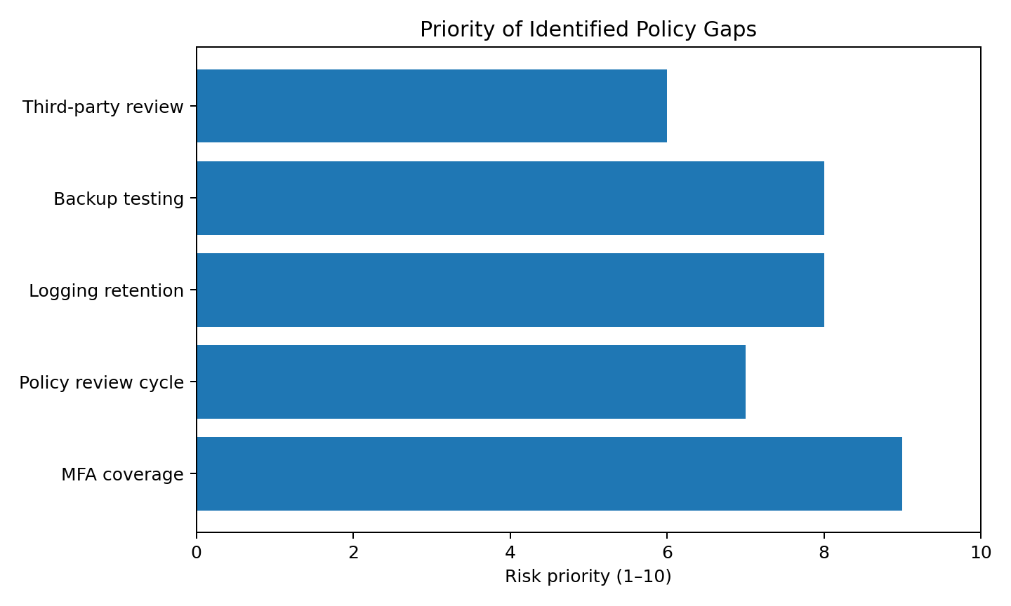
Figure 2. Simulated priority ranking of identified policy gaps.

7. Benchmark Against Industry Practices
NIST CSF 2.0 provides a flexible structure for managing cybersecurity risk. NIST SP 800-53 provides a broad catalog of security and privacy controls, while ISO/IEC 27001:2022 defines requirements for an information security management system. These references are used as benchmarks rather than as claims of formal compliance.
Policy Area | Benchmark Practice | Assessment
Governance | Defined ownership, risk management and continuous improvement | Needs clearer accountability
Access | Least privilege, strong authentication and account management | MFA coverage should be expanded
Data | Classification, protection, retention and secure handling | Baseline exists; retention needs detail
Monitoring | Audit logging, review and response to security events | Retention/monitoring needs formalization
Incident Response | Defined roles, escalation and response procedures | Good foundation; link to IRP
Resilience | Backups, restoration testing and recovery planning | Testing requirement should be explicit
People | Security awareness and role-based training | Metrics should be added
Suppliers | Security requirements, due diligence and ongoing review | Contractual controls should be strengthened
NIST notes that its CSF is intended to help organizations understand and improve management of cybersecurity risk. NIST SP 800-53 provides a customizable control catalog. ISO/IEC 27001:2022 provides requirements for an ISMS. Together, these sources support a governance approach in which policies are owned, implemented, assessed, monitored, and improved.

8. Improvement Recommendations
ID | Recommendation | Rationale | Priority | Target
R-01 | Enforce MFA | Require MFA for privileged, remote, administrative and other high-risk access. Use phishing-resistant methods where practical. | Critical | 0–30 days
R-02 | Formalize Policy Governance | Assign a policy owner, annual review date, approval authority, version history and event-driven review triggers. | High | 0–30 days
R-03 | Define Logging Standard | Specify critical log sources, minimum retention, access restrictions, monitoring ownership and escalation thresholds. | High | 0–60 days
R-04 | Test Backup Restoration | Define restoration tests at least periodically and record success/failure, recovery time and corrective actions. | High | 30–90 days
R-05 | Measure Awareness | Require onboarding and recurring awareness training with completion targets and phishing-awareness exercises. | Medium | 30–90 days
R-06 | Strengthen Supplier Controls | Add security requirements covering access, incident notification, data protection, vulnerability management and offboarding. | Medium | 60–120 days
R-07 | Add Exception Management | Require documented risk acceptance and expiry dates for policy exceptions. | Medium | 60–120 days

9. Prioritized Improvement Roadmap
Phase | Timeline | Key Actions | Expected Outcome
Phase 1 | 0–30 days | MFA expansion; assign policy owners; approve review calendar | Immediate reduction of high-risk gaps
Phase 2 | 30–60 days | Logging standard; awareness metrics; backup test plan | Better detection and resilience
Phase 3 | 60–120 days | Supplier clauses; exception process; evidence tracking | Stronger governance and third-party control
Phase 4 | Quarterly | Control testing, KPI review, policy updates and management reporting | Continuous improvement
Implementation should be risk-based. Critical items should receive executive sponsorship and measurable completion criteria. Lower-priority improvements can be scheduled alongside normal governance and technology refresh cycles.

10. Governance and Review Cycle
Activity | Owner | Frequency | Evidence
Policy review | Security/IT owner | Annual + after major changes | Approved version and review record
Access review | System/data owners | Quarterly | Access review report
MFA coverage check | Identity/security team | Monthly | Coverage dashboard
Backup restoration test | IT operations | Quarterly | Test results and corrective actions
Log/monitoring review | Security operations | Monthly | Review/alert records
Supplier security review | Procurement + security | Annual / renewal | Supplier assessment
Incident exercise | Security + business teams | At least annually | Exercise report and lessons learned

11. Metrics and Assurance
- MFA coverage percentage for privileged and remote accounts.
- Percentage of users completing required security awareness training.
- Percentage of critical systems with defined and monitored security logs.
- Backup restoration test success rate and average recovery time.
- Percentage of active suppliers reviewed against security requirements.
- Number and age of open policy exceptions.
- Time taken to close high-risk policy findings.
- Percentage of scheduled policy reviews completed on time.
Metrics should be reviewed by responsible owners and summarized for management. A metric is useful only when it has a defined owner, target, measurement method, and action when performance falls below target.

12. Conclusion
The simulated security policy provides a useful baseline, but several requirements are too general to provide strong assurance in a modern threat environment. The largest weaknesses concern authentication, governance, monitoring, backup validation, and third-party security. The recommended improvements convert broad statements into measurable controls with clear ownership and review cycles.
The overall recommendation is to treat security policy as a living governance document rather than a one-time document. Regular assessment, evidence collection, metrics, incident lessons learned, and changes in technology or business risk should feed the next policy revision. This approach supports continuous improvement and better alignment with recognized cybersecurity practices.

13. References
- NIST Cybersecurity Framework 2.0 — https://www.nist.gov/cyberframework
- NIST SP 800-53 Rev. 5 / current updates — https://csrc.nist.gov/pubs/sp/800/53/r5/final
- NIST SP 800-53 control downloads and RMF resources — https://csrc.nist.gov/projects/risk-management/sp800-53-controls/downloads
- ISO/IEC 27000 family – Information security management — https://www.iso.org/standard/iso-iec-27000-family
- ISO/IEC 27001:2022 – Information security management systems requirements — https://www.iso.org/management-system-standards-list.html

End of Report

