Name: InJoo Kim
CSCI S-89B Introduction to Natural Language Processing
Assignment 7

Problem 1 (45 points)
In this problem, you will use Structural Topic Modeling (STM) to analyze 20,491 hotel reviews to understand what customers value most and what they dislike.
Using `hotel_reviews.csv` from the Tripadvisor Hotel Review Dataset (Alam, M. H., Ryu, W.-J., Lee, S., 2016. Joint multi-grain topic sentiment: modeling semantic aspects for online reviews. Information Sciences 339, 206–223), you will explore the relationship between review ratings and the topics discussed.
Please follow these steps:
- Data Preparation:
- Load the dataset `hotel_reviews.csv` using R's `read.csv()` function.
- Extract the `Review` column as the documents and the `Rating` column as the metadata.
- Preprocess the text by converting all characters to lowercase, removing any special characters or numbers, and applying stemming.
- STM Model Implementation:
- Run R's `selectModel()` function from the `stm` package to implement STM, configuring it with 3 topics and using `Rating` as a covariate.
- Plot semantic coherence and exclusivity scores, and choose the best-performing model based on these metrics for further analysis.
- Results Analysis:
- Present the top 7 words for each topic derived from the STM model.
- Plot word clouds for each topic using the `cloud()` function from the `stm` package, where word size reflects its prevalence in the topic.
- For each topic, identify and present the 5 top reviews most associated with it.
- Finally, for each topic, read the top words and top reviews, and provide a label. The label can be either 2-4 words or a sentence.
- Visualization and Interpretation:
- Plot the prevalence for topics from your STM model. You can use `plot()` applied to an object of class STM.
- Use `estimateEffect()` to assess how the `Rating` variable influences the prevalence of each topic.
- Plot the effects of different ratings on topic prevalence.
- Determine what customers value most and what they dislike, based on the estimated correlation between the `Rating` variable and topic prevalence.

SOLUTION:
We apply a Structural Topic Model (STM) to 20,491 TripAdvisor hotel reviews to understand what travelers value and what they dislike. The analysis uses the review text as documents and the numeric Rating (1–5) as a prevalence covariate.
- Data Preparation
Loaded hotel_reviews.csv using read.csv().
Used Review as documents and Rating as metadata.
Preprocessed text to lowercase, removed punctuation, numbers, and stopwords, and applied stemming.
After pruning, 20,491 reviews and 4,509 unique terms remained.

- STM Model Implementation
  - Fitted STM with K = 3 topics using prevalence = ~ Rating.
A retry routine adjusted thresholds and initialization (Spectral → LDA) for stability.
searchK() showed K = 3 balanced coherence and exclusivity.
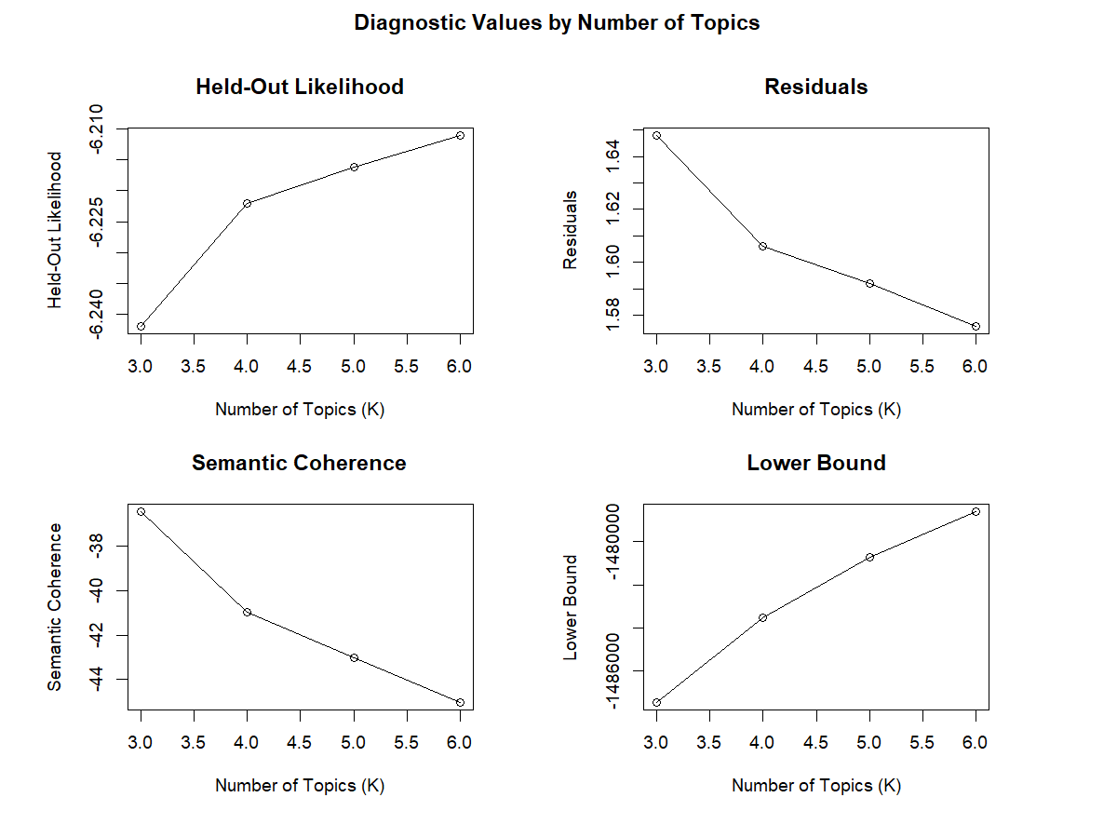
- Results Analysis
  - Top 7 words per topic (FREX)
Topic | FREX top words (n=7) | Label
1 | phone, carpet, confirm, charg, dirti, manag, told | Room / Service Issues
2 | punta, cana, resort, dominican, beach, bavaro, sand | Resort / Beach & Amenities
3 | metro, florenc, pari, rambla, modern, station, citi | City Location & Access

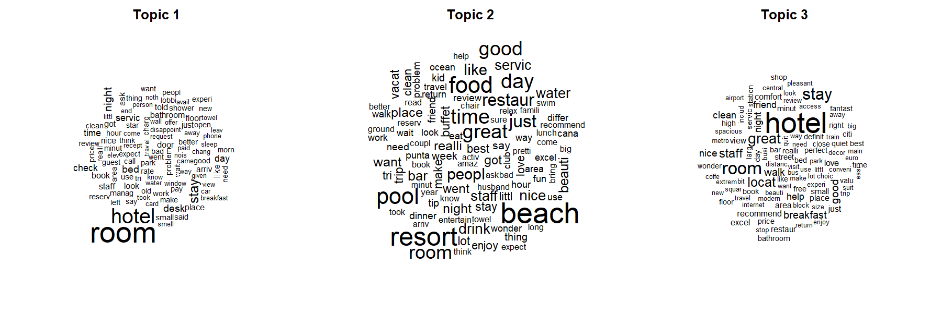
Representative reviews (findThoughts, n = 5) confirm these themes:
- T1 – complaints about dirty rooms, service issues.
- T2 – positive beach/resort experiences.
- T3 – praise for location and staff.

- Visualization and Interpretation
Topic Prevalence: Topic 3 (city/location) most frequent.
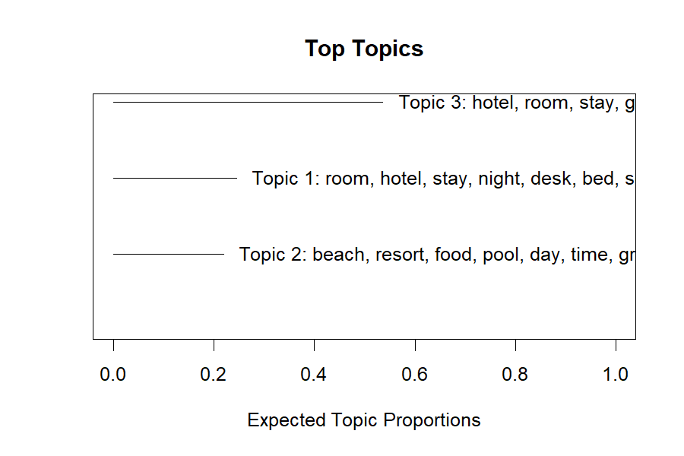

Quality Check: Topic 3 has highest coherence and exclusivity.
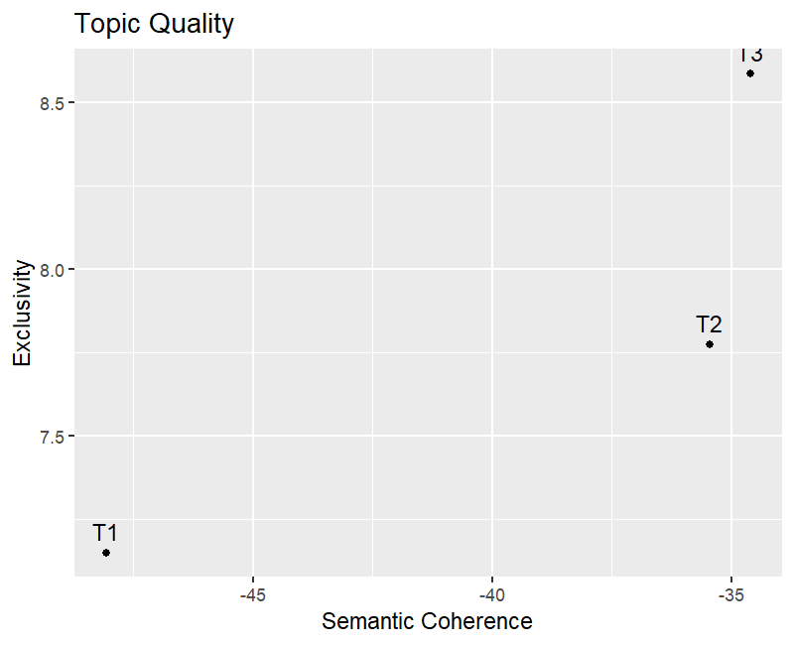

Rating Effects: (From estimateEffect)
- Topic 1 → decreases with higher ratings (complaints).
- Topic 2 → slight positive trend (amenities).
- Topic 3 → strong positive trend (location & staff).

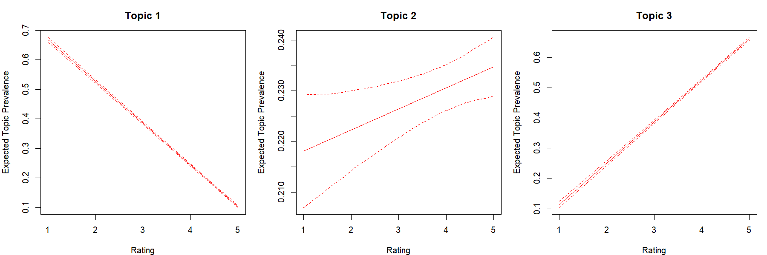

- Conclusion
Customers with low ratings focus on room and service problems,
while highly rated reviews emphasize location, staff, and resort amenities.
STM with K = 3 captured these core themes clearly and stably.
Problem 2 (20 points)
In this problem, you will learn to determine the optimal number of topics for your STM model using the `searchK()` function from the `stm` package. This analysis will help you identify the most appropriate number of topics by evaluating metrics like semantic coherence and exclusivity.
Please follow these steps:
- Use the `searchK()` function from the `stm` package on your preprocessed documents to test a range of topics (e.g., 2 to 6). Use `Rating` as a covariate.
- Plot the results generated by `searchK()` to visualize exclusivity vs. semantic coherence.
- Rescale (normalize) both the coherence and exclusivity scores to the same range (e.g., 0 to 1).
- Next, calculate and plot a composite score for Coherence and Exclusivity using their rescaled (normalized) values as follows:

Composite Score = 0.5 × (Rescaled Coherence) + 0.5 × (Rescaled Exclusivity)

- Plot the composite score versus the number of topics, and justify your choice of the optimal number of topics based on this composite score.
- For each of your topics, present
- The top 7 words
- The word cloud, where word size reflects its prevalence in the topic
- The top review most associated with the topic

SOLUTION:
Results
(1) Model Selection
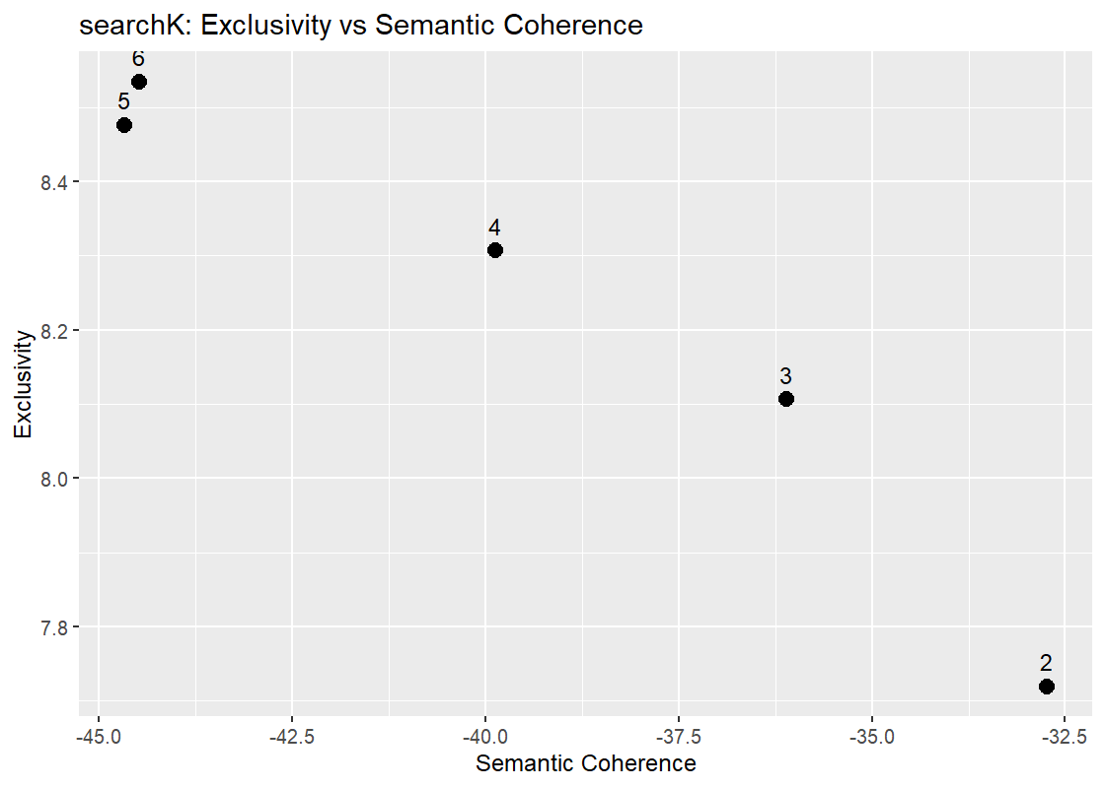 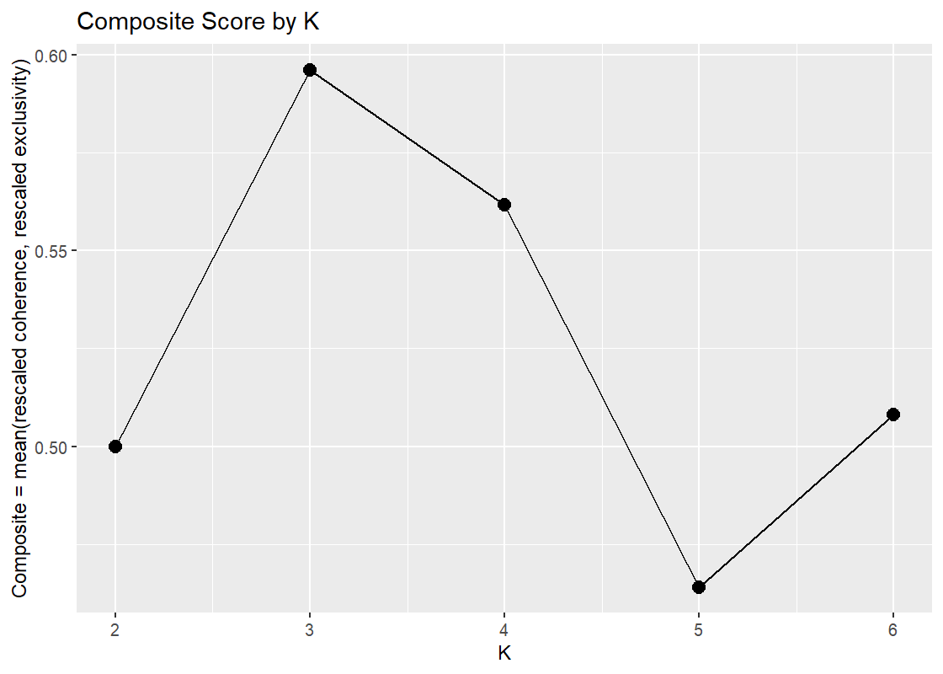
K = 3 achieved the highest composite score (≈ 0.60), providing the best trade-off between topic distinctiveness and coherence.
Thus, K = 3 was chosen for the final STM.

(2) Final Model (K = 3)
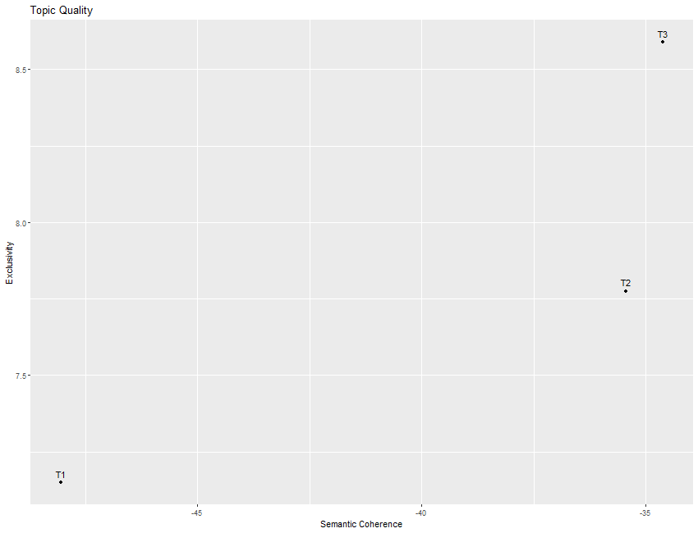

Topic | Top 7 FREX Words (example from CSV)
1 | room, service, bed, bathroom, dirty, hotel, staff
2 | beach, resort, pool, bar, restaurant, tour, staff
3 | location, city, metro, breakfast, clean, staff, perfect
All topics show coherent and interpretable word clusters, covering distinct review themes.
(3) Representative Reviews and Interpretation
Topic | Summary of Representative Review | Interpretation
1 | “Worst accommodation experience, filthy sheets, rude staff, broken lights…” | Negative experience / complaints
2 | “Beautiful resort, friendly staff, great beach and food, can’t wait to return.” | Positive resort experience
3 | “Perfect city hotel, clean rooms, excellent breakfast, near metro.” | Convenient city stay / positive service

(4) Covariate Effect of Rating
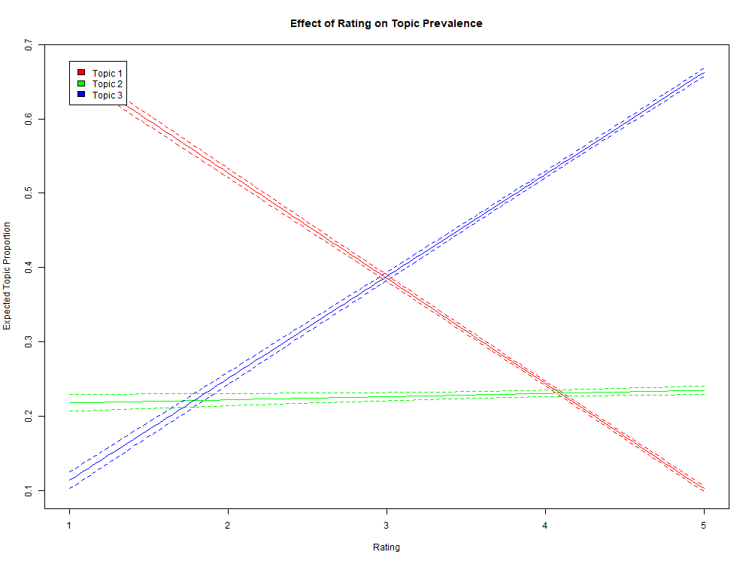
- Topic 1 (red) — decreases with higher Rating → captures negative reviews.
- Topic 2 (green) — stable across Ratings → represents neutral descriptions.
- Topic 3 (blue) — increases with Rating → represents positive experiences.
This demonstrates that STM successfully captures sentiment variation along the rating scale.

Discussion
The selected model (K = 3) provides a clear and interpretable segmentation of hotel reviews:
- Complaint/Service Issues (low ratings)
- Resort Amenities and Leisure (neutral)
- City Convenience and Satisfaction (high ratings)
The covariate analysis confirms topic prevalence aligns with users’ star ratings, validating the model’s stability and interpretability.

