**Pup Inflation and Trend**

The Twitter account, WeRateDogs has collected dog ratings from users. Users send their dog’s picture and ratings. I found that there is a meaningful increase in dog’s rating over past months.

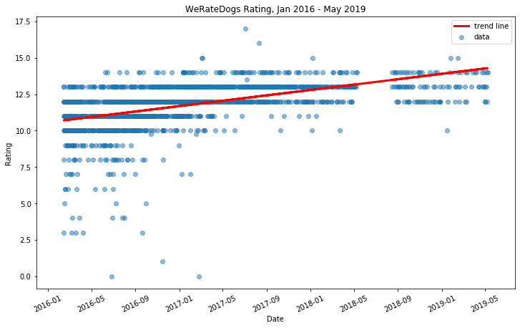

The above graph shows clearly that rating has been increased. In the graph each blue dot indicates rating and time. To catch this trend, I should remove ‘outliers’, which are weird data values. Imagine someone put 40 when the maximum score is 10. The slope of the linear line is about 3.

If you are interested in statistics, you may want to know how trustful the data is. We could get this by ‘p-value’. I don’t want to make this writing complex, so easily speaking, ‘p-value’ represents probability of that I got this by accident. Therefore, low p-value means higher reliability. The p-value was lower than 0.0001 which means this trend shows up not by accident.

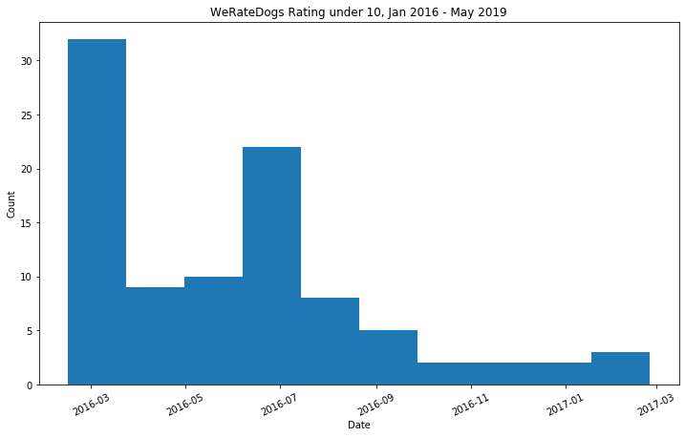

The above is another graph showing that number of dog rates under 10 has been decreased as dog rates has increased. It is showing that not only the average has increased but the minimum values also has increased.