1. *What models or machines did you attempt to fit?*



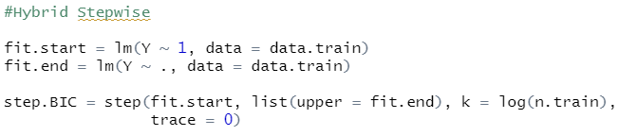

C.





D.

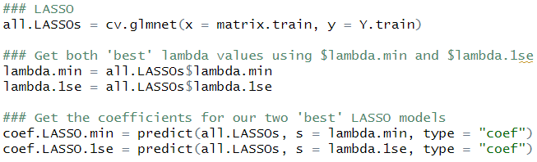

E.



F.



G.





H.





I.





1. *What process(es) did you use to evaluate and compare models and to select your final model?* I am thinking of Lecture 3, specifically:

I used 10-kfolds, fit all models to each training set. After that, I found the model with smallest MSPE.

3. *Did you tune any methods?* If so, (a) what process(es) did you use to evaluate and

compare models and to select your final model (b) **for each method list all parameter values that were considered**

1. For “ridge regression” to choose a lambda values, I use a sequence from 0 to 100 by 0.05.
2. For “GAM” to choose a k value, I used for loop from 1 to 10 but when k=6, an error occurred.
3. For “random-forest”, I used a grid of values mtry = (1… 13) and nodesize = (2, 5, 8, 11, 15)
4. *What was your chosen prediction machine?*





