**REPORT**

Your report, which is submitted to Crowdmark, should answer these questions, as numbered below:

1. *What models or machines did you attempt to fit?* For each one, paste the R code from your program for the initial successful model fit. I want to see what you tried. For

example, "fit1 = lm(y~., data=train)" is what I would list if I used multiple linear

regression on all of the variables and my training data were called "train". **The answer**

**should be a list (e.g., with bullets) of nothing but the code for each of these**

**model fits.** Don’t list code that did not run. If tuning was involved in the initial fitting

process, you can can paste the function with variable names for the tuning parameters

(e.g., your function might have "mtry=mm" if you looped over a variable called "mm").

A.



To get parameter tuning

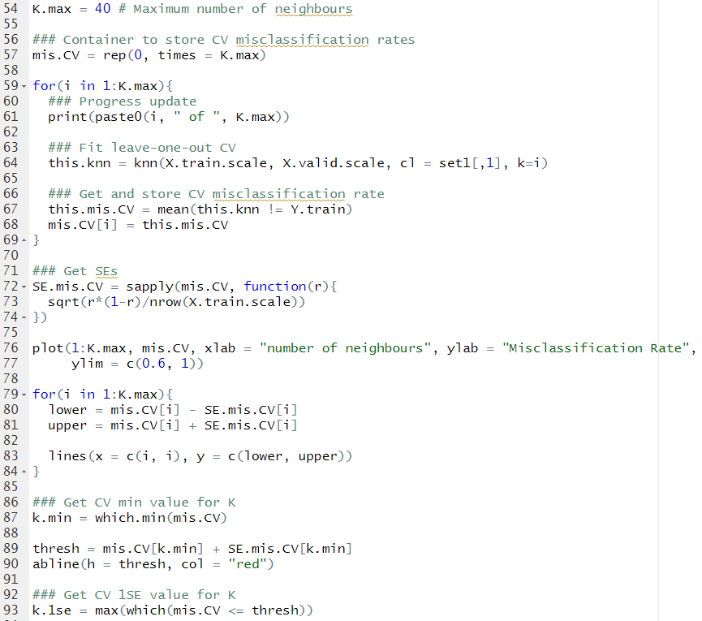



B.





C.





D.





E.





F.





G.





F.



