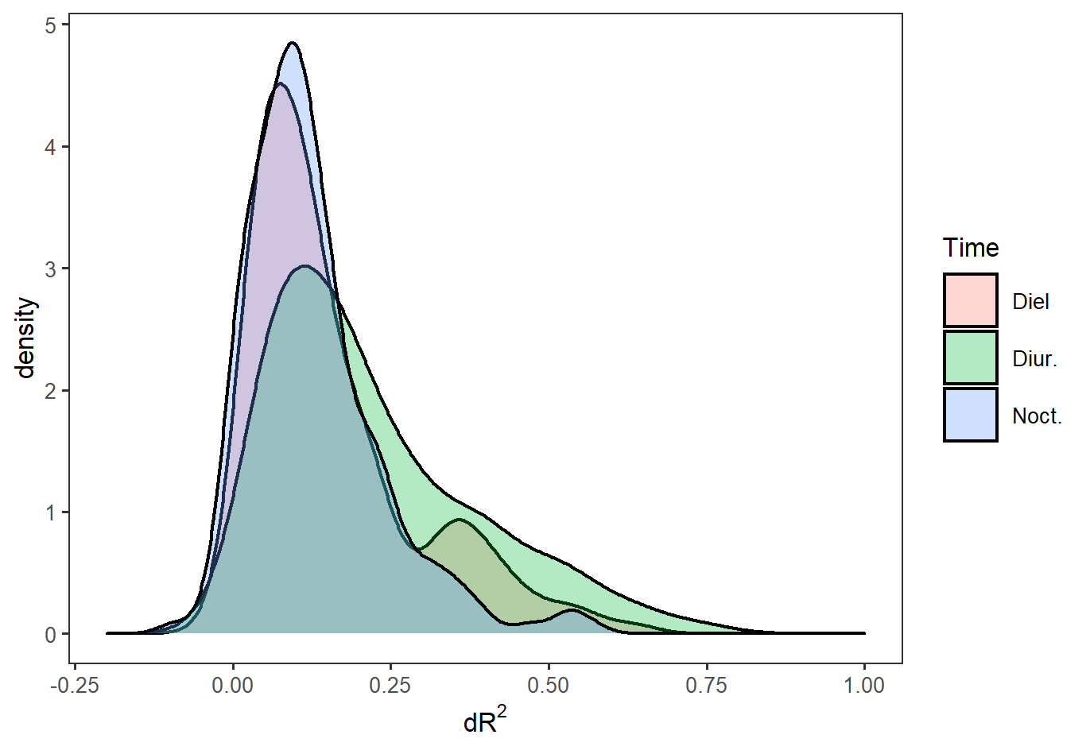  (a) | 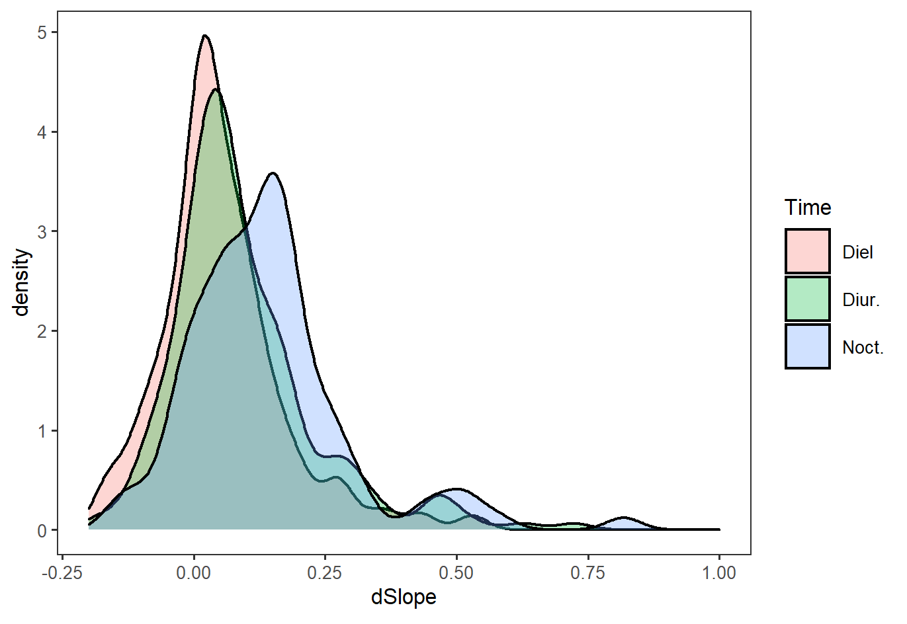  (b)
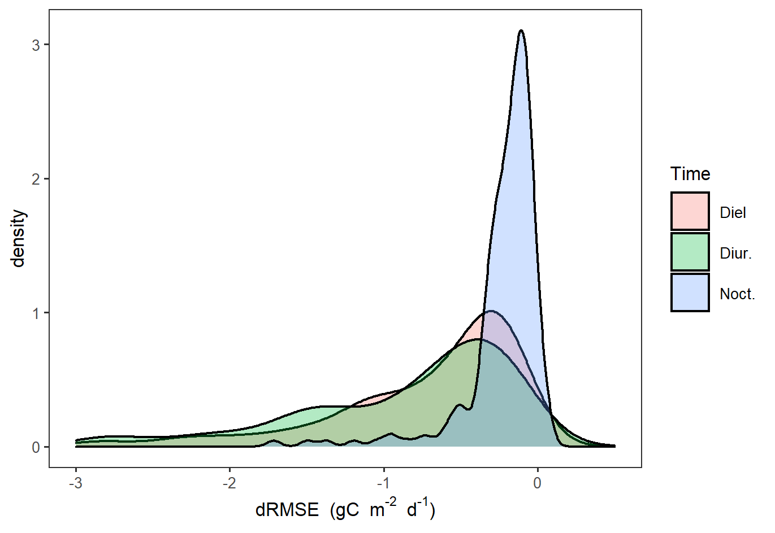  (c) | 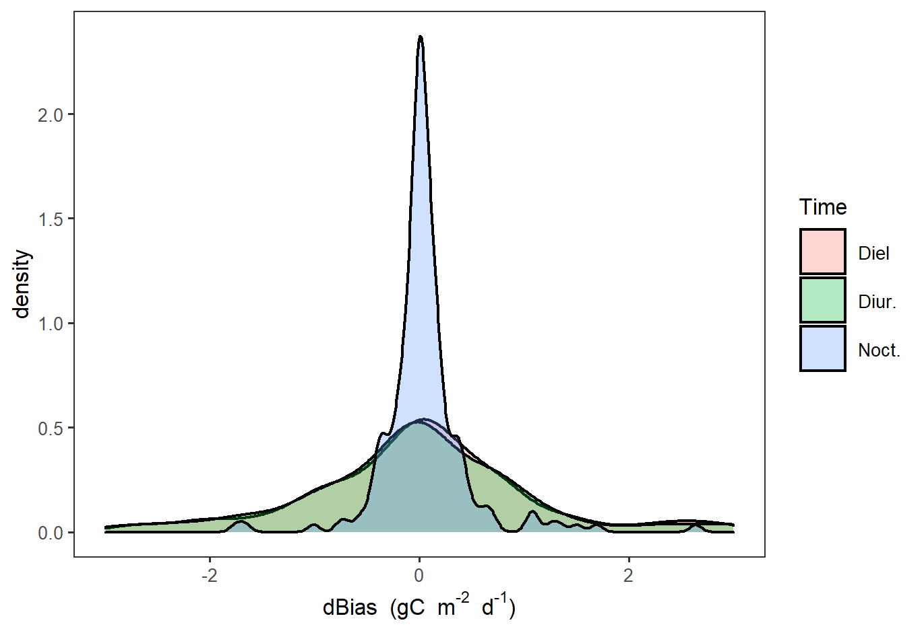  (d)
Supplementary Figure S1. Difference of statistics between RFR₃ and random forest without the “receptive-limiter” (ORF) (RFR₃-ORF) for 194 sites. The unit of RMSE and bias is gC m⁻² d⁻¹.

