Sensitivity of gap-filling to gap length

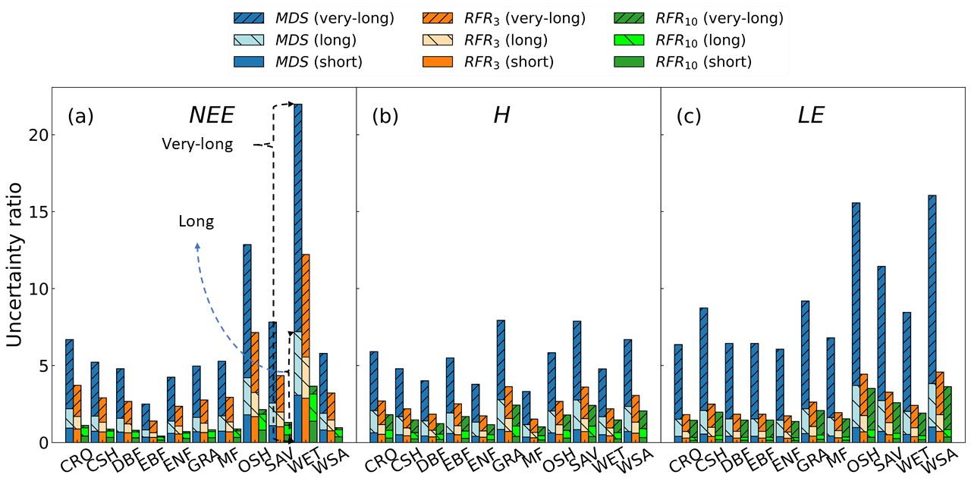
Figure 8 Ratio of gap-filling bias (of MDS, RFR₃, and RFR₁₀) to flux joint uncertainty estimation grouped by IGBP across NEE, H, and LE.
The ratio interquartile range (IQR) of bias (i.e. gap-filling uncertainty) to mean flux (referred as to R_{bias/flux}) and flux join uncertainty estimation (referred as to R_{bias/unc}) increased largely as the gap length increased (Figure 8 and Table S8). For MDS, the R_{bias/flux} across fluxes for short gaps was less than 30 %, and it was separately nearly doubled and fourfold for long gaps and very-long gaps, as gap-filling bias IQR almost reached 1.5 times of flux (Table S8). However, the R_{bias/flux} for RFR approaches increased more steadily as gap-length increased; bias IQR for RFR₁₀ was nearly less than 30 % of NEE and Le, and less than 45 % of H for very-long gaps (Table S8).
Similar patterns was seen for the R_{bias/unc}, for MDS, the R_{bias/unc} increased about 5~10 times as the gap-length increased from short to very-long; smaller increment in R_{bias/unc} was seen for RFR approaches (Figure 8), and R_{bias/unc} of RFR₁₀ was nearly smaller than two for very-long gaps, especially for NEE (R_{bias/unc} of RFR₁₀ <1) (Table S8). In addition, R_{bias/unc} varied among ecosystem types, open shrubland, savannah, and wetland were seen with the largest R_{bias/unc} for NEE (Figure 8a); grassland (GRA), SAV, and woody savannah (WSA) were seen with relatively larger R_{bias/unc} for H (Figure 8b); OSH, SAV, and WSA were seen with the largest R_{bias/unc} for LE (Figure 8c).

