You have been assigned to test the phone login system of a new utility company where customers will login in the system and be able to transfer to support or request their current account balance using an account number.

The client has provided the diagram and workflow table for the function below. Your current task is to make a testing plan to define the scenarios that should be tested based on the requirements below. Define as many testing scenarios below as possible and be detailed in terms of data entry, boundary testing, and data setup.

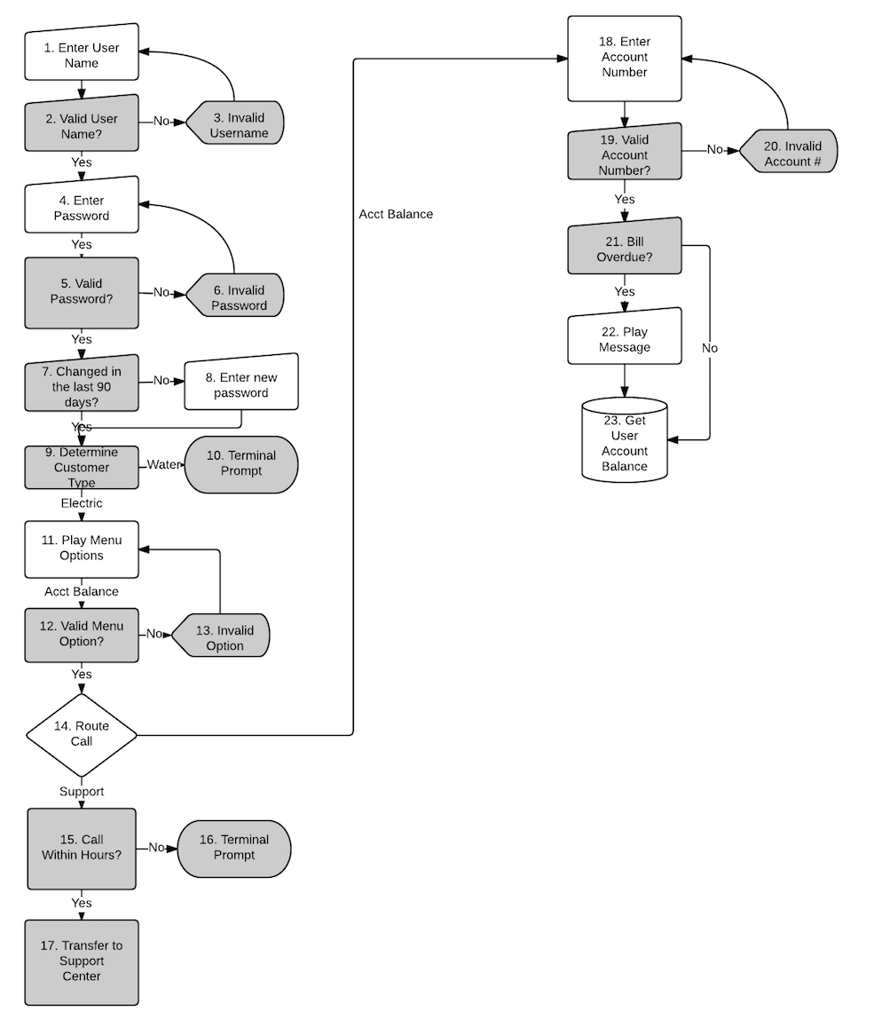

| Step # | Logic/Process | Message Display/Prompt |
| --- | --- | --- |
|  |  | Please enter your 4-digit User ID. |
|  | System verifies if username is valid?  If Yes – Go to step 4.  If No – Go to step 3. |  |
|  | Go to step 1 after prompt. | That was not a valid entry. |
|  |  | Please enter your 4-digit password. |
|  | System verifies if the password is valid?  If Yes – Go to step 7.  If No – Go to step 6. |  |
|  | Go to step 4 after prompt. | The password you entered is invalid. |
|  | System verifies if password has been reset within the last 90 days?  If Yes – Go to step 9.  If No – Go to step 8. |  |
|  | System will save new password and continue to step 9. | Your password is required to be reset. Please enter a new password. |
|  | System will determine if customer has electrical services, water services, or both.  If electrical or both – Go to step 11.  If water only – Go to Step 10. |  |
|  |  | Our records indicate that you do not have electrical services active. Please call our toll-free number for information about your water utility bill. |
|  |  | Please select from the following options:  Press 1 for Account Balance.  Press 2 for Customer Support. |
|  | System will verify if the selected option is a valid menu option.  If Yes – Go to step 14.  If No – Go to step 13. |  |
|  | Go to step 11 after prompt | That was not a valid entry. |
|  | System will verify user’s menu option.  If 1 - Go to step 18.  If 2 – Go to step 15. |  |
|  | System will determine if current call time is later than 5 PM EST or earlier than 9 AM EST  If Yes – Go to step 16.  If No – Go to step 17. |  |
|  |  | Our hours for support are between 9 AM and 5 PM Eastern Standard Time. Please try to call again later. |
|  | System will transfer Support Call using Telephony Integration. | Please Wait while we transfer your call. |
|  |  | Please enter your 8-digit account number. |
|  | System verifies if the number entered is a valid account.  If Yes – Go to step 21.  If No – Go to step 20. |  |
|  | Go to step 18 after prompt. | Our records indicate that account number is invalid. |
|  | System will determine if a late payment flag has been set for the customer’s current balance.  If Yes – Go to step 22.  If No – Go to step 23. |  |
|  | Go to step 23 after prompt. | Our records indicate that you have an overdue bill. Your last payment was due on {Date}. |
|  | System will retrieve subject’s current account balance from the database. | You currently have an amount due of [Total Amount Due]. |

Step 1 (user name verification):

1.1 Testing of the system to ensure that entering a user ID of 3-digits, 5-digits, and an invalid 4-digit User ID (user ID does not exist in the database) results in the correct error response.

1.2 Testing of the system to ensure that after display message user can re-enter the user ID.

1.3 Testing of the system to ensure that SQL-injection or XSS-attack doesn’t work (for example, entering some user ID + *’ or 1=1*).

1.4 Testing of the system to ensure that entering a valid 4-digit user ID allows user to continue working in the system and enter the password.

Step 2 (password verification):

2.1 Testing of the system to ensure that entering an invalid password (3-digits, 5-digits) results in the correct error response.

2.2 Testing of the system to ensure that entering a valid 4-digit password, but from another user ID, results in an error response.

2.3 Testing of the system to ensure that after display message user can re-enter the password.

2.4 Testing of the system to ensure that entering a valid 4-digit password allows user to continue working in the system.

2.5 Data setup: user ID with a password, which didn't change for last 90 days.

2.5.1 Testing of the system to ensure that entering user ID with a password, which didn't change for last 90 days, results in the correct display message and resets password.

2.5.2 Testing of the system to ensure that entering an incorrect new password (3-digits, 5-digits, 4-digits with an invalid symbols) results in a correct error message.

2.5.3 Testing of the system to ensure that after display message user can re-enter password.

2.5.4 Testing the system to ensure that after entering a valid password (4-digit without invalid characters), the new password has been saved and the user can log in using the new password.

Step 3 (customer type):

Data setup: customer with electrical service, customer with water service, customer with electrical and water services, customer without services (if it is possible).

3.1 Testing the system to ensure that the correct prompt is displayed for the customer with water service.

3.2 Testing the system to ensure that the customer without services will be correctly identified.

3.3 Testing the system to ensure that the customer with electrical service will be correctly identified and redirected to menu.

3.4 Testing the system to ensure that the customer with both services will be correctly identified and redirected to menu.

3.5 Testing the system to ensure that the menu consists of 2 items and choosing invalid options (0, 3 or another invalid symbol) results in a correct error message.

3.6 Testing the system to ensure that selecting first item of menu redirects user to entering account number.

3.7 Testing the system to ensure that selecting second item of menu redirects user to customer support.

Step 4 (customer support):

Data setup: before 7:59 am or after 5:01 pm Eastern Standard Time.

4.1 Testing the system to ensure that the call to the help desk outside the set time will be redirected to the answering machine.

Data setup: after 8:00 am or before 5:00 pm Eastern Standard Time.

4.2 Test the system to ensure that the call will be redirected to the Support Center with the correct message.

Step 5 (account balance):

5.1 Testing of the system to ensure that entering an account number of 7-digits, 9-digits, and an invalid 8-digit account number (account number does not exist in the database) results in the correct error response.

5.2 Testing of the system to ensure that after display message user can re-enter the account number.

5.3 Testing of the system to ensure that entering a valid 8-digit account number allows user to continue working in the system.

5.4 Testing of the system to ensure that SQL-injection doesn’t work (for example, entering some account number + *’ or 1=1*).

Data setup: customer with overdue bill, customer without overdue bill.

5.5 Testing of the system to ensure that the customer without an overdue bill will be correctly identified and the account balance will be shown without any messages.

5.6 Testing of the system to ensure that the customer with an overdue bill will be correctly identified and will be shown a message about the presence of debt with the last payment date. After that the user should be redirected to the account balance information.