CARDIFF COUNCIL

Strategic Climate Change Resilience Action Plan

1. Reason for an Action Plan

Cardiff Council’s participation in the UK pilot project Changing Climate, Changing Places and research undertaken to support the preparation of the Local Development Plan clearly demonstrate that there are significant social, environmental and economic impacts across the Authority and city from future climate change. As such this report and draft action plan outlines the next steps required to progress work on climate change resilience and energy security.

2. Background
2.1 Climate change:
Climate change is one of the greatest threats to environmental, social and economic sustainability facing the world today. Rising global temperatures will bring changes in weather patterns, rising sea levels and increased frequency and intensity of extreme weather events. The evidence base for impacts relating to climate change is rapidly evolving and the Stern Review on the Economics of Climate Change (2006) and the Intergovernmental Panel on Climate Change (2007 onwards) reports clearly demonstrate the need to act immediately. We need to act now to prepare for climate change (adaptation) and to reduce the risk of accelerated climate change by reducing our contribution to greenhouse gas emissions (mitigation).

The anticipated climate predictions for Wales resulting from global climate change (based on UK Climate Impacts Programme data) are broadly:
- Increased summer average maximum temperatures: 2°C by 2020s, 5°C by 2080s
- Average increase in winter rainfall: 7% by 2020s, 11% by 2040s (from intense rain events)
- Sea level rise: 15cm by 2040s, 35cm by 2080s
- Increased frequency & intensity of extreme weather events

The UK Climate Change Risk Assessment (2012) further highlights the key issues at the South Wales level to be an increase in:
  - Frequency and severity of flooding; and
  - Heatwave events.

Figures 1 and 2 (below) illustrate these anticipated impacts. Figure 1 demonstrates impact to the Wentlooge area of the city from future tidal flooding in 2085 and 2110, taking into account sea level rise. Figure 2 explains how the UK 2003 summer heavwave is predicted to be an average event by 2050 and a cool event by 2080 due to global climate change.

Figure 1: Draft Strategic Flood Consequences Assessment data for Wentlooge area of Cardiff (Atkins). (NB: this level of data is only available for areas of the city identified as at high risk of flooding as part of the LDP process).
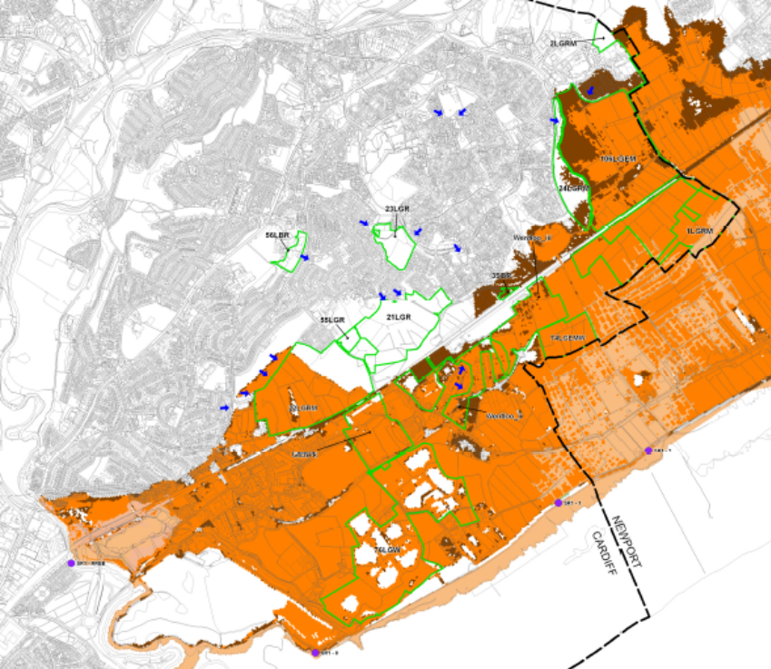

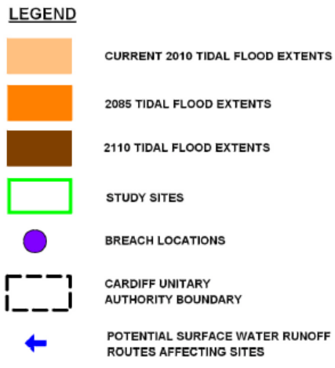

Figure 2: Graph of predicted European summer temperatures (UK Climate Impacts Programme).

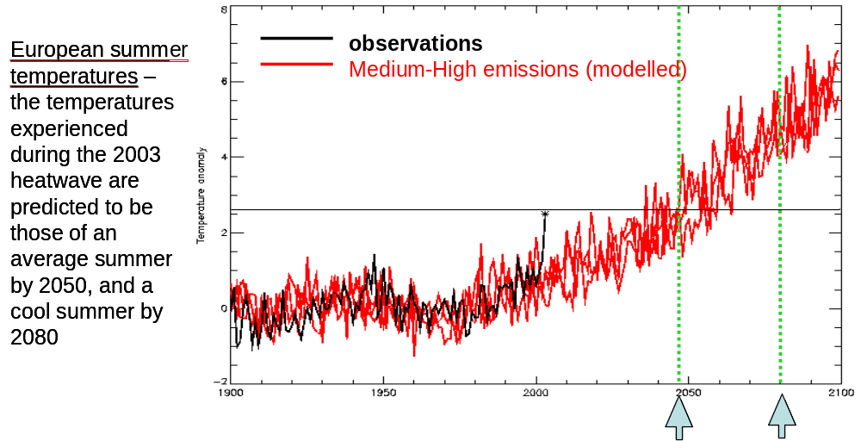
Preparing for climate change is a dynamic process and there is no steady state of ‘being adapted’. Decisions with long term implications (e.g. infrastructure and planning) will tend to be more affected by climate change. However, anticipatory adaptation is more effective and less costly than retrospective or emergency action, and will make our communities more resilient to future changes.

2.2 Energy security and peak oil:
The global demand for energy is projected to be over 50% higher in 2030 than 2004 (based on current energy policies), mainly driven by rapid economic and population growth in developing countries. By 2020, half of the world’s oil will be produced by countries currently considered at risk of internal instability. In Britain, as indigenous energy sources decline, dependence on imported fuels will rise to meet demand. This dependence upon vulnerable supplies suggests an uncertain future for our energy supply, especially when the concept of ‘peak oil’ is considered. Peak oil is the point in time when the maximum rate of global petroleum production is reached, after which the rate of production enters decline.

The likely consequence is that there will be increased oil prices and a more limited supply. With oil currently being the primary source for supplying our energy needs (transport, food, pharmaceuticals, agriculture etc.) there will be a need to shift in the way we use and produce energy in the decades ahead.

2.3 Changing Climate, Changing Places (CCCP):
Cardiff Council was a partner in the CCCP UK pilot project along with WLGA, UK Climate Impacts Programme (UKCIP), EAW, CCW, Welsh Government and 4 Welsh Local Authorities (Cardiff, RCT, Flintshire, Gwynedd). The projects aim was to work with local authorities on climate change adaptation, utilising the UKCIP toolkit. Cardiff Council also integrated the related issue of energy security into its process.

The CCCP project has had a number of stages:

- Local Climate Impacts profile (LCLIP) – to assess the impact of heat, heavy rain, cold weather and high winds on the Authority from a financial, reputational and disruption perspective. The key outcome from Cardiff’s LCLIP was that services are coping (just) with current weather events, but that if these are to become more severe and/or frequent (as is anticipated with climate change) there is need to take action now so that service areas can continue to deliver their corporate objectives.

Examples of findings from the LCLIP include the correlation between an increase in noise complaints and hot weather periods; and a 16% income loss for Parks Services due to heavy rainfall during winter 2006/07.

- Business Areas Climate Impact Assessment Tool (BACLIAT) – the second stage was to complete a BACLIAT across the Council to identify the key impacts from climate change to services. Management Teams identified over 50 perceived risks that came under the general headings of flooding, increased number and severity of storm events and increased summer temperatures.

Examples of discussions from the BACLIAT process included the threshold temperature our roads will melt at, the potential need for increased waste collections in heatwaves, how the Cardiff Bay Barrage will cope with sea level rise, and how biodiversity will migrate in the region as conditions change due to climate change.

- Risk Assessment - the risks identified by the BACLIAT process were risk assessed using corporate methodology by the Corporate Risk Group. This resulted in two risks being entered onto the Corporate Risk Register and initial outline actions to address the risks. The two risks are:
  - Climate Change – unpreparedness to the effects of climate change due to lack of future proofing for key (social and civil) infrastructure and business development.
  - Energy Security – inability to secure consistent energy supply due to rising energy costs and insecurity of energy supply.

These risks identified in the Corporate Risk Register should then be addressed in the corporate and service area business planning cycles. However in reality, due to the long term nature of climate change impacts, service areas have only progressed actions relating to flood risk across the city via this mechanism.

A senior manager’s workshop was held in 2011 to identify additional service area and corporate actions to assist service areas in addressing these risks, and to help develop a strategic climate change resilience plan. The issues raised during the workshop included the capacity of Council buildings and property for potential energy generation; flood risk across the city and how this relates to the Council’s asset management; and staff turnout and business continuity during periods of extreme weather.

During 2010 and 2011 this resilience work has been shared with the Carbon Lite Cardiff partnership, including a workshop focused around heatwave action planning. In the workshop partner organisations examined the effect of heatwave across the city – both on their own operations, and the resulting knock on effect from their suppliers and to their customers on service delivery.

The evaluation report for the WLGA on the CCCP project complimented the authority on its excellent and methodological way of working across such a large and complex organisation. However it also highlighted that work with our external partners, in particular the Local Service Board and Vision Forum, had been limited to date, and suggested that there was scope to develop this partnership working in future years.

NB Following workshops with internal and external stakeholders the decision was taken to rename ‘climate change adaptation’ as ‘climate change resilience’. The term ‘adaptation’ is frequently misunderstood and ‘resilience’ better describes the action required to prepare for climate change.

3. Issues
Resilience to climate change will need to be a consideration for many parts of the Council and for partners across the city. There needs to be a mechanism in place to ensure that climate change resilience issues are taken on board by all, and that it is integrated into the Council’s long term business planning.

In particular action is required to:
- Influence the Councils business planning process by developing a corporate climate change resilience performance indicator for service areas to address in a systematic manner; and
- Influence the business planning of our partners across the city by working more closely with the Cardiff Partnership Board (CPB) and other strategic partnerships.

3.1 Welsh Government powers and guidance
Welsh Government (WG) have powers under the 2008 Climate Change Act to require reporting authorities (which includes local authorities and many of our key partner organisations, particularly CPB partners) to report back on their climate change adaptation preparations and actions. The use of this power was consulted on during 2011, and WG stated that this would not be put into force until an evaluation of the standard of voluntary reporting already in place by reporting authorities was undertaken.

It is highly likely that the Council will need to report back to WG on adaptation action planning in the future, with strong indication given from WG that this will be from 2013/14 onwards. The work that has been progressed as part of the CCCP project will ensure that Cardiff Council will be ahead of most other Welsh local authorities, particularly in relation to identifying the risks from climate change. However there is still considerable work to be undertaken by the authority, and partners, to ensure that Cardiff is resilient to a changing climate and energy security issues.

To assist reporting authorities with this work WG are issuing guidance. Parts 1 (‘starting’) and 2 (‘investigating’) of the WG climate change guidance for reporting authorities was issued in early 2012. This has caused a delay in resilience work during 2011 for the Authority as there is need to ensure that the direction taken by the authority complies with WG guidance. The Council’s approach to climate change risk assessment was used as a best practice case study within this guidance.

Parts 3-5 of the guidance were issued during March 2013 and cover planning, implementation and monitoring; plus a ‘knowledge hub’ is under construction to support this guidance. Funding has been sourced from WG, via the WLGA Sustainable Development Framework, to help Cardiff Council progress a strategic climate change resilience action plan for the city, and in particular to develop a corporate climate change resilience PI. This will partly assist Cardiff through parts 3-5 of the guidance, and also provide WG with practical examples of action to support their guidance.

4. Strategic Climate Change Resilience Action Plan
Taking these issues into account a strategic climate change resilience action plan has been developed to demonstrate action already underway and highlight key areas where new action is required. This would form the basis for reporting back to the Welsh Government when required, plus progress resilience work in the key areas highlighted above in section 3.

Strategic Climate Change Resilience Action Plan

Action area | Action | Responsibility
Current framework and controls
 | Carbon Lite Action Plan – developed with the Carbon Lite Partnership. This includes actions on carbon reduction and broad commitments to undertaking climate change adaptation / resilience actions. | Sustainable Development Unit (SDU)
 | The Cardiff: What Matters - Integrated Partnership Strategy - represents shared priorities for the city, of which Carbon Lite is a recognised partnership priority and is addressed through the Urban Environment Programme.  Whilst the responsibility for taking this work forward lies with a nominated lead officer from a partnership organisation, the Cardiff Council Partnership team produce Highlight Reports to monitor the performance and outcomes of activities undertaken in partnership. | Development of Programme Highlight Reports: Rachel Jones (Partnerships & Citizen Focus)
 | Corporate Risk Register – contains two climate change resilience risks of ‘climate change’ and ‘energy security’. This is updated quarterly and reported back to senior managers. Register to support corporate PI work. | Derek King (Risk Management) / Corporate Risk Owners
 | Cardff ‘Area’ Risk Register – as part of the Civil Contingencies Act the Register identifies the main risks to the city which include flooding (fluvial, coastal and surface water) and heatwave. | Gavin Macho (EMU)
Research and evidence base
 | Supporting narrative on climate change - develop a detailed narrative for the city based on the projected 20, 50, 80 year social, environmental and economic impacts and opportunities of climate change. A narrative is required to fully engage external partners into action and internally to use in the ongoing development of the city. | Sustainable Places Research Institute to be approached to undertake
 | Supporting narrative on energy security - develop a complementary narrative on energy security to gain a clearer picture of how this upcoming issue will impact on the city. | Sustainable Places Research Institute to be approached to undertake
Policy and Strategy
 | Local Flood Risk Management Strategy – to develop a holistic strategy that goes beyond the requirements of the Flood and Water Management Act which designates the authority as a Local Lead Flood Authority. The strategy aims help reduce the risks of flooding and coastal erosion for Cardiff and consider all sources of flooding from ordinary  Watercourses, surface water run-off and coastal erosion. | Jane Cherrington (City Servcies)
 | Local Development Plan – land allocations and policies to take into account climate change resilience issues, in particular flooding. A Strategic Flood Consequences Assessment is underway which takes into account the impact of future climate change. The LDP will be subject to a Sustainability Appraisal that covers climate change issues. | James Clemence (Planning Policy)
 | Supplementary Planning Guidance and planning policy – ensure that climate change resilience issues (eg SUDS, green roofs, green infrastructure, renewable energy) are integrated into existing and emerging SPG and planning policy, and develop a best practice design note to draw together these issues for developers and householders. | Gareth Harcombe (Regeneration)
 | Cardiff Heatwave Plan – to translate the Heatwave Plan for Wales principles into a local level action plan, including social and healthcare issues. | Gavin Macho (EMU)
Performance and decision making
 | Corporate PI on climate change resilience – to develop a stepped and systematic PI to ensure that the authority and its services are prepared for a changing climate, and to enable robust reporting to WG on this work (in line with the potential reporting requirements of the Climate Change Act and proposed Sustainable Development Bill). To focus on different aspects of climate change resilience annually:  - Year 1 infrastructure and assets  - Year 2 service delivery and business continuity  - Year 3 long term strategy and partnerships  This will build upon CCCP work, and is an onoing area of work for service areas as there is never a state of being fully ‘adapted’. | To coordinate and support: SDU / Vivienne Pearson (Improvement and Information Management)  To implement across services: all Service Areas
 | Corporate PI support - to arrange workshops to support service areas in their annual work on the corporate PI. | SDU to co-ordinate
 | Outcome Agreement, Theme 7 – to implement the WG agreement on climate change. This includes actions on progressing the LA Carbon Management Programme and the Carbon Lite Cardiff partnership. | Viv Pearson (Improvement and Information Management)
 | Improvement Plan – report back on corporate climate change resilience PI progress annually as part of the Authorities reporting obligations. | Viv Pearson (Improvement and Information Management)
Engagement and partnerships
 | Partnership best practice – facilitation of workshop to highlight existing resilience action taking place across the city. To give positive news story and share best practice amongst partners, including sharing of the Council’s corporate PI work with CPB members. | Multi Agency approach coordinated by Council through the Cardiff Partnership Model  SDU [liaise with Rachel Jones (Partnerships & Citizen Focus)]
 | Partnership mapping – facilitation of workshop to map out key vulnerable areas of the city with regard to resilience. An area focused approach based on identified risks of flood and heat-wave. Bringing together potential reporting requirement to WG as many of the Authorities key partners are also identified as ‘reporting authorities’. | Multi Agency approach coordinated by the Council through the Cardiff Partnership Model  SDU [liaise with Rachel Jones (Partnerships & Citizen Focus)]
 | Neighbourhood Management Team pilot – to work with one NMT in the city on resilience issues at a direct community level, primarily on engagement of the issue at a local level.  NB: post Corporate PI and partnership mapping work to enable clear recommendations of action required at a community level. | Multi Agency approach coordinated by Council through the Cardiff Partnership Model  SDU and Gavin Macho (EMU) [liaise with Rachel Jones (Partnerships & Citizen Focus)]
 | Flood risk communication – to carry out a large and long term communication strategy in the city, in conjunction with partner agencies, highlighting flood awareness and how residents, businesses and communities can be aware to the risks in their area and better prepare should the risk materialise. | Gavin Macho (EMU) / Natural Resources Wales
 | Heatwave communication – to carry out a targeted communication strategy in the city, in conjunction with partner agencies, highlighting heatwave awareness and how residents, businesses and communities can be aware to the risks in their area and better prepare should the risk materialise. | Gavin Macho (EMU) / Health Board
 | Training for Scrutiny committee chairs – investigate the potential for training on climate change resilience to enable this cross cutting issue to be raised in all scrutiny committees. | SDU / Paul Keeping (Scrutiny Services)
Physical developments and infrastructure
 | Council asset disposal - develop methods to include climate resilience into asset disposal. | Charles Coats (Strategic Estates)
 | Renewable energy generation on Council property – to progress the Radyr Weir hydro scheme, Lamby Way wind turbine, PV on Council buildings, and identify other potential schemes. | Charles Coats (Strategic Estates)
 | District heating – to investigate a pilot scheme in the city centre or Bay area with partners. | Tara King (City Services)
 | Citywide renewable energy generation – to seek opportunities and partnerships to enable more local energy generation in the city, particularly related to LDP growth. | Tara King (City Services)

