|  |  |
| --- | --- |
| **AP Computer Science** | **TextLab05 Java Assignment** |
| **The Rational Class Program II** | **80, 90 & 100 Point Versions** |
| **Assignment Purpose:**  The purpose of this lab is to demonstrate knowledge of creating a class with object methods, instantiate multiple objects of the created class, and then call the object methods from the main program method. Additionally, this lab requires knowledge of the GUI input output and string to number conversion. | |

This lab assignment continues the **Rational** class that was started with the **Lab08MATH02** assignment. Now comes the times to add, subtract, multiply and divide fractions with your nifty **Rational** class. This assignment will also be the first *unit* lab assignment. A unit assignment implies a more challenging assignment that carries greater weight for your average computation. A unit assignment involves bringing together a greater number of computer skills in one assignment. For instance, the last keyword assignment provided complete **main** methods, which handled all the GUI input and output. For this assignment you will need to write the **Rational** class and also handle most of the code in the **main** method.

|  |  |
| --- | --- |
| **TextLab05 Student Version** | **Do not copy this file, which is provided.** |
| // TextLab05st.java  // The Rational Class Program II  // This is the student, starting version of the Text Lab 05 assignment.  **// There are 5 return methods in the Rational class that have temporary return statements**  **// which allow the program to compile. Students will need to change these statements.**  import java.util.Scanner;  public class TextLab05st  {  static int num1, den1; // numerator and denominator of the 1st rational number  static int num2, den2; // numerator and denominator of the 2nd rational number  public static void main (String args[])  {  enterData();  Rational r1 = new Rational(num1,den1);  Rational r2 = new Rational(num2,den2);  Rational r3 = new Rational();  r3.multiply(r1,r2);  System.out.println("\n\n" + r1.getOriginal() + " * " + r2.getOriginal() + " = " + r3.getRational());  r3.divide(r1,r2);  System.out.println("\n" + r1.getOriginal() + " / " + r2.getOriginal() + " = " + r3.getRational());  **// 100 Point Version Only**  // r3.add(r1,r2);  // System.out.println("\n" + r1.getOriginal() + " + " + r2.getOriginal() + " = " + r3.getRational());  // r3.subtract(r1,r2);  // System.out.println("\n" + r1.getOriginal() + " - " + r2.getOriginal() + " = " + r3.getRational());  System.out.println();  }  public static void enterData()  {  Scanner input = new Scanner(System.in);  System.out.print("\nEnter the 1st numerator ----> ");  num1 = input.nextInt();  System.out.print("\nEnter the 1st denominator --> ");  den1 = input.nextInt();  System.out.print("\nEnter the 2nd numerator ----> ");  num2 = input.nextInt();  System.out.print("\nEnter the 2nd denominator --> ");  den2 = input.nextInt();  }  }  class Rational  {  private int firstNum; // entered numerator  private int firstDen; // entered denominator  private int num; // reduced numerator  private int den; // reduced denominator  public Rational()  {  }  public Rational(int n, int d)  {  }  private int getGCF(int n1,int n2)  {  int rem = 0;  int gcf = 0;  do  {  rem = n1 % n2;  if (rem == 0)  gcf = n2;  else  {  n1 = n2;  n2 = rem;  }  }  while (rem != 0);  return gcf;  }  public int getNum()  {  return 0;  }  public int getDen()  {  return 0;  }  public double getDecimal()  {  return 0.0;  }  public String getRational()  {  return "";  }  public String getOriginal()  {  return "";  }  public void reduce()  {  }  public void multiply(Rational r1, Rational r2)  {  }  public void divide(Rational r1, Rational r2)  {  }  public void add(Rational r1, Rational r2)  {  }  public void subtract(Rational r1, Rational r2)  {  }  } | |

**80 Point Version Specifics**

This lab assignment starts by doing everything that was required for the MathLab02 assignment. You need to write methods **Rational**, **getNum**, **getDen**, **getDecimal**, **getRational**, and **getOriginal**. You will also need to write methods **multiply** and **divide**. Your fractions do not need to be reduced.

**80 Point Version Outputs**

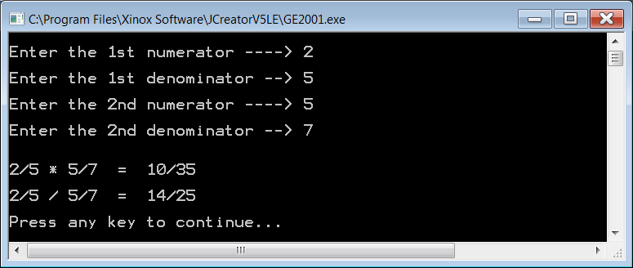

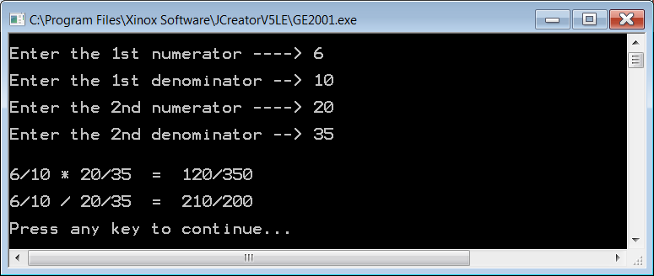

**90 Point Version Specifics**

The 90 point version adds the **reduce** method. As with **TextLab04**, you are provided with the **getGCF** method. Not only do you need to write the **reduce** method, but you also need to call it in the appropriate places so that the product and quotient will be displayed in lowest terms.

**90 Point Version Outputs**

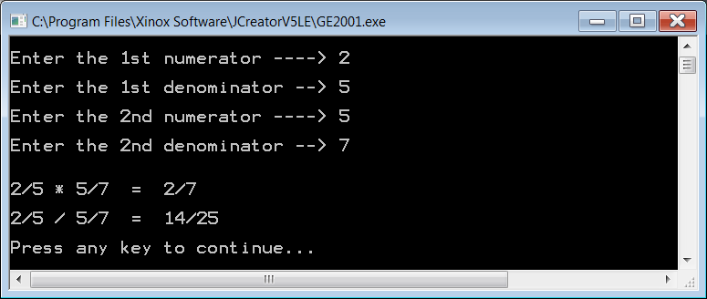

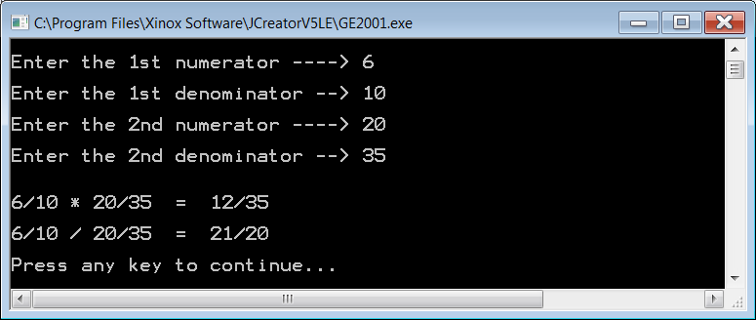

**100 Point Version Specifics**

The 100-point version completes the **Rational** class with methods **add** and **subtract**. The sum and difference also need to be displayed in lowest terms.

**100 Point Version Outputs**

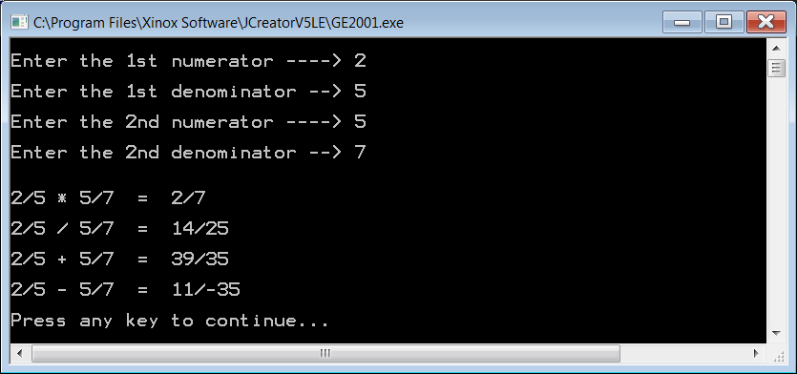

NOTE: In the subtraction answer, the negative sign might show up in the numerator.

It also might show up in the denominator. Either way is fine.

