CIS4014-N Interactive Visualization — Group 4
Team Meeting 04 — Sprint 4 Kickoff: Dashboard Integration & Testing Planning
Meeting Date | 11 October 2026
Meeting Number | 04
Week | Week 04
Meeting Type | Sprint Review & Planning
Project Management Tool | Trello
Development Approach | Scrum / Agile
Team | Group 4

1. Meeting Objective
The purpose of the fourth team meeting was to review the completed Sprint 3 work — the shared D3.js v7 environment, the three D3.js charts with their tooltips and interactions, the first-pass dashboard and the individual chart reviews — and to agree the Week 04 Sprint Plan for integrating the three charts into one dashboard, adding shared filters and a Reset button, connecting and synchronising the charts, and carrying out functional, cross-chart and usability testing with bug fixing, ahead of the final website checks and submission in Sprint 5.

2. Team Members
Member | Student Number | Role | Confirmed Chart Ownership (Week 04)
Imasha Chathurangi Ilamperuma | F5692459 | Team Leader | Project coordination, Scrum/Trello management, and Individual Chart 2 — Store Location Map (integration and testing); leads connecting the charts
Singappuli Arachchige Isuru Dayanga Samarakoon | F5692600 | Team Member | Individual Chart 1 — Temporal Heat Map (integration and testing); leads the shared filters and synchronized interactions
Wijaya Hewage Matheesha Priyan Harshana De Silva | F5692734 | Team Member | Individual Chart 3 — Scatter Plot (integration and testing); leads the common dashboard layout and the Reset button

3. Topics Discussed
- Reviewed Sprint 3 completion against the Sprint 3 Backlog and burndown chart: all 15 items (S3-01 to S3-15) closed. The shared set-up closed Day 1, the Chart 1 and Chart 2 builds Day 2, the Chart 3 build Day 3, all six tooltips and interactions Day 4, the first-pass dashboard Day 5 and the individual chart review Day 6, with the burndown finishing at zero (see Section 4).
- Reviewed the Sprint 3 Retrospective. What went well: the shared foundation finished on Day 1, the common UI design was locked before development, Chart 3 was no longer the critical path, and the burndown stayed on or below plan every day. What did not: work was closed unevenly (six tasks on Day 4), the first-pass dashboard only came together on Day 5, shared set-up depended heavily on one member, and interaction consistency could only be checked at the end of the sprint.
- Reviewed the three completed D3.js charts and the first-pass dashboard as a group for the first time, confirming each chart reproduces the encoding validated in its Excel prototype and carries its tooltip and interaction (see Section 5).
- Confirmed the dashboard integration design — KPI band, shared filter bar, chart layout and cross-chart behavior — that all three charts will follow in Sprint 4 (see Section 6).
- Agreed the Sprint 4 approach: build the shared layout first, integrate the charts one at a time (each led by its owner), then add the filters and Reset button, connect the charts and synchronize their interactions; hold a mid-sprint integration checkpoint on Day 3; and use the remaining days for testing, bug fixing and updating the testing documentation.
- Discussed spreading integration and coordination across all three members — a named lead for each whole-team task and pairing on shared work — so that no single member is a bottleneck, as raised in the Sprint 3 Retrospective.
- Noted that the overarching and three individual research questions remain unchanged from Meeting 01 and Meeting 02, and will not be revisited during Sprint 4.
- Discussed keeping GitHub commits and Trello statuses current daily, and updating the Sprint 4 burndown each day from the actual Trello checklist count, given three members integrating into one shared codebase.

4. Sprint 3 Review — Week 03 Backlog Status
Sprint 3 Task IDs | Backlog Item | Status | Evidence / Notes
S3-01, S3-11, S3-13, S3-14 | Shared set-up: D3.js v7 environment, common CSS, common dataset load, D3.js version check | Done | Closed Day 1: version-pinned D3.js v7 scaffold; cleaned dataset (149,116 rows × 23 columns) loading; shared stylesheet applying the confirmed palette, typography and layout (Meeting 3, Section 7; Sprint 3 Backlog).
S3-02–S3-04 | Chart 1 (Temporal Heat Map): D3.js build, tooltip, interaction | Done | Build closed Day 2; tooltip (exact day/hour counts) and hover-to-isolate / click-to-hold closed Day 4 (Sprint 3 Burndown; Sprint 3 Backlog).
S3-05–S3-07 | Chart 2 (Store Location Map): D3.js build, tooltip, interaction | Done | Build closed Day 2; tooltip (store revenue/transaction detail) and click-to-filter with release closed Day 4 (Sprint 3 Burndown; Sprint 3 Backlog).
S3-08–S3-10 | Chart 3 (Scatter Plot): D3.js build, tooltip, interaction | Done | Build closed Day 3; tooltip (daily units/revenue detail) and drag-to-zoom box-select closed Day 4 (Sprint 3 Burndown; Sprint 3 Backlog).
S3-12 | Initial dashboard with all three D3.js charts | Done | Closed Day 5: all three charts placed together on one page for the first time (Sprint 3 Burndown; Sprint 3 Backlog).
S3-15 | Individual chart review | Done | Closed Day 6: each chart checked against its research question and Excel prototype figures; burndown finished at 0 of 15 items remaining (Sprint 3 Retrospective, Sections 2–3).

5. D3.js Chart Summary (All Three Complete)
Chart | Owner | What the D3.js Chart Shows | Encoding and Interaction Implemented
Chart 1 — Temporal Heat Map | Samarakoon | Color-scale grid, 7 days × 15 hourly columns (6:00–20:00), reproducing the validated Excel prototype. Prototype figures: busiest hour 10:00 (18,545 transactions); KPI band $698,812 revenue, 149,116 transactions, 214,470 units. | Cell position = day/hour; color intensity = transaction count. Tooltip shows exact day/hour counts; hover to isolate, click to hold.
Chart 2 — Store Location Map | Ilamperuma | Bubble map plotting each store by latitude/longitude with bubble size mapped to revenue, alongside ranked store detail: Hell's Kitchen $236,511 → Astoria $232,244 → Lower Manhattan $230,057. | Position = geography (lat/long); bubble size = revenue. Tooltip shows store revenue/transaction detail; click to filter, click again to release.
Chart 3 — Scatter Plot | De Silva | Scatter of daily units sold against daily revenue for the three stores, reproducing the validated Excel prototype and built from the cleaned dataset. | X-axis = quantity sold; Y-axis = revenue; color = store location. Tooltip shows daily units/revenue detail; drag to zoom (box-select).

6. Dashboard Integration Design Confirmed
Element | Decision
Page structure | Fixed KPI band across the top (revenue, transactions, units sold, per-transaction value, busiest hour), with the shared filter bar (Store / Category / Month) and Reset button beneath it, as confirmed in Meeting 03 and the UI Design Document.
Chart layout | Heat map ,store map; scatter plot full-width below each in order of mention. Each chart keeps its title, one-line instruction and supporting figures.
Shared filters | The Store / Category / Month filters apply to all three charts and the KPI band together, rather than to each chart separately.
Reset button | One click clears every active filter and any held or selected chart state (held hour, selected store, zoom) and returns the dashboard to its default view.
Cross-chart behaviour | Selecting a store on the map (click-to-filter) updates the KPI band, heat map and scatter plot; releasing the selection returns all charts to the current filter state.
Interaction consistency | Hover/tooltip style, transition timing and highlight color stay identical across the connected charts. Store accents follow the finalized palette: Hell's Kitchen #E0705F, Astoria #E4A94D, Lower Manhattan #58B09C.
Themes | The cream/espresso design carries over unchanged to the integrated dashboard in both the light and dark themes.

7. Week 04 Sprint Plan
Task | Owner | Expected Output | Deadline
Create common dashboard layout (S4-04) | All (lead: Ilamperuma) | Single page with KPI band, shared filter bar and chart panels placed as confirmed in Section 6, using the common CSS | Day 1
Integrate Chart 1 (S4-01) | All (lead: Samarakoon) | D3.js Temporal Heat Map running full width inside the shared layout on the common dataset | Day 2
Integrate Chart 2 (S4-02) | All (lead: Ilamperuma) | D3.js Store Location Map running full width inside the shared layout on the common dataset | Day 2
Integrate Chart 3 (S4-03) | All (lead: De Silva) | D3.js Scatter Plot running full-width inside the shared layout on the common dataset | Day 2
Add common filters (S4-05) | All (lead: Ilamperuma) | Store / Category / Month filter bar driving all three charts and the KPI band | Day 3
Add Reset button (S4-06) | All (lead: Ilamperuma) | Reset button returning all filters and chart selections to the default view | Day 3
Mid-sprint integration checkpoint | All | Integrated dashboard reviewed together so cross-chart issues surface before testing begins | Day 3
Connect charts (S4-07) | All (lead: Ilamperuma) | A selection in one chart updates the other charts and the KPI band | Day 4
Synchronize interactions (S4-08) | All (lead: Ilamperuma) | Identical hover, highlight and transition behavior, linked across all three charts | Day 4
Functional testing and data validation (S4-09, S4-10) | All | Dashboard behavior and displayed figures checked against the cleaned dataset and Excel prototype values | Day 4–5
Tooltip, filter and cross-chart testing (S4-11, S4-12, S4-13) | All | Tooltips, shared filters and linked selections tested across all three charts | Day 5
Browser, responsive and usability testing (S4-14, S4-15, S4-16) | All | Dashboard tested across browsers and screen sizes, with usability feedback recorded | Day 5–6
Record bugs, fix high-priority bugs and retest fixes (S4-17, S4-18, S4-19) | All | Bug log kept as testing proceeds; high-priority bugs fixed and retested | Day 4–6
Update testing documentation (S4-20) | All | Testing results, bug log and retest outcomes documented | End of Week 04

8. Decisions Made
- Chart ownership unchanged: Chart 1 (Temporal Heat Map) — Samarakoon; Chart 2 (Store Location Map) — Ilamperuma; Chart 3 (Scatter Plot) — De Silva.
- Sprint 4 tasks remain whole-team tasks in Trello, each with a named lead (De Silva: layout and Reset; Samarakoon: filters and synchronized interactions; Ilamperuma: connecting the charts), with pairing on shared work, so integration and coordination are spread across all three members.
- The integrated dashboard follows the confirmed layout and finalized palette in Section 6; no new encoding or design decisions will be made, and each chart keeps the encoding validated in its Excel prototype.
- The Store / Category / Month filters and the Reset button apply to all three charts and the KPI band, and cross-chart selection follows the behavior set out in Section 6.
- A mid-sprint integration checkpoint will be held on Day 3 so cross-chart problems are found early, before testing starts.
- Testing covers functional, data validation, tooltip, filter, cross-chart, browser, responsive and usability checks; bugs are recorded, high-priority bugs fixed and retested, and results written into the testing documentation. The final website checks, ethical review, documentation and submission preparation follow in Sprint 5.
- The Sprint 4 burndown will be updated daily from the actual Trello checklist count, with Ilamperuma keeping Trello, the burndown and Scrum evidence up to date.

9. Action Items Before Meeting 05
Action | Owner | Status | Due
Create common dashboard layout (KPI band, filter bar, chart panels) | Ilamperuma (lead), All | Not Started | Day 1
Integrate Chart 1, Chart 2 and Chart 3 into the shared layout | Samarakoon, Ilamperuma, De Silva | Not Started | Day 2
Add shared Store / Category / Month filters and Reset button | Ilamperuma (lead), All | Not Started | Day 3
Hold mid-sprint integration checkpoint | All | Not Started | Day 3
Connect the charts and synchronize interactions | Ilamperuma (connect), All (Synchronize) | Not Started | Day 4
Complete functional testing and data validation | All | Not Started | Day 4–5
Complete tooltip, filter and cross-chart testing | All | Not Started | Day 5
Complete browser, responsive and usability testing | All | Not Started | Day 5–6
Record bugs, fix high-priority bugs and retest fixes | All | Not Started | Day 4–6
Update testing documentation | All | Not Started | End of Week 04
Keep Trello statuses, the Sprint 4 burndown and GitHub commit up to date daily | All (Ilamperuma leads Trello and burndown) | Not Started | Ongoing

10. Next Meeting
Meeting 05 will review the integrated dashboard — shared filters, Reset button and connected charts — together with the Sprint 4 testing results and bug log, and begin planning the Sprint 5 final website checks: final UI review, ethical review (misleading axes, calculations, data-source attribution and limitations), documentation, and submission preparation.

11. Meeting Evidence

Chart 1 — Temporal Heat Map (D3.js build, tooltip, interaction)

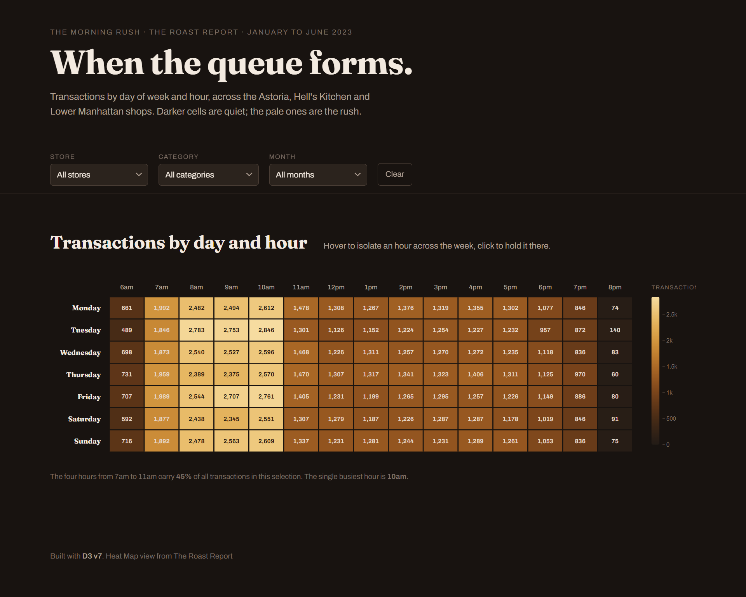

Chart 2 — Store Location Map (D3.js build, tooltip, interaction)

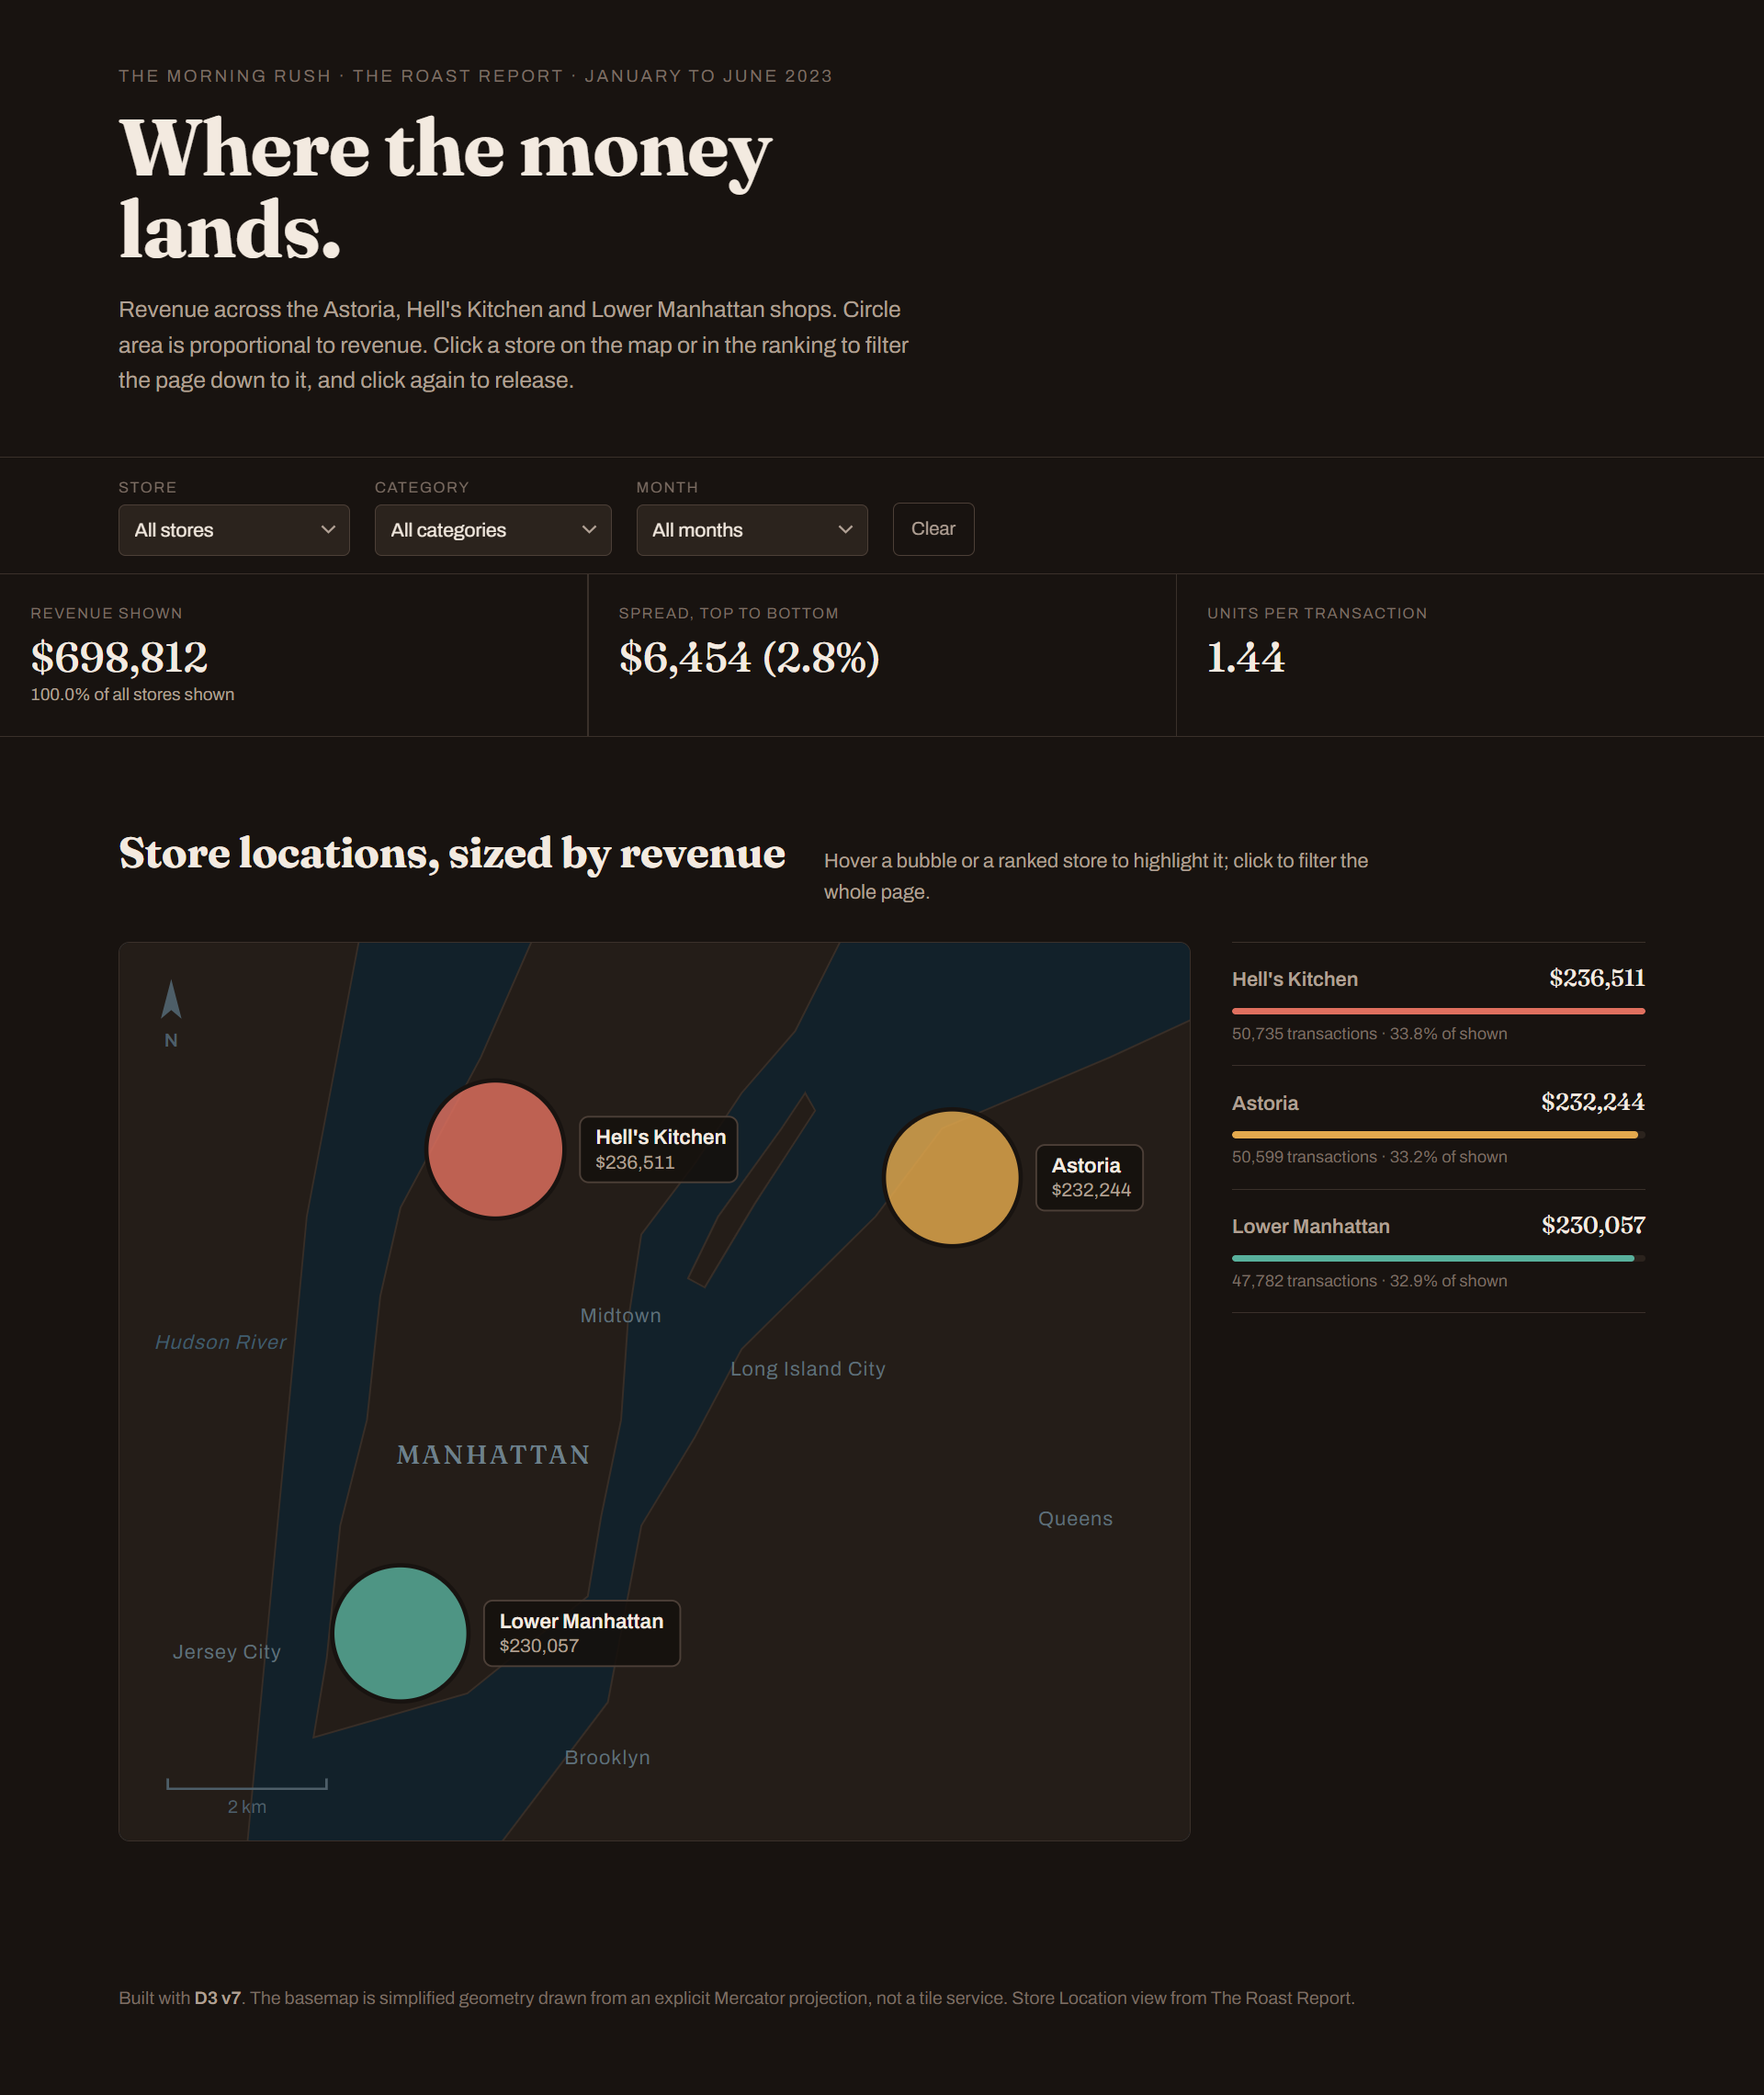

Chart 3 — Scatter Plot(D3.js build, tooltip, interaction)
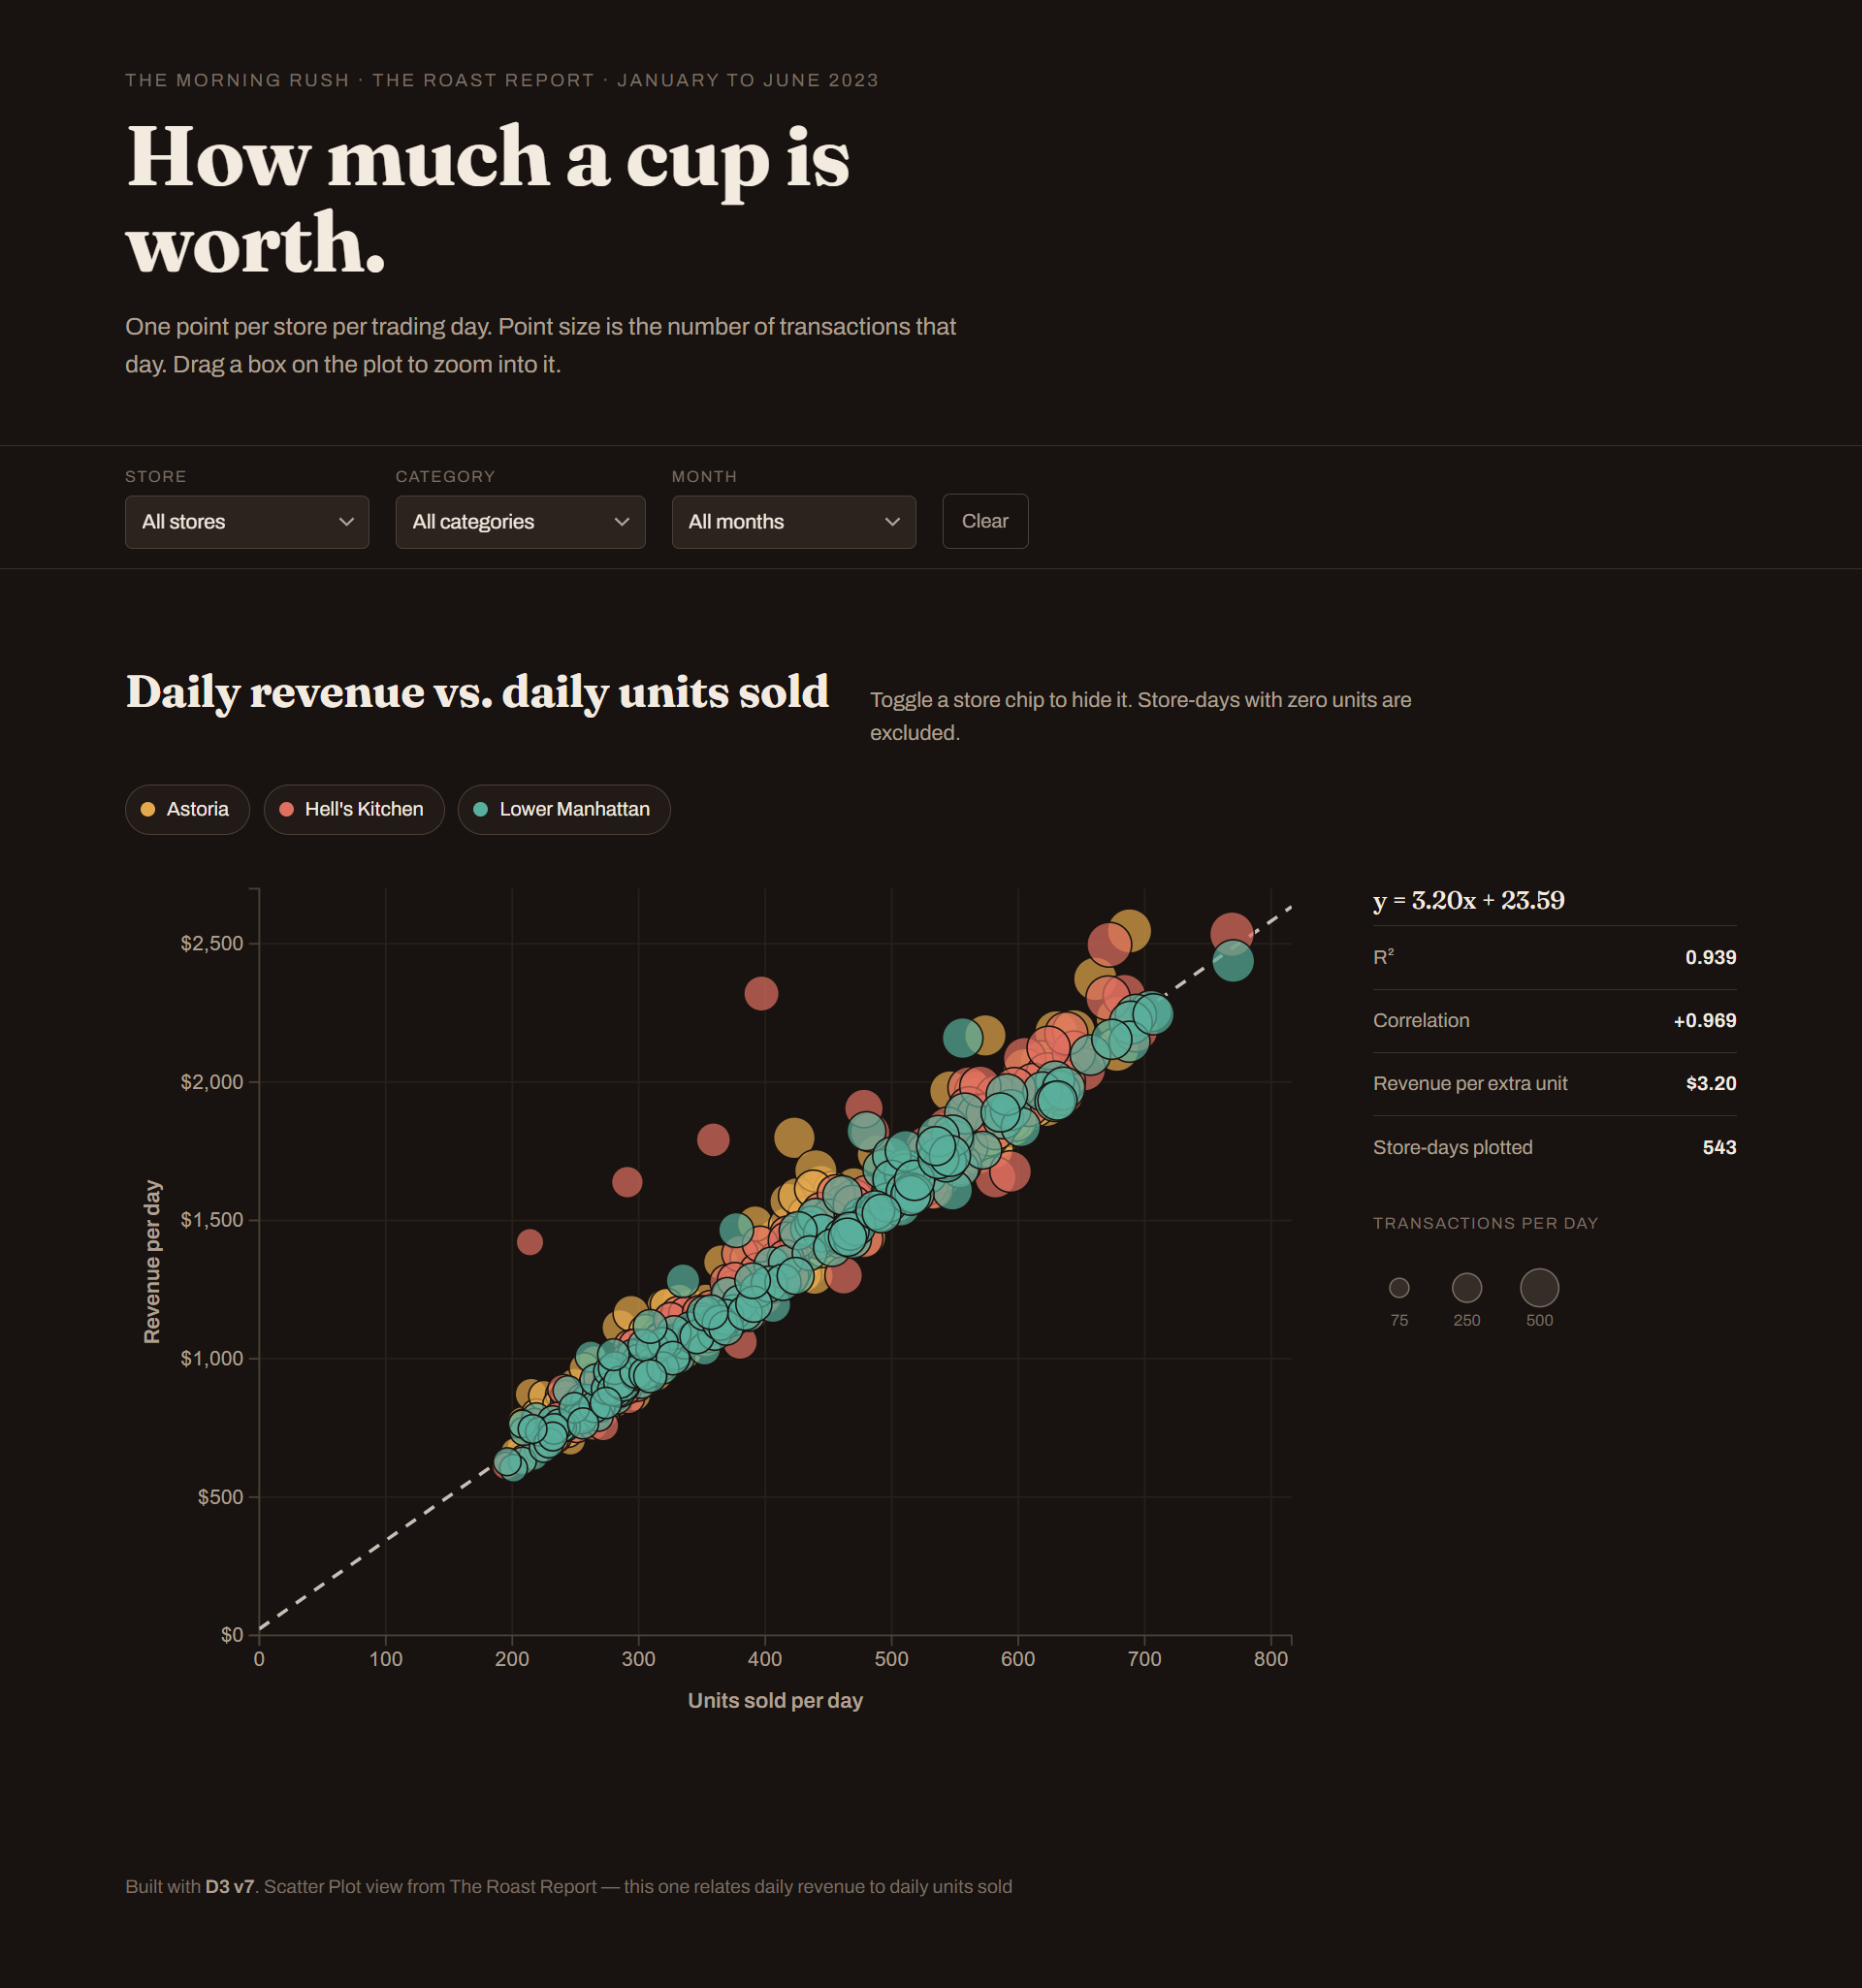

Initial Dashboard
