CIS4014-N Interactive Visualization — Group 4
Team Meeting 03 — Sprint 3 Kickoff: D3.js Development Planning
Meeting Date | 4 October 2026
Meeting Number | 03
Week | Week 03
Meeting Type | Sprint Review & Planning
Project Management Tool | Trello
Development Approach | Scrum / Agile
Team | Group 4

1. Meeting Objective
The purpose of the third team meeting was to review the completed Sprint 2 work — the cleaned and documented dataset, all three chart prototypes, and the joint review and common UI sign-off — and to agree the Week 03 Sprint Plan for converting each validated Excel prototype into a working D3.js chart, ahead of dashboard integration and testing in Sprint 4.

2. Team Members
Member | Student Number | Role | Confirmed Chart Ownership (Week 03)
Imasha Chathurangi Ilamperuma | F5692459 | Team Leader | Project coordination, Scrum/Trello management, and Individual Chart 2 — Store Location Map (D3.js development)
Singappuli Arachchige Isuru Dayanga Samarakoon | F5692600 | Team Member | Individual Chart 1 — Temporal Heat Map; sets up the shared D3.js v7 environment for the team
Wijaya Hewage Matheesha Priyan Harshana De Silva | F5692734 | Team Member | Individual Chart 3 — Scatter Plot (D3.js development and testing support)

3. Topics Discussed
- Reviewed Sprint 2 completion against the Sprint 2 Backlog and burndown chart: data cleaning, processing, data dictionary and documentation closed at kickoff; Chart 1 and Chart 2 prototypes closed at kickoff; Chart 3 prototype closed Day 2, with interactions and rationale by Day 3; joint review and common UI sign-off by Day 5; progress-review prep by Day 6 (see Section 4).
- Reviewed the Chart 3 — Scatter Plot prototype as a group for the first time, now that De Silva had completed it, alongside the already-reviewed Chart 1 and Chart 2 prototypes (see Section 5).
- Confirmed the common UI design — color palette, typography, layout and interaction consistency — that all three D3.js charts will follow in Sprint 3 (see Section 6).
- Agreed the D3.js development approach: Ilamperuma to set up the shared D3.js v7 environment and load the common dataset; each member to build their own chart individually, then add its tooltip and interaction; the team to assemble a first-pass dashboard and complete an individual chart review before Meeting 04.
- Noted that the overarching and three individual research questions remain unchanged from Meeting 01 and Meeting 02, and will not be revisited during Sprint 3.
- Discussed keeping GitHub commits and Trello statuses current daily, given three concurrent D3.js development workstreams.

4. Sprint 2 Review — Week 02 Backlog Status
Sprint 2  Task IDs | Backlog Item | Status | Evidence / Notes
S2-01–S2-04 | Data cleaning, processing, data dictionary and data-source documentation | Done | 149,116-row dataset cleaned via the 20-step Cleaning Log; 0 exceptions across all checks (Meeting 2, Section 6; Sprint 2 Backlog).
S2-05–S2-08 | Chart 1 (Temporal Heat Map): variable analysis, prototype, interactions, rationale | Done | Excel conditional-formatting grid; encoding validated against real hourly totals; busiest hour 10:00 (Meeting 2, Section 5).
S2-09–S2-12 | Chart 2 (Store Location Map): variable analysis, prototype, interactions, rationale | Done | Excel bubble chart with ranked store table; Hell's Kitchen $236,511 → Astoria $232,244 → Lower Manhattan $230,057 (Meeting 2, Sections 5 & 11).
S2-13–S2-16 | Chart 3 (Scatter Plot): variable analysis, prototype, interactions, rationale | Done | Completed Days 1–3 after kickoff: daily units sold vs. revenue across the three stores, with a linear trendline (equation and R²) (Sprint 2 Backlog; Retrospective, Section 4).
S2-17–S2-19 | Joint prototype review, common UI sign-off, Meeting 03 progress-review prep | Done | Review and UI sign-off completed Days 4–5; progress-review prep completed Day 6 (Sprint 2 Burndown; Retrospective, Section 4).

5. Chart Prototype Summary (All Three Complete)
Chart | Owner | What the Prototype Shows | Encoding Validated
Chart 1 — Temporal Heat Map | Samarakoon | Conditional-formatting color-scale grid, 7 days × 15 hourly columns (6:00–20:00). KPI band: $698,812 revenue, 149,116 transactions, 214,470 units, $4.69 per transaction. Busiest hour: 10:00 (18,545 transactions). | Cell position = day/hour; color intensity = transaction count. Validated against real hourly totals.
Chart 2 — Store Location Map | Ilamperuma | Bubble chart plotting each store by latitude/longitude, bubble size mapped to revenue. Ranked table: Hell's Kitchen $236,511 → Astoria $232,244 → Lower Manhattan $230,057; spread $6,454; 1.44 units per transaction. | Position = geography (lat/long); bubble size = revenue. Size differences readable but not exaggerated.
Chart 3 — Scatter Plot | De Silva | Scatter of daily units sold against daily revenue for each of the three stores, with a linear trendline (equation and R²) fitted per store, built from the cleaned dataset. | X-axis = quantity sold; Y-axis = revenue; color = store location. Validated against real daily aggregates.

6. Common UI Design Confirmed
Element | Decision
Color palette | Warm cream background with espresso-brown text/headers; each store keeps one consistent accent color across all three charts — Hell's Kitchen (amber), Astoria (teal), Lower Manhattan (maroon).
Typography | Semi-bold display font for headings and KPI figures; a plain sans-serif for body text, axis labels and tooltips.
Layout | Fixed KPI band (revenue, transactions, units sold, per-transaction value) across the top; a shared filter bar (Store / Category / Month) with a Reset button beneath it; heat map ,store map side and scatter plot full-width below ,stacked in that order..
Interaction consistency | Hover/tooltip style, transition timing and highlight color kept identical across all three charts, per the Interactive Features note reviewed in Meeting 02, so the dashboard reads as one instrument rather than three separate charts.

7. Week 03 Sprint Plan
Task | Owner | Expected Output | Deadline
Set up D3.js v7 environment | Ilamperuma | Shared, version-pinned D3.js v7 project scaffold ready for chart development | Day 1
Load common dataset | All | Cleaned dataset (149,116 rows × 23 columns) loading correctly for all three charts | Day 1
Check D3.js version | All | Confirmed D3.js v7 compatibility across all three members' local environments | Day 1
Create common CSS | All | Shared stylesheet applying the confirmed color palette, typography and layout | Day 1
Develop Chart 1 | Samarakoon | Working D3.js Temporal Heat Map reproducing the validated Excel prototype | Day 2–3
Develop Chart 2 | Ilamperuma | Working D3.js Store Location Map reproducing the validated Excel prototype | Day 2–3
Develop Chart 3 | De Silva | Working D3.js Scatter Plot reproducing the validated Excel prototype | Day 2–3
Add Chart 1 tooltip and interaction | Samarakoon | Hover tooltip with exact day/hour counts; hover-to-isolate / click-to-hold implemented | Day 4
Add Chart 2 tooltip and interaction | Ilamperuma | Hover tooltip with store revenue/transaction detail; click-to-filter (with release) implemented | Day 4
Add Chart 3 tooltip and interaction | De Silva | Hover tooltip with daily units/revenue detail; drag-to-zoom box-select implemented | Day 4
Create initial dashboard | All | All three D3.js charts placed together in a first-pass dashboard layout | Day 5
Individual chart review | All | Each member's chart reviewed against its research question and Excel prototype | End of Week 03

8. Decisions Made
- Chart ownership unchanged: Chart 1 (Temporal Heat Map) — Samarakoon; Chart 2 (Store Location Map) — Ilamperuma; Chart 3 (Scatter Plot) — De Silva.
- Ilamperuma will set up the shared D3.js v7 environment and load the common dataset before individual chart development begins.
- Each D3.js chart will reproduce the encoding already validated in its Excel prototype; no new encoding decisions will be made at this stage.
- The common UI design confirmed in Section 6 (color palette, typography, layout) is locked in for all three charts and the initial dashboard.
- Tooltips and interactions will be added to each chart individually before the team assembles the first-pass dashboard.

9. Action Items Before Meeting 04
Action | Owner | Status | Due
Set up shared D3.js v7 environment, load dataset, confirm version, create common CSS | Ilamperuma(lead), All | Not Started | Day 1
Develop Chart 1 (Temporal Heat Map) in D3.js | Samarakoon | Not Started | Day 2–3
Develop Chart 2 (Store Location Map) in D3.js | Ilamperuma | Not Started | Day 2–3
Develop Chart 3 (Scatter Plot) in D3.js | De Silva | Not Started | Day 2–3
Add tooltip and interaction to each chart | Samarakoon, Ilamperuma, De Silva | Not Started | Day 4
Assemble first-pass dashboard with all three charts | All | Not Started | Day 5
Complete individual chart review ahead of Meeting 04 | All | Not Started | End of Week 03
Keep Trello statuses and GitHub commits up to date daily | All | Not Started | Ongoing

10. Next Meeting
Meeting 04 will review the three completed D3.js charts (each with its tooltip and interaction implemented), the first-pass dashboard layout, and begin planning the Sprint 4 integration and testing phase — connecting the charts, adding shared filters, and functional and cross-chart testing.

11. Meeting Evidence
Chart 1 — “When the queue forms” (Temporal Heat Map), Owner: Samarakoon — file: 1_Heatmap_WhenTheQueueForms.xlsx
Built as a conditional-formatting color-scale grid (day of week × hour, 6:00–20:00), driven by the same KPI band (revenue, transactions, units sold, per-transaction value) and busiest-hour figure (10:00, 18,545 transactions) later carried into the dashboard footer.
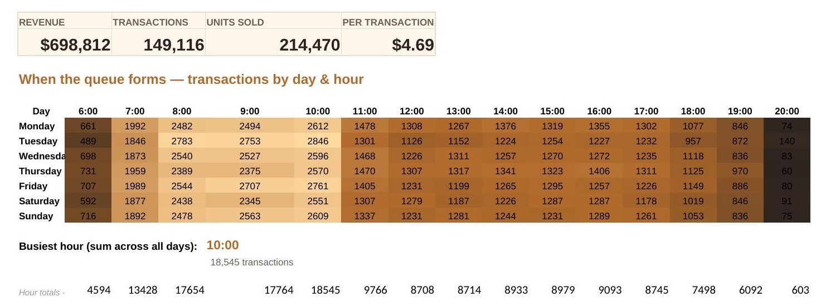
Chart 2 — “Where the money lands” (Store Location Map), Owner: Ilamperuma — file: 2_StoreMap_WhereTheMoneyLands.xlsx
Built as a bubble chart plotting each store by latitude/longitude, with bubble size mapped to revenue, alongside a ranked table (Hell's Kitchen $236,511 → Astoria $232,244 → Lower Manhattan $230,057) and the spread/units-per-transaction stats later carried into the final map's ranking panel.
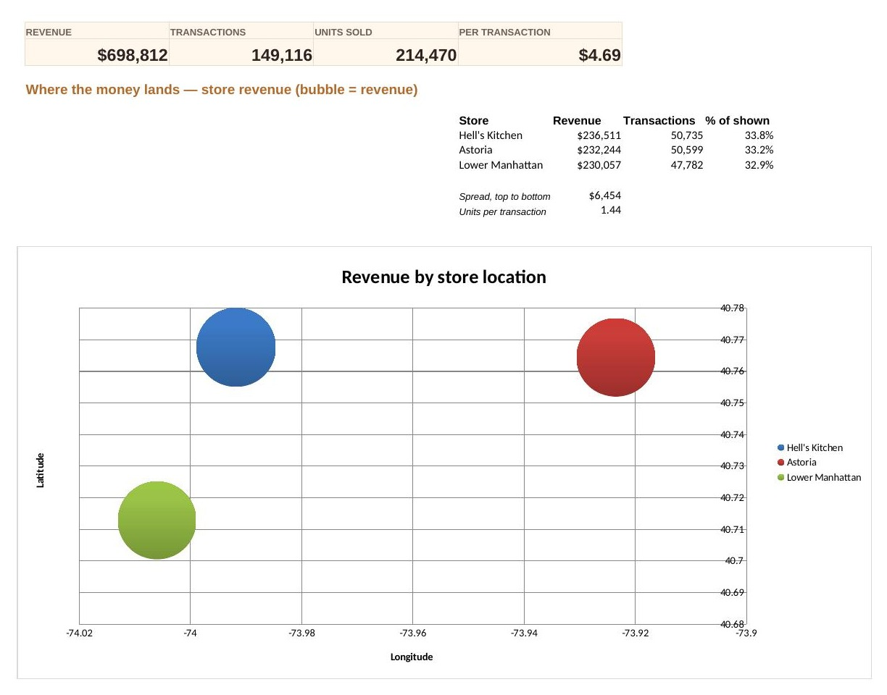
Chart 3 — “How much a cup is worth” (Scatter Plot), Owner: De Silva— file: 3_Scatter_HowMuchACupIsWorth.xlsx
Built as a scatter of daily units sold against daily revenue for each of the three stores, with a linear trendline (equation and R²) fitted per store, built from the cleaned dataset.
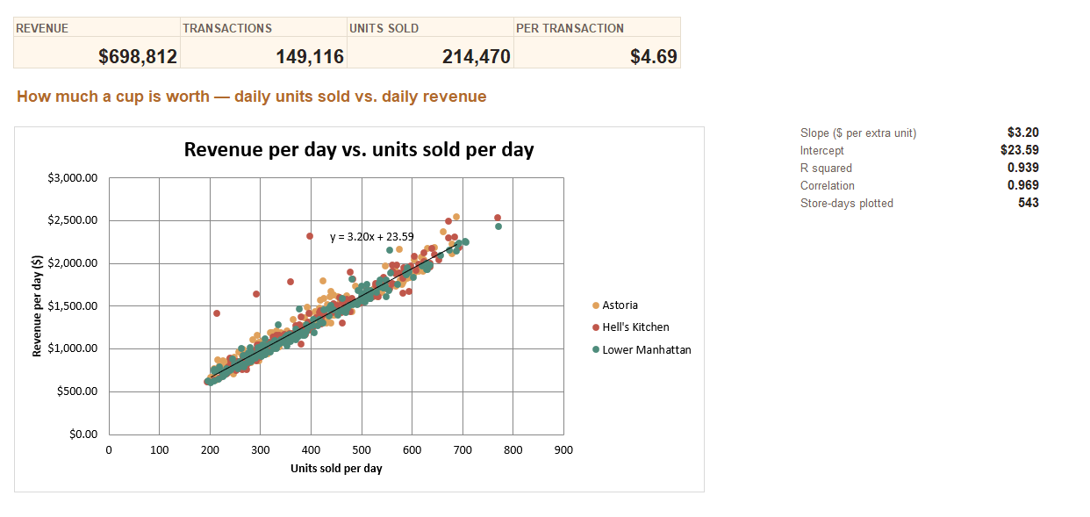

Proposed and Finalized color palette locked in

Role | Hex | Suggested token | Swatch | Where it is used
Page background (light) | #E4CDB0 | --bg-light |  | Warm cream page background
Headings and KPI text | #2B1D11 | --ink |  | Espresso-brown headings, KPI figures, axis titles
Body text | #5A4530 | --text |  | Descriptions, labels, tooltips, footnotes
Page background (dark) | #181310 | --bg-dark |  | Dark “roast” page background
Text on dark | #F3EAE0 | --ink-dark |  | Headings, KPI figures and body text in the dark theme
Map panel | #241D18 | --panel |  | Store Location Map canvas
Hell’s Kitchen accent | #E0705F | --store-hk |  | Red: map circle, ranking bar, scatter points
Astoria accent | #E4A94D | --store-as |  | Amber: map circle, ranking bar, scatter points
Lower Manhattan accent | #58B09C | --store-lm |  | Teal: map circle, ranking bar, scatter points
Heat map ramp | #955720 → #EEC97E | --heat-mid, --heat-peak |  | Dark espresso (quiet hours) to pale gold (rush hours)

Proposed typography and layout locked in
Element | Locked-in decision | Notes and Details
Headings and KPI figures | Semi-bold display font | Page title, section titles and the five KPI values
Body text | Plain sans-serif for body text, axis labels and tooltips | Chart descriptions, filters, axis labels, ranking table
Page structure | Header, shared filter bar and KPI band above the charts | Store / Category / Month filters with Clear; KPI band: revenue, transactions, units sold, per-transaction value, busiest hour
Chart layout | Chart 1 (heat map), Chart 2 (store map) and Chart 3 (scatter plot) in one consistent style | Each chart has a title, one-line instruction and its supporting figures beside or beneath it
Store colors | One accent color per store, kept identical across all three charts | Same colors in the map bubbles, ranking bars, scatter legend and points
Interaction consistency | Same hover, highlight and transition style on every chart | Hover to isolate and click to hold (heat map); click to filter and release (map); drag to zoom (scatter)
Themes | Cream/espresso design applied identically in both themes | Light and dark versions share the same layout, accents and typography

(Refer to the UI_Design.docx in design folder for finalized clarifications)

