CIS4014-N Interactive Visualization — Group 4
Team Meeting 01 — Sprint 1 Kickoff : Project Initiation & Planning
Meeting Date | 20 September 2026
Meeting Number | 01
Week | Week 01
Meeting Type | Sprint Planning & Progress Review
Project Management Tool | Trello
Development Approach | Scrum / Agile
Team | Group 4

1. Meeting Objective
The purpose of the first team meeting was to establish the initial direction of the CIS4014-N Interactive Visualization project, agree on a suitable project management approach, discuss the project topic and dataset, identify individual visualization responsibilities, and establish the initial development plan for Week 01.

2. Team Members
Member | Student Number | Role | Initial Responsibility
Imasha Chathurangi Ilamperuma | F5692459 | Team Leader | Project coordination, Scrum/Trello management, data preparation and Individual Chart 1
Singappuli Arachchige Isuru Dayanga Samarakoon | F5692600 | Team Member | Individual Chart 2 and D3.js development
Wijaya Hewage Matheesha Priyan Harshana De Silva | F5692734 | Team Member | Individual Chart 3, D3.js development and testing support

3. Topics Discussed
- Reviewed the main requirements of the Interactive Visualization assignment.
- Discussed the need for three individual visualizations, with one graph produced by each team member.
- Discussed the importance of having one overarching investigation so that the three visualizations form one coherent team product.
- Discussed possible datasets and the need to select a dataset with sufficient variables for meaningful interactive visualizations.
- Selected a dataset and the topic.
- Discussed using D3.js v7, JavaScript, HTML and CSS for the web-based visualization.
- Discussed using Scrum as a simple Agile project-management approach.
- Agreed to use Trello as the team's project-management tool for the Product Backlog, Sprint tasks, task ownership and progress tracking.
- Discussed creating a shared GitHub repository for source code, data, prototypes and project documentation.

4. Agreed Project Management Approach
The team agreed to manage the project using a simplified Scrum approach because the project has a short development period of approximately four to five weeks. The work will be organized into weekly sprints. Trello will be used as the central task-management tool, while GitHub will be used for version control and project files.

5. Trello Board Structure
The team agreed to create the following Trello lists:
- Project Backlog – all identified project tasks.
- Sprint 1 – Week 01 – tasks planned for the first week.
- Sprint 2 – Week 02 – tasks planned for the second week.
- Sprint 3 – Week 03 – D3.js development tasks.
- Sprint 4 – Week 04 – integration and testing tasks.
- Sprint 5 / Finalization – final fixes and documentation, if required.
- To Do – tasks that will be starts working on.
- In Progress – tasks currently being worked on.
- Review / Testing – completed development tasks waiting for checking.
- Done – completed and verified tasks.

6. Initial Product Backlog
ID | Task | Owner | Priority | Initial Status
T01 | Select project topic and dataset | All | High | To do
T02 | Define overarching research question | All | High | To do
T03 | Define three individual research questions | All | High | To do
T04 | Analyse dataset and variables | All | High | To do
T05 | Clean and prepare dataset | All | High | To do
T06 | Select suitable chart types | All | High | To do
T07 | Create individual chart prototypes | All | High | To do
T08 | Create GitHub repository | Ilamperuma | High | To do
T09 | Create Trello board and add members | Ilamperuma | High | To do
T10 | Prepare Week 01 documentation | Ilamperuma | Medium | To do

7. Week 01 Sprint Plan
Task | Owner | Expected Output | Deadline
Confirm topic and dataset | All | Agreed dataset and topic | End of Week 01
Define overall research question | All | Final overarching question | End of Week 01
Define 3 individual questions | All | One question per member | End of Week 01
Initial data analysis | All | Variable and quality review | End of Week 01
Create Trello board | Ilamperuma | Shared Trello board | Day 1
Create GitHub repository | Ilamperuma | Shared repository | Day 1–2
Agree chart types | All | Three proposed chart types | End of Week 01

8. Decisions Made
- The project will be managed using a simplified Scrum approach with weekly sprints.
- Trello will be used to manage the Product Backlog, sprint tasks, task assignment and progress.
- GitHub will be used for source-code version control and sharing project files.
- Coffee Shop Sales dataset was selected and selected a topic "The morning rush pays for the day"
- Each team member will be responsible for developing one individual interactive D3.js visualization.
- The three visualizations will be connected through one overarching investigation and a common dashboard design.

9. Action Items Before Meeting 02
Action | Owner | Status | Due
Create Trello board and invite team members | Ilamperuma | Done | Week 01
Create GitHub repository and invite team members | Ilamperuma | Done | Week 01
Investigate and confirm dataset | All | Done | Week 01
Complete initial data analysis | All | Done | Week 01
Propose overarching research question and individual research questions | All | Done | Week 01
Propose suitable chart types | All | Done | Week 01

10. Next Meeting
Meeting 02 will review the selected dataset, finalize the overarching and individual research questions, confirm the three chart types, review the Trello Sprint 1 board, and begin the prototype/design stage.

11. Meeting Evidence

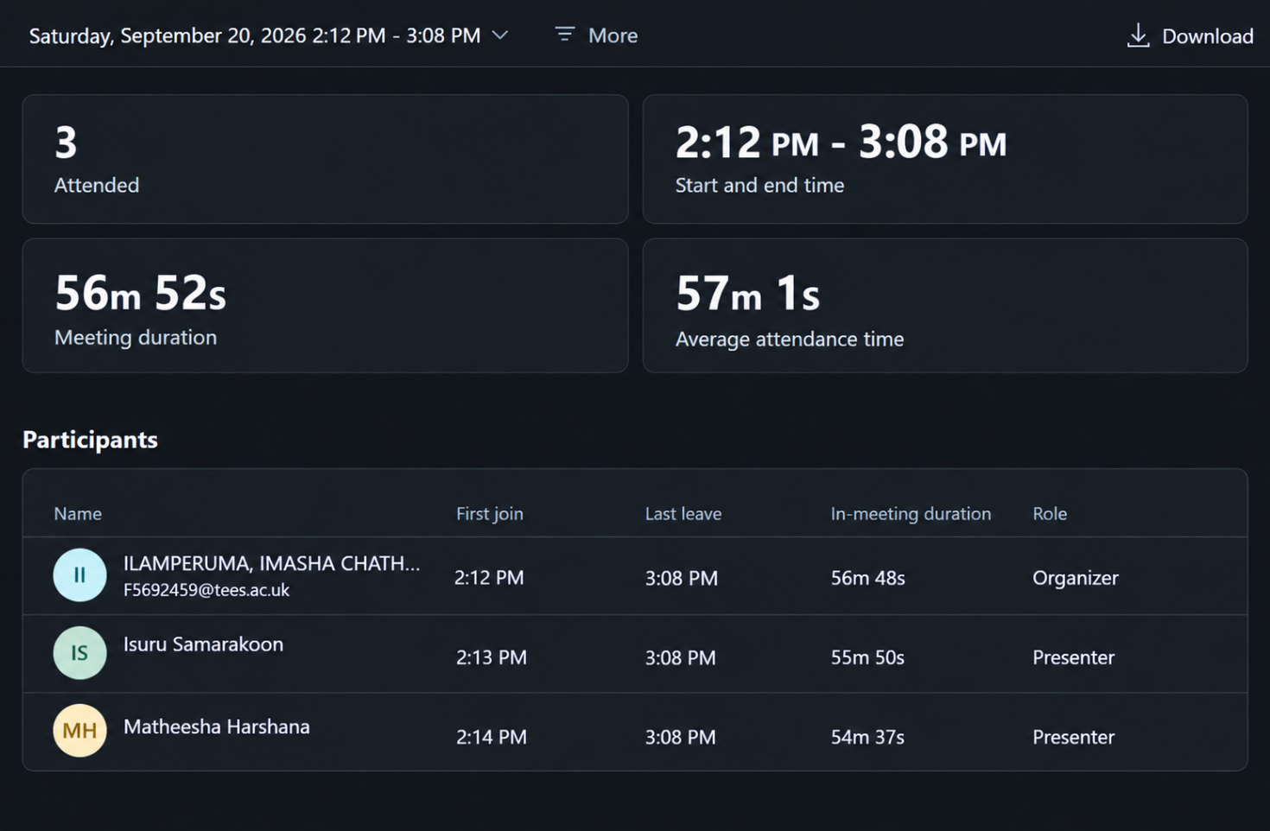
Dataset: Coffee Shop Sales
Topic: The morning rush pays for the day
Trello Board: Link
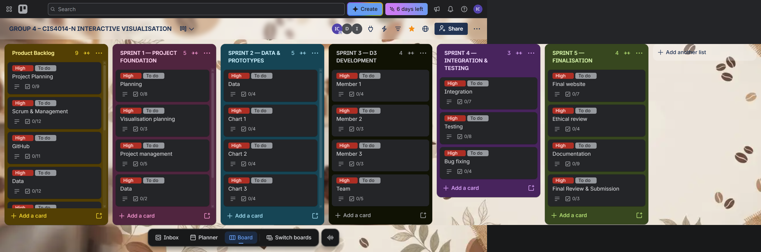
GitHub Repository: Link
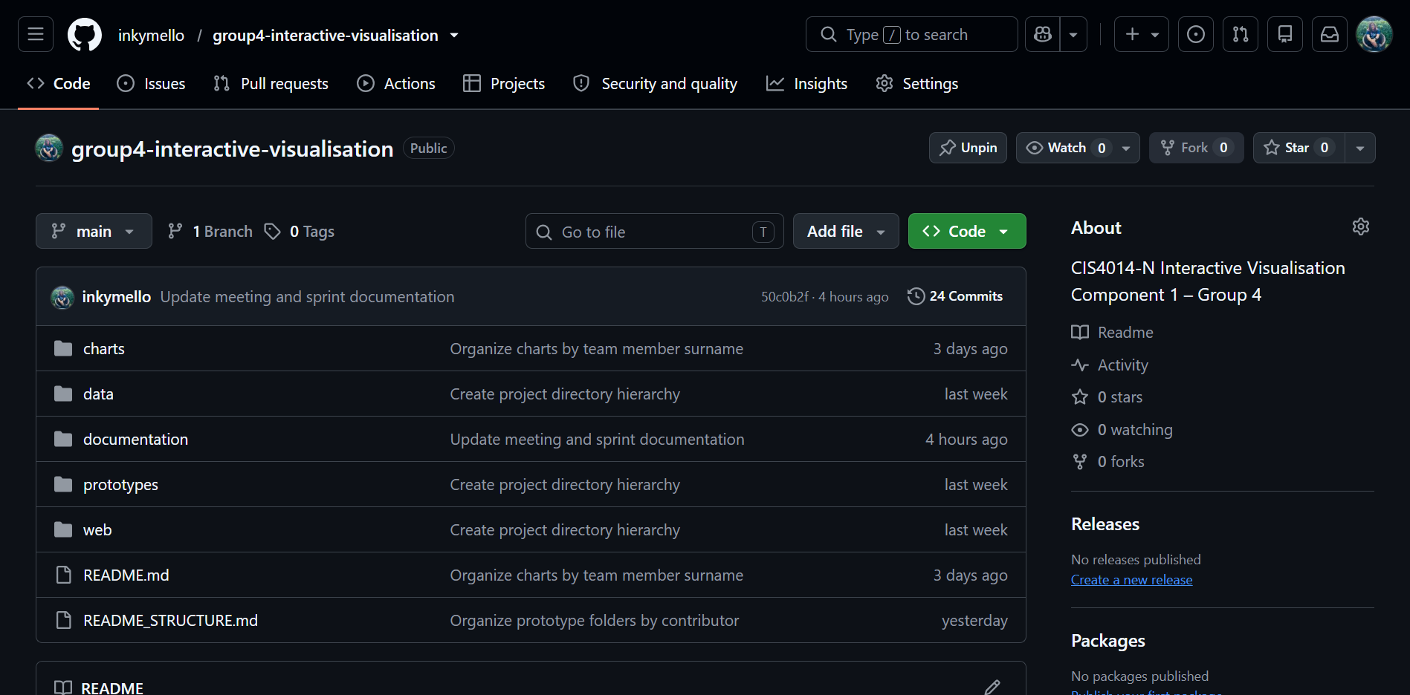
Raw Dataset — Coffee Shop Sales Dataset: Link
Scope | Research Question | Objective
Overarching | How do coffee shop sales vary in terms of when customers buy, where revenue is generated, and the relationship between units sold and daily revenue during the morning rush?
Chart 1 – When: Temporal Heatmap showing transaction activity across different days of the week and hours of the day. | When are coffee shop transactions busiest across different days of the week and hours of the day? | To identify patterns and variations in coffee-shop transaction activity across different days of the week and hours of the day.
Chart 2 – Where: Store Location Map visualization showing revenue distribution across the three coffee shop locations. | How does revenue vary across the three coffee shop locations? | To explore the geographical distribution of coffee-shop sales and compare transaction activity and revenue across different store locations.
Chart 3 – How Much: Scatter Plot showing the relationship between daily units sold and daily revenue across the coffee shop locations. | What is the relationship between daily units sold and daily revenue across the coffee shop locations? | To investigate the relationship between the quantity of products sold and the revenue generated by the coffee shop.

