CIS4014-N Interactive Visualization — Group 4
Team Meeting 02 — Sprint 2 Kickoff: Data Cleaning & Chart Prototyping
Meeting Date | 27 September 2026
Meeting Number | 02
Week | Week 02
Meeting Type | Sprint Planning & Progress Review
Project Management Tool | Trello
Development Approach | Scrum / Agile
Team | Group 4

1. Meeting Objective
The purpose of the second team meeting was to review the team's progress against the Week 01 Sprint Plan agreed in Meeting 01, confirm the final dataset and finalize the overarching and three individual research questions, confirm each member's chart type and ownership, review the initial data-quality issues identified in the raw dataset, and agree the Week 02 Sprint Plan covering full data cleaning, data-dictionary creation, and the development of each member's chart prototype.

2. Team Members
Member | Student Number | Role | Confirmed Chart Ownership (Week 02)
Imasha Chathurangi Ilamperuma | F5692459 | Team Leader | Project coordination, Scrum/Trello management, data preparation, and Individual Chart 2 — Store Location Map
Singappuli Arachchige Isuru Dayanga Samarakoon | F5692600 | Team Member | Individual Chart 1 — Temporal Heat Map, and D3.js development
Wijaya Hewage Matheesha Priyan Harshana De Silva | F5692734 | Team Member | Individual Chart 3 — Scatter Plot, D3.js development and testing support

Note: Meeting 01 recorded Chart 1 as Ilamperuma's initial responsibility alongside team-leader duties. On review of workload and each member's proposed encoding approach, the team reallocated Chart 1 (Temporal Heat Map) to Samarakoon and confirmed Chart 2 (Store Location Map) as Ilamperuma's individual chart, alongside her team-leader responsibilities. Chart 3 (Scatter Plot) remains De Silva's, unchanged from Meeting 01. This is the ownership carried forward into the Product Backlog and Sprint Task Log for the remainder of the project.

3. Topics Discussed
- Reviewed completion of the Week 01 Sprint Plan: Trello board and GitHub repository created, dataset confirmed, and initial data analysis completed.
- Reviewed and confirmed final chart-type assignment per member, reallocating Chart 1 from Ilamperuma to Samarakoon (see §2 note).
- Reviewed the initial data-quality issues found during the Week 01 data analysis: a corrupted prefix on the product_category field (e.g. “%%%@C0ff33”), a combined product-detail field mixing type/name/size, no geographic coordinates for the three stores, and no pre-computed revenue or calendar/time-analysis fields.
- Agreed the full data-cleaning approach for Week 02: validate types, missing values, duplicates and value ranges; standardize text/category values; derive revenue, store coordinates, product_type/name/size, and calendar/day-of-week/hour/week fields; and produce a data dictionary.
- Reviewed each member's chart-prototype progress — two prototypes built and presented (Chart 1, Chart 2), one still pending (Chart 3) (see §5).
- Agreed to review all three prototypes together at the end of Week 02 and confirm a common UI design before Sprint 3 development begins.
- Discussed preparing a short progress review update ahead of Meeting 03.

4. Sprint 1 Review — Week 01 Backlog Status
All ten Week 01 backlog items (T01–T10, as recorded in Meeting 01) are confirmed complete and now tracked within the team's full Product Backlog (PB-001 through PB-106) and Sprint Task Log:
Sprint_1 Task IDs | Task | Product Backlog Reference | Status
T01 | Select project topic and dataset | PB-002, PB-003 | Done
T02 | Define overarching research question | PB-005 | Done
T03 | Define three individual research questions | PB-006, PB-007, PB-008 | Done
T04 | Analyze dataset and variables | PB-034 Inspect dataset structure | Done
T05 | Clean and prepare dataset | PB-033–PB-044 (Data epic) | In Progress — carried into Sprint 2
T06 | Select suitable chart types | PB-048, PB-049, PB-050 | Done
T07 | Create individual chart prototypes | PB-051, PB-052, PB-053 | In Progress — carried into Sprint 2
T08 | Create GitHub repository | PB-022 | Done
T09 | Create Trello board and add members | PB-013, PB-014 | Done
T10 | Prepare Week 01 documentation | PB-096 Meeting 01 minutes | Done

5. Chart Prototype Summary (Built This Week)
Two of the three prototypes were built this week as Excel-native mock-ups, using real aggregates from the cleaned dataset rather than placeholder figures, so the encoding approach could be validated before D3.js development begins in Sprint 3. Full images are attached as evidence in section 11.
Chart | Owner | What the Prototype Shows | Encoding Validated
Chart 1 — Temporal Heat Map | Samarakoon | Conditional-formatting color-scale grid, 7 days × 15 hourly columns (6:00–20:00), built from Heatmap Data (transactions per day/hour). KPI band matches the full dataset: $698,812 revenue, 149,116 transactions, 214,470 units, $4.69 per transaction. Busiest hour confirmed as 10:00 (18,545 transactions across all seven days), with an hour-totals row for cross-checking. | Cell position = day/hour; color intensity = transaction count. Validated against real hourly totals, not sample data.
Chart 2 — Store Location Map | Ilamperuma | Bubble chart plotting each store by latitude/longitude, bubble size mapped to revenue, built from Store Map Data. Ranked table confirms Hell's Kitchen $236,511 (50,735 txns, 33.8%) → Astoria $232,244 (50,599 txns, 33.2%) → Lower Manhattan $230,057 (47,782 txns, 32.9%); spread top-to-bottom $6,454; 1.44 units per transaction. | Position = geography (lat/long); bubble size = revenue. Ranked table confirms the size differences are readable but not exaggerated.
Chart 3 — Scatter Plot | De Silva | Not yet submitted at the time of this meeting. | — pending prototype

Both delivered prototypes reuse the same KPI band values and store color meaning that will anchor the final dashboard, so the cross-chart consistency agreed in Meeting 01 is already holding at prototype stage.

6. Data Cleaning Log (Sprint 2)
The team reviewed the completed data-cleaning log from the Coffee Shop Sales workbook (Cleaning Log sheet), covering the full 20-step process applied to the raw 149,116-row, 10-column export:
# | Step | Description | Purpose
1 | Initial data inspection | Inspected the raw dataset containing 149,116 transaction records and 10 fields. | Understand structure, data types, missing values and potential quality issues before processing.
2 | Transaction ID validation | Checked transaction_id for duplicate values. No duplicate transaction IDs were identified. | Ensure each transaction could be uniquely identified.
3 | Duplicate row check | Checked the dataset for completely duplicated records. No duplicate full rows were found. | Prevent duplicated transactions from affecting visualization and analysis.
4 | Date validation | Validated transaction_date and retained it in standard yyyy-mm-dd format. | Support accurate temporal analysis and D3.js time-based visualizations.
5 | Time validation | Validated transaction_time and standardized it to hh:mm:ss. | Enable hourly and time-of-day analysis.
6 | Quantity validation | Checked transaction_qty for missing, zero and negative values. No invalid quantities were found. | Ensure sales quantities were valid for calculating sales performance.
7 | Unit price validation | Checked unit_price for missing, zero and negative values. No invalid prices were found. | Ensure revenue calculations were based on valid prices.
8 | Revenue calculation | Created a new revenue field using transaction quantity × unit price. | Provide a direct measure for sales/revenue visualizations.
9 | Store location standardization | Trimmed and standardized store location values. | Ensure consistent grouping of stores in charts and map visualizations.
10 | Store coordinate creation | Added latitude and longitude values representing approximate central coordinates for the three store areas. | Support geographical visualization in D3.js.
11 | Product category cleaning | Removed corrupted source prefixes and corrected the value (e.g. C0ff33 → Coffee). | Create consistent and meaningful product-category labels.
12 | Product type extraction | Derived product_type from the product detail field using the text before the first hyphen. | Enable product-family/category analysis.
13 | Product name extraction | Derived product_name from the product detail using the text after the first hyphen. | Provide clean product names for interactive charts.
14 | Product size extraction | Extracted size values such as Sm, Md, Rg and Lg. Values without an identifiable size were classified as “Not specified”. | Enable comparison of sales by product size.
15 | Calendar feature creation | Derived year, month and month_name from the transaction date. | Support monthly and temporal trend visualizations.
16 | Day-of-week derivation | Created day_of_week_num and day_of_week. | Support analysis of sales patterns across different days.
17 | Hour extraction | Derived the hour field from the transaction time. | Support hourly sales and customer activity visualisations.
18 | Week number derivation | Created week_of_year using the ISO week number. | Support weekly sales trend analysis.
19 | Final missing-value validation | Checked the cleaned dataset for missing values. No missing values were identified. | Ensure reliable data binding and interaction in D3.js.
20 | Final data-quality validation | Rechecked duplicates, invalid quantities, invalid prices and invalid date/time values. All checks passed. | Confirm that the cleaned dataset was ready for visualization.

Result: the cleaned dataset (149,116 rows × 23 columns, 13 new derived fields) passed every check with zero exceptions — 0 missing values, 0 duplicate transaction IDs, 0 duplicate rows, 0 invalid quantities or prices, and 0 invalid date/time values, across 3 stores, 9 categories and 80 products spanning 2023-01-01 to 2023-06-30. This closes out T05 (section 4) and PB-033–PB-044, and is the dataset both prototypes in section 5 are built from.

7. Week 02 Sprint Plan
Task | Owner | Expected Output | Deadline
Complete data cleaning | All | Fully validated, cleaned transaction dataset | Day 1–2
Process dataset | All | Derived revenue, coordinate, product-split and calendar fields | Day 1–2
Create data dictionary | All | Field-by-field reference for the cleaned dataset | Day 3
Document data source | All | Short write-up of dataset origin and cleaning approach | Day 3
Analyze & prototype Chart 1 | Samarakoon | Temporal Heat Map prototype with interactions defined | End of Week 02
Write Chart 1 rationale | Samarakoon | Short design-rationale note for Chart 1 | End of Week 02
Analyze & prototype Chart 2 | Ilamperuma | Store Location Map prototype with interactions defined | End of Week 02
Write Chart 2 rationale | Ilamperuma | Short design-rationale note for Chart 2 | End of Week 02
Analyze & prototype Chart 3 | De Silva | Scatter Plot prototype with interactions defined | End of Week 02
Write Chart 3 rationale | De Silva | Short design-rationale note for Chart 3 | End of Week 02
Review three prototypes together | All | Joint review notes and agreed changes | End of Week 02
Confirm common UI design | All | Shared colour palette, typography and layout direction for all three charts | End of Week 02
Prepare progress review | All | Short progress summary for Meeting 03 | End of Week 02

8. Decisions Made
- Chart ownership confirmed: Chart 1 (Temporal Heat Map) — Samarakoon; Chart 2 (Store Location Map) — Ilamperuma; Chart 3 (Scatter Plot) — De Silva.
- The overarching and three individual research questions from Meeting 01 are finalized and will not be changed further (see section 9).
- Full data cleaning, processing and data-dictionary creation are confirmed complete, per the 20-step Cleaning Log reviewed in §6.
- Chart 1 and Chart 2 prototypes are complete and were reviewed in §5; De Silva will complete the Chart 3 prototype before Meeting 03.
- The three prototypes will be reviewed together, and a common UI design (color palette, typography, layout) will be confirmed before Sprint 3 D3.js development begins.

9. Action Items Before Meeting 03
Action | Owner | Status | Due
Complete full data cleaning and processing | All | Done | Week 02
Create data dictionary and document data source | All | Done | Week 02
Build Chart 1 prototype and write rationale | Samarakoon | Done — see section 11 evidence | Week 02
Build Chart 2 prototype and write rationale | Ilamperuma | Done — see section 11 evidence | Week 02
Build Chart 3 prototype and write rationale | De Silva | In Progress — prototype not yet submitted | Week 02
Review the three prototypes together | All | Not Started — pending Chart 3 | End of Week 02
Confirm common UI design | All | Not Started — pending Chart 3 | End of Week 02
Prepare progress review for Meeting 03 | All | Not Started | End of Week 02

10. Next Meeting
Meeting 03 will review the three completed chart prototypes, confirm the finalized common UI design, review the completed cleaned dataset and data dictionary, and begin planning the Sprint 3 D3.js development phase.

11. Meeting Evidence

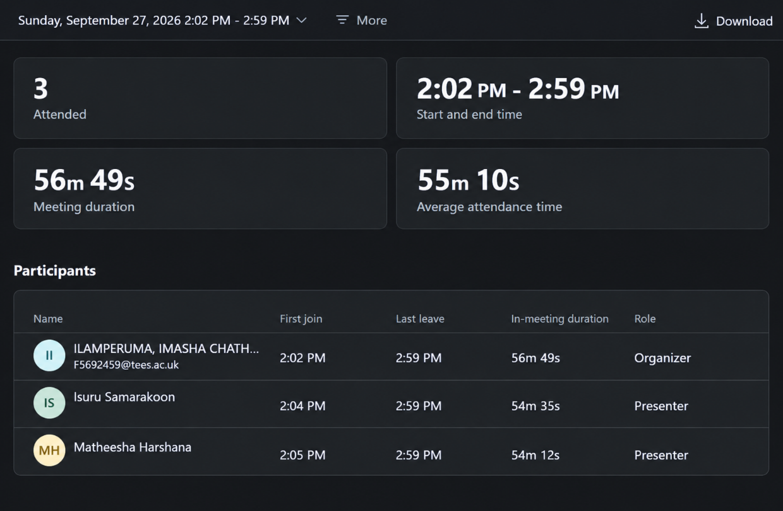
Dataset: Coffee Shop Sales
Topic: The morning rush pays for the day
Trello Board: Link
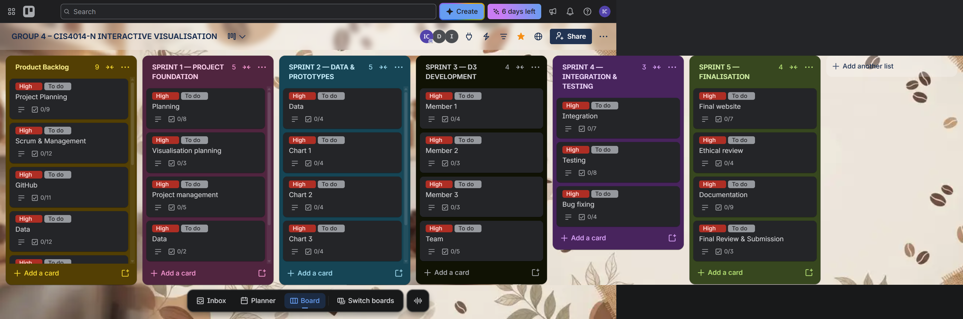
GitHub Repository: Link
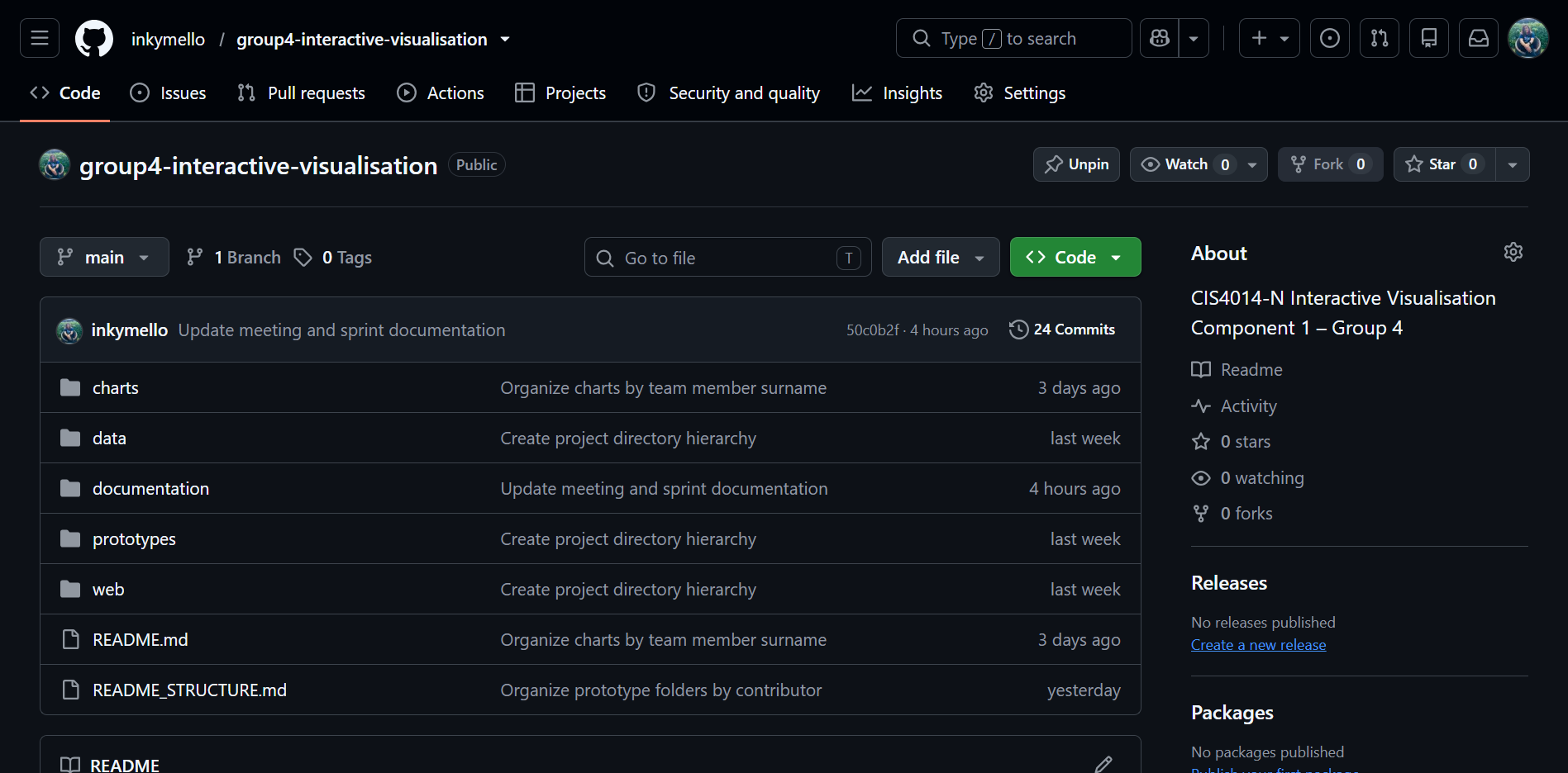
Raw Dataset — Coffee Shop Sales Dataset: Link

Chart Prototypes Presented at This Meeting
Two of the three individual chart prototypes were built and presented as Excel-native mock-ups ahead of D3.js development, using the KPI figures and per-store/per-hour aggregates from the cleaned dataset:
Chart 1 — “When the queue forms” (Temporal Heat Map), Owner: Samarakoon — file: 1_Heatmap_WhenTheQueueForms.xlsx
Built as a conditional-formatting color-scale grid (day of week × hour, 6:00–20:00), driven by the same KPI band (revenue, transactions, units sold, per-transaction value) and busiest-hour figure (10:00, 18,545 transactions) later carried into the dashboard footer.
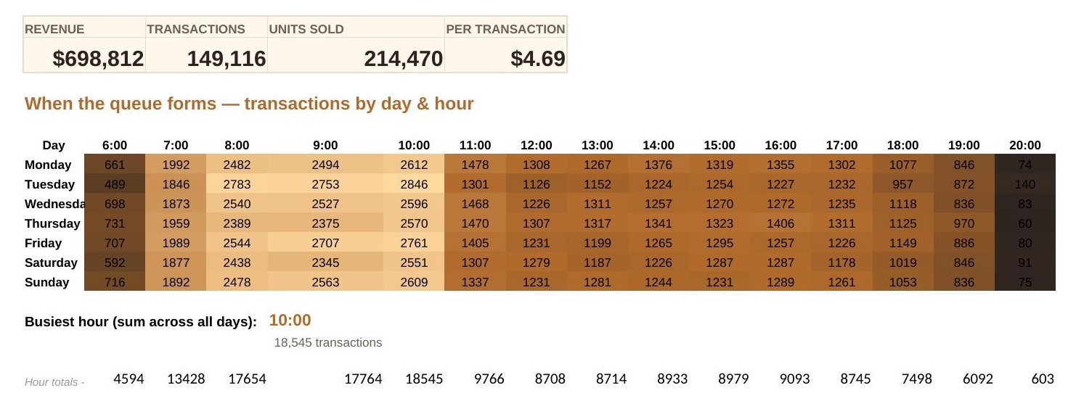
Chart 2 — “Where the money lands” (Store Location Map), Owner: Ilamperuma — file: 2_StoreMap_WhereTheMoneyLands.xlsx
Built as a bubble chart plotting each store by latitude/longitude, with bubble size mapped to revenue, alongside a ranked table (Hell's Kitchen $236,511 → Astoria $232,244 → Lower Manhattan $230,057) and the spread/units-per-transaction stats later carried into the final map's ranking panel.
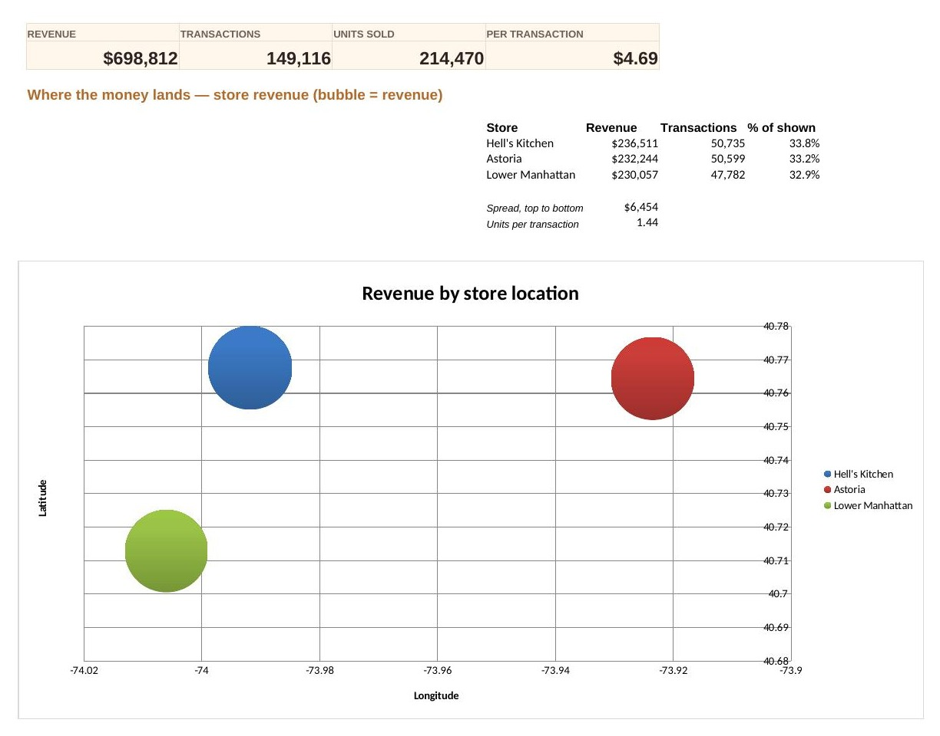
Chart 3 — “How much a cup is worth” (Scatter Plot), Owner: De Silva — not yet submitted at the time of this meeting. Carried forward as an open action item (section 9).

Intended Interactive Features and Their Added Value
The team also reviewed a shared note (Interactive_Features_Added_Value.xlsx) setting out the interactive features planned for the integrated dashboard and why each earns its place, ahead of Sprint 3 development:
Feature | What it does | Added value
Global filters (Store / Category / Month) | One set of controls drives all three views at once | Keeps the three views mutually consistent and turns three static snapshots into a single coherent instrument, rather than three separately-filtered charts that could contradict each other.
Heatmap hover-to-isolate / click-to-hold | Highlights one hour across all seven days | Turns “when in general is it busy” into “is 9am consistently busy, or is Monday 9am an outlier” — a comparison that's hard to make by eye across a 7×15 grid without the highlight.
Click-to-filter on the map (with release) | Clicking a store filters the whole page down to it | Provides a one-click drill-down from portfolio-level (“which store earns most”) to single-store diagnosis (“why is Lower Manhattan behind”).
Drag-to-zoom on the scatter | Lets the user box-select a cluster of points | With 56+ store-days plotted, lets someone isolate a low-volume cluster and check whether it still tracks the same trendline slope, or breaks down at the extremes.
Tooltips on hover (implied throughout) | Exact values on demand | Keeps the base charts uncluttered while still giving precise numbers when needed.

Confirmed Research Questions
Scope | Research Question | Objective
Overarching | How do coffee shop sales vary in terms of when customers buy, where revenue is generated, and the relationship between units sold and daily revenue during the morning rush? | —
Chart 1 — When: Temporal Heat Map | When are coffee shop transactions busiest across different days of the week and hours of the day? | To identify patterns and variations in coffee-shop transaction activity across different days of the week and hours of the day.
Chart 2 — Where: Store Location Map | How does revenue vary across the three coffee shop locations? | To explore the geographical distribution of coffee-shop sales and compare transaction activity and revenue across different store locations.
Chart 3 — How Much: Scatter Plot | What is the relationship between daily units sold and daily revenue across the coffee shop locations? | To investigate the relationship between the quantity of products sold and the revenue generated by the coffee shop.

