INTERACTIVE VISUALISATION GROUP PROJECT
UI Design Document
“The Morning Rush — The Roast Report” | January–June 2023 | Astoria · Hell’s Kitchen · Lower Manhattan
Chart 1 (When) owner: Samarakoon | Chart 2 (Where) owner: Ilamperuma | Chart 3 (How much) owner: De Silva

1. Introduction

1.1 Purpose
This document specifies the user interface of the “The Morning Rush” dashboard: its visual identity (color and typography), page layout, component behavior, interaction, theming, responsiveness and accessibility. It is the single reference for building the shared stylesheet (Sprint 3 task “Create common CSS”) and for checking each D3.js chart against the common UI design that Meeting 03 locked in for all three charts and the initial dashboard (Minutes §8).
The dashboard analyses point-of-sale data from three coffee shops for January to June 2023: 149,116 transactions, 214,470 units sold and $698,812 in revenue, at an average of $4.69 per transaction. Its audience is store and regional managers who need to know when demand peaks, where revenue is strongest and how reliably volume converts into revenue.

1.2 Source documents and citation convention
Every design decision below is traced to one or more of the following sources, cited in short form in the tables.
Source | Cited as | What it contributes
Design Rationale | Rationale §n | Why each design decision was made: research questions, design principles, chart choices, ethics (§1–§9).
Design Requirements | REQ-xxx-nn | Verifiable “shall” statements with priority, source section and test reference.
Sprint 3 Meeting Minutes (Meeting 03) | Minutes §n | §5 prototype summary, §6 Common UI Design Confirmed, §7 Week 03 Sprint Plan, §8 Decisions Made, §11 Meeting Evidence (palette, typography and layout tables, dashboard screenshots).
Dashboard screenshots (light and dark) | Figures 1–8 | Meeting Evidence for the common UI design (Minutes §11); cropped in this document to show each component.

1.3 Scope
In scope: the whole page and its three charts, the shared filters and KPI band, light and dark themes, responsive behaviour and accessibility. Out of scope: data cleaning (Minutes §4), the functional test cases (Sprint 4 Testing Documentation) and the underlying data dictionary.

2. Design Goals and Audience
The overarching question is: how do sales patterns across the three stores vary by time, location and volume, and what do those patterns imply for staffing, stock and site performance? (Rationale §2). Each chart answers one plain-language question, and each UI decision is tested against one criterion: does it make the answer to that question easier to see? (REQ-AUD-01 to REQ-AUD-03).
Chart | Research question | Section shortcut
Chart 1 — When the queue forms | When during the week and day do the stores experience their busiest and quietest periods? | “When”
Chart 2 — Where the money lands | How is total revenue distributed across the three store locations, and how large are the differences? | “Where”
Chart 3 — How much a cup is worth | What is the relationship between units sold and revenue on a given trading day, and how consistent is it across stores? | “How much”

The UI therefore aims to:
- Lead with the topline. Five headline numbers appear before any chart (REQ-KPI-01).
- Frame every chart as one question, not a generic “sales overview”, and state its finding in one written sentence (REQ-AUD-03, REQ-AUD-04).
- Keep one shared state. One filter set drives all three charts and the KPI band, so views cannot contradict each other (REQ-FIL-01).
- Look and behave like one instrument. One color code, one type system and one interaction style across all charts (Minutes §6, Interaction consistency).
- Read anywhere. Light and dark themes, a fluid layout and keyboard support are design requirements in their own right (Rationale §3, §7).

3. Visual Identity
The identity echoes a coffee-roast theme: warm cream and espresso neutrals with amber, terracotta and teal accents, set in an editorial serif and sans-serif pairing (Rationale §3). The values below are the palette locked in at Meeting 03 (Minutes §8 and §11).

3.1 Color palette
Role | Hex | Suggested token | Swatch | Where it is used
Page background (light) | #E4CDB0 | --bg-light |  | Warm cream page background
Headings and KPI text | #2B1D11 | --ink |  | Espresso-brown headings, KPI figures, axis titles
Body text | #5A4530 | --text |  | Descriptions, labels, tooltips, footnotes
Page background (dark) | #181310 | --bg-dark |  | Dark “roast” page background
Text on dark | #F3EAE0 | --ink-dark |  | Headings, KPI figures and body text in the dark theme
Map panel | #241D18 | --panel |  | Store Location Map canvas
Hell’s Kitchen accent | #E0705F | --store-hk |  | Red: map circle, ranking bar, scatter points
Astoria accent | #E4A94D | --store-as |  | Amber: map circle, ranking bar, scatter points
Lower Manhattan accent | #58B09C | --store-lm |  | Teal: map circle, ranking bar, scatter points
Heat map ramp | #955720 → #EEC97E | --heat-mid, --heat-peak |  | Dark espresso (quiet hours) to pale gold (rush hours)
Token names are suggestions for the shared stylesheet; hex values were read from the dashboard screenshots in Minutes §11.

Color rules
- One store color code, used everywhere. Hell’s Kitchen is red, Astoria amber and Lower Manhattan teal on the map, the ranking list and the Chart 3 legend and points, so the code is learned once (REQ-C2-03, REQ-C2-09, REQ-C3-03, REQ-ETH-03; Rationale §5, §7). The heat map does not split by store, so it uses only the ramp.
- Single-hue sequential ramp for counts, dark for quiet and pale for rush. No diverging or rainbow scale, so the encoding stays meaningful when printed or viewed by a color-blind reader (REQ-C1-02; Rationale §4).
- Color never carries a finding alone. Exact counts are printed in every heat map cell and the ranking list repeats the map’s values (REQ-C1-03, REQ-C2-04).
- Defined once, re-mapped per theme. Data colors, ramp and gridlines are not hard-coded (REQ-THM-05).

3.2 Typography
Role | Style | Where it is used
Display | Semi-bold serif, large | Page title (“The morning rush pays for the day.”), section titles, KPI figures
Body | Plain sans-serif | Intro text, chart instructions, filters, axis labels, tooltips, ranking table, footnotes
Label | Small uppercase, letter-spaced sans-serif | Kicker line, filter labels, KPI labels, legend titles
Data figures | Bold sans-serif, small | Counts printed inside heat map cells; values in the ranking list
Rationale: large serif headings give the page an editorial, data-journalism voice suited to communicating a business finding, while a plain sans-serif keeps dense numeric content legible at small sizes (Rationale §3; Minutes §6, Typography).
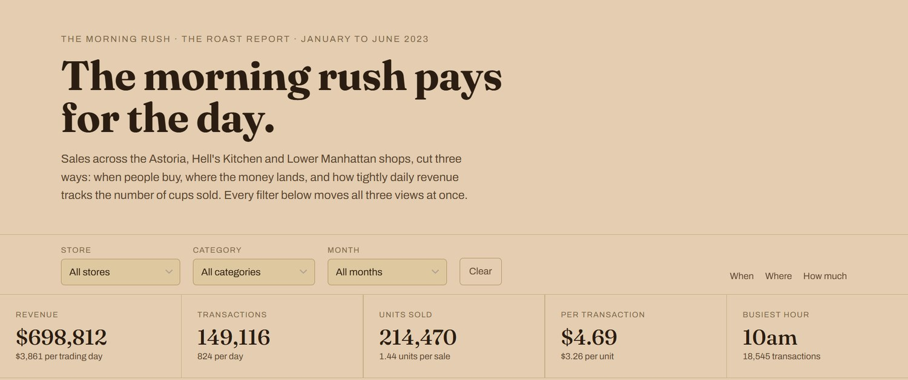
Figure 1: Header, shared filter bar and KPI band (light theme), showing the display serif, sans-serif body and uppercase labels.

4. Page Layout and Structure

4.1 Page anatomy
The page is a single reading column that follows the order of the questions: topline first, then when, where and how much. The shared filter bar and KPI band sit above all three charts so they govern everything below (REQ-FIL-01, REQ-KPI-01).
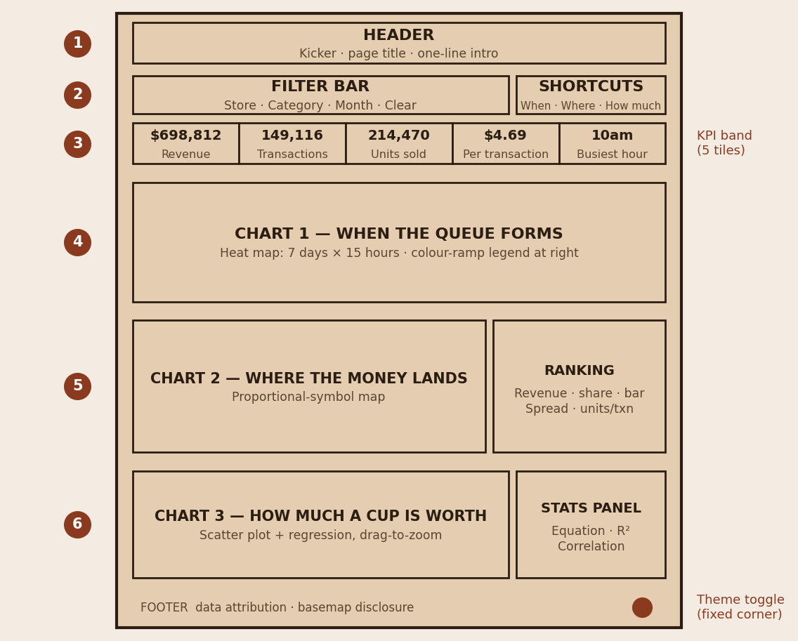
Figure 2: Page anatomy (schematic). Numbers refer to the zones in the table below.
# | Zone | Content | Requirements
1 | Header | Kicker (“The morning rush · The roast report · January to June 2023”), page title, one-paragraph introduction | REQ-AUD-02, REQ-AUD-03
2 | Filter bar | Store, Category and Month dropdowns; Clear button; section shortcuts “When · Where · How much” at the right | REQ-FIL-01 to REQ-FIL-04
3 | KPI band | Five tiles: revenue, transactions, units sold, per-transaction value, busiest hour | REQ-KPI-01, REQ-KPI-02
4 | Chart 1 section | Title, one-line instruction, heat map with color-ramp legend, takeaway sentence | REQ-C1-01 to REQ-C1-05
5 | Chart 2 section | Title, one-line instruction, store location map with ranking panel beside it | REQ-C2-01 to REQ-C2-09
6 | Chart 3 section | Title, one-line instruction, store legend chips, scatter plot with statistics panel beside it | REQ-C3-01 to REQ-C3-06
– | Footer | Data attribution and basemap disclosure | REQ-DATA-02, REQ-DATA-03
– | Theme toggle | Fixed control in the corner of the screen | REQ-THM-02

4.2 Layout rules
- Each chart section repeats the same pattern: serif title, one-line instruction to its right, the chart, then its supporting figures. Sections are separated by a thin horizontal rule.
- Supporting panels (ranking list, regression statistics) sit beside the chart on wide screens and wrap beneath it on narrow ones (REQ-RES-03).
- The KPI tiles are equal-width, separated by hairline dividers, with a label above, a display-serif value and a small sub-line beneath.

4.3 Responsive breakpoints
The stylesheet defines breakpoints at 900 px, 880 px, 820 px, 640 px and 480 px, and the layout must remain usable across representative desktop, tablet and mobile viewports (REQ-NFR-02). All three charts are scalable vector graphics sized by proportion rather than fixed pixel width, so no separate mobile artwork or JavaScript resize handler is needed (REQ-RES-01, REQ-RES-02; Rationale §3).

5. Component Specifications

5.1 Filter bar
Control | Type | Behavior
Store | Dropdown (default: All stores) | Filters all three charts and the KPI band. Also set by clicking a store on the map or in the ranking list.
Category | Dropdown (default: All categories) | Filters all three charts and the KPI band. Category chips are keyboard reachable (REQ-ACC-01).
Month | Dropdown (default: All months) | Filters all three charts and the KPI band.
Clear | Button | Resets every filter in one action: dropdowns, category chips, pinned heat map cell and scatter zoom (REQ-FIL-02).
Section shortcuts | Text links: When, Where, How much | Jump to the matching chart section; wording mirrors the three chart questions (REQ-FIL-03).
Changing any filter recomputes all three charts and the KPI band without a page reload (REQ-NFR-03) and automatically clears an active scatter zoom and releases a pinned heat map cell, so no view shows stale context (REQ-FIL-04).

5.2 KPI band
Tile | Value (all data) | Sub-line | Recomputes with filters
Revenue | $698,812 | $3,861 per trading day | Yes
Transactions | 149,116 | 824 per day | Yes
Units sold | 214,470 | 1.44 units per sale | Yes
Per transaction | $4.69 | $3.26 per unit | Yes
Busiest hour | 10am | 18,545 transactions | Yes
All values come directly from the cleaned transaction table (149,116 rows), never from a separately rounded figure (REQ-DATA-01, REQ-KPI-02).

5.3 Chart 1 — “When the queue forms” (heat map)
Chart type | Day-of-week × hour-of-day matrix, 7 rows × 15 columns (6am to 8pm), 105 cells (REQ-C1-01)
Encoding | Transaction count as single-hue sequential color (dark = quiet, pale = rush); exact count printed inside every cell (REQ-C1-02, REQ-C1-03)
Legend | Vertical color-ramp bar at the right of the grid, labelled 0 to 2.5k
Interaction | Hover an hour column to highlight that hour across all seven days; click to pin the highlight until released; tooltip with exact day/hour count (REQ-C1-04, REQ-C1-05)
Takeaway line | “The four hours from 7am to 11am carry 45% of all transactions in this selection. The single busiest hour is 10am.” (REQ-AUD-04)
Sources | Rationale §4; Minutes §5 (Chart 1 row), §7 (Develop Chart 1, Day 2–3; interaction, Day 4)
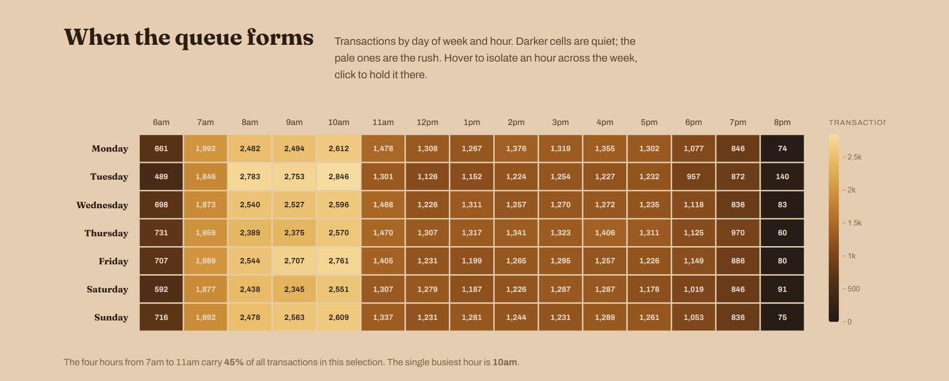
Figure 3: Chart 1 heat map with legend and takeaway line (light theme).

5.4 Chart 2 — “Where the money lands” (store location map)
Chart type | Proportional-symbol map: one circle per store at its real coordinates on a simplified Manhattan-area basemap (REQ-C2-01)
Encoding | Circle area (not radius) proportional to revenue via a square-root radius scale; one color per store; each circle labelled with store name and revenue (REQ-C2-02, REQ-C2-03)
Basemap | Dark map panel (#241D18) with river and district labels in a muted tone, north arrow and a 2 km scale bar; disclosed in the footer as simplified geometry (REQ-DATA-03)
Ranking panel | Beside the map: store name and revenue, a proportional bar in the store color, transactions and percentage share; then the spread between top and bottom store ($6,454, 2.8%) and units per transaction (1.44) (REQ-C2-04, REQ-C2-05)
Interaction | Highlight ring on hover or selection; click a circle or ranking row to filter the whole dashboard to that store; click again to release; keyboard reachable (REQ-C2-06 to REQ-C2-08, REQ-ACC-01)
Store ranking (all data) | Hell’s Kitchen $236,511, Astoria $232,244, Lower Manhattan $230,057
Sources | Rationale §5; Minutes §5 (Chart 2 row), §7 (Develop Chart 2; interaction, Day 4)
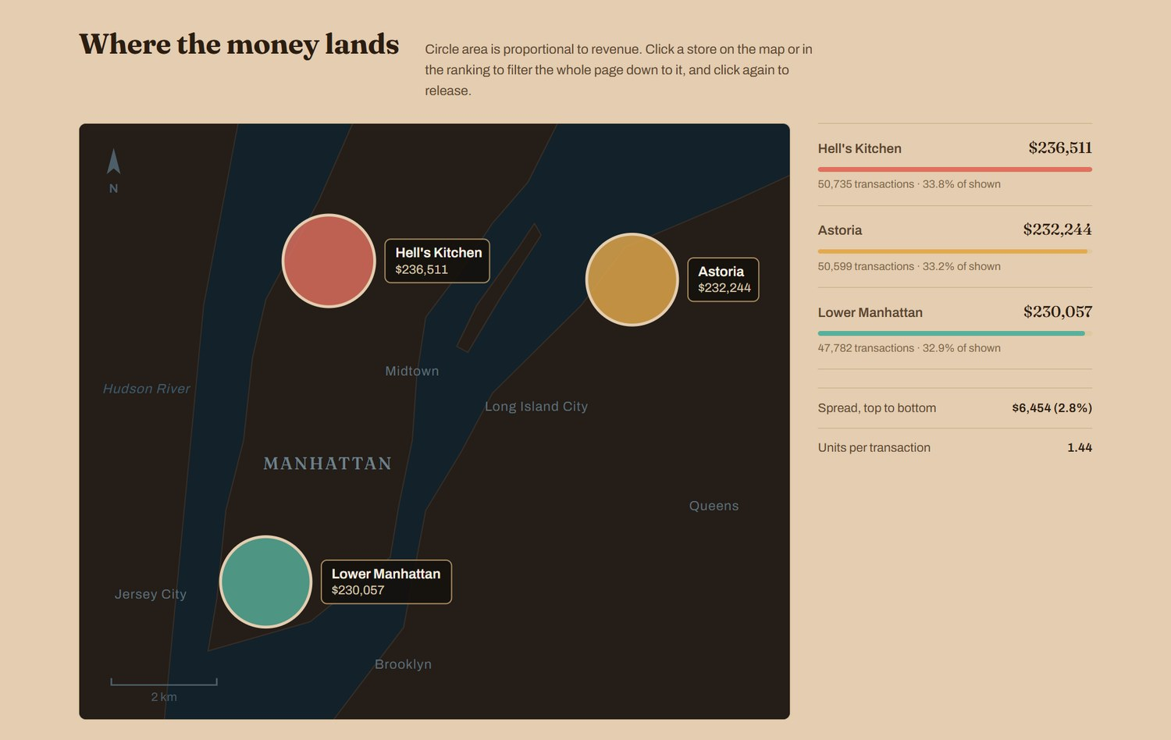
Figure 4: Chart 2 store location map and ranking panel (light theme).

5.5 Chart 3 — “How much a cup is worth” (scatter plot)
Chart type | Scatter plot with linear regression; one point per store per trading day, 543 store-days (REQ-C3-01)
Encoding | x = units sold per day, y = revenue per day, both axes starting at zero (0–800 units, $0–$2,500); point size = that day’s transactions (legend: 75, 250, 500); point color = store (REQ-C3-02, REQ-C3-03, REQ-C3-05)
Trend line | Dashed line with statistics panel: y = 3.20x + 23.59, R² 0.939, correlation +0.969, revenue per extra unit $3.20, store-days plotted 543 (REQ-C3-04)
Legend | Store chips (Astoria, Hell’s Kitchen, Lower Manhattan) above the plot, using the shared store colors
Interaction | Drag a box on the plot to zoom into the densest cluster (about 200–700 units per day); tooltip with daily units and revenue; zoom cleared by Clear or any filter change (REQ-C3-06, REQ-FIL-04)
Sources | Rationale §6; Minutes §5 (Chart 3 row), §7 (Develop Chart 3; interaction, Day 4)
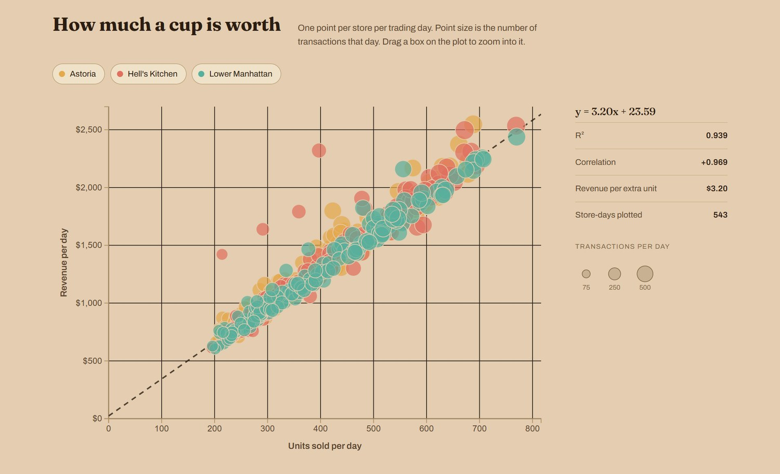
Figure 5: Chart 3 scatter plot with regression statistics (light theme).

5.6 Footer and data attribution
The footer states the row count, units sold and total revenue the page is built from ($698,812.33 across the full period) and discloses that the basemap is simplified geometry drawn from an explicit Mercator projection, not a tile service (REQ-DATA-02, REQ-DATA-03; Rationale §7).
Figure 6: Footer with data attribution and basemap disclosure.

6. Interaction and Feedback Design

6.1 Interaction inventory
Element | Gesture | Result | Reset | Requirements
Heat map hour column | Hover | Highlights that hour across all seven days; tooltip with exact count | Move away | REQ-C1-04
Heat map cell / column | Click | Pins the highlight in place | Click again, Clear, or any filter change | REQ-C1-05, REQ-FIL-04
Store circle or ranking row | Hover or select | Highlight ring around the circle | Move away | REQ-C2-06
Store circle or ranking row | Click | Filters the whole dashboard to that store | Click the same store again | REQ-C2-07, REQ-C2-08
Scatter plot | Drag a box | Zooms into the selected region | Clear or any filter change | REQ-C3-06, REQ-FIL-04
Filter dropdowns | Select | Recomputes all charts and KPIs, no page reload | Clear | REQ-FIL-01, REQ-NFR-03
Clear button | Click | Resets dropdowns, chips, pinned cell and zoom in one action | – | REQ-FIL-02
Section shortcuts | Click | Scrolls to the When, Where or How much section | – | REQ-FIL-03
Theme toggle | Click | Switches light and dark theme; choice remembered | Click again | REQ-THM-02, REQ-THM-04

6.2 Consistency rules
- One interaction language. Hover and tooltip style, transition timing and highlight color are identical across all three charts, so the dashboard reads as one instrument rather than three separate charts (Minutes §6, Interaction consistency; Rationale §3).
- Tooltips give exact values. Chart 1: day/hour count. Chart 2: store revenue and transaction detail. Chart 3: daily units and revenue (Minutes §7, Day 4 tasks).
- Immediate, consistent feedback. Tooltips, drag-to-zoom and brush selection respond at once and never leave a stale pin or an off-screen tooltip (REQ-NFR-04).
- Interactions add no permanent controls to the base view; pinning and zooming are gestures on the chart itself (Rationale §4, §6).

7. Light and Dark Theming
The dashboard ships with a light “cream” theme and a dark “roast” theme built on the same layout, type and accents (REQ-THM-01; Minutes §11, Themes).
Property | Light “cream” theme | Dark “roast” theme
Page background | #E4CDB0 | #181310
Headings and figures | #2B1D11 (body text #5A4530) | #F3EAE0
Map panel | #241D18 | #241D18
Store accents and heat ramp | Red, amber, teal; espresso to gold ramp | Same colors and ramp
Best suited to | Bright daylight, printing | Low-glare reading; coffee-roast identity

- Default: the page opens in the theme that matches the visitor’s operating-system preference, using a light/dark media query (REQ-THM-03).
- Control: a fixed toggle in the corner of the screen switches theme (REQ-THM-02); a manual override is remembered for the next visit (REQ-THM-04).
- Construction: every data color is defined once and re-mapped per theme, so neither theme is an afterthought (REQ-THM-05).
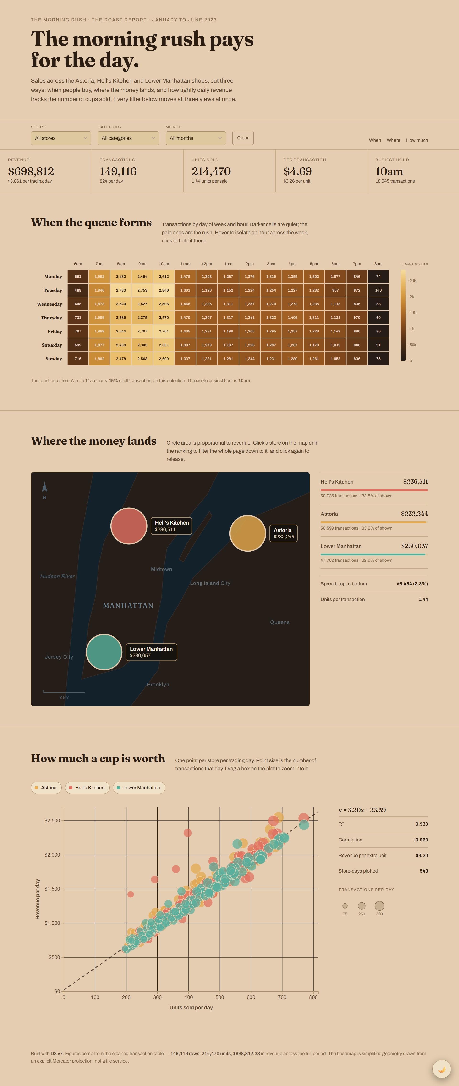  Figure 7: Light theme | 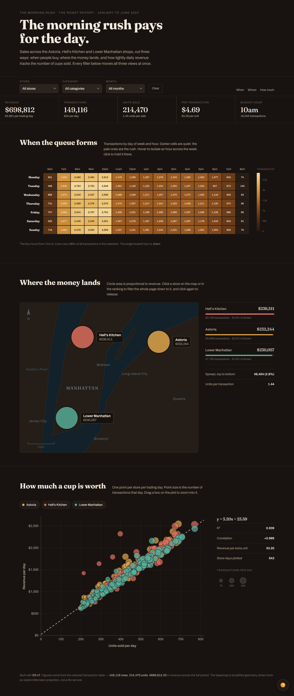  Figure 8: Dark theme

8. Accessibility and Design Integrity

8.1 Accessibility
Need | Design response | Requirements
Keyboard use | Filter chips, ranking rows, map circles and the theme toggle are reachable with Tab and activated with Enter or Space | REQ-ACC-01
Screen readers | Interactive elements carry ARIA roles and labels so cross-filtering is not mouse-only | REQ-ACC-02
Reduced motion | Non-essential animation and smooth-scroll are disabled when the operating system requests reduced motion | REQ-ACC-03
Color-blind readers | Single-hue ramp, printed counts in cells, ranking list repeating the map values | REQ-C1-02, REQ-C1-03, REQ-ETH-04
Bright daylight | Light theme with re-tuned contrast | REQ-THM-01, REQ-ETH-04
Phones and tablets | Proportional SVG charts and wrapping filters, KPI band and ranking list | REQ-RES-01 to REQ-RES-03

8.2 Guarding against misleading visuals
Safeguard | How the UI applies it | Requirements
Zero-based axes | Both scatter axes start at zero, avoiding truncated-axis distortion | REQ-C3-05, REQ-ETH-01
Area, not radius | Map circle area tracks revenue through a square-root scale; the numeric spread is stated beside the map | REQ-C2-02, REQ-C2-05, REQ-ETH-02
One color code | The same store colors on every chart and list | REQ-C2-09, REQ-ETH-03
Data attribution | Footer states the exact rows, units and revenue; every value is drawn from the cleaned table | REQ-DATA-01, REQ-DATA-02
Schematic map disclosed | Footer states the basemap is simplified geometry, not a tile service | REQ-DATA-03

9. Traceability Matrix
Each UI element is traced to the Design Rationale, the Design Requirements and the Meeting 03 Minutes.
UI element | Rationale | Requirements | Minutes sections | Doc. section
Color palette and store colors | §3, §5, §7 | REQ-C2-03, C2-09, C3-03, ETH-03, THM-05 | §6, §8, §11 (palette) | 3.1
Typography | §3 | No dedicated REQ (see Appendix A) | §6, §11 (typography) | 3.2
Header and chart framing | §2, §3 | REQ-AUD-01 to AUD-04 | §3, §5 | 2, 4
Filter bar | §3 | REQ-FIL-01 to FIL-04 | §6 (layout), §11 | 5.1
KPI band | §3 | REQ-KPI-01, KPI-02, DATA-01 | §5, §6, §11 | 5.2
Chart 1 heat map | §4 | REQ-C1-01 to C1-05 | §5, §7, §11 | 5.3
Chart 2 store map | §5 | REQ-C2-01 to C2-09 | §5, §7, §11 | 5.4
Chart 3 scatter plot | §6 | REQ-C3-01 to C3-06 | §5, §7, §11 | 5.5
Footer | §7 | REQ-DATA-02, DATA-03 | – | 5.6
Interaction consistency | §3, §4–§6 | REQ-NFR-03, NFR-04 | §6, §7 | 6
Light and dark themes | §3, §7 | REQ-THM-01 to THM-05 | §11 (themes) | 7
Responsive layout | §3, §7 | REQ-RES-01 to RES-03, NFR-02 | – | 4.3
Accessibility and integrity | §3, §7 | REQ-ACC-01 to ACC-03, ETH-01 to ETH-04 | – | 8
Common CSS and locked UI | §3 | – | §7 (Create common CSS), §8 (decision 4) | 1.1

10. UI Conformance Checklist
For the individual chart review at the end of Week 03 and the first-pass dashboard (Minutes §7). Each member checks their own chart and the shared page.
# | Check | Reference | Pass / notes
1 | Palette, typography and store colors come from the shared stylesheet, not hard-coded per chart | §3; REQ-THM-05 | Pass
2 | Hell’s Kitchen red, Astoria amber and Lower Manhattan teal are identical on map, ranking list and scatter | REQ-C2-09 | Pass
3 | Filters sit above all charts and one Clear resets everything | REQ-FIL-01, FIL-02 | Pass
4 | Five KPI tiles recompute with the filters | REQ-KPI-01, KPI-02 | Pass
5 | Heat map is 7 × 15 with counts printed in every cell and a single-hue ramp | REQ-C1-01 to C1-03 | Pass
6 | Map uses a square-root radius scale; ranking panel states the spread | REQ-C2-02, C2-05 | Pass
7 | Scatter axes start at zero; equation, R² and correlation shown | REQ-C3-04, C3-05 | Pass
8 | Hover, tooltip and highlight styles match across all three charts | §6.2 | Pass
9 | A written takeaway sentence follows every chart | REQ-AUD-04 | Pass
10 | Light and dark themes both render correctly; toggle is keyboard reachable | REQ-THM-01, ACC-01 | Pass
11 | Layout remains usable at desktop, tablet and phone widths | REQ-RES-01 to RES-03 | Pass
12 | Footer states row count, units, revenue and basemap disclosure | REQ-DATA-02, DATA-03 | Pass

Appendix A. Points to Confirm
While building this document the source files were compared against each other and against the dashboard screenshots. The differences below need a team decision; the last column shows the value this document uses.
# | Item | Where the sources differ | Screenshots / other source | Used in this document
1 | Store colors | Minutes §6: Hell’s Kitchen amber, Astoria teal, Lower Manhattan maroon | Rationale §5, REQ-C2-03 and screenshots: Hell’s Kitchen red, Astoria amber, Lower Manhattan teal | Rationale, requirements and screenshots
2 | Chart arrangement | Minutes §6: heat map and store map side by side, scatter plot full-width below | Screenshots: all three charts stacked full-width, each with a side panel | Screenshots
3 | Filter bar and KPI band | Minutes §6: KPI band at the top with four tiles, filter bar beneath with a Reset button | Screenshots and REQ-KPI-01: filter bar above the KPI band, five tiles, button named Clear | Screenshots and requirements
4 | Default theme | Rationale §3 describes the dark roast theme first; Minutes §6 describes a cream palette | REQ-THM-03: follows the OS preference | Both themes; OS preference default
5 | Chart 3 trend line | Minutes §5: trendline fitted per store in the Excel prototype | Rationale §6 and screenshot: one overall regression (y = 3.20x + 23.59) | Single overall regression
6 | Takeaway sentences | REQ-AUD-04: one under every chart | Screenshots show one only under Chart 1 | Required; confirm in build
7 | REQ-C3-05 status | Status cell is blank in the Requirements document | Duplicate REQ-ETH-01 is marked Done | Treated as Done; confirm
8 | Typography and layout requirements | No dedicated REQ ID covers typography or page layout | Governed by Rationale §3 and Minutes §6 | Traced to those sources

