CIS4014-N Interactive Visualization — Group 4
Team Meeting 05 — Sprint 5 Kickoff: Final Website Checks, Ethical Review & Submission Planning
Meeting Date | 18 October 2026
Meeting Number | 05
Week | Week 05
Meeting Type | Sprint Review & Planning
Project Management Tool | Trello
Development Approach | Scrum / Agile
Team | Group 4

1. Meeting Objective
The purpose of the fifth team meeting was to review the completed Sprint 4 work — the integrated D3.js dashboard with its shared filters, Reset button, connected charts and synchronized interactions, and the full round of functional, data validation, tooltip, filter, cross-chart, browser, responsive and usability testing — and to agree the Week 05 Sprint Plan for the final website checks and ethical review, the remaining Scrum and project documentation, the final GitHub and team review, and preparing the submission. Sprint 5 is the project's final sprint.

2. Team Members
Member | Student Number | Role | Confirmed Ownership (Week 05)
Imasha Chathurangi Ilamperuma | F5692459 | Team Leader | Project coordination and Scrum/Trello management; leads the Scrum, testing, design rationale and design requirements documentation and the README update (S5-12–S5-17); leads the final GitHub repository check (S5-18)
Singappuli Arachchige Isuru Dayanga Samarakoon | F5692600 | Team Member | Leads the final UI review, chart-label and tooltip checks (S5-01–S5-03) and the misleading-axes and calculation checks (S5-08, S5-09); reviews Ilamperuma's documentation
Wijaya Hewage Matheesha Priyan Harshana De Silva | F5692734 | Team Member | Leads the responsive-layout check (S5-07) and the data-source-attribution and limitations checks (S5-10, S5-11)

3. Topics Discussed
- Reviewed Sprint 4 Completion against the Sprint 4 Backlog and burndown chart: all 20 items (S4-01 to S4-20) closed. The common layout closed Day 1, all three charts were integrated full width Day 2, the shared filters and Reset button Day 3, connecting the charts and synchronising interactions Day 4, most testing Day 5, and the remaining testing, bug fixes, retests and testing documentation Day 6, with the burndown finishing at zero (see Section 4).
- Reviewed the Sprint 4 Retrospective. What went well: all eight integration tasks finished by Day 4, the design decisions were settled before integration began, dependence on a single member was reduced by giving every task a named lead, and the burndown was kept up to date every day. What did not: the actual burndown ran behind the planned line from Day 1 to Day 5, 55% of items closed in the last two days, bug fixing, retesting and documentation were all left to Day 6 with no spare day, and the planned line itself did not reflect the sprint plan's dependencies.
- Agreed the lessons to carry into Sprint 5: build the planned burndown line from the sprint plan's due dates rather than a straight line; check each area as soon as it is finished instead of batching checks at the end; keep a spare day before submission for any late fix; and record a named lead for every whole-team task on its Trello card.
- Reviewed the finished integrated dashboard as a group — the KPI band, the heat map, store map and scatter plot stacked full-width in that order, the shared Store / Category / Month filters, the Reset button and the linked store selection — confirming it matches the design agreed at Meeting 04 (see Section 5).
- Confirmed the final website checks and ethical review criteria that Sprint 5 will apply to the dashboard, and the documentation items still to be completed before submission (see Section 6).
- Agreed the Week 05 Sprint Plan: final website checks first, then the ethical review, then the remaining documentation (led by Ilamperuma with peer review from Samarakoon), and finally the GitHub check, final team review and submission on the last day, kept free of new checks (see Section 7).
- Noted that the overarching and three individual research questions, the chart encodings and the common UI design are all unchanged from Meeting 04 and will not be revisited in Sprint 5; this sprint is checks and documentation only, with no new development.
- Discussed keeping GitHub commits and Trello statuses current daily, and updating the Sprint 5 burndown from the actual Trello checklist count using the due dates in Section 7, addressing the Sprint 4 Retrospective's point that a straight-line planned burndown does not reflect the sprint plan.

4. Sprint 4 Review — Week 04 Backlog Status
Sprint 4 Task IDs | Backlog Item | Status | Evidence / Notes
S4-04 | Common dashboard layout: KPI band, shared filter bar, chart panels | Done | Closed Day 1 using the common CSS, per the dashboard integration design confirmed at Meeting 04 (Sprint 4 Burndown; Sprint 4 Backlog).
S4-01–S4-03 | Integrate Chart 1, Chart 2 and Chart 3 full width into the shared layout | Done | Closed Day 2, each keeping the encoding, tooltip and interaction validated in its Excel prototype and built in Sprint 3 (Sprint 4 Burndown; Sprint 4 Backlog).
S4-05, S4-06 | Common Store / Category / Month filters and Reset button | Done | Closed Day 3, alongside the mid-sprint integration checkpoint (Sprint 4 Burndown; Sprint 4 Backlog).
S4-07, S4-08 | Connect charts; synchronise interactions | Done | Closed Day 4: a store selection on the map now updates the KPI band, heat map and scatter plot together, with identical hover/highlight/transition behaviour (Sprint 4 Burndown; Sprint 4 Backlog).
S4-09–S4-14, S4-17 | Functional, data validation, tooltip, filter, cross-chart and browser testing; bug recording | Done | Closed across Day 4 and Day 5 (Sprint 4 Burndown; Sprint 4 Backlog; Testing & Bug Fixing Documentation).
S4-15, S4-16, S4-18, S4-19, S4-20 | Responsive and usability testing; high-priority bug fixes; retests; testing documentation | Done | Closed Day 6, sprint end. Burndown finished at 0 of 20 items remaining (Sprint 4 Retrospective, Sections 2–3).

5. Integrated Dashboard Summary
The dashboard is one scrolling page — "The Roast Report" — covering the Astoria, Hell's Kitchen and Lower Manhattan stores from January to June 2023. A KPI band (revenue $698,812; 149,116 transactions; 214,470 units sold; $4.69 per transaction; busiest hour 10am with 18,545 transactions) sits below the shared Store / Category / Month filters and Reset button, followed by the three charts stacked full-width in order: the temporal heat map, the store location map with its ranking panel, and the units-sold-versus-revenue scatter plot with its trend statistics (y = 3.20x + 23.59; R² 0.939; correlation +0.969; 543 store-days plotted). Selecting a store on the map filters all three charts and the KPI band together; the Reset button clears every filter and any held or selected chart state.

6. Final Website Checks & Ethical Review Plan Confirmed
Final website checks (S5-01–S5-07)
Check | What It Covers
Final UI review | Overall look and consistency of the published dashboard against the common UI design and finalized palette.
Chart labels | Titles, axis labels, legend text and units are present, correctly worded and consistent across all three charts.
Tooltips | Each chart's tooltip (heat map day/hour counts, store revenue/transaction detail, scatter daily units/revenue detail) shows correct figures.
Filters | The shared Store / Category / Month filters correctly narrow all three charts and the KPI band together.
Reset button | One click clears every active filter and any held or selected chart state and returns the dashboard to its default view.
Cross-chart interaction | Selecting and releasing a store on the map correctly updates the KPI band, heat map and scatter plot.
Responsive layout | The dashboard remains usable and readable across common screen sizes.
Ethical review (S5-08–S5-11)
Check | What It Covers
Misleading axes | Chart axes start at zero or are otherwise not scaled in a way that exaggerates or understates differences between stores or time periods.
Verify calculations | KPI band, ranking and regression figures re-checked against the cleaned dataset and the values validated in the Excel prototypes (e.g. $698,812 revenue, 149,116 transactions, 214,470 units).
Data-source attribution | The dashboard footer and documentation correctly credit the cleaned transaction dataset and state that the basemap is simplified geometry, not a tile service.
Document limitations | Known limitations recorded — for example, the simplified basemap geometry, the six-month data window, and the single overall (not per-store) scatter trendline.

7. Week 05 Sprint Plan
Task | Owner | Expected Output | Deadline
Final UI review; check chart labels (S5-01, S5-02) | All (lead: Ilamperuma) | Dashboard visuals and chart labels confirmed correct and consistent | Day 1
Check tooltips (S5-03) | All (lead: Ilamperuma) | All three chart tooltips confirmed showing correct figures | Day 1
Check filters; check Reset button (S5-04, S5-05) | All (lead: Ilamperuma) | Shared filters and Reset button confirmed working across all three charts | Day 2
Check cross-chart interaction (S5-06) | All (lead: Ilamperuma) | Store selection and release confirmed updating all linked views | Day 2
Check responsive layout (S5-07) | All (lead: Ilamperuma) | Dashboard confirmed usable across common screen sizes | Day 3
Mid-sprint checkpoint: review final website checks together | All | Final website checks (S5-01–S5-07) confirmed complete before ethical review begins | Day 3
Check for misleading axes; verify calculations (S5-08, S5-09) | All (lead: Ilamperuma) | Chart axes and all displayed figures confirmed accurate | Day 4
Check data-source attribution; document limitations (S5-10, S5-11) | All (lead: Ilamperuma) | Attribution confirmed correct; limitations recorded in the documentation | Day 4
Complete Scrum documentation; complete meeting minutes (S5-12, S5-13) | Ilamperuma (reviewed by Samarakoon and De Silva) | Scrum records and all meeting minutes finalized | Day 5
Complete testing documentation; design rationale; design requirements (S5-14–S5-16) | Ilamperuma (reviewed by Samarakoon and De Silva) | Testing, design rationale and design requirements documentation finalized | Day 5
Update README (S5-17) | Ilamperuma (reviewed by Samarakoon and De Silva) | README reflects the finished dashboard and project structure | Day 5
Check GitHub repository (S5-18) | All (lead: Ilamperuma) | Repository structure, commits and files confirmed complete and organized | Day 6
Final team review (S5-19) | All | Whole team signs off the finished dashboard and documentation | Day 6
Prepare submission (S5-20) | All | Submission package assembled and ready to hand in | Day 6

8. Decisions Made
- Sprint 5 is checks and documentation only: no new charts, encodings or UI design decisions will be made. Any issue found during the final website checks or ethical review is logged and fixed within Sprint 5, not treated as new development.
- Final website checks (S5-01–S5-07) are completed and reviewed together at a Day 3 mid-sprint checkpoint before the ethical review begins, addressing the Sprint 4 Retrospective's point that checks should not be batched at the end of the sprint.
- Ilamperuma leads the Scrum, meeting-minutes, testing, design-rationale and design-requirements documentation and the README update (S5-12–S5-17); Samarakoon reviews each of these before they are marked Done, so no single member is a bottleneck (Sprint 4 Retrospective, Action A5).
- Named leads are recorded for every whole-team Sprint 5 task, both in these minutes and on the corresponding Trello card.
- Day 6 is reserved for the GitHub check, final team review and submission only; no checks are scheduled to start on Day 6, keeping a spare day as recommended in the Sprint 4 Retrospective.
- The Sprint 5 burndown will be built from the due dates in Section 7 rather than a straight line from 20 to 0, so it reflects the sprint plan's actual order of work.
- The Sprint 5 burndown, Trello statuses and GitHub commits are kept up to date daily, with Ilamperuma keeping the burndown and Scrum evidence current.

9. Action Items Before Submission
Action | Owner | Status | Due
Complete final UI review, chart-label and tooltip checks | Ilamperuma (lead), All | Not Started | Day 1
Check shared filters, Reset button and cross-chart interaction | Ilamperuma (lead), All | Not Started | Day 2
Check responsive layout; hold mid-sprint checkpoint | Ilamperuma (lead), All | Not Started | Day 3
Complete ethical review: misleading axes, calculations, attribution, limitations | Ilamperuma (lead), All | Not Started | Day 4
Complete Scrum, meeting-minutes, testing, design rationale and design requirements documentation; update README | Ilamperuma (reviewed by Samarakoon and De Silva) | Not Started | Day 5
Check GitHub repository | Ilamperuma (lead), All | Not Started | Day 6
Hold final team review | All | Not Started | Day 6
Prepare and submit the project | All | Not Started | Day 6
Keep Trello statuses, the Sprint 5 burndown and GitHub commit up to date daily | All (Ilamperuma leads Trello and burndown) | Not Started | Ongoing

10. Next Meeting
Sprint 5 is the project's final sprint. No further Scrum planning meeting is scheduled after Meeting 05: the final team review on Day 6 (S5-19) serves as the project's closing review, held immediately before the submission is prepared and handed in (S5-20).

11. Meeting Evidence

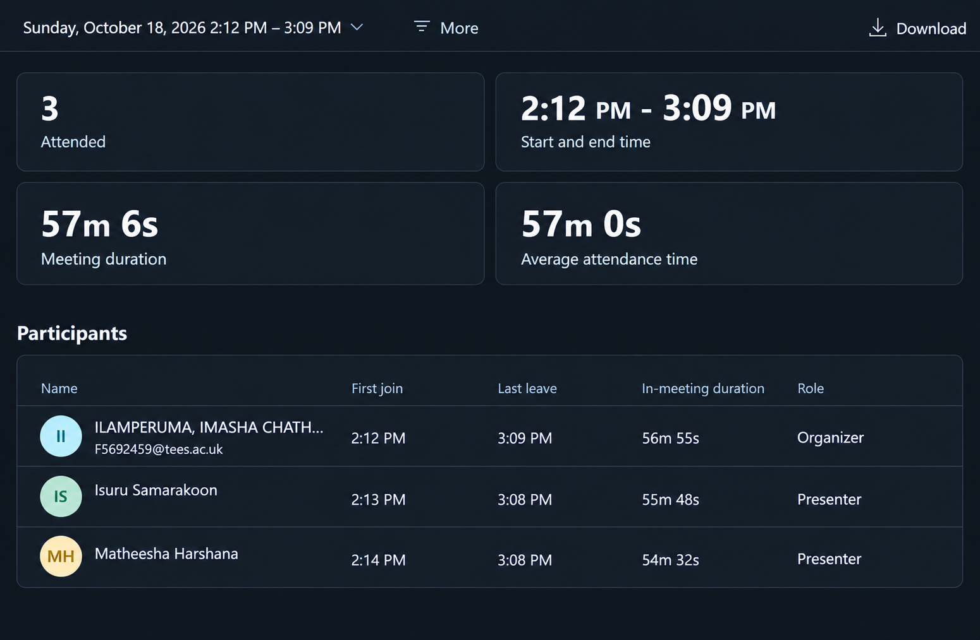

Integrated dashboard — reviewed live at Meeting 05
The finished dashboard reviewed by the team.
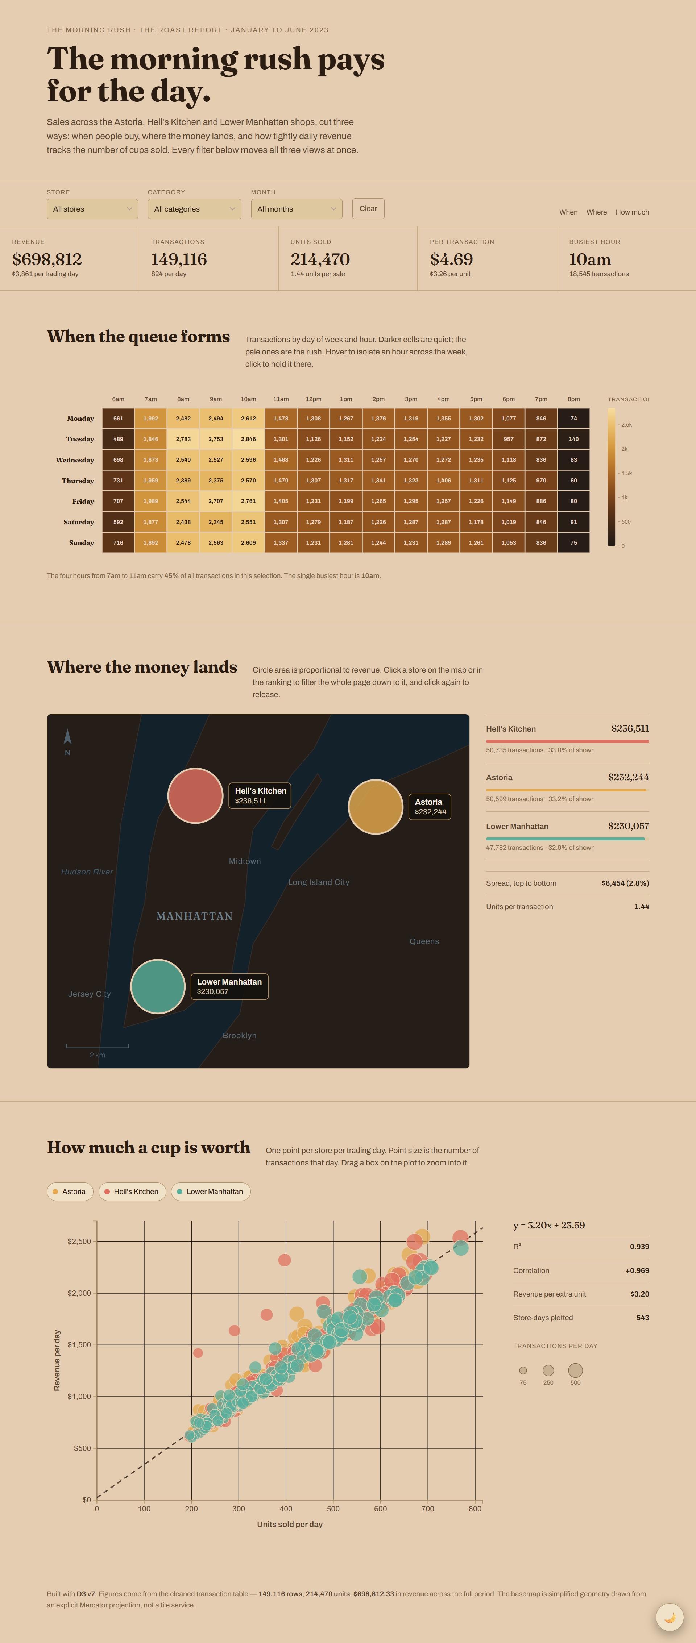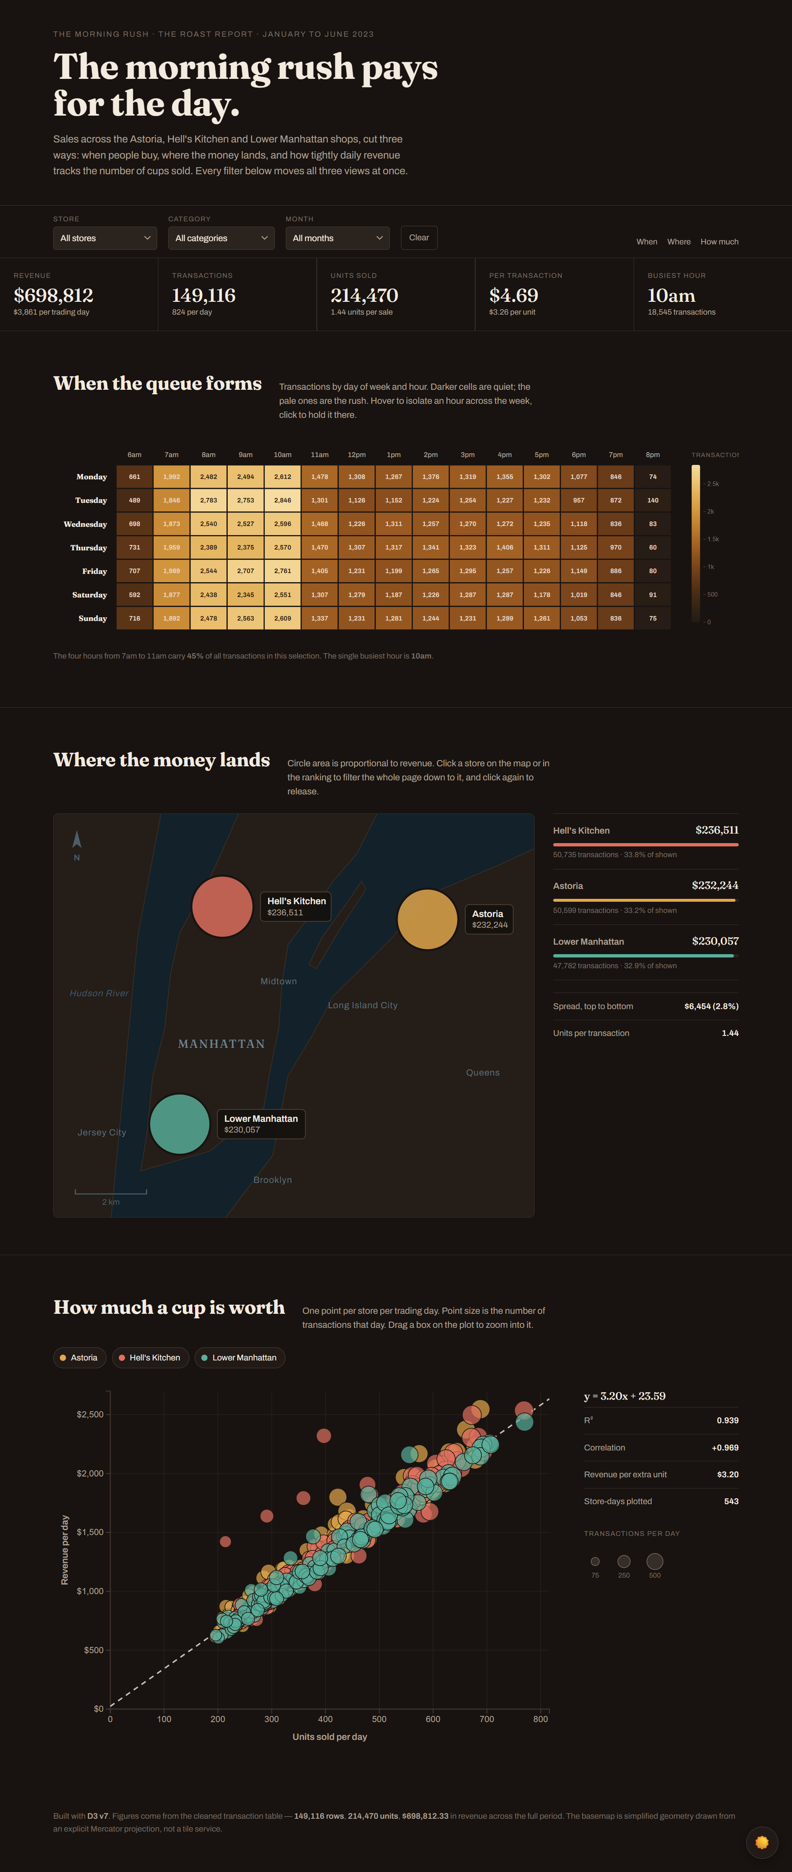

Completed Testing and Bug Fixing Document – Link

