CIS4014 – Interactive Visualization
Final Scrum Review
Group: Group 4 | Team of 3 Members
Field | Details
Project | The Roast Report – an interactive D3.js dashboard on coffee shop sales
Topic | “The morning rush pays for the day” (Coffee Shop Sales dataset)
Duration | 20 September 2026 – 24 October 2026 (five weekly sprints)
Approach | Simplified Scrum / Agile with weekly sprints, a kickoff review-and-planning meeting and a retrospective for every sprint
Tools | Trello (product backlog, sprint tasks, ownership, progress); GitHub (version control and project files)
Scope of Review | Sprint 1 to Sprint 5: backlog, burndown charts (all five sprints), meeting minutes (Meetings 01–05) and retrospectives
1. Project Summary
Group 4 set out to build one coherent interactive product from three individual D3.js visualizations, tied together by a single overarching question: how do coffee shop sales vary in terms of when customers buy, where revenue is generated, and the relationship between units sold and daily revenue during the morning rush. Over five weekly sprints the team moved from project set-up and data preparation, through Excel prototypes and D3.js chart development, to an integrated, tested and ethically reviewed dashboard.
Across the five sprints the team planned 94 backlog tasks (20, 19, 15, 20 and 20). Sprints 2 to 5 each closed with every task Done and the burndown at zero on the last day of the sprint; Sprint 1 ended Day 6 with its two documentation items still open on the burndown. The final sprint, Sprint 5, was a checks-and-documentation sprint with no new development, and it closed the project.
2. Sprint-by-Sprint Summary
Sprint | Dates | Focus and Main Deliverables | Tasks | Outcome
Sprint 1 | 20 – 26 Sep 2026 | Project foundation: topic and dataset selection, research questions, initial chart types, Trello and GitHub set-up, initial dataset assessment, Scrum documentation. | 20 | Foundation established; 18 of 20 items closed by Day 5. The two documentation items (S1-19, S1-20) were still open on the Day 6 burndown, though Meeting 02 records the Week 01 documentation as Done. Full data cleaning and prototypes carried into Sprint 2.
Sprint 2 | 27 Sep – 3 Oct 2026 | Data preparation and prototyping: 20-step cleaning log, data dictionary, three Excel prototypes, joint review and common UI design. | 19 | All 19 tasks Done; burndown at zero on Day 6 and ahead of plan every day. Cleaned dataset (149,116 rows × 23 columns) with zero exceptions; Chart 3 finished later than Charts 1 and 2.
Sprint 3 | 4 – 10 Oct 2026 | D3.js chart development: shared D3.js v7 environment, common CSS, three charts with tooltips and interactions, first-pass dashboard, individual chart reviews. | 15 | All 15 tasks Done; burndown at zero on Day 6 and on or below plan every day.
Sprint 4 | 11 – 17 Oct 2026 | Integration and testing: common layout, shared Store / Category / Month filters, Reset button, connected charts, synchronised interactions, seven test types, bug fixing. | 20 | All 20 tasks Done on Day 6; burndown behind the planned line from Day 1 to Day 5.
Sprint 5 | 18 – 24 Oct 2026 | Final website checks, ethical review, remaining documentation and README, GitHub check, final team review and submission. | 20 | All 20 tasks Done on Day 6; every sprint-plan due date met; project closed.
3. Delivered Product
The final dashboard is one scrolling page covering the Astoria, Hell’s Kitchen and Lower Manhattan stores from January to June 2023. It was built on the cleaned dataset and validated against the Excel prototypes throughout Sprints 3 to 5.
Component | What Was Delivered
KPI band | $698,812 revenue; 149,116 transactions; 214,470 units sold; $4.69 per transaction; busiest hour 10am with 18,545 transactions.
Chart 1 – When (Samarakoon) | Temporal heat map, 7 days × 15 hourly columns. Tooltip with exact day/hour counts; hover-to-isolate and click-to-hold.
Chart 2 – Where (Ilamperuma) | Store location bubble map with ranking panel: Hell’s Kitchen $236,511, Astoria $232,244, Lower Manhattan $230,057. Tooltip with store detail; click-to-filter with release.
Chart 3 – How Much (De Silva) | Scatter plot of daily units sold against daily revenue, coloured by store, with trend statistics (y = 3.20x + 23.59; R² 0.939; correlation +0.969; 543 store-days). Tooltip with daily detail; drag-to-zoom.
Shared interaction | Store / Category / Month filters and a Reset button drive all three charts and the KPI band together; a store selection on the map updates every view; hover, highlight and transition behaviour is identical across charts.
Design | Cream and espresso palette in light and dark themes; one accent per store (Hell’s Kitchen #E0705F, Astoria #E4A94D, Lower Manhattan #58B09C), locked at Meeting 03 and unchanged afterwards.
4. Delivery and Burndown Analysis
The burndown charts show how delivery changed as the team matured. Sprint 1 ran ahead of its planned line from Day 0 to Day 5 (for example 4 remaining against 7 planned on Day 4), but the two documentation items were still open on Day 6, leaving 2 against a planned 0. Sprint 2 ran ahead of plan every day because 12 of its 19 items were already closed at the Meeting 02 kickoff (7 remaining against 19 planned on Day 0), and it finished at zero. Sprint 3 stayed on or below its planned line every day (for example 11 against 13 planned on Day 1 and 2 against 5 on Day 4). Sprint 4 ran behind plan from Day 1 to Day 5, with a peak gap of 4 items on Days 3 and 4. Sprint 5 also sat above the straight line on Days 2 to 4, but its actual progress matched the due dates in the Week 05 Sprint Plan exactly.
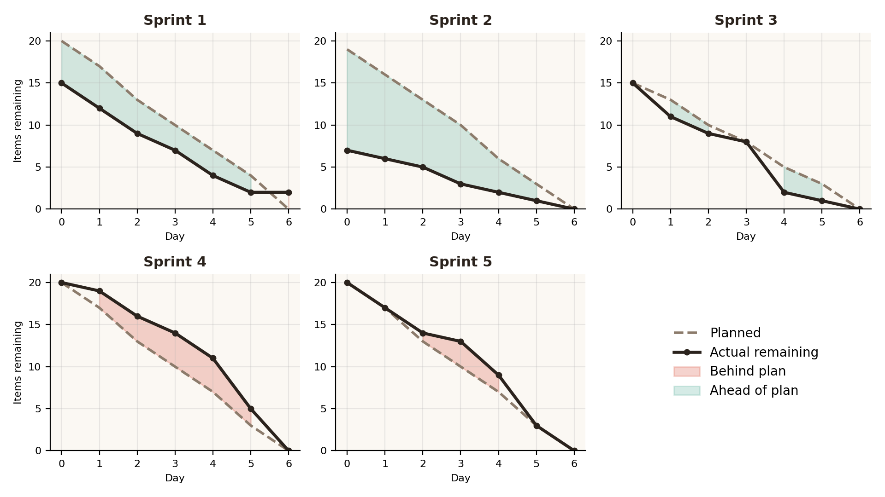
Sprint | Day 0 | Day 1 | Day 2 | Day 3 | Day 4 | Day 5 | Day 6
Sprint 1 | 15 (20) | 12 (17) | 9 (13) | 7 (10) | 4 (7) | 2 (4) | 2 (0)
Sprint 2 | 7 (19) | 6 (16) | 5 (13) | 3 (10) | 2 (6) | 1 (3) | 0 (0)
Sprint 3 | 15 (15) | 11 (13) | 9 (10) | 8 (8) | 2 (5) | 1 (3) | 0 (0)
Sprint 4 | 20 (20) | 19 (17) | 16 (13) | 14 (10) | 11 (7) | 5 (3) | 0 (0)
Sprint 5 | 20 (20) | 17 (17) | 14 (13) | 13 (10) | 9 (7) | 3 (3) | 0 (0)

Each cell shows actual items remaining, with the planned figure in brackets. The planned line in every workbook falls in a straight line from the sprint’s task count to zero. Because Sprint 5’s actual counts equal those implied by its own due dates (20, 17, 14, 13, 9, 3, 0), its gap from the line on Days 2 to 4 reflects the planning formula, not slippage (Sprint 5 Retrospective, Section 3).
Work was back-loaded in most sprints. Sprint 1 left its documentation to Day 6; Sprint 3 closed six tooltip and interaction tasks on Day 4; in Sprint 4, 11 of 20 items (55%) closed in the last two days; and in Sprint 5, all six documentation items closed on Day 5 and three closing tasks on Day 6.
5. Recurring Themes Across the Retrospectives
Theme | How It Appeared | Position at Project End
Late or uneven closing of work | Sprint 2: Chart 3 late, so joint review and UI sign-off near the end. Sprint 3: six tooltip and interaction tasks closed on Day 4. Sprint 4: 55% closed in the last two days. Sprint 5: six documentation tasks on Day 5. | Improved for checks (Sprint 5 spread across Days 1–4) but documentation still batched on one day.
Decisions made before development | Sprint 2 lesson to agree shared conventions early was applied in Sprint 3 (UI locked at Meeting 03), Sprint 4 (integration design at Meeting 04) and Sprint 5 (no new design decisions). | Resolved and carried through all later sprints.
Dependence on one member | Sprint 3: Ilamperuma held the most tasks and the shared set-up. Sprint 4: named leads and pairing on all 20 whole-team tasks. Sprint 5: leads recorded in the Task Register, but all six documentation tasks fell to Ilamperuma with review by the others. | Reduced, not removed: documentation load stayed concentrated.
Mid-sprint checkpoints | Recommended after Sprints 2 and 3; planned for Day 3 in Sprint 4 and held on Day 3 in Sprint 5 after all seven website checks closed. | Adopted; Sprint 5 checkpoint had no standalone evidence beyond S5-07’s note.
Burndown planned line | Sprint 4 found the straight line did not reflect task dependencies. Meeting 05 decided to rebuild it from due dates. | Not done in the workbook; recorded as a lesson (Sprint 5 Retrospective, Section 4).
Accuracy checks against Excel prototypes | Lesson from Sprint 3 onwards: re-check figures such as $698,812 / 149,116 / 214,470. | Applied in the Sprint 4 data validation and Sprint 5 calculation checks.
Trello, GitHub and Scrum evidence | Kept as an action in every sprint; daily burndown notes linked to task IDs from Sprint 4. | Maintained to the end; lead-on-Trello-card evidence not shown in the documents reviewed.
6. What Went Well Across the Project
- The Scrum cycle worked as intended: each kickoff meeting reviewed the previous sprint against its backlog and burndown, and each retrospective fed lessons into the next sprint’s actions.
- The team went from limited Scrum experience in Sprint 1 to four consecutive sprints (2 to 5) with every task completed and the burndown finishing at zero.
- Front-loading design decisions removed the Chart 3 bottleneck seen in Sprint 2 and let Sprints 4 and 5 run without changes to encodings, research questions or the common UI design.
- Data quality was established early: the 20-step cleaning log left the dataset with zero missing values, duplicates or invalid values, giving a reliable base for every chart.
- Ownership became more visible over time, from “All” for every task in Sprint 4 to individual leads in the Sprint 5 Task Register.
- The final sprint met every due date in its plan and reserved Day 6 for the GitHub check, final review and submission, with no new checks scheduled.
7. What Could Have Gone Better
- Back-loading persisted in every sprint, leaving little or no spare day for fixes, retests or late documentation.
- The planned burndown line stayed a straight line in Sprint 5 even though Meeting 05 decided to rebuild it from due dates, so the chart understated real progress on Days 2 to 4.
- Documentation was concentrated on one member on one day in Sprint 5 (6 of 20 tasks, 30% of the workload), continuing a pattern flagged in Sprint 4.
- The ethical review was carried out only by the team that built the dashboard, with no independent reviewer.
- Some records disagree across documents. For example, Meeting 04 names De Silva as lead for the layout and Reset button, while the Sprint 4 Backlog lists Ilamperuma for those tasks; a single source of truth for leads would avoid this.
8. Team Roles and Ownership
Member | Role | Contribution Over the Project
Imasha Chathurangi Ilamperuma  F5692459 | Team Leader | Trello and Scrum management, GitHub set-up and evidence; Chart 2 (Store Location Map), reallocated from Chart 1 at Meeting 02; leads for filters, Reset, chart connection and the Sprint 5 documentation tasks, D3.js development; Sprint 5 leads for the UI review, chart-label and tooltip checks, misleading-axes and calculation checks, testing support; Sprint 5 leads for the responsive-layout, data-source attribution and limitations checks and GitHub check.
Singappuli Arachchige Isuru Dayanga Samarakoon  F5692600 | Team Member | Chart 1 (Temporal Heat Map); D3.js development; Sprint 5 leads for the UI review, chart-label and tooltip checks, misleading-axes and calculation checks, and review of Ilamperuma’s documentation.
Wijaya Hewage Matheesha Priyan Harshana De Silva  F5692734 | Team Member | Chart 3 (Scatter Plot); D3.js development and testing support; Sprint 5 leads for the responsive-layout, data-source attribution and limitations checks.
9. Final Assessment
The project delivered what it set out to: a single, tested dashboard that answers the three research questions and the overarching question, built through a Scrum process that visibly improved from sprint to sprint. The team’s strongest practices were agreeing design decisions early, validating figures against Excel prototypes, and turning each retrospective into concrete next-sprint actions. The main gaps were process visibility rather than delivery: the planned burndown line, concentrated documentation ownership and the absence of an independent ethical review.
Known Limitations Recorded
- The basemap is simplified geometry, not a tile service.
- The data covers a six-month window (January to June 2023).
- The scatter plot uses a single overall trendline rather than one per store.
Recommendations for Future Projects Using This Process
- Update the artifact itself (for example the burndown formula) before closing an action, not only the minutes.
- Give documentation-heavy tasks a second co-owner, not only a reviewer.
- Record each task’s lead on the Trello card and in the task register from Sprint 1.
- Keep a genuinely task-free day before a submission deadline.
- Schedule checks and tests as each area finishes rather than in the last two days of a sprint.
- Where possible, ask someone outside the team to review the ethical checks.
10. Team Confirmation
Member | Name | Student Number | Role | Confirmation Date
Member 1 | Imasha Chathurangi Ilamperuma | F5692459 | Team Leader | 25 October 2026
Member 2 | Singappuli Arachchige Isuru Dayanga Samarakoon | F5692600 | Team Member | 25 October 2026
Member 3 | Wijaya Hewage Matheesha Priyan Harshana De Silva | F5692734 | Team Member | 25 October 2026

