# Wright Brothers’ Patent

In 2000 the **National Archives** were setting up for a turn of the century exhibit and went to pull what could arguably be considered one of the nation’s most important historical documents, to discover it missing (Lewis). It turns out that the last time that the patent for the Wright Brother’s “Flying Machine” was last seen after an exhibit in *1979* to celebrate the 75th year anniversary of the filing of the patent, and the anniversary of the creation of flight as we know it. (“National Archives Honors Wright Brothers with Upcoming Special Display”).

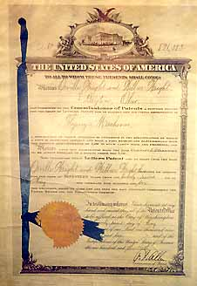

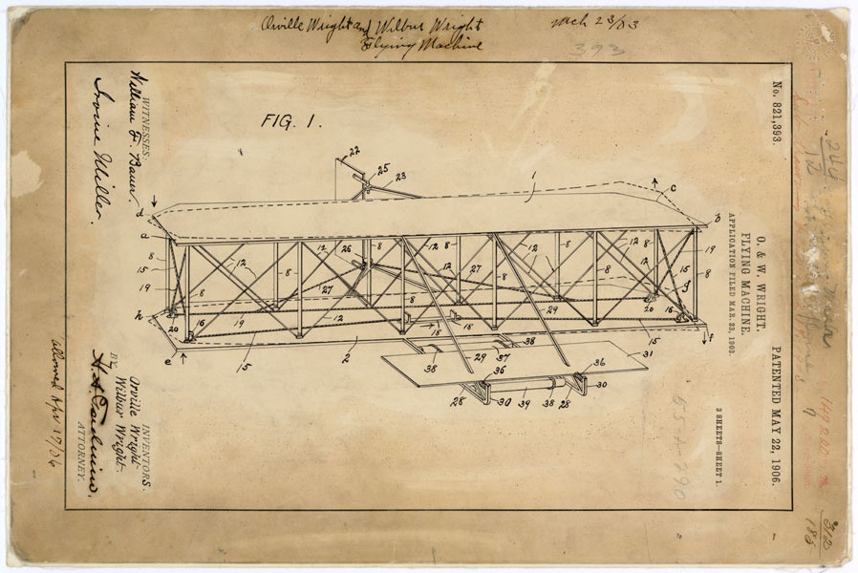

The Wright Brothers filed their patent in March 1903, and were able to make the first man made flight in Kitty Hawk, North Carolina in December 1903. They were officially issued patent number 821.393 in May 1906, forever changing the face of modern travel. After being found missing in 2000 the patent was presumed misplaced or stolen, since the National Archives has a long history of thieves pilfering some of America’s most precious artifacts (Ferriero), as well as over 269 millions patents stored, wherein one folder could easily be misplaced.

|  |  |
| --- | --- |
| Other Missing Documents | Date Created |
| Eli Whitney Cotton Gin Drawing | 1804 |
| Hiroshima Target Map | 1945 |
| Nagasaki Target Map | 1945 |
| Polesti Mission Report | 1943 |
| Wright Brothers' Flying Machine | 1903 |

A team of recovery agents launched a targeted search to recover alienated and stolen archival materials, and were able to recover the missing patent and subsequent documents in a limestone storage cave in Kansas in March 2016(Lewis, National Archives Honors Wright Brothers with Upcoming Special Display). There are 18 of these storage facilities that are currently holding the 107,600 cubic feet of patents (Namowitz). The National Archives will be displaying the recovered patent staring May 20th of this year to commemorate the 110th anniversary of issuing the patent for the “Flying Machine” and it will be displayed in the National Archive Museums’ West Rotunda Gallery.

“We had to ask ourselves, ‘Is this something that could have been stolen?’, noted the Chief Operating Office of the National Archives, William J. Bonsanko while speaking to the Washington Post (Ruane). This presents a question of ethics with archivists, one that looks as though is consistently an issue within our society (Ferriero). It seems that there is quite a history of theft within our National Archives and with other archives around the country as there have been several individuals obtaining long prison sentences for stealing some of the more valuable materials in recent years (Ferriero).

The Archives have attempted to prevent more documents from being stolen by increasing surveillance programs in the reading rooms, and instituted check of bags when researchers and staff leave the building (Ferriero). They are doing what they can to keep people, such as Barry Landau, who had his jackets tailored with pockets large enough to take large sized documents, from stealing some of our nation’s most prized possessions (CBSNewsOnline.). Barry would say he was a Presidential Archivist (although there is nothing saying he was an archivist at all) and was notorious for charming over archivists and historians with snacks and cupcakes while he would steal and sell archival documents (CBSNewsOnline.)

The National Archives does have a code of ethics, known as the Archivist’s Code, which archivists are expected to abide by. It states that:

The Archivist has a moral obligation to society to take every possible measure to ensure the preservation of valuable records, not only those of the past but those of his own time and of equal zeal (“The Archivist’s Code).

Even given this code of ethics, it seems that there is a problem with stealing, with archivists and patrons, and it seems that a call for respect of the materials is needed on all sides to be able to help protect our nation’s treasures.

William Bonsanko also stated “If someone puts something back in the wrong place, it’s essentially lost.” The fact that the National Archives has so many files to keep up with it’s not hard to understand how things can get misplaced and it seems to be an ongoing issue within the archival world (Ruane). Even though it isn’t hard to understand how things go missing, it still is very upsetting to me that we are failing to properly arrange our documents so that they are easily found and cared for.

The Wright Brothers’ Patent, although not where it was supposed to be, was in a decent condition for a 100-year-old document (Ruane). But there are many documents that require special attention, or preservation, that if misplaced will not get the care that they so desperately deserve. The National Archives having so many documents to care for reminds me of the American Heritage Center, who had so many things to care for, that they had to deaccession a large part of their archives to ensure that they could care for the documents they had (Jackson, Laura, and D. Thompson). I do not want to suggest that any of the documents in the National Archive’s possession aren’t important enough, or shouldn’t be housed with the National Archives, because that is probably the best place for most of the documents within their holdings. However, it does seem to me that the National Archives is in need of staff and funding to be able to account for and properly care for the documents in their possession. The targeted searches are evidence that they are attempting to increase their numbers in order to find some of these misplaced files, and maybe the discovery of the Wright Brother’s Patent, directly after two extra staff were hired for the purpose of the Archival Recovery Program, will bring more needed attention to this area.

In addition to sending out recovery teams for targeted searches to recover misplaced and stolen items, the National Archives is also reaching out to the public, and those who deal in historical documents, as well those who work at libraries, archives and museums asking them to avoid buying or selling lost or stolen goods and reporting any identified goods to the National Archives ("Help the National Archives Recover Lost and Stolen Documents.") The National Archives has a listing showing all of the missing historical documents that you can help recover, ranging from Civil War Documents to missing Presidential Items. (“Missing Documents from the National Archives).

While I am personally ecstatic that the missing Wright Brother’s Patent was found, it does raise some serious questions in my mind about archives. How can we gain more security to aid against those would pilfer our country’s historical documents? How can we ensure those who go into the field of archives are ethical, and want to preserve these documents instead of taking them for their own accord? How can we enact a better filing system for an archive containing billions of pieces of paper? As archivists we have a moral obligation to “ensure the preservation of valuable records”, and it appears that that statement is two-fold in that we must ensure the preservation of records by preventing them from being stolen, and ensuring their preservation by filing and ordering them properly.

**Works Cited**

"The Archivist's Code." National Archives and Records Administration. National Archives and Records Administration, n.d. Web. 08 Oct. 2016.

<http://www.archives.gov/preservation/professionals/archivist-code.html>

CBSNewsOnline. "National Archives' Treasures Targeted by Thieves." YouTube. YouTube, 2012. Web. 08 Oct. 2016.

<https://www.youtube.com/watch?v=EJ9D0kfRYW0>

Ferriero, David S. "Tracking Down Missing Titles." National Archives. N.p., 2016. Web.

<https://www.archives.gov/publications/prologue/2016/summer/archivist.html>

"Help the National Archives Recover Lost and Stolen Documents." National Archives and Records Administration. National Archives and Records Administration, n.d. Web. 08 Oct. 2016.

<http://www.archives.gov/research/recover/>

Jackson, Laura, and D. Thompson. "But You Promised: A Case Study of Deaccessioning at the American Heritage Center, University of Wyoming." The American Archivist 73.2 (2010): 669-85. Web.

<http://americanarchivist.org/doi/pdf/10.17723/aarc.73.2.297691q50gkk84j4>

Lewis, Danny. "After 36 Years, Archivists Finally Found the Wright Brothers' Airplane Patent." Smithsonian Magazine. Smithsonian, n.d. Web. 08 Oct. 2016.

<http://www.smithsonianmag.com/smart-news/after-36-years-archivists-finally-found-wright-brothers-airplane-patent-180958649/?no-ist>

"Lost Plans for Wright Brothers' 'Flying Machine' Found after 36 Years." Washington Post. The Washington Post, n.d. Web. 08 Oct. 2016.

<https://www.washingtonpost.com/local/lost-plans-for-wright-brothers-flying-machine-found-after-36-years/2016/04/02/e526fd56-f6b2-11e5-9804-537defcc3cf6_story.html?tid=sm_tw>

"Missing Documents from the National Archives." National Archives and Records Administration. National Archives and Records Administration, n.d. Web. 08 Oct. 2016.

[*http://www.archives.gov/research/recover/*](http://www.archives.gov/research/recover/)

Namowitz, Dan. "Missing Wright Brothers' Patent File Found." - AOPA. N.p., n.d. Web. 08 Oct. 2016.

<https://www.aopa.org/news-and-media/all-news/2016/april/06/missing-wright-brothers-patent-file-found-will-be-displayed>

"National Archives Honors Wright Brothers with Upcoming Special Display." National Archives and Records Administration. National Archives and Records Administration, n.d. Web. 08 Oct. 2016.

<http://www.archives.gov/press/press-releases/2016/nr16-52.html>