The State, Religion, and Works of Art

Brynna Wainwright

History of Western Art I

Word Count: 1341
The role of the state in various aspects of life whether it be religion, family dynamics, or art, varies drastically throughout both time and geographical regions. The influence of the state in Early Western art extended into religion even from the earliest civilizations, creating a single cohesive unit. With emphasis placed on religion in these early civilizations being so prominent, the way in which rulers and individuals came to represent their own culture nearly always included some divine aspect. From the kingdoms of Sumer and Egypt, to Greece and Rome, to Byzantium, the influence of the state and its religion is evident in works of art due to the piece's subject matter, purpose, and commissioner. Both buildings as well as statues and sarcophagi prioritize representation of divine and state power over any stylistic decisions of the specific artist. Thus, any influence the individual, specifically the artist, has on a piece of art is overpowered by the cultural impact of the state and its religion on the work.
Throughout the reign of the Egyptian Empire, the role of religion and state dominated most aspects of people's lives. The leader of the state, the pharaoh, was even believed to become a deity when he or she died. The Palette of Narmer from Early Dynastic Egypt was a tool used to mix and grind materials for makeup. On one side of the palette, Narmer is depicted wearing the white crown of Upper Egypt about to crush the head of a foe with the help of a falcon shown to his right, believed to be the earthly form of the Sun God Horus. On the opposite side of the palette is the head of the Goddess Harthor and Narmer wearing the Red Crown of Lower Egypt. While the physical purpose of this piece is to hold makeup, the stylistic elements are meant to convey a message of authority through associating the King's power with that of the Gods. By implementing this subject matter rather than merely an eye-pleasing design, the influence of the state becomes evident.
In addition to the Palette of Narmer among Egyptian works of art, the Hypostyle Hall of Rameses II in the Temple of Amun serves as another example of the far-reaching influence of religion. The temple was built in nineteenth dynasty and the Hypostyle Hall was designed around the Creation Story of the Egyptians. The columns featured detailed pictorial reliefs with swamp and lotus near the bottom of the columns and the sky pictured above. This hall was built as a place “where common people extol the name of his majesty” as referred to by Rameses II. In creating a building with the subject being the creation story of the practiced religion and a purpose of providing a place for people to praise the Pharaoh reveals the connection between the state and religion as well as its importance. The east-west orientation of the whole temple, following the daily path of the sun, also points to religious connotations. Additionally, Ramses II himself was the commissioner of this building, showing the influence of the state over art in Egyptian culture.
The Greeks, while differing from the Egyptians in prominent elements of culture including religion and government structure, created artwork that continued to embody the power of their gods and emperors more so than the style of the individual artist. This pattern is seen in the Altar of Zeus, which was erected during the Hellenistic Period of Greece. The single-story ionic style temple had elaborate sculptures carved into the frieze, which extended around the whole base of the building. This frieze depicts the battle between the giants and the gods which the Greeks viewed as similar to their own battle with all outsiders to the Empire. The structure's purpose was to thank the deity Zeus while also to commemorate the state's victory over the Gauls. In doing so, the subject matter supports this purpose and focuses on the battle of the gods. The state and the divine are further connected through the analogy of the gods and the giants with the Greeks and the barbarians. Once again, the state and its religion are connected and together form the central themes of the building.
The statue Augustus of Primaporta was created in the Early Imperial Period of the Roman Empire. The piece shows Augustus as a Roman General with his arm extended in a commanding pose. Cupid is riding a dolphin near Augustus' right leg, referencing the claim that the emperor's family is descent from the Goddess Venus. Additionally, his breastplate depicts a scene of his diplomatic victory over the Parthians. While the artist chose to idealize Augustus' body but show distinguishing characteristics of his face, this effect is insignificant compared to the subject matter and purpose of the work. The statue serves as propaganda in support of Augustus by depicting diplomatic victory and divine justification for his rule. Cupid symbolizes the support of the gods. The inclusion of the detailed breastplate and Cupid contribute to the overall effect of the piece more so than the stylistic choices of the artist.
As the religion of the Roman state transitioned towards Christianity, so too did the influences over various works of art.The Sarcophagi of Junius Bassus was created during the Late Imperial/Early Christian Period of the Roman Empire. The design is centered on the Christian narrative, with each of the ten square sections depicting scenes from the New and Old Testament. The middle scenes of each of the two levels both depict Christ as a Roman emperor either resting his feet on Coelus, the pagan God of the Heavens, or as a Roman Emperor entering the city of Jerusalem. The surrounding eight sections on the outside of the Sarcophagi depict scenes from the Christian narrative as well. This particular piece most prominently exemplifies the impact of religion on art. The whole sarcophagi is dedicated to portraying various scenes from the Christian beliefs rather than anything that relates specifically to Junius Bassus' life. The influence of religion carries over to every aspect of the people's live even to death. The specific artistic choices such as how to represent the people are less significant than the overall theme itself.
After the reign of the Greeks and Romans in the western world, the Empire of Byzantium became the dominant civilization of the area. The connection between the emperor and the gods/goddesses of the religion remains in the Byzantine works of Art. Specifically, the Hagia Sophia was built by Emperor Justinian in an effort to build a church to convey the imperial and Christian power. In order to do so, the huge central dome was built to appear as if it is mysteriously floating due to the use of gold mosaic, windows, and pendentives. The purpose of the building was to prove to the people of Byzantium the power of Justinian and his divine connections. While the unique design elements of the building as a whole were decided by the architect's own preferences, they contributed to the purpose and central meaning of the structure. The power of the state and its connection to divine power. Each design element decided by the architects were made to further the celestial effect.
Ultimately, by examining various works of art throughout distinct time periods and civilizations, the common pattern of the influence of the state and its religion is more evident over the artist's individual choices. The strategy of associating the power of the ruler, whether it be a pharaoh or emperor, with the support of a higher power and establishing this through art persists throughout civilizations. The subject matter of pieces of art, the purpose, and the commissioner of the work are all in some way influenced greatly by the state and its religion. The effects of any individual stylistic choices made by the artist are rendered obsolete in comparison. Throughout thousands of years, this pattern of reliance on religion to give guidance in people's lives remains and in doing so, extends into cultural aspects, especially works of art.
Title of Work | Image
Palette of Narmer | 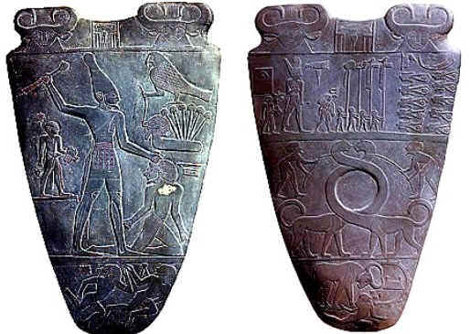
Hypostyle Hall of Rameses II | 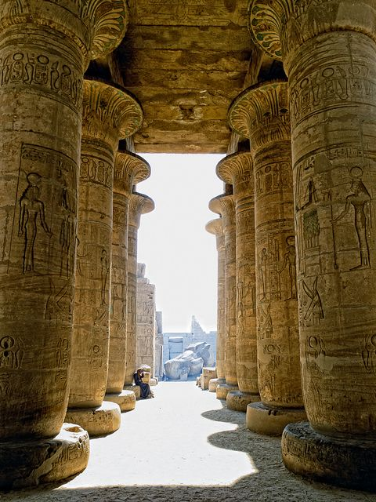
Altar of Zeus | 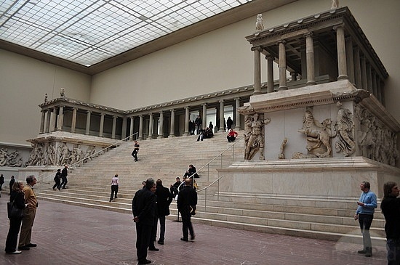
Augustus of Primaporta | 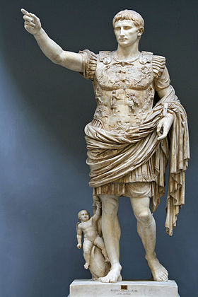
Sarcophagi of Junius Bassus | 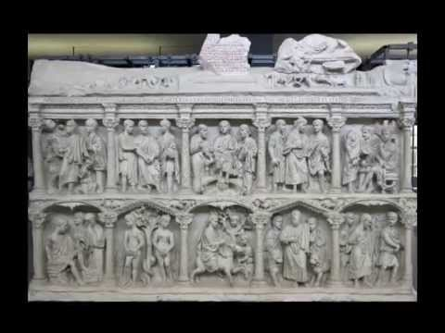
Hagia Sophia | 