John Mullan

ENEC 490

Professor Yates

3 November 2014

Economic, Environmental, and Political Implications of Future Large-Scale Lithium-Ion Battery Storage

The idea of capturing and storing energy has always been an attractive concept. In fact, since the inception of batteries in the 19th century, scientists and inventors have been looking to increase capacity in order to store mass amounts of electricity. Since the adoption of an on-demand electric grid fueled by constantly running power plants, the progress made for storing large quantities of energy essentially came to a halt. As the cost of producing electricity when it is needed is decreased, building massive energy storage centers became less attractive. Today, companies are looking to change the belief that batteries are too expensive and too short-lived to be used cost-effectively at scale. There is a field of companies looking to fill the growing market for electricity storage. Tesla is leading the charge into the energy storage domain with the introduction of the Powerwall and Powerpack. This paper will explore the economic, environmental, and political implications of widespread adoption of these products, as well as competitors’, examining the battery composition, production process, operational costs, and lifespan of these batteries.

**Background of Batteries**

To begin, it is necessary to understand what batteries are and how they are manufactured and operate. There are three relatively common battery types: Lead Acid, Nickel Metal Hydride, and Lithium-ion. Lead Acid batteries are the most common type; they provide high current and have a low cost, but they can only store about 25 watt-hours per kilogram. Nickel Metal Hydride batteries contain rare earth metals; they store about 100 watt-hours per kilogram and are very thermally stable. Finally, Lithium-ion batteries have high cell voltage and very high power density, registering at roughly 150 watt-hours per kilogram. Tesla and other energy storage companies are looking to Lithium-ion batteries as the future of batteries because of their extremely high energy density, allowing large amounts of energy to be stored in a relatively light battery1.

**Advantages and Limitations of Lithium-ion Batteries**

There are several advantages and limitations regarding Lithium-ion batteries. The cost of manufacturing these batteries is decreasing while the energy density capabilities are increasing, making lithium-ion batteries more attractive. Another advantage is that Lithium-ion battery cells cause little harm when disposed, so they are of relatively low environmental impact in this aspect. However, there are obvious limitations to the physical batteries as well. As Lithium-ion batteries age, the usable bandwidth of electricity decreases, which increases the stress placed on the battery. In turn, this enhances the aging process of the battery. Another limitation is the effect of diminishing returns on batteries; that is, oversizing Lithium-Ion batteries eventually becomes inefficient. Lithium-ion batteries also perform significantly worse in climates with extreme heat, humidity, and cold. For example, when the temperatures near zero degrees Fahrenheit, a fully charged battery has less than half of its potential power. These limitations affect the economic value of the batteries, and therefore affect the return on investment of purchasing the batteries.2

**Economic, Environmental, and Geopolitical Implications of Composition and Production**

Tesla’s production of the Powerpack and Powerwall are going to have a direct effect on the Lithium-ion battery market and the future of energy storage as a whole. There are several implications – economic, environmental, and geopolitical – from the production and use of these Tesla products that will be discussed moving forward. Beginning with the composition of Tesla’s Powerwall and Powerpack, the remainder of this paper will aim to discuss and evaluate every aspect of these products.

**Environmental Implications of Composition of Batteries**

Tesla will be using a high-energy Lithium-ion NCA (Nickel Cobalt Aluminum Oxide) battery for the Powerpack – the grid battery. These grid batteries target utility companies for huge amounts of energy storage. For its smaller battery, Tesla will be using an NMC (Nickel Manganese Cobalt Oxide) cathode. These batteries, the Powerwalls, are targeted at residential and business buildings for daily cycling and backup power. Regarding the Powerwall, Elon Musk said, “There’s quite a lot of manganese in there.”3

The implications of using these compositions are large, from the extraction of the component metals to the production process. As Figure 1 shows, Lithium-ion batteries are regarded as very light and very energy dense. However, as stated in the above paragraph, there are nearly a dozen metals that are required to construct Tesla’s Powerwall and Powerpack, and because Tesla is planning to roughly double the worldwide production of Lithium-ion Batteries, the extraction of these metals will also need to increase. In a 2013 report, the U.S. Environmental Protection Agency’s Design for the Environment program concluded, “batteries using nickel and cobalt, like lithium-ion batteries, have the ‘highest potential for environmental impacts.’”4

Cobalt – found in both the Powerwall and Powerpack – is typically found in copper ore and refined out. Copper ore is mined using open pit and underground techniques, both of which have serious environmental consequences through pollution, runoff, and erosion. Open Cut requires the removal of vegetation and expose previously unexposed rock. This rock, when crushed, can release “radioactive elements, asbestos-like minerals, and metallic dust,” which, when mixed with liquid, can create devastating wastewater. Underground mining requires “large movements of waste rock and vegetation.” Additionally, there is a large potential for the release of toxic substances into the air and water. Thus, the increase in demand for Cobalt will require increased mining efforts, likely resulting in additional environmental problems.5

A life-cycle analysis of an NCA-Graphite battery – one very similar to Tesla’s future utility-sized Powerpack – is comprised of roughly 16.5% graphite. Graphite is primarily mined and processed in China. According to reports, “graphite pollution has fouled air and water, damaged crops and raised health concerns.”6. This effect in China has caused authorities to shut down mines and processing plants, leading to several other potential problems. Furthermore, the processing of graphite requires the use of the highly corrosive hydrochloric acid, and in China, poorly managed mines often release hydrochloric acid through untreated wastewater, threatening all forms of life. Another significant component of Tesla’s future energy storage batteries is nickel. 12.1% of the mass of an NCA-Graphite battery is nickel, and the production process of nickel is environmentally unfriendly. The extraction of nickel requires the particularly damaging open cut or underground mining techniques. Obviously, there are serious environmental impacts that are caused by the composition of batteries, mostly through the mining techniques required to extract the necessary elements.7

**Environmental Implications of Production**

According to a recent study, “a high energy demand occurs in the production of aluminum and these other metals – especially in the combination of the production of all of these metals together to build the actual components.”8 Furthermore, a 2012 comprehensive life-cycle analysis in the Journal of Industrial Ecology shows that nearly half of lifetime carbon-dioxide emissions of an electric vehicle come from producing the car, especially the battery.9 Obviously, there are variations in the production of electric vehicle batteries and the future Powerwall and Powerpack, but the principle analysis is roughly the same in that the production process is energy intensive. For instance, the size of the battery in electric cars is much larger than that of the Powerwall and significantly smaller than that of the Powerpack. The above analysis found that production of an electric vehicle produces roughly 30,000 pounds of carbon, a majority coming from producing the battery. Furthermore, there are subtleties that are often overlooked in the analysis of the production of Tesla’s Powerpack and Powerwall. These products will be developed in Tesla’s future “Gigafactory,” which will be operated entirely on renewable energy, “with the goal of achieving net zero energy.”10 The environmental impacts of the actual production of the Powerwall and Powerpack will be relatively small when compared with other production processes. The Gigafactory will have the ability to recycle old lithium-ion batteries, extracting the lithium, nickel, aluminum, and cobalt for future use in batteries, but recycling these products can be tedious and expensive.10

**Economic Effects of Composition**

Still focusing on composition and production, this paper will now discuss the economic and geopolitical implications of the Powerwall and Powerpack, especially regarding the effects of large-scale production of the products. As previously stated, the Powerwall and Powerpack are both lithium-ion batteries, which are comprised of a myriad of metals and materials. Specifically, rare earth elements are a key component in the composition of these products and lithium-ion batteries in general. Despite their name, rare earth elements are relatively plentiful in Earth’s crust; however, because of their chemical properties, they are typically scattered and not found in concentrated quantities. This makes the mining of rare earth elements especially difficult, and therefore, more costly.11

For example, Dysprosium is a rare earth element that is necessary to the configuration of lithium-ion batteries. In recent years, the cost of Dysprosium has increased and because it is so rare, as more batteries are produced, more reserves will be depleted and new reserved will become increasingly difficult to find. Therefore, it may appear that component prices of lithium-ion batteries will decrease in the short run. In the long run, however, prices of batteries will be susceptible to the changes in prices of the component metals, which may be sporadic and significant as reserves deplete.12  A note should be made that according to Tesla, there are no rare earth elements – by definition – in the automobile lithium-ion batteries, but it is unknown whether there will be any in the Powerpack and Powerwall. However, there are rare earth elements in several competitors’ similar energy storage products; this is mainly due to the use of magnets in DC batteries in competitors’ products. Tesla’s use of AC batteries allows for a lack of magnets, but considering the size of Tesla’s future Powerpack, there is a realistic probability that rare earth elements will be located in the product.13

A prime example of an element in Tesla’s batteries that is becoming increasingly rare is manganese. As mentioned previously, there are significant amounts of manganese in Tesla batteries, but the reserves of manganese are slowly decreasing across the world. With the ramping up of production of lithium-ion batteries, the world will have to find an eventual substitute for manganese or new reserves. That is not to say reserves of manganese will run out, but as they continue to fall, the price will certainly rise.13

As Figure 2 shows, there are several elements that are of drastic importance to clean energy, especially the production of batteries and energy storage. Of the five elements listed as “critical,” Dysprosium has the greatest importance to battery composition and also has the highest supply risk. In the future, unless substitutes are found for important rare earth elements, there may be long-term price increases and less economic feasibility in lithium-ion production, which would directly affect the Powerpack and Powerwall, as well as other lithium-ion battery storage systems. Just as nearly all non-renewable resources, these important rare earth elements will likely follow the idea of “peak oil.” Peak oil refers to the point in time when the maximum rate of oil extraction is reached and begins to decline forever. Rare earth elements may indeed follow this same idea if large-scale lithium-ion energy storage systems are constructed.

**Geopolitical Concerns of Composition**

There are also several geopolitical concerns that will arise as the demand for the Powerwall and Powerpack grow and will be even more significant if wide scale use of these products comes to fruition. Currently, 97% of the world’s supply of rare earth elements is located in China. Furthermore, China expects to use a majority of these rare earth elements for its own production and because of this, tightly controls exports. If energy storage is to gain significant traction in the future outside of China, there will need to be negotiation with China to increase exports or manufacturers will need to find alternative sources of these necessary metals. In order for the Powerwall and Powerpack to be cost effective and feasible, there must be a consistent supply of component metals at a constant price.14

An additional implication of the production of the Powerwall and Powerpack is the increased demand of lithium. According to Figure 3, battery production accounts for 26% of lithium demand. Tesla is planning to more than double battery production by 2020, so the demand for lithium will undoubtedly reach new heights. The supply of lithium is unlikely to run out, but in the future, when demand skyrockets, current supply will be unable to satisfy demand. Additionally, lithium can be recycled an unlimited number of times, but the process can be expensive and tedious. Therefore, just as with rare earth metals, the price, supply, and demand of lithium will have a affect on the price and feasibility of the Powerwall and Powerpack. Prices may initially fall because of economies of scale, but in the long-term, prices may eventually rise as the prices of lithium, nickel, aluminum, manganese, and cobalt also rise.2

**Economic Feasibility of Large Scale Lithium-ion Production**

Considering the possibilities of supply shortage and exponential demand growth, there is still the high probability of huge economic profits from the production of the Powerwall and Powerpack. Using economies of scale, Tesla will be able to mass-produce lithium-ion batteries at historically low levels. Furthermore, Tesla will be able to reduce costs of these lithium-ion batteries by locating the entirety of manufacturing within the Gigafactory. Assuming Tesla will be able to acquire all of the necessary elements, metals, and materials for the Powerwall and Powerpack inexpensively and consistently, the economics behind producing these products appear to be very promising and will undoubtedly jumpstart the energy storage market.10

**Environmental Effects of Owning and Operating Powerwall**

We have discussed the economic, environmental, and geopolitical implications of the composition and production of energy storage systems. This paper will now discuss the environmental and economic benefits and costs to the individual and society of owning these products. There are huge environmental benefits for society of owning a Powerwall to society. Firstly, if an individual has installed solar panels on his or her rooftop, the Powerwall would be an obvious choice in that the electricity going to the Powerwall would be completely clean. Essentially, the home would be completely net zero.

Without solar, the Powerwall still provides a huge environmental benefit. During peak times of electrical use, the grid often has to “switch on” peak power plants, which are some of the dirtiest power plants. According to Environment America Center, the total U.S. carbon dioxide emissions are roughly 5,277 MMT (Million Metric Tons). Of that figure, roughly 656 MMT of emissions is produced by the 50 dirtiest power plants – most of which are the peak power plants that switch on during times of extremely high demand.15 The Powerwall can effectively stop the use of these extremely dirty power plants by storing electricity from the grid when demand is low and releasing that electricity when demand is high instead of switching on peak power plants.

This would be compounded with the use of renewable energy systems to produce the electricity that would be stored in the Powerwall. Using wind or solar power would have multiple benefits. Firstly, they would effectively eliminate the need for peak power plants because the combination of the renewable power coupled with energy storage would supply the peak power when it is needed. Secondly, wind and solar power are both intermittent; that is, they are not able to produce electricity on demand. Therefore, coupling energy storage with these types of energy production would effectively allow on-demand energy from renewable energy systems.16 In order for this system to be successful, however, there will need to be mass-installation of both renewable energy systems and energy storage systems – a mission that energy storage systems are looking to bolster.

**Environmental Benefits of Large Scale Implementation of Powerpack**

The Powerpack is the utility-scale version of the energy storage system offered by Tesla. These batteries can be interconnected in order to form a massive energy storage system. The Powerpack has a much higher environmental benefit than the Powerwall for several reasons. Firstly, if the Powerpack is purchased by utilities, the benefits would reach thousands of customers, which is more plausible than having thousands of individual customers purchase individual Powerwalls. Secondly, the Powerpack, if implemented in large scale, does not need to rely on renewable energy for the product to provide huge environmental benefits. Elon Musk recently commented on these benefits saying, “You can basically, in principle, shut down half of the world’s power plants if you had stationary storage.” As mentioned earlier, this is because utilities have to build and operate peak power plants to meet high demand. In fact, utilities must have more capacity than what is needed at peak demand because of the risk of causing a blackout across regions. The employment of the Powerpack by utilities would effectively cut out this necessity, allowing the utilities “to store energy when demand is low and use it when demand is high, without turning on more power plants.”17

Other environmental benefits of installing gigawatt-sized would be the potential decrease in the mining efforts for coal and natural gas. With the discovery of “fracking,” many environmental groups have cried foul at the massive amounts of water needed and the pollution caused by fracking. The application of wide-scale energy storage would allow for a decrease in current production and consumption of natural gas and coal.18

**Economic Implications of Owning Powerwall**

There are also several economic implications to owning the Powerwall that need to be considered. Even with Tesla’s Gigafactory producing mass amounts of lithium-ion batteries, the costs of these systems will be high. According to Figure 4, the two most reasonable options for purchasing the Powerwall are through a cash payment or a 9-year lease. The total cost for these systems, respectively, are $7,140 and $5,000. For most consumers, these costs are entirely too expensive for the products to even be considered. When broken down to the cost per kilowatt-hour, a cash-purchase option is roughly $0.25/kWh and the 9-year lease is roughly $0.26/kWh. However, according to the U.S. Energy Information Administration, even in the most expensive region (New England), the cost for electricity is only $0.18/kWh. Thus, if the prices of the Powerwall remain at their current rates, the majority of consumers would be paying more for their stored electricity than if they were to buy through the grid. Moreover, even in the least expensive region, East South Central, electricity is merely $0.12/kWh, meaning the costs must come down significantly for these energy storage systems to be feasible to the consumer. This is different, however, if the consumer owns solar panels and is able to sell excess energy back to the grid. In this case, the consumer would likely save money through buying a Powerwall.19

**Economic Implications of Owning Powerpack**

The economic results of the Powerpack are much more favorable than the Powerwall. The Powerpack starts at a capacity of 100kWh and is scalable to gigawatt levels. There has been roughly $1 billion in reservations for both the Powerwall and Powerpack, with about 70% of these reservations being for the Powerpack. Tesla claims the Powerpack has a capital cost of $250/kWh, which according to recent research, is beneath the threshold of $350/kWh wherein utilities can save money using the Powerpack and idling power plants.

According to Figure 5, over the course of its lifecycle (5000 cycles), the Powerpack has a cost per kWh of $0.05. This cost is less than half the cost of electricity produced by the grid in even the least expensive of regions. These large-scale batteries offer a significantly less expensive option for electricity when demand is high than switching on a peak power plant. This would be attractive to consumers especially in areas with variable electricity pricing, offering a constant price for electricity even in times of high demand.

The system-wide savings of large-scale energy storage through a product like the Powerpack is illustrated in Figure 6. Figure 6 shows that with energy storage of 8,000MW, system wide savings would be over $1 billion annually. However, this figure is considering the expected battery capital costs of $350/kWh, but as Tesla has announced, the Powerpack provides electricity at a capital cost of $250/kWh, which would mean even higher system-wide savings.

**Additional Benefits of Large Scale Implementation of Powerwall and Powerpack**

There are additional benefits to owning a Powerwall that consumers would likely see. The most significant benefit is security. Owning a Powerwall effectually protects the consumer from problems with the grid, namely blackouts. When hurricanes and snowstorms hit, homes often lose power for days at a time. The Powerwall would allow these consumers to be able to operate the essentials of their home until the grid is able to provide electricity again. This would be especially important to businesses that need a consistent source of electricity. In times when the grid is offline, these businesses would still be able to operate. An additional benefit to these businesses would be that instead of running costly gasoline generators while the grid is down, the energy storage systems would already be charged and ready to take over any necessary power needs.20

Another potential benefit regarding the implementation of wide-scale energy storage is cyclical in its nature. If more energy storage is made available to the grid, more emphasis will be made on the value of wind and solar power, because the intermittency of each of these energy production techniques will become less severe. With an increased investment in additional wind and solar energy production systems, a higher value will be placed on the energy storage systems that will be needed to store the electricity that is produced. This cycle would produce thousands of new jobs and additional income in the renewable energy and energy storage sectors, which in turn would further the reduction in costs of both renewable energy systems and energy storage.

**Conclusion**

Energy storage is the way of the future, through means of lithium-ion batteries or through future technology. Currently, the best, most viable option appears to be lithium-ion energy storage systems. There are wondrous benefits from implementing extensive energy storage systems, but there are also economic, environmental, and geopolitical concerns that must be addressed or at least be made aware before moving forward with such a massive overhaul of the electricity grid.

There are environmental concerns with lithium-ion batteries: the extraction of the component metals can be environmentally unfriendly and the production process requires large amounts of energy. There are economic interests in that the price will decrease initially, but as increasingly more lithium-ion batteries are produced, the elements and metals necessary for production may eventually increase. Finally, there are geopolitical concerns regarding the production of lithium-ion batteries, especially that as more rare earth elements are needed, companies will be forced to turn to countries such as China, Russia, and Namibia.

On the other hand, there are obvious benefits to large-scale construction of lithium-ion energy storage systems. Energy storage would decrease individual’s dependence on the grid for electricity, utility-scale energy storage would allow some of the dirtiest power plants to be idled, and as the price of producing the energy storage systems decrease, their attractiveness increases. Once the price of energy storage surpasses the threshold necessary for utility companies to actually save money by purchasing these systems, their adoption will spike as utilities realize the abundant savings possible. This would allow the grid to become cleaner, increasing investment in renewable energy systems and decreasing the extraction of oil and natural gas.

Energy storage is a fast-growing industry. Energy storage will allow for better grid security, more economic savings, and overall, a less polluted planet. Tesla’s products – the Powerwall and Powerpack – seek to solidify this market. These products will continue to evolve into more efficient, more affordable technologies, and as technology advances, energy storage will be viewed as the most economically feasible and environmentally friendly process for delivering electricity to consumers.

Figure 1

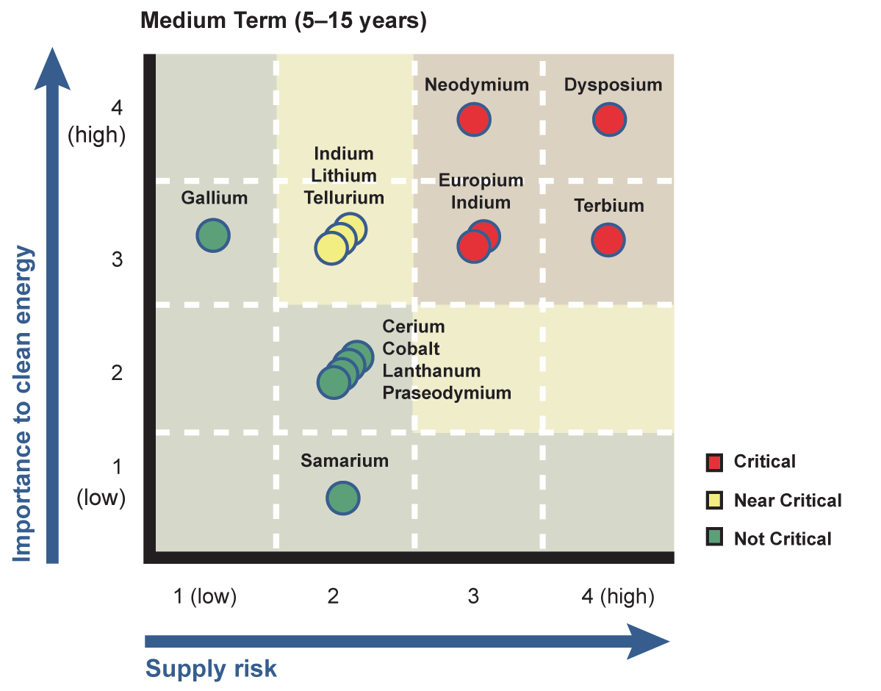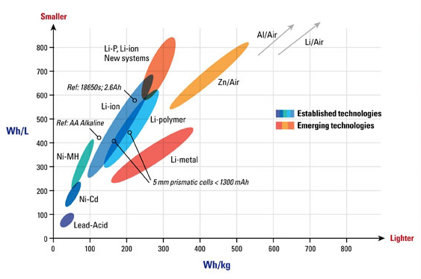Figure 2

Figure 3

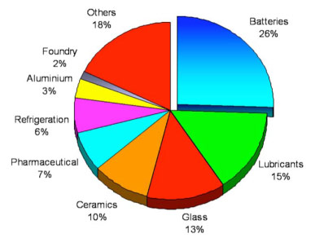

|  |  |  |  |  |  |  |  |
| --- | --- | --- | --- | --- | --- | --- | --- |
|  | Powerwall (cash purchase from SolarCity) | Powerwall (9-year lease from SolarCity) | Powerwall (wholesale cash purchase Tesla) | Powerwall (retail purchase from distributor) | Aquion Energy S20P | Aquion Energy M100-L082P | Iron Edison 24V Lithium Battery |
| Cycles | 5,000 | 3,285 | 5,000 | 5,000 | 3,000 | 3,000 | 2,000 |
| kWh/cycle (efficiency & degradation assumptions included in calcs) | 5.80 | 5.80 | 5.80 | 5.80 | 1.81 | 21.73 | 2.76 |
| Total kWh produced over product lifetime | 28,980 | 19,040 | 28,980 | 28,980 | 5,430 | 65,178 | 5,530 |
| Total Cost | $7,140 | $5,000 | $3,000 | $3,600 | $1,155 | $15,795 | $2,761 |
| $/kWh used | $0.25 | $0.26 | $0.10 | $0.12 | $0.21 | $0.24 | $0.50 |

Figure 4

Figure 5

|  |  |  |  |  |  |  |
| --- | --- | --- | --- | --- | --- | --- |
|  | Powerpack (utility) | Eos Aurora 1000 | 6000 | Imergy (current pricing, 15 years of life) | Imergy (current pricing, 30 years of life) | Imergy (projected pricing, 15 years of life) | Imergy (projected pricing, 30 years of life) |
| Cycles | 5,000 | 10,000 | 5,475 | 10,950 | 5,475 | 10,950 |
| kWh/cycle (efficiency & degradation assumptions included in calcs) | 8,280 | 4,050 | 7,500 | 7,500 | 7,500 | 7,500 |
| Total kWh produced over product lifetime | 41,400,000 | 40,500,000 | 41,062,500 | 82,125,000 | 41,062,500 | 82,125,000 |
| Total Cost | $2,070,000 | $648,000 | $3,750,000 | $3,750,000 | $2,250,000 | $2,250,000 |
| $/kWh used | $0.05 | $0.02 | $0.09 | $0.05 | $0.05 | $0.03 |

Figure 6

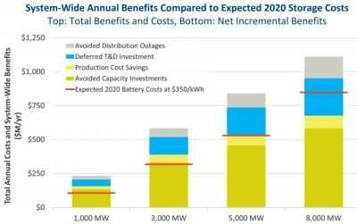

**Sources**

1. Shapley, Patricia. "Common Battery Types." University of Illinois, 2012. Web. 02 Nov. 2015.
2. "What Causes Lithium-Ion To Die?" *Battery University*. Ed. Jeff Dahn. N.p., n.d. Web. 2 Nov. 2015.
3. Fehrenbacher, Katie. "Why Tesla's Grid Batteries Will Use Two Different Chemistries." *Fortune*. N.p., 18 May 2015. Web. 02 Nov. 2015.
4. Westervelt, Amy. "Tesla's New Battery May Be Harder On The Environment Than You Think." *The Guardian*. N.p., 10 June 2015. Web. 2 Nov. 2015.
5. "Environmental Risks Of Mining." *The Future Of Strategic Natural Resources*. Massachusetts Institute of Technology, n.d. Web. 2 Nov. 2015.
6. Behrmann, Elisabeth. "Green Batteries' Graphite Adds to China Pollution." *BloombergBusiness*. Bloomberg, 30 Apr. 2014. Web. 02 Nov. 2015.
7. Mudd, Gavin. "Global Trends and Environmental Issues in Nickel Mining: Sulfides versus Laterites." *ScienceDirect*. N.p., 1 June 2010. Web. 02 Nov. 2015.
8. Notter, Dominic, Marcel Gauch, Rolf Widmer, Patrick Wager, Anna Stamp, Rainer Zah, and Hans-Yorg Althaus. "Contribution of Li-Ion Batteries ToThe Environmental Impact Of Electric Cars." *Environment Science Technology* 44 (2010): 6550-556. Swiss Federal Laboratories for Materials Science and Technology, 24 June 2010. Web. 2 Nov. 2015.
9. Lomborg, Bjorn. "Bjorn Lomborg: Green Cars Have a Dirty Little Secret." *The Wall Street Journal*. N.p., 11 Mar. 2013. Web. 02 Nov. 2015.
10. "Tesla Gigafactory." *Tesla Gigafactory*. Tesla, n.d. Web. 02 Nov. 2015.
11. "Rare Earth Elements." *Rare Earth Elements*. Rare Element Resources, n.d. Web. 02 Nov. 2015.
12. "Why Invest in Rare Earths?" *Investment Opportunity: Namibia Rare Earths Inc.* Namibia Rare Earths Inc., n.d. Web. 02 Nov. 2015.
13. "Powerwall." *Tesla*. N.p., n.d. Web. 02 Nov. 2015.
14. "World Manganese Reserves 2016 | Forecast." *Statista*. N.p., n.d. Web. 02 Nov. 2015.
15. Jones, Nicola. "A Scarcity of Rare Metals Is Hindering Green Technologies." *Yale Environment 360*. Yale University, 18 Nov. 2013. Web. 02 Nov. 2015.
16. Schneider, Jordan, Travis Madsen, and Julian Boggs. "America's Dirtiest Power Plants." (2013): n. pag. Environment America Research and Policy Center, Sept. 2013. Web. 2 Nov. 2015.
17. "Top Energy Companies Join Forces to Launch Utility-Scale Energy Storage System." *Renewable Energy World*. N.p., 8 Oct. 2015. Web. 02 Nov. 2015.
18. McMahon, Jeff. "Elon Musk: Tesla Powerpack Doesn't Need Renewables, Battery Market 'Staggeringly Gigantic'" *Forbes*. Forbes Magazine, 5 Aug. 2015. Web. 02 Nov. 2015.
19. "What Is Fracking and Why Is It Controversial? - BBC News." *BBC News*. N.p., 27 June 2013. Web. 02 Nov. 2015.
20. Shahan, Zachary. "Tesla Powerwall & Powerpacks Per-kWh Lifetime Prices vs Aquion Energy, Eos Energy, & Imergy." *CleanTechnica*. N.p., 09 May 2015. Web. 02 Nov. 2015.
21. "Energy Storage: The Key to a Reliable, Clean Electricity Supply." *Energy.gov*. N.p., 22 Feb. 2012. Web. 2 Nov. 2015.