The Spotify Web API is a powerful tool that allows you to access and make changes to songs, albums, playlists, and other data objects stored in Spotify's database. The best part is, it's completely free!
In this tutorial, you will learn:
- How to install the API in Eclipse
- How to register your application

Install the API
To use the Spotify Web API, We'll need a 3rd party library to help our application communicate with Spotify's servers. Luckily for us, Spotify has provided us with one Here. However, since the API library depends on other 3rd party libraries that we don't have, we must install it as a Maven dependency.

Installing the Maven Dependency
Step | Screenshot
First, right click on your java project and select configure -> convert to maven project | 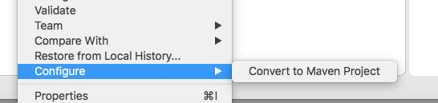
Left click on the folder again and select maven -> add dependency A dialog box should prompt you for a group id, an artifact id, and a version. | 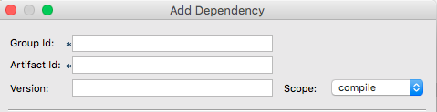
Find the latest version of the library here. Select the file spotify-web-api-version.jar and copy the information into the dialog box in Eclipse | 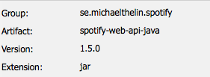
Click "Ok." The library binaries should appear in your project under Maven Dependencies | 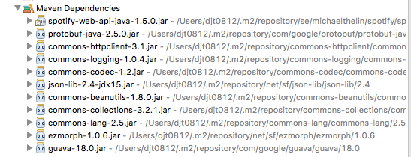

Register your application
In order to get faster request speeds or access any user-specific data, you will have to register your application with Spotify's Developer Page. You'll need a spotify account (both free and premium accounts will work)
After creating an account, go to the My Applications page and select "Create an App". After submitting a name and description for your application, you will be provided with a Client ID and a Secret ID. Store these keys somewhere safe, you will need them for the Authorization Code Flow.
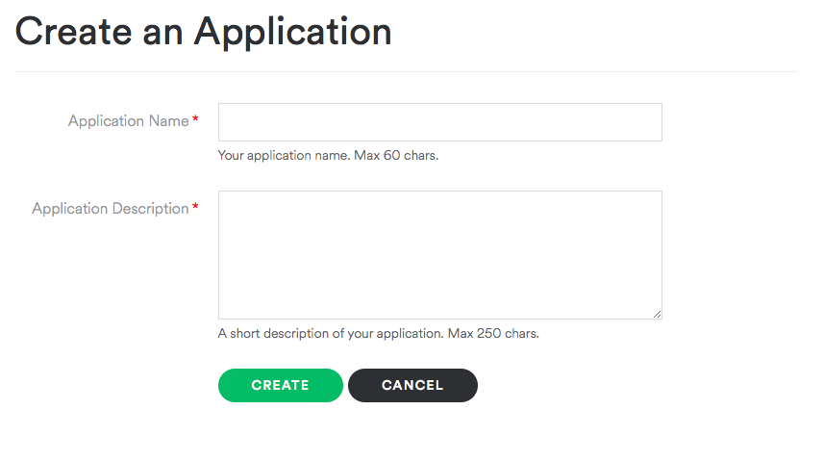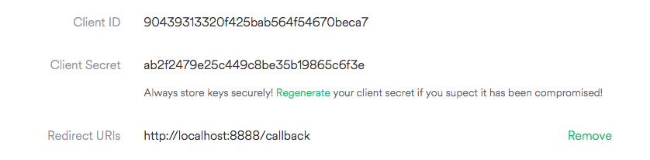
Set a Redirect URI if you plan on authenticating users. The link does not have to work, but the user sign-in page has to redirect to somewhere or it will cause an error.

All Done!
You are now all set to start programming with the Spotify Web API! For documentation on how to use the API, check out the readme.

