# Oct 29, 2015 9 am

**We all take time to heal**  
**forget what we can't appeal**  
**regret what we don't feel**  
**indulge in a world we find real**  
**go deep within and break the seal**  
**a mask is no true shield**  
**we find doom from the weapons we wield**  
**find solace in a moonlit field**  
**find solace by a rushing river**  
**the morning dew, a soft wind shiver**  
**the moment before a kiss, warm lips quiver**  
**the stars endless when the moon's a sliver**  
**warm rain among waterfall mist**  
**the sunset and clouds, a vivid tryst**  
**the feeling of gazing into an abyss**  
**the playful magnetism that fuels each kiss**  
**engaging dreams before a shift**  
**porous pain fostered by a rift**  
**small hands find sands to sift**  
**seeking colorful seashells to gift**  
**can we let go of the things we believe?**  
**create a world, when we're ready we'll leave**  
**find beauty in all we perceive**  
**let go of what we used to conceal**  
**interactions fateful and real**  
**gratitude for all we can feel**  
**after all, we take time to heal**

Colorful seashells to gift

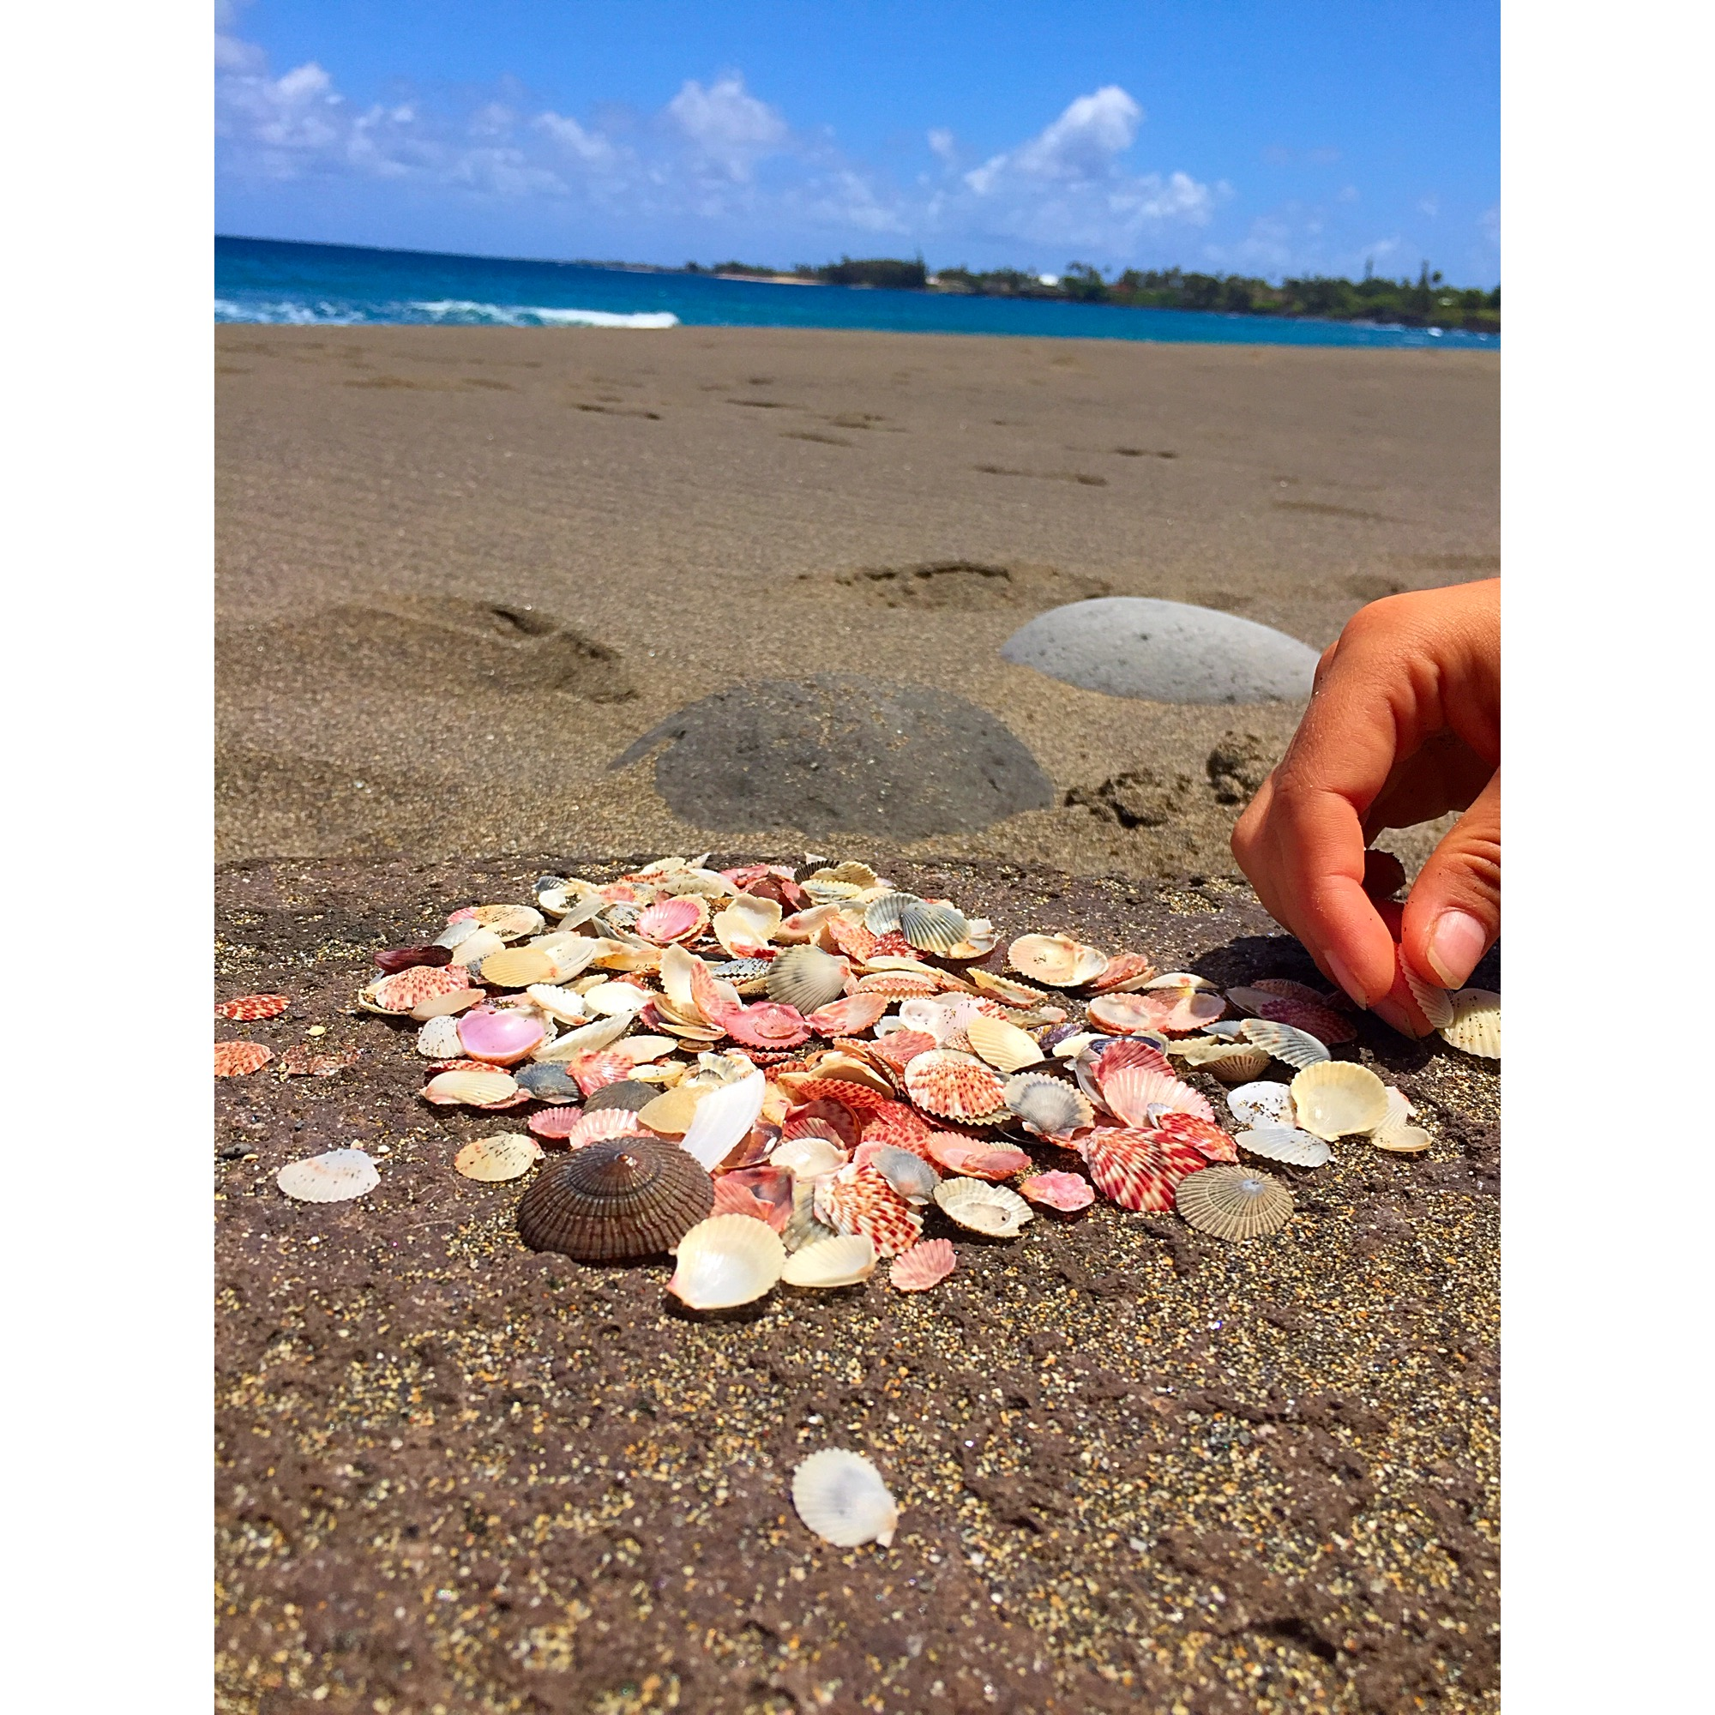 ___

|  |
| --- |
| Number of Instances where word rhymes with: |
| heal | 9 |
| shield | 3 |
| river | 4 |
| mist | 2 |
| kiss | 2 |
| shift | 4 |
| believe | 3 |

[For some stimulating visuals](https://gavvy.github.io/design/tool/2016/10/03/placesiwannago.html)

Concepts touched on by poem:  
 * the feelings that each of the events inspire  
 * connection between humans on a deep and genuine level  
 * relation through [vulnerability](https://www.ted.com/talks/brene_brown_on_vulnerability?language=en)