This Class So Far

September 26, 2016
This is my reflection write-up from assignment 2 with a few changes so that it meets the requirements of assignment 3.
Here is a quote. It’s a movie quote that has nothing to do with the contents of this write-up, but it’s here because the assignment requires quotes.
“Happiness can be found even in the darkest of times, when one only remembers to turn on the light.” -Dumbledore, Harry Potter and the Prisoner of Azkaban
Now here is some text formatting. There can be bold text, or there can be italics text. All of these are for emphasis.
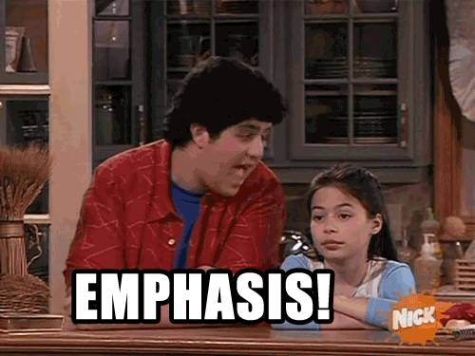
And finally, here is the reflection from assignment 2 with a table added.
It’s been a little over a month since I’ve started my sophomore year at UNC and enrolled in this class called INLS 161. A month may seem like a short amount of time, but a lot can be learned in a small time frame. Here is a summary of what I’ve learned so far.
I’m a computer science major, and I’ve heard about github and have even downloaded files from the site in my past classes, but I never really knew exactly what it was or what you could do with it. This class has expanded my knowledge about github and has allowed me to gain experience with using the website. This class has also given me an introduction to linux and linux commands. Coincidentally, I’m also learning and using linux commands in another class that I am taking this semester, so it’s helpful that the things I’m learning in this class are also helping me in other classes and might also potentially be useful in my future career in computer science.
Here are some basic commonly-used linux commands that I’ve learned in this class.
Command | Action
cd | changes directory
pwd | prints working directory
ls | lists contents of directory
For more information on linux, this resource provides a great overview of different commands.
Moreover, I’ve learned the basics of creating and editing websites using html, css, and markdown and how to display websites on github. I’ve learned about customizing the way a website looks, like editing colors, fonts, and text sizes, and I’ve learned about adding different types of data to a website, like adding pictures, embedding videos, sounds, or widgets, and adding snippets of code. It’s a likely possibility that I might have to create or work with websites in my future career, so it’s good that I’m learning these useful skills.
Overall, I think the things I’ve learned in this class so far and the things that I’m going to learn in this class later in the semester are helpful skills and will allow me to succeed in other classes and in the future.

